Experiences of the forecasters related to the ALADIN model

The weak point of the model

As every forecaster knows the weak point of the models is the inversion situation. In January, February and December last year, we already had periods with inversion and persistent fog or stratus. According to our regular verification, in these situations the models very often are not able to capture the lower cloudiness and fog leading to an overprediction of diurnal temperature (Figure 1.). It must be said that in these situations none of the models have considerably improved compared verifications of previous years. Therefore, the model results need to be modified by the forecasters as the 1 Table shows.

Performance of the model and forecaster (Budapest, 16. 01. 2006.)

ECMWF ALADIN Forecasters Obs.
Cloudiness (oktas) 1-2 0-1 6,5-7,4 8,0
during the day
Minimum -7 -10 -3 -4

The interesting aspect of these situations is, that regarding maximum temperature forecasts the ALADIN model was a little bit better than the ECMWF model in some cases in December 2006, while the model underestimated the cloudiness like the ECMWF one. According to our investigations, it seems that even if the models are able to capture lower cloudiness or fog, the breaking of the inversion is too early in the model compared to the reality.

Figure 1.: MSG image (15. December, 12 UTC) and ALADIN total cloudiness forecast for 15. December, 2006, 12 UTC (the model based on 15. 06 UTC)
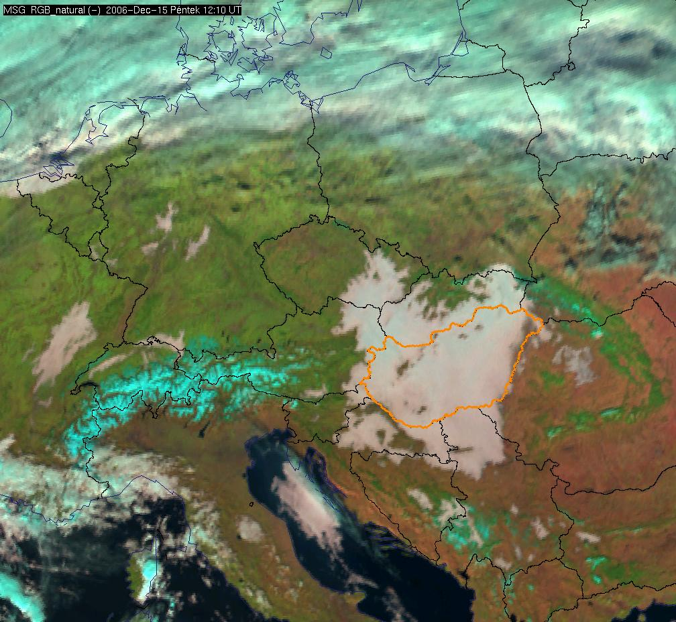
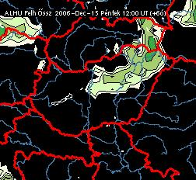
Temperature

The 2 m temperature is not well-predicted element compared to the ECMWF model, which is very often better regarding this element (results of verifications based on coded forecasts 2006). The maximum temperature is generally underestimated during summer, especially in those cases, when the model predicts lot of cloudiness without precipitation. The minimum temperature is very often overestimated, but during strong wind or overcast situation (especially in winter) it is underestimated.

The cloudiness

The total cloudiness is very often overestimated due to the high relative humidity at higher levels (300-500 hPa).

Wind

The strong point of the model is the wind forecasts. Compared to the other models the ALADIN model is the best. The model is usually able to capture the fine structures of the wind field for example the convergences lines, which play important role in the development of convective precipitation. The wind gust forecasts generally are also perfect.

Precipitation

The reliability of the precipitation forecasts improved considerably in the last 2-3 years.

Snow depth

The minimum temperature is over-estimated in case of high snow depth (20 cm). Regarding this problem we did not have experiences this year.

