Report on stay at ZAMG
01/06 – 30/06/2006, Vienna, Austria

Combination of large scale initial conditions uncertainty with small scale initial perturbations obtained by breeding method using blending procedure

::Supervised by
Yong Wang (ZAMG)
yong.wang@zamg.ac.at

::Author
Martin Belluš (SHMU)
martin.bellus@shmu.sk

::Content

Acknowledgement
Introduction
I Spectral blending of initial conditions
II Limited area ensemble forecast – breeding method
III Blending script – technological line
IV Low spectral resolution setting
V Digital filter tuning
VI Blending results

Conclusion

::Acknowledgement

Many thanks to Mária Derková for willingness to share her blending know-how with me and especially for her light-fast response to my frequent e-mails. I am also very grateful to the whole local team for their hospitality and friendly atmosphere.
::Introduction

The main goal of this stay was to create a technological line for producing blended initial conditions from ARPEGE singular vector members and ALADIN breeding members in order to prepare initial file for further limited area ensemble forecast integration. We suppose that such combination of large scale perturbations obtained from driving model with the small scale perturbations generated by breeding method will be more consistent with used lateral boundary conditions, while it still may keep the small scale features produced by breeding cycle. For this purpose a complex Perl script was written and basic setup of transformation to the low spectral resolution and tuning for DFI filtering was done. A detailed description of blending procedure used here can be found in the following chapters.

::I Spectral blending of initial conditions

The general and well known idea of blending is to combine the large scale features resolved by global model analysis (or global model source of information – in our case ARPEGE singular vectors) with the small scale features provided by limited area model (usually by short-range forecast). In our case, we are not going to use any short-range forecast, but instead an initial file obtained by breeding method (will be explained in the next chapter). However, the theory laying behind is still the same. The short-wave part of our ALADIN breeding files is more realistic than the short-wave part of corresponding interpolated ARPEGE files. But here blending method is used to introduce the large scale perturbations produced by singular vectors into the ALADIN breeding files rather than the original idea of meso-scale data assimilation without direct input of the observations.

::II Limited area ensemble forecast – breeding method

Limited area ensemble forecast is connected to the global ensemble forecast in the same manner as limited area model depends on global one. In our case the global ARPEGE PEARP system for short range ensemble prediction was used. It is based on singular vector technics, where perturbed initial conditions are created by adding and subtracting singular vector perturbations to the unperturbed analysis. It consists of 10 members (5 pairs) and 1 control run.

Here not a simple downscaling of global ensemble forecast is done, but the breeding method is used. Breeding has to simulate the effect of uncertainty in observations by rescaling the nonlinear perturbations. It is used to prepare the perturbed initial conditions for limited area ensemble prediction. Since these initial conditions have to be still coupled with the global ensemble members which are actually incompatible with the breeding files – an idea to blend two corresponding initial states was chosen.

The general scheme of breeding cycle is shown on the following picture (Fig.1). After 12 hours of integration (coupled with ARPEGE PEARP every 6 hours) there is computed the difference between two forecasts belonging to the same pair (positive and negative one). The difference is actually computed for some meteorological variables as temperature, specific humidity, wind components in 3D and for surface pressure. Afterwards, it is rescaled and centred around the new analysis in order to obtain new initial states (perturbed ones) for the subsequent limited area ensemble forecast integration. In the manner of our thinking (mentioned in the previous paragraph), these perturbed analysis provided by breeding are going to be blended with the corresponding ARPEGE singular vector initial states. (As a final goal, breeding-blending cycle will be used to prepare new initial conditions for limited area ensemble forecast.)

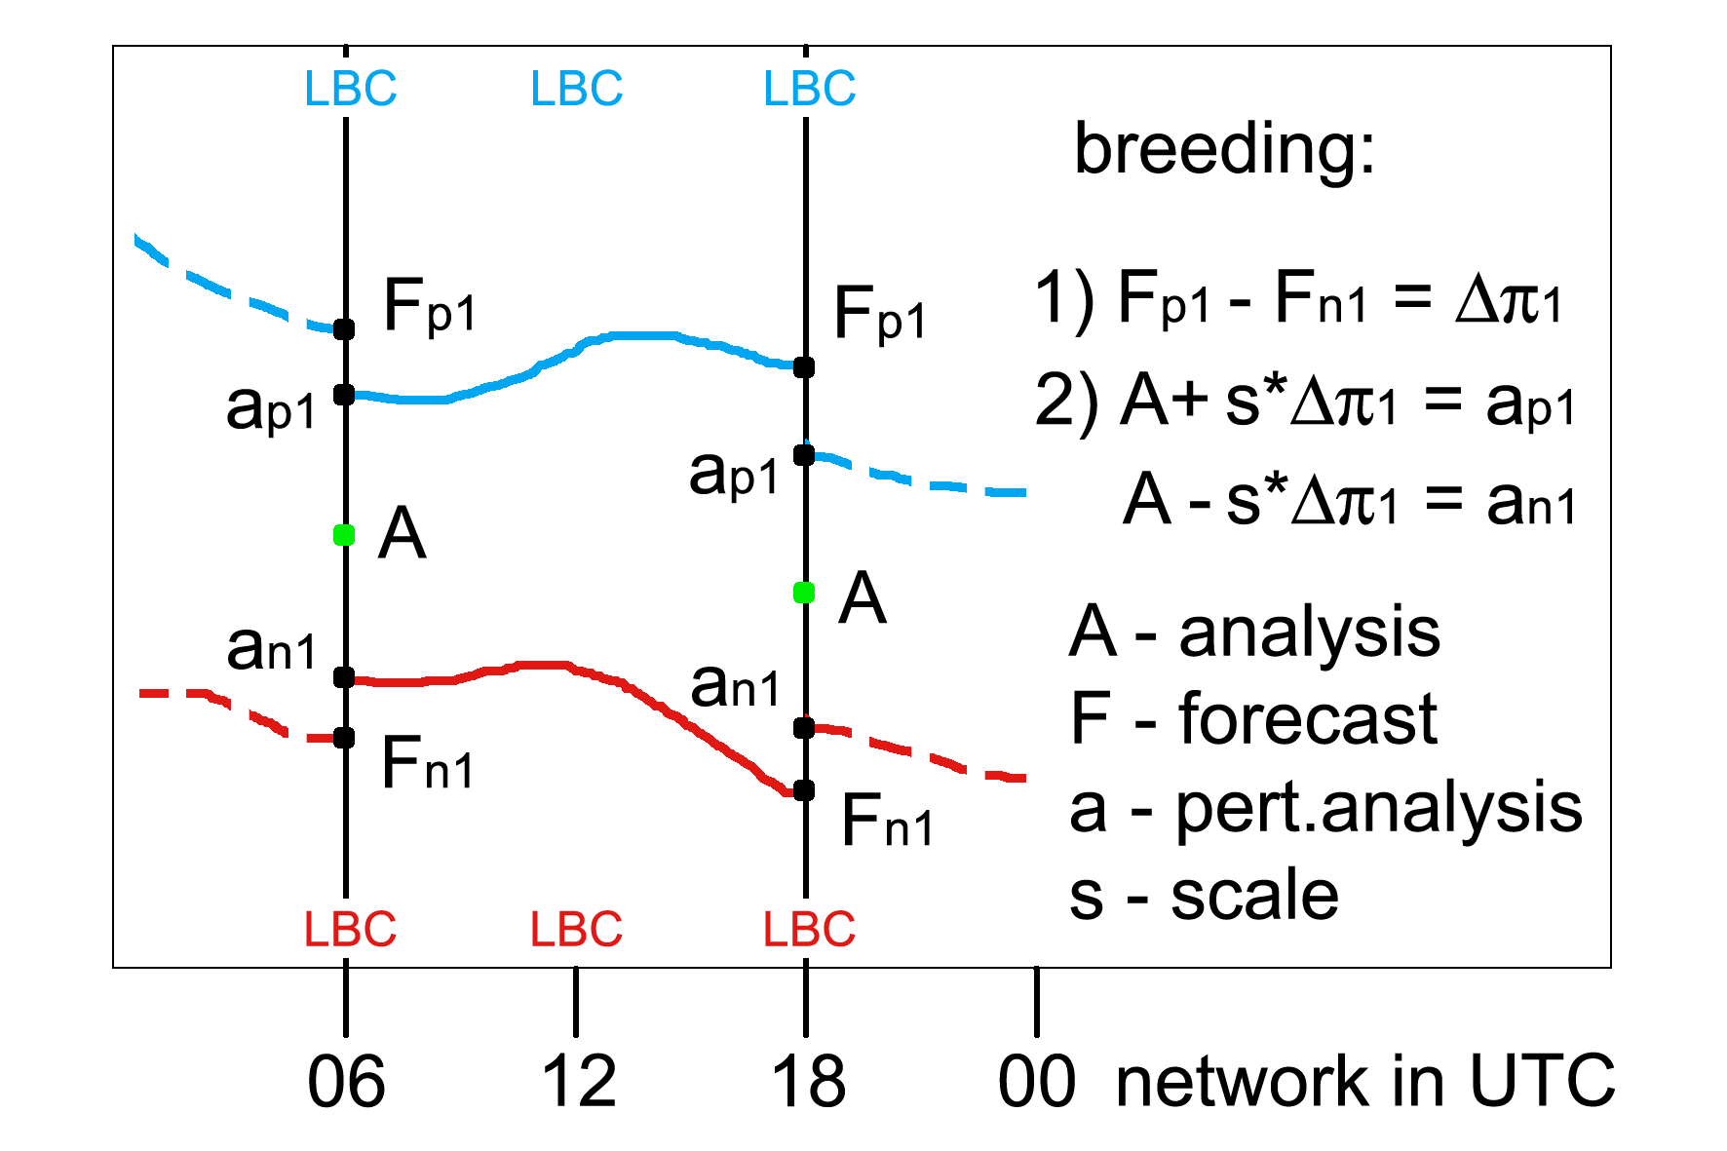

::Fig.1 The scheme of breeding cycle.

::III Blending script – technological line

This chapter is fully devoted to the technical description of blending procedure and should provide also some useful documentation about the script (to perform blending) itself. The general idea of blending was already introduced in the first chapter and now particular steps to reach that final result are going to be shown.

The whole process consists of several steps. But the main principle is to apply a digital filter on both ARPEGE and ALADIN files on the original ALADIN grid but at a lower spectral resolution. The difference between those filtered files, already at the ALADIN full spectral resolution, represents a large scale increment which should be added to the original ALADIN file. The computation leading to an appropriate low spectral resolution will be shown in the next chapter and some basic tuning of digital filter will be discussed in the chapter V.

Detailed information about used blending procedure can be obtained from the following diagram (Fig.2). The equation at the top just summarizes what was already said (“SV” stands for singular vector and “BR” means breeding). Further, all individual steps to reach the final result are displayed, while the processes are red coloured and grouped by the grey zones and the different spectral resolutions are highlighted by yellow (low resolution) and cyan (high resolution) colours.

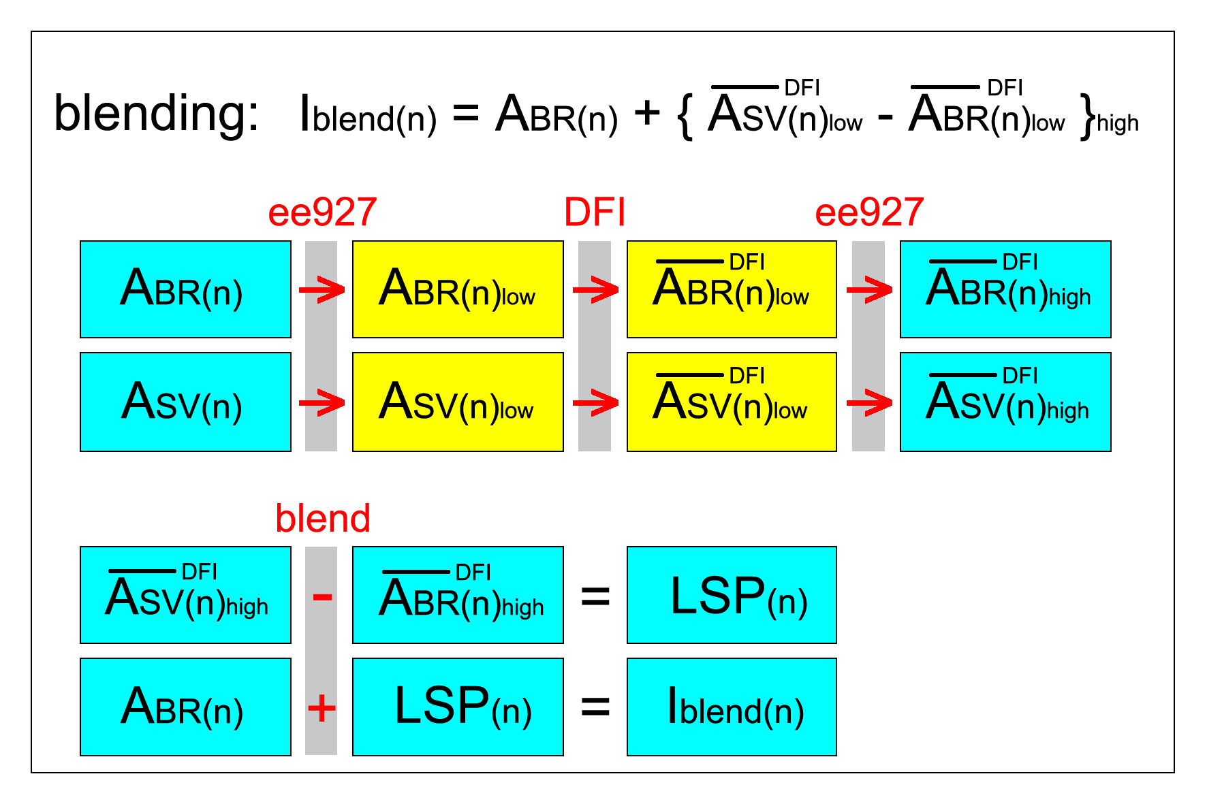
::Fig.2 The blending procedure.

Actually, to perform all the above displayed processes (Fig.2) we need just 3 different functions. In the blending script this was reached by programming the following 3 dedicated subroutines:

&chspecreso($fileA, $fileB, $kA, $kB)
It changes the spectral resolution of fileA characterised by the elliptic spectral truncations kA and saves it into fileB with the new truncations kB. To go from one spectral resolution to the other, ee927 model configuration is used without any geometry changes but with different climatological files for input and target domain. They were created (e923) in the same way but with the different NSMAX a NMSMAX values. The existence, date validity and spectral resolution of the input file are verified. The spectral resolution of climatological files for input and target domain is also verified. Necessary ENV setup is done and namelist is dynamically created from the template (lancelot.template) according to the local configuration in subroutine. When the output file is created, its new spectral resolution is finally controlled as well.

&filteratls($fileA, $fileB)
It does the digital filtration of fileA and the result is saved into fileB. To perform the filtration a model configuration e001 with only DFI and constant coupling is used. The existence and date validity of the input file is verified. Necessary ENV setup is done and namelist is dynamically created from the template (morganeDFI.template) according to the local configuration in subroutine.

&blendathis($fileA, $fileB, $fileC, $nsign)
It does the combination of fileA and fileB which is then saved into fileC. Whether the first two files will be added together or the second file will be subtracted from the first one, depends on the value of nsign. In this case it makes sense to have either nsign equal 1.0 (add) or -1.0 (subtract). Necessary ENV setup is done and namelist is dynamically created from the template (blend.template). The limited file name size, variable type and special copy procedure at the beginning of the process required by the external aladin/blending executable are fully controlled by the subroutine and user do not need to take care about.

In the script part called “EDITABLE SETUP” one can change the following variables: the main working directory path (which is always automatically created – do not need to take care about); model root paths (different ALADIN cycles were used for individual processes); full paths to the several external executables used in the script including ALADIN master paths; original ARPEGE and ALADIN input file paths (i.e. singular vector and breeding members); output file name and path (this path wont be created automatically, so be sure that it exists otherwise an copy error will be announced); high and low resolution spectral truncations specification (this will be verified in input and output files as well as in climatological files, and these values will be also automatically substituted in the namelists); paths to the climatological files with high and low spectral resolution; namelist root path (where all namelist templates are stored).

The blending script has to be released with the following arguments (to see some help, just run it without any):

dd [day] mm [month] yyyy [year] HH [network] SVm [SV member] BRm [BR member]

The date consistency is verified in the beginning of the process using some support date subroutines written for this purpose. This date will be also checked in the headers of input files (they must have of course the same validity).

The following file names can be found during the process in working directory with the corresponding meanings:

ARLyyyymmdd-HH – ARPEGE file in low spectral resolution
ALLyyyymmdd-HH – ALADIN file in low spectral resolution
ARFyyyymmdd-HH – ARPEGE file after DFI in low spectral resolution
ALFyyyymmdd-HH – ALADIN file after DFI in low spectral resolution
ARHyyyymmdd-HH – ARPEGE file transformed back to the high spectral resolution
ALHyyyymmdd-HH – ALADIN file transformed back to the high spectral resolution
BLAyyyymmdd-HH – large scale increment
BLByyyymmdd-HH – final blended file (will be saved differently)

(All the files are valid at dd.mm.yyyy HH UTC.)

Each of the three aforementioned subroutines (called eight times all together) creates its own working subdirectory (under the main working directory) named by the subroutine name and appended with the resultant file name (e.g. chspecreso.ARL20060210-18). At the end of the process (in normal circumstances) the whole main working directory is removed and only the final blended file is saved into the specified output directory. If the environmental variable CNF_DEBUG is defined, nothing will be removed and this is also true if some fatal error occurs during the process, so one can check the error output listings and all the files.

Blending script and related staff location on SGI:
/home/bellus/blend/bin (blend.pl)
/nam (lancelot.temlate, morganeDFI.template, blend.template)
/doc (this report)

::IV Low spectral resolution setting

Consider this chapter to be a kind of very basic manual to set the suitable low spectral resolution parameters for blending purpose with some useful hints and sample computations.

Chosen low spectral truncation depends on the limit resolution of ARPEGE analysis (in our case ARPEGE singular vectors) and on the location, size and resolution of target ALADIN domain. Firstly an average resolution (truncation) of ARPEGE forecast over the target domain has to be computed (1). It can be acquired from the actual ARPEGE truncation multiplied by the average map factor over the domain (map factor m can vary from 1/c to c, where c is the actual ARPEGE stretching). Further we can compute the mean resolution of ARPEGE analysis (i.e. singular vectors) over the target domain (2), which is the geometric mean between the truncation obtained in the previous computation and resolution of ARPEGE singular vectors. Than we can perform the computation of equivalent-ARPEGE truncation for ALADIN (3). This is actually the truncation which would have ARPEGE with ALADIN original resolution and corresponding grid (for linear grid there should be “2” in denominator, but we have still quadratic one). The last computation is the ARPEGE-equivalent low spectral truncation (4).

$$\begin{aligned}\begin{matrix}1 & \end{matrix}T^{{\text{fa}}_{\text{ARP}}}=T^{f_{\text{ARP}}}∗m=\text{358}∗2\text{.}\text{26}≃\text{805} \\ \begin{matrix}2 & \end{matrix}T^{a_{\text{ARP}}}=\sqrt{T^{{\text{fa}}_{\text{ARP}}}∗T^{m_{\text{ARP}}}}=\sqrt{\text{805}∗\text{95}}≃\text{227} \\ \begin{matrix}3 & \end{matrix}T^{f_{\text{ALD}}}=L/3∗\text{dx}={\text{40000}}/3∗\text{18}≃\text{741} \\ \begin{matrix}4 & \end{matrix}T^{c_{\text{ALD}}}=\sqrt[3]{T^{{a^{2}}_{\text{ARP}}}T^{f_{\text{ALD}}}}=\sqrt[3]{{\text{277}}^{2}\text{741}}\text{385}\end{aligned}$$

Now we have everything to get the final blending ratio (5), which should be larger than the coupling ratio (6) – in our case perfectly satisfied.

$$\begin{aligned}\begin{matrix}5 & \end{matrix}r_{b}={T^{f_{\text{ALD}}}}/{T^{c_{\text{ALD}}}}≃1\text{.}\text{92} \\ \begin{matrix}6 & \end{matrix}r_{c}={T^{f_{\text{ALD}}}}/{T^{{\text{fa}}_{\text{ARP}}}}≃0\text{.}\text{92}\end{aligned}$$

As a final step, this blending ratio must be used to compute the elliptic truncations (NSMAX and NMSMAX) for low spectral resolution (7). (N stands for NSMAX and M for NMSMAX, while L and H represent the low and high spectral resolution respectively.)

$$\begin{matrix}7 & \end{matrix}\sqrt{N_{L^{2}}+M_{L^{2}}}∗r_{b}≃\sqrt{N_{H^{2}}+M_{H^{2}}}\begin{matrix} & \end{matrix}\text{and}\begin{matrix} & \end{matrix}\frac{N_{L}}{M_{L}}≃\frac{N_{H}}{M_{H}}≃\frac{\text{NDGL}}{\text{NDLON}}$$

If our original ALADIN truncations are NSMAX=74 and NMSMAX=107, than low spectral resolution truncations will be NSMAX=39 and NMSMAX=56.

::V Digital filter tuning

Since we cannot just simply combine the ARPEGE large scale information up to some specific truncation with the ALADIN small scales (this would lead at least to an initial inconsistency in physical processes), we need to use a digital filter for smooth transition between the two spectra centred around that truncation.

We have used standard Doplh-Chebyshev filter and according to the theory we chose the stop-band edge period of 5 hours (TAUS=18000.). Digital filter is applied twice, adiabatic integration backward and diabatic forward (NEDFI=7). Further, we have to recompute the number of filter steps in such way, that the real time-span of the filter (Ts) will be at least the minimum time-span associated to the given stop-band edge and at the same time it will be an even number of time steps (see following computation). (Since we are working now in lower spectral resolution, we can prolong the time step by the blending factor, i.e. we will have now TSTEP=RTDFI=1200s.)

$$\begin{aligned}\text{Ts}≥f(r)∗\text{TAUS}≥0\text{.}\text{69}∗\text{TAUS}≥\text{12420}=3\text{.}\text{45}h \\ \text{Ts}=2∗\text{NSTDFI}∗\text{RTDFI} \\ \text{NSTDFI}≥{{\text{12420}}/2}/{\text{1200}}≥5\text{.}\text{175} \\ \text{=>}\text{NSTDFI}=6\begin{matrix} & \end{matrix}\text{and}\begin{matrix} & \end{matrix}\text{Ts}=\text{14400}=4h\end{aligned}$$

This means, that we will integrate 12 steps (4 hours) each direction (with constant coupling). One has to keep in mind, that also horizontal diffusion coefficients must be rescaled by the blending factor (if some older ALADIN cycle is used, where this is not done automatically).

::VI Blending results

In order to test the whole blending procedure, we computed the blended initial conditions for all 10 members for one selected date from the cold period in February.

At the charts of kinetic energy spectra (Fig.3) one can see how the spectra of resultant file was modified after the blending (red dotted line) in comparison with the spectra of both input files – ARPEGE singular vector member (blue line) and ALADIN breeding member (green line). ARPEGE control run spectra is not clearly visible, since it is mostly hidden under the spectra of ARPEGE singular vector member. These two spectra are usually very close to each other. But in principle it doesn’t mean, that in ARPEGE singular vector members there is no additional information over the control run (keep in mind, that the general idea of singular vectors is to produce some spatially distributed perturbations centred around the original analysis, and this is just an average over the whole domain). What is more important here, the spectra of blended file well corresponds to the theory. For the small wave numbers it converge to the ARPEGE spectra and for the big wave numbers (short waves) it clearly follows the ALADIN one while the transition in-between is smooth enough.

The results are very satisfactory, since the new initial conditions apparently acquired the large scale perturbations from ARPEGE PEARP members (which were not present in ALADIN breeding files) while this is further enhanced with the small scale perturbations provided by ALADIN breeding method. These features of blended initial state can be clearly observed at the following images (Fig.4), where 2D maps of temperature perturbations for breeding member, singular vector member and blended file respectively are shown. As a consequence, such initial state will be more consistent with the lateral boundary conditions provided by ARPEGE PEARP system and hence the ALADIN ensemble forecast shall be supposedly more trustworthy.
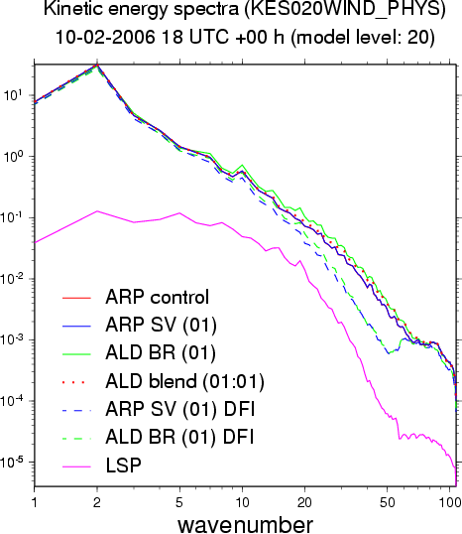

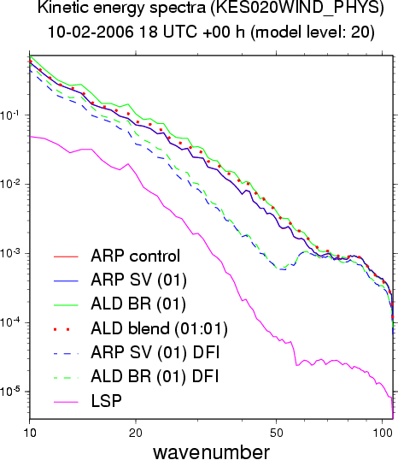

::Fig.3 Kinetic energy spectra for different files,
all wave numbers (up) and zoom (down).
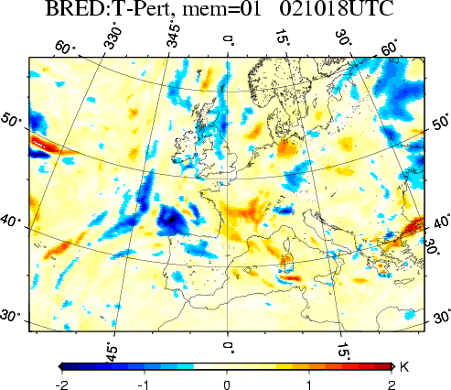

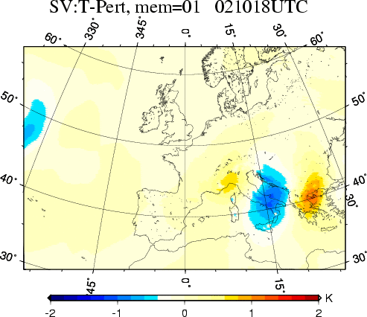

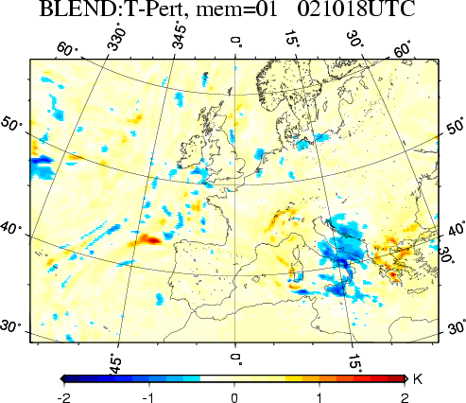

::Fig.4 Temperature perturbations for breeding (up)
singular vectors (middle) and blending (down).
For illustration now follows an example of output listing (STDOUT) with timing from successful blending procedure for ARPEGE singular vector member 1 blended with ALADIN breeding member 1 for February the 10th 2006 18 UTC (command line: blend.pl 10 02 2006 18 1 1):

BLENDING PROCEDURE FOR: 10-02-2006 18 UTC (SVmemb: 01, BRmemb: 01)

=> started at: 07:12:50

[1] Convert ARPEGE file to low spectral resolution (via ee927):
+ OK: [COUPL00R1800_0210] input file date [10-02-2006 18 UTC]
+ OK: [COUPL00R1800_0210] input file truncation [NSMAX=74, NMSMAX=107]
+ OK: input clim file truncation [NSMAX=74, NMSMAX=107]
+ OK: target clim file truncation [NSMAX=39, NMSMAX=56]
+ OK: namelist was fully modified
+ OK: [ARL20060210-18] target file truncation [NSMAX=39, NMSMAX=56]
=> ARL20060210-18 is READY
--->[time spent: 74 sec]

[2] Convert ALADIN file to low spectral resolution (via ee927):
+ OK: [ICMSHAUST+0000_0210] input file date [10-02-2006 18 UTC]
+ OK: [ICMSHAUST+0000_0210] input file truncation [NSMAX=74, NMSMAX=107]
+ OK: input clim file truncation [NSMAX=74, NMSMAX=107]
+ OK: target clim file truncation [NSMAX=39, NMSMAX=56]
+ OK: namelist was fully modified
+ OK: [ALL20060210-18] target file truncation [NSMAX=39, NMSMAX=56]
=> ALL20060210-18 is READY
--->[time spent: 74 sec]

[3] Run DFI on ARPEGE file with low spectral resolution (via e001):
+ OK: [ARL20060210-18] input file ready
+ OK: LBCs for constant coupling ready
+ OK: namelist was fully modified
=> ARF20060210-18 is READY
--->[time spent: 448 sec]

[4] Run DFI on ALADIN file with low spectral resolution (via e001):
+ OK: [ALL20060210-18] input file ready
+ OK: LBCs for constant coupling ready
+ OK: namelist was fully modified
=> ALF20060210-18 is READY
--->[time spent: 478 sec]

[5] Convert filtered ARPEGE file to high spectral resolution (via ee927):
+ OK: [ARF20060210-18] input file ready
+ OK: [ARF20060210-18] input file truncation [NSMAX=39, NMSMAX=56]
+ OK: input clim file truncation [NSMAX=39, NMSMAX=56]
+ OK: target clim file truncation [NSMAX=74, NMSMAX=107]
+ OK: namelist was fully modified
+ OK: [ARH20060210-18] target file truncation [NSMAX=74, NMSMAX=107]
=> ARH20060210-18 is READY
--->[time spent: 78 sec]

[6] Convert filtered ALADIN file to high spectral resolution (via ee927):
+ OK: [ALF20060210-18] input file ready
+ OK: [ALF20060210-18] input file truncation [NSMAX=39, NMSMAX=56]
+ OK: input clim file truncation [NSMAX=39, NMSMAX=56]
+ OK: target clim file truncation [NSMAX=74, NMSMAX=107]
+ OK: namelist was fully modified
+ OK: [ALH20060210-18] target file truncation [NSMAX=74, NMSMAX=107]
=> ALH20060210-18 is READY
--->[time spent: 77 sec]

[7] ARPEGE filtered minus ALADIN filtered at high spectral resolution (via blend):
+ OK: [ARH20060210-18] input file ready
+ OK: [ALH20060210-18] input file ready
+ OK: namelist was fully modified
=> BLA20060210-18 is READY
--->[time spent: 6 sec]

[8] Add ARPEGE long wave spectra to the ALADIN short wave spectra (via blend):
+ OK: [ICMSHAUST+0000] input file ready
+ OK: [BLA20060210-18] input file ready
+ OK: namelist was fully modified
=> BLB20060210-18 is READY
--->[time spent: 5 sec]

=> Final result was saved under: /home/bellus/blend_data/18/ICMSHBLEN+0000_20060210_01:01

(Working directory was removed.)

=> finished at: 07:33:32

As one can see, the whole process consists of eight steps with different time consumption. The most costly is the filtering process (DFI) at low spectral resolution, which has to be applied twice (about 7-8 min running on 6 SGI processors), even thought we have exploited the possibility to prolong the time step because of the lower spectral resolution. Input files and the other important components are carefully checked in the beginning of each step. Working directory (dynamically created at the beginning) together with all temporary files is removed at the end of the process (except the case when running in debug mode).

::Conclusion

A complex Perl script (nearly 1000 lines of code) to perform spectral blending on ARPEGE singular vector members and ALADIN breeding members was written during the stay. Some basic setup of low spectral resolution used in the procedure and tuning of DFI filtering was done as well. The first blending results are quite satisfactory, since the blended initial states inherited the large scale perturbations from ARPEGE singular vectors (which were not present in ALADIN breeding files), while still kept the small scale perturbations generated by breeding. The main profit from the blending procedure is, that the blended initial conditions (needed for further limited area ensemble forecast integration) suppose to be now more compatible with the appropriate APREGE PEARP coupling files. However, it might be useful to invest some more time to make detailed tuning based on real cases to get as much as possible out of the blending procedure. In practice this would mean only the changes in used model namelist or alternatively the preparation of new climatological files (in case of changes in low spectral resolution definition).

Nothing is certain, nor the
uncertainty in initial conditions. ☺

<mbell>

