Staying report at ZAMG
Viena, Austria
4.06.2010 – 30.07.2010

Simona Tascu
NMA, Romania

Supervised by:
Yong Wang

In order to verify the performance of the solutions provided by a deterministic model and by an ensemble, two experiments were done:

I.) First experiment uses different runs of the limited area model ALADIN to compute an ensemble (a lagged ensemble). For example, for one day, the lagged ensemble is computed as follows (see Table 1): from the current day is used only the integration from 00 UTC (from 00h up to 48h), from the previous day, 4 runs are used: 18 UTC (from 06h up to 54h),12 UTC (from 12h up to 60h), 06 UTC (from 18h up to 60h) and 00 UTC (from 24h up to 72h). In this way, 5 members are obtained.

ALADIN - AUSTRIA
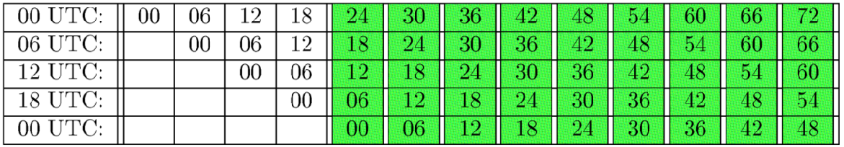

For experiments the ensemble systems used are:
- Lagged – Ensemble (using ALADIN – AUSTRIA) – 5 members
- ALADIN – LAEF (BBSM – Breeding – Blending – Surface perturbation Multiphysics) - 16 members

For these two ensembles and for a period of two months (from 15 June 2007 – 20 August 2007) the verification package developed in the framework of RC-LACE was applied (with 0.15 x 0.15). To investigate which ensemble performances better, some parameters from surface and upper levels are verified. For surface: MSLP, T_{2m}, W_{10m} and 12 hours cumulated precipitation and for different pressure levels (at 500 mb and 850 mb): temperature, geopotential, wind speed and relative humidity. The verification of the surface parameters uses observation from 1219 stations and for upper levels, ECMWF analyses is used. For skill scores, the model used as reference is the ALADIN – AUSTRIA model (the deterministic model used in operational).

In the figures below, some verification scores for surface parameters are illustrated and in these figures it can be seen that the performance of the ensemble BBSM is better that the performance of the lagged ensemble consisting only of the deterministic model. The same results are obtained for upper levels parameters.

For MSLP, wind speed at 10m, total precipitation cumulated in 12 hours (figure1.1, a), c), d)), the spread is larger for BBSM ensemble than it is the case for the lagged ensemble. The same performance is showed and for RMSE which has better values. In contrast to that, for temperature, the lagged ensemble shows better values bias than BBSM, but the spread is smaller than for BBSM. Figures 1.2 and 1.3 show the Brier Score and Brier Skill Score and figures 1.4 and 1.5 show the Continuous Ranked Probability Score and Continuous Ranked Probability Skill Score for the same surface parameters. In these figures the performance of BBSM ensemble for each surface parameter can be seen. The number of outliers is bigger for the lagged ensemble, so the BBSM ensemble is more reliable. The same results are obtained in case of RPS and RPSS scores (figures 1.7 and 1.8), Reliability diagram (figure 1.9) and ROC score (figure 1.10).
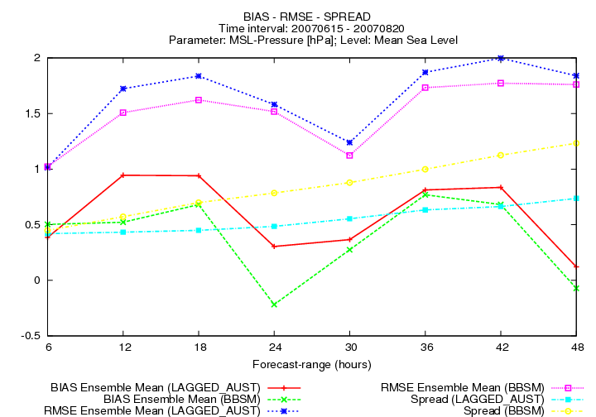
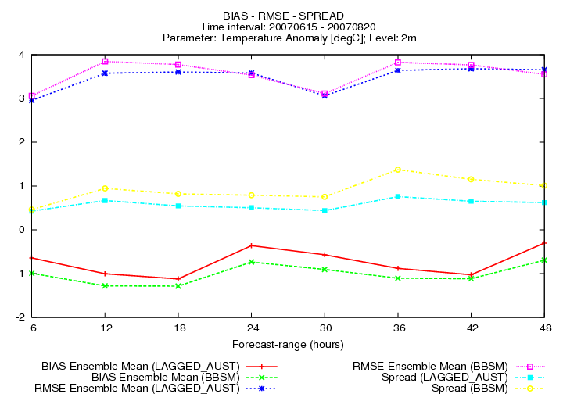

a) b)

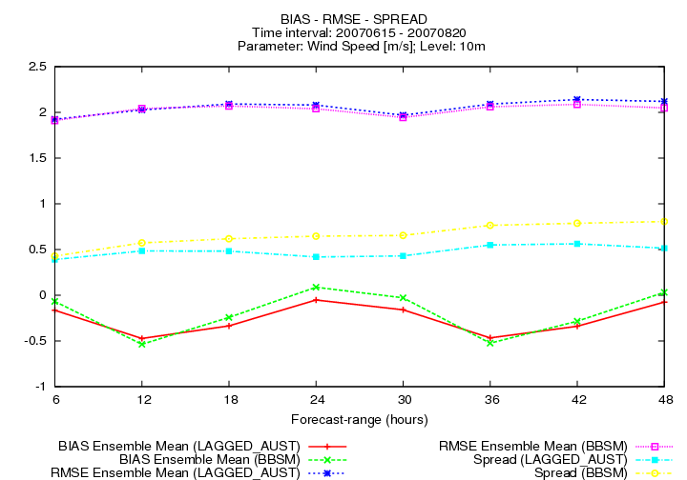
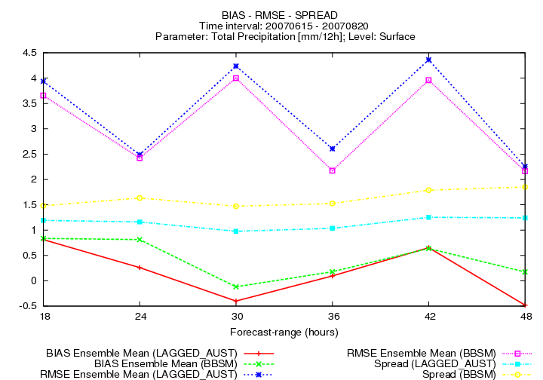

c) d)

Fig. 1.1 Bias, RMSE and SPREAD: Mean Sea Level Pressure, temperature at 2m, wind speed at 10m and precipitation cumulated in 12hours for lagged ensemble (labelled AUST) and laef ensemble (BBSM).

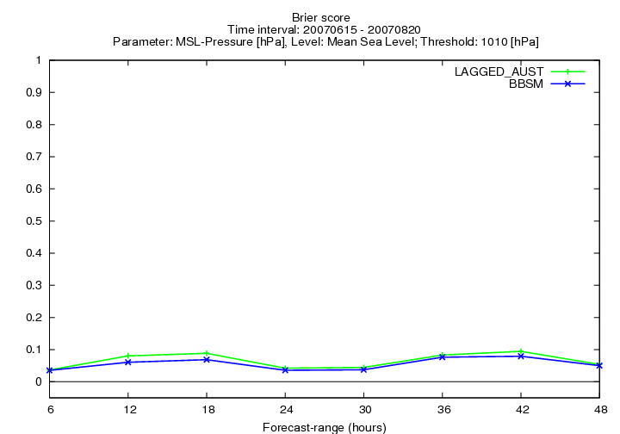
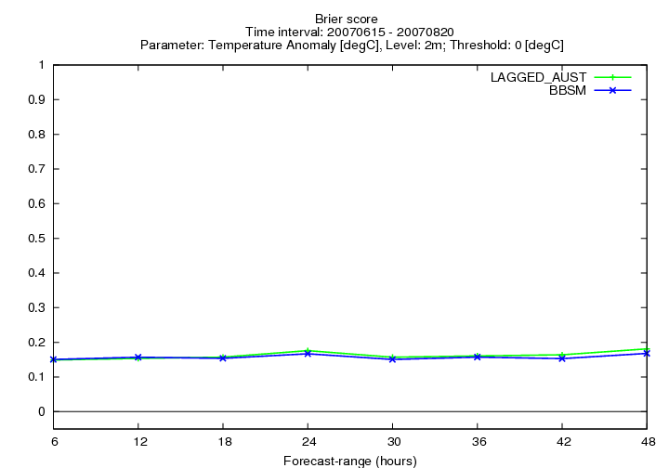

a) b)

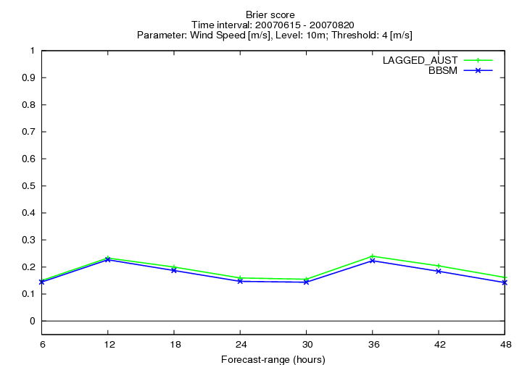
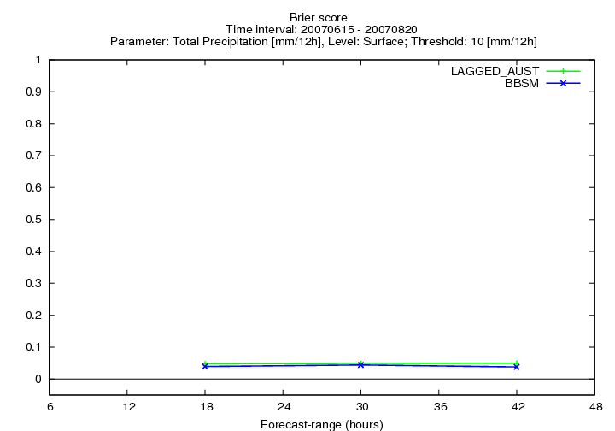

c) d)

Fig. 1.2 Brier Score: Mean Sea Level Pressure, temperature at 2m, wind speed at 10m and precipitation cumulated in 12hours for lagged ensemble (labelled AUST) and laef ensemble (BBSM).
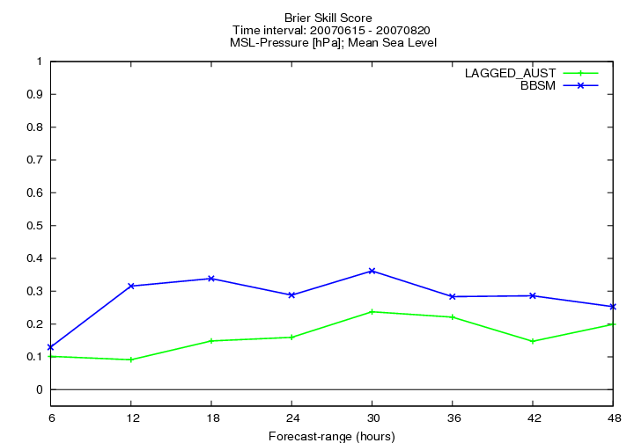
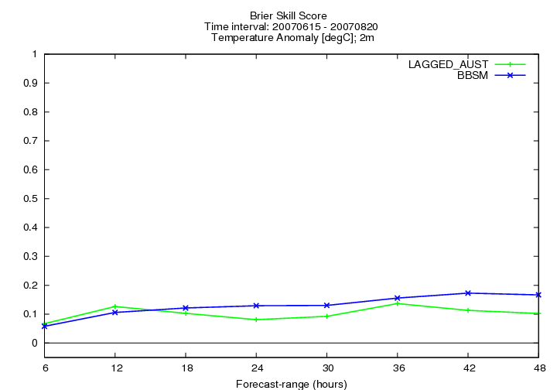

a) b)

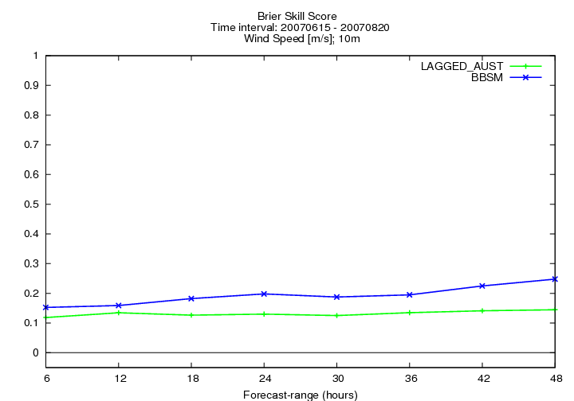
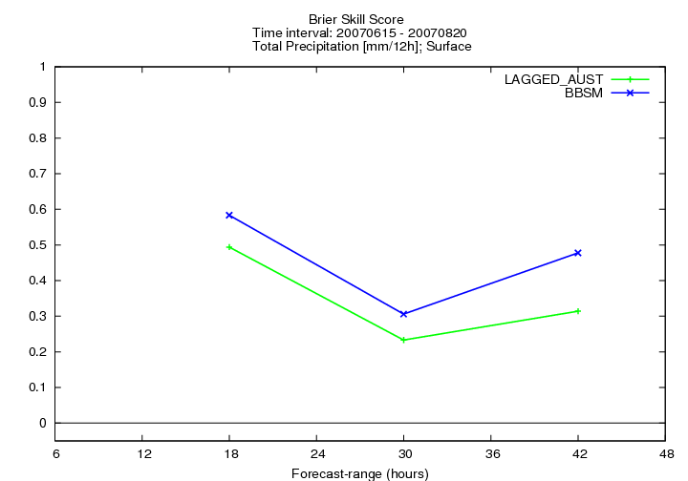

c) d)

Fig.1. 3 Brier Skill Score: Mean Sea Level Pressure, temperature at 2m, wind speed at 10m and precipitation cumulated in 12hours for lagged ensemble (labelled AUST) and laef ensemble (BBSM).
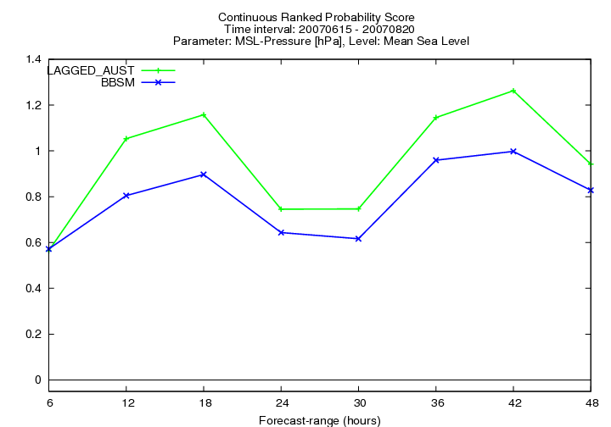
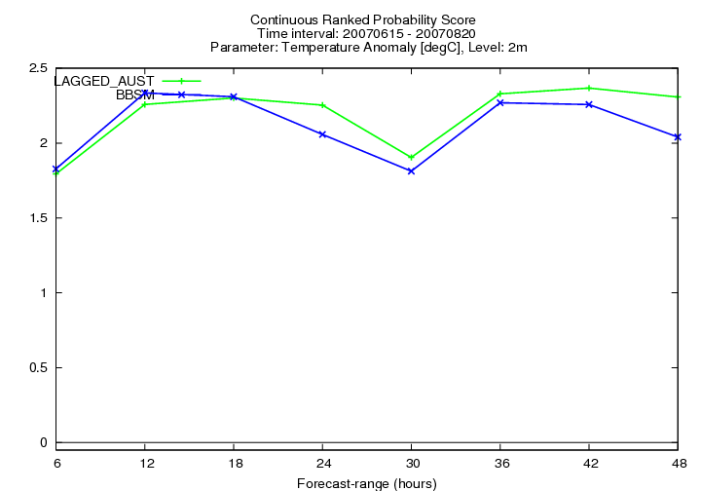

a) b)

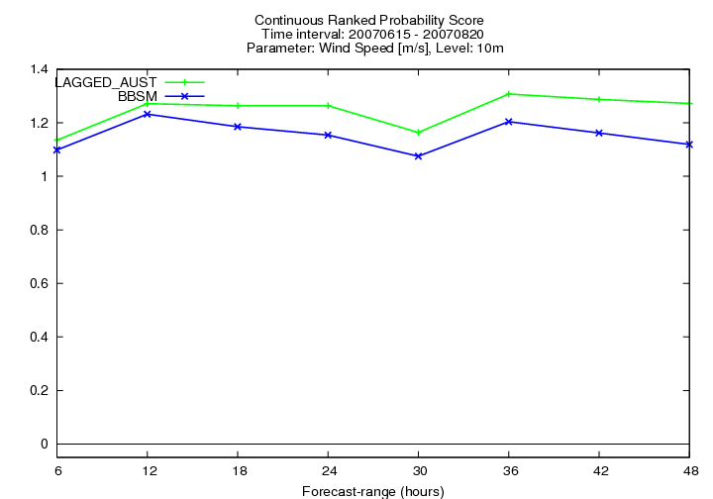
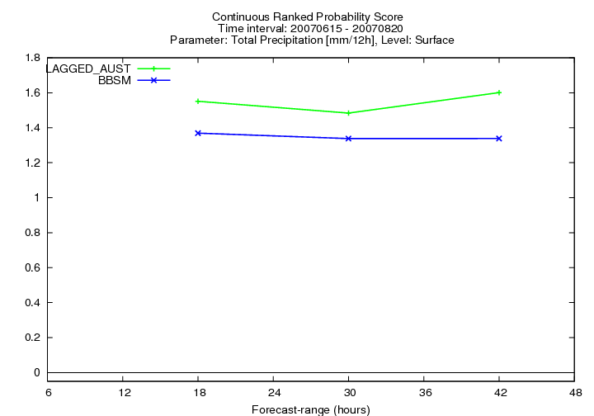

c) d)

Fig.1. 4 Continuous Ranked Probability Score: Mean Sea Level Pressure, temperature at 2m, wind speed at 10m and precipitation cumulated in 12hours for lagged ensemble (labelled AUST) and laef ensemble (BBSM).
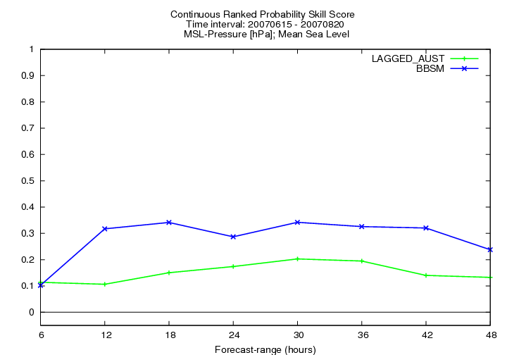
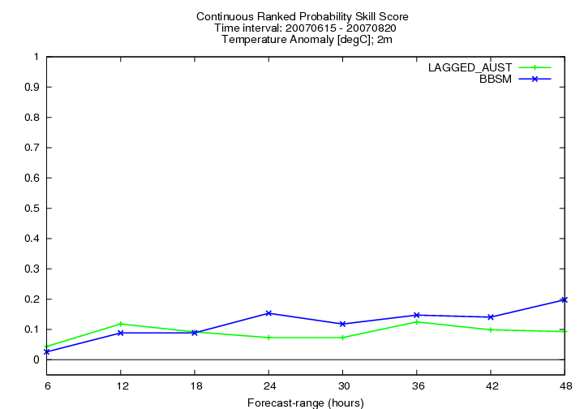

a) b)

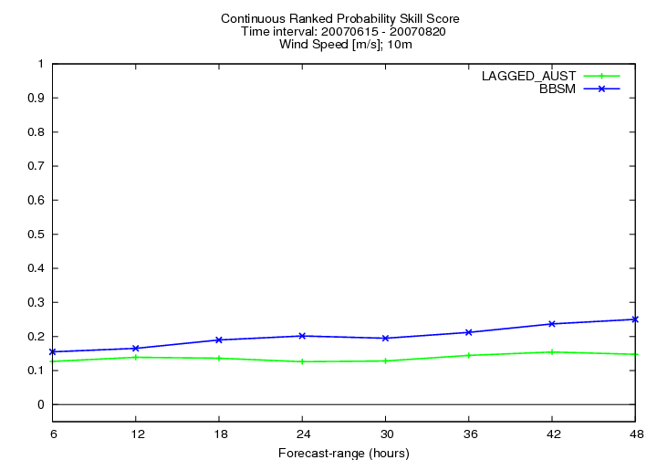
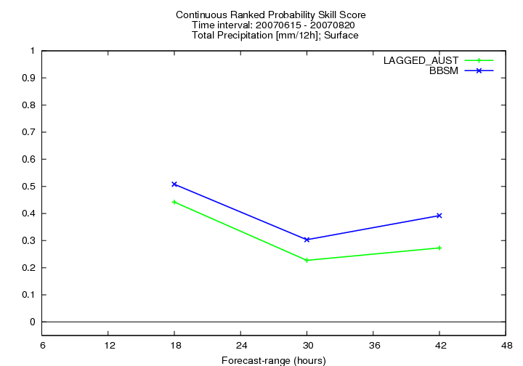

c) d)

Fig. 1.5 Continuous Ranked Probability Skill Score: Mean Sea Level Pressure, temperature at 2m, wind speed at 10m and precipitation cumulated in 12hours for lagged ensemble (labelled AUST) and laef ensemble (BBSM).

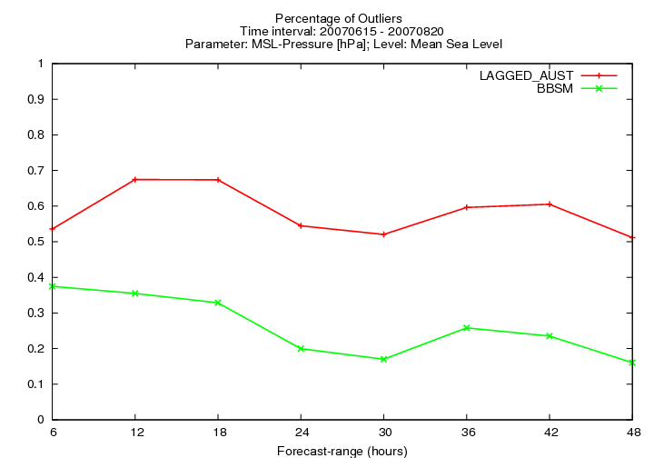
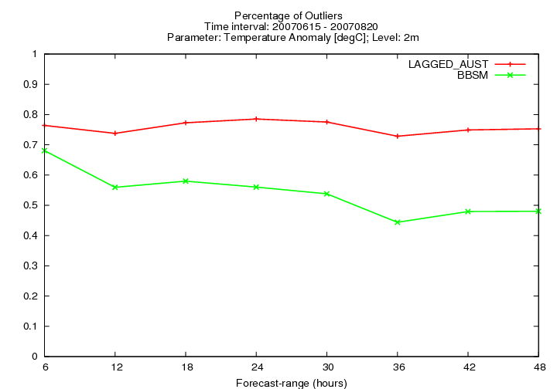

a) b)

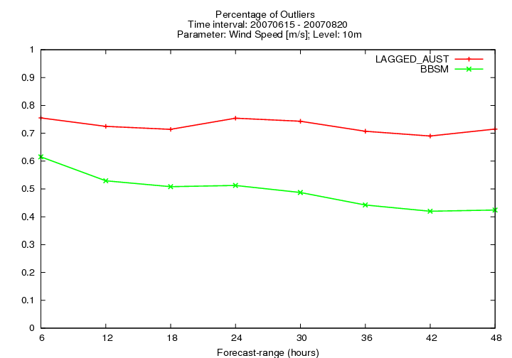
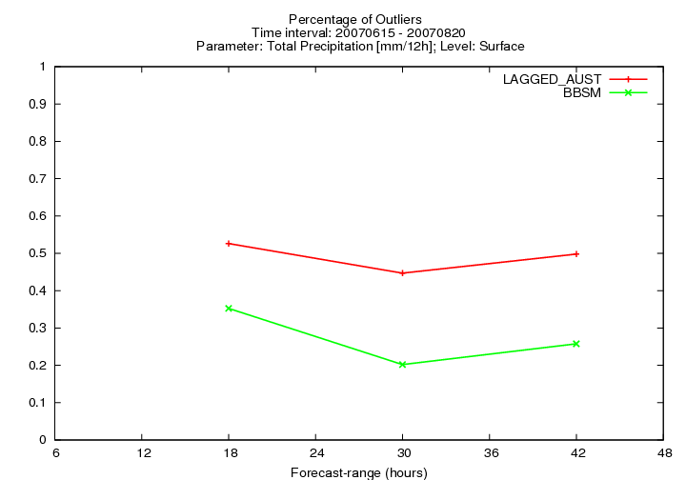

c) d)

Fig. 1.6 Percentage of Outliers: Mean Sea Level Pressure, temperature at 2m, wind speed at 10m and precipitation cumulated in 12hours for lagged ensemble (labelled AUST) and laef ensemble (BBSM).
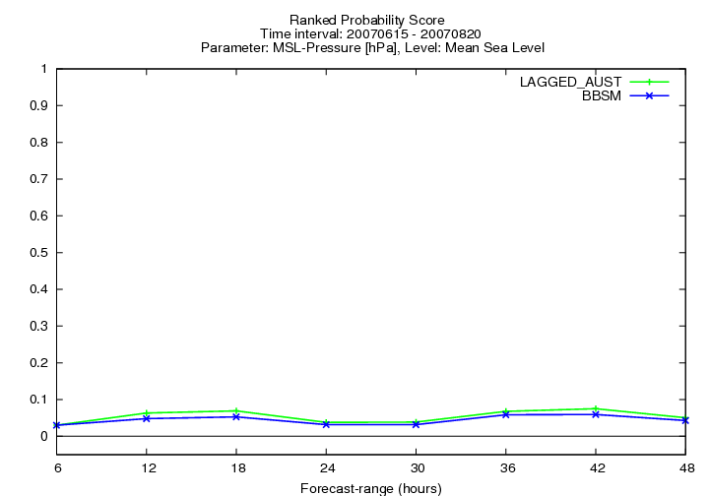
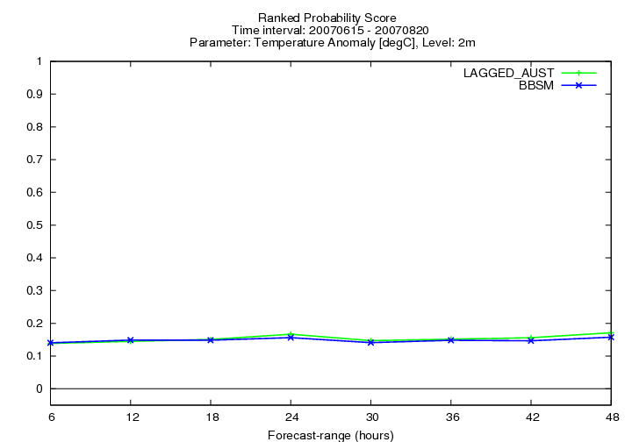

a) b)

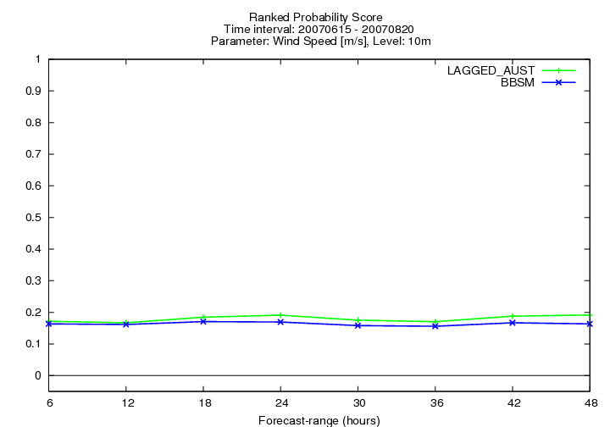
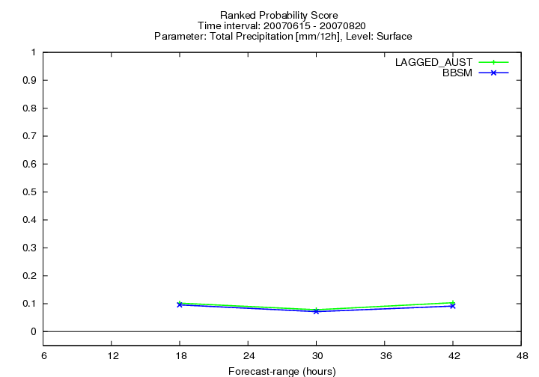

c) d)

Fig. 1.7 Ranked Probability Score: Mean Sea Level Pressure, temperature at 2m, wind speed at 10m and precipitation cumulated in 12hours for lagged ensemble (labelled AUST) and laef ensemble (BBSM).

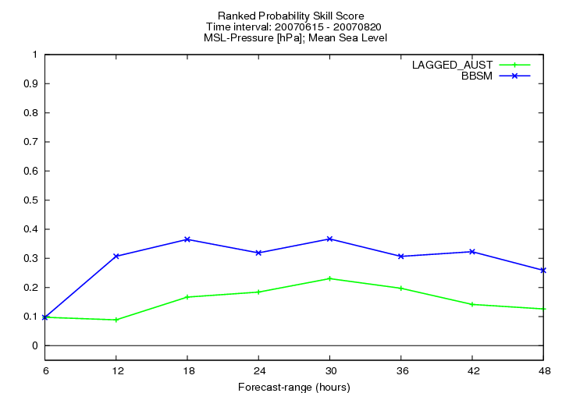
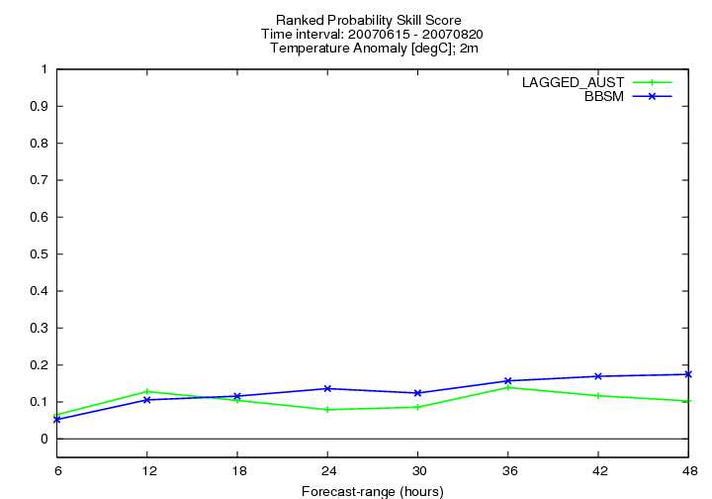

a) b)

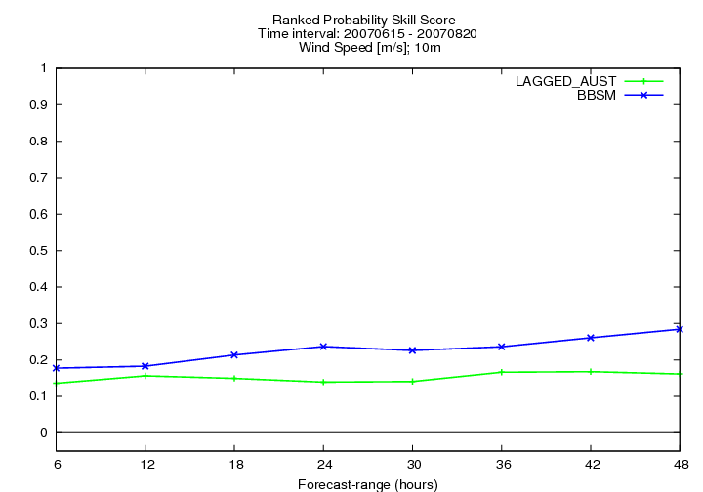
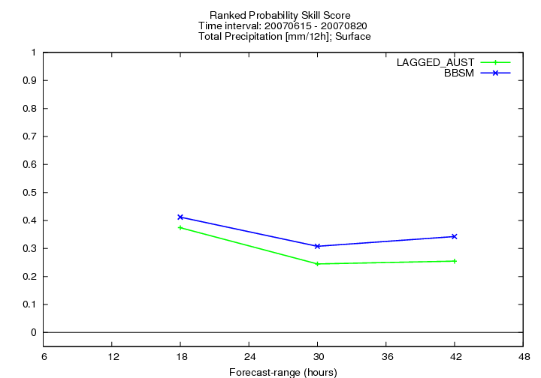

c) d)

Fig. 1.8 Ranked Probability Skill Score: Mean Sea Level Pressure, temperature at 2m, wind speed at 10m and precipitation cumulated in 12hours for lagged ensemble (labelled AUST) and laef ensemble (BBSM).

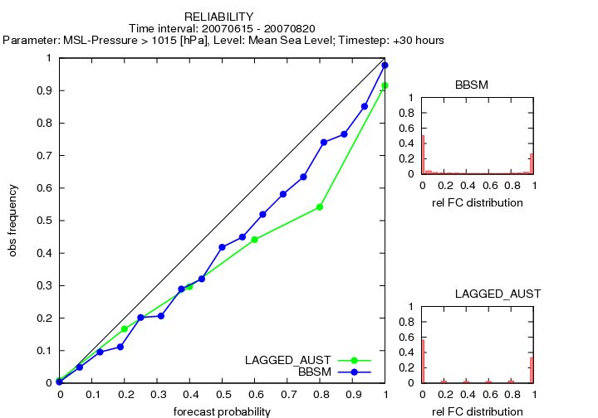
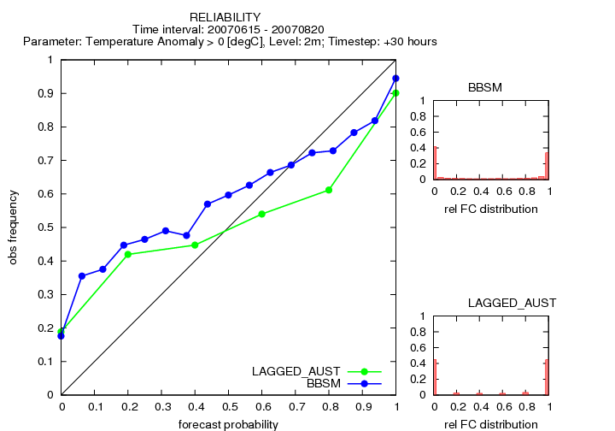

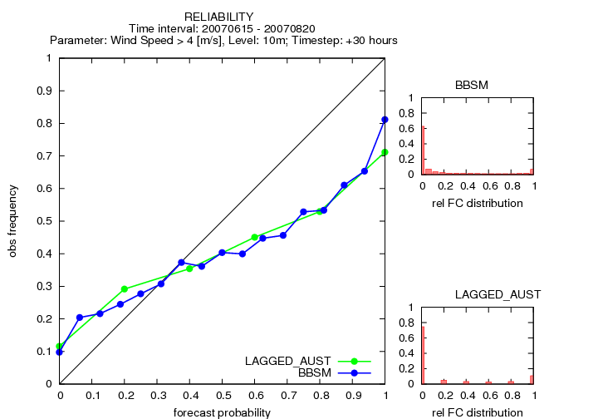
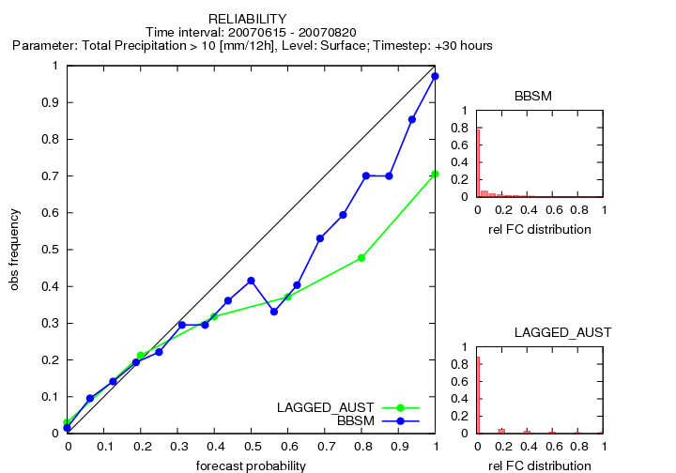

Fig. 1.9 Reliability: Mean Sea Level Pressure, temperature at 2m, wind speed at 10m and precipitation cumulated in 12hours for lagged ensemble (labelled AUST) and laef ensemble (BBSM).

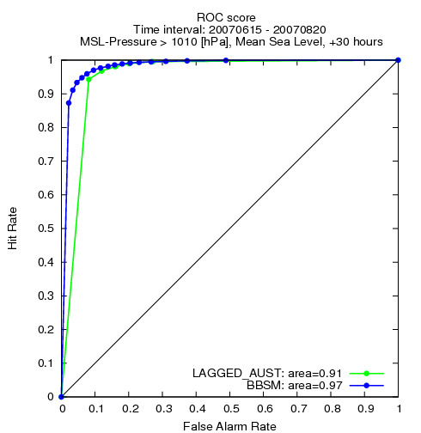
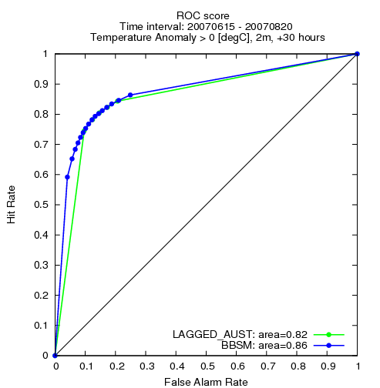

a) b)

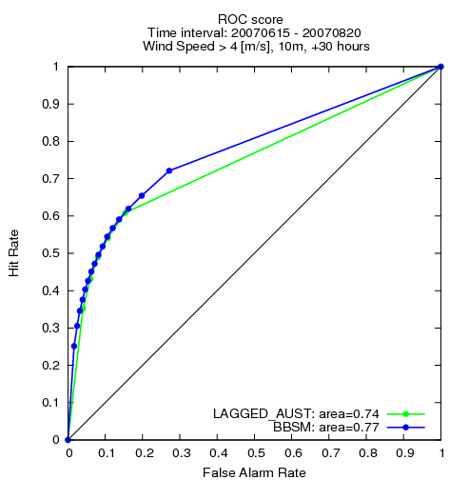
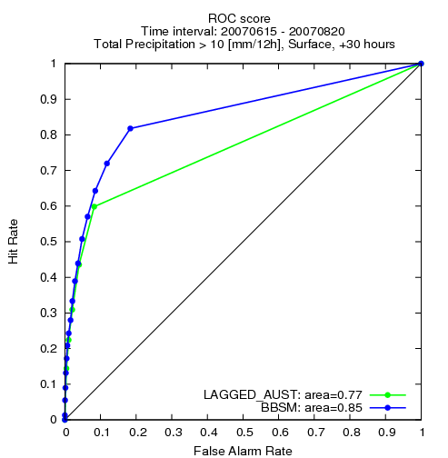

c) d)

Fig.1. 10 ROC Score: Mean Sea Level Pressure, temperature at 2m, wind speed at 10m and precipitation cumulated in 12hours for lagged ensemble (labelled AUST) and laef ensemble (BBSM).

II) The second experiment consists in doing the verification of the deterministic ALADIN-AUSTRIA model output against the solution of BBSM mean (ensemble mean for one day including 16 members from BBSM), against the solution of BBSM median and the control forecast of the BBSM ran with ECMWF control forecast. The mean and the median values were assembled in grib files and treated as solutions of deterministic models.

In order to perform this verification for dichotomous forecasts, the following scores are computed: Hit Rate, False Rate Alarme, Equitable Threat Score, Accuracy score, Hanssen and Kuipers discriminant, Threat Score and Correlation Coeficient and the verification package is applied for the same period (15.06.2007 – 20.08.2007) and the same resolution (0.15 x 0.15) like in the first experiment.

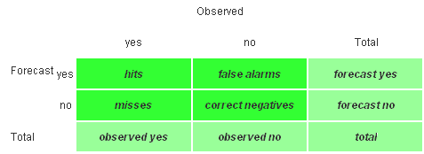
Table2.1. Contingency Table

Considering the above contingency table, the scores are computed as follows:

Accuracy (fraction correct):
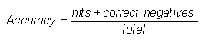
, Range: 0 to 1. Perfect score: 1.

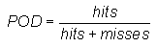
Probability of detection (hit rate):
, Range: 0 to 1. Perfect score: 1.
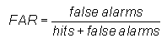
False alarm ratio:
, Range: 0 to 1. Perfect score: 0.
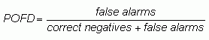
Probability of false detection (false alarm rate):
, Range: 0 to 1. Perfect score: 0.
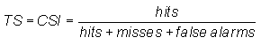
Threat score (critical success index):

Range: 0 to 1, 0 indicates no skill. Perfect score: 1.
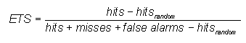
Equitable threat score (Gilbert skill score):
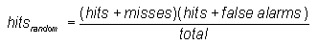
where
Range: -1/3 to 1, 0 indicates no skill. Perfect score: 1.
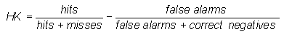
Hanssen and Kuipers discriminant (true skill statistic, Peirces's skill score):
Range: -1 to 1, 0 indicates no skill. Perfect score: 1.
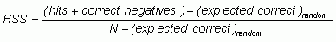
Heidke skill score (Cohen's κ):
where
Range: -∞ to 1, 0 indicates no skill. Perfect score: 1.
For these scores, the verification parameters are precipitation cumulated in 12 hours and wind at 10m. The hit values contain all the hits that belong to various intervals. The false alarms, misses and correct negatives values are obtained in the same way like hit values.
For precipitation, the above values are stored from the following intervals: between 1 and 2, 2 and 5, 5 and 10, 10 and 25, and for wind at 10m from the next ones: between 1 and 5, 5 and 10, 10 and 15, 15 and 20, 20 and 25.
In the next figures, the deterministic ALADIN- AUSTRIA model is labelled with AUST, the mean of BBSM ensemble with BBSM_MEAN and the median with BBSM_MEDIAN.
Figure 2.1, which shows BIAS, MAE and RMSE scores, indicates the performance of the median value against the mean and the deterministic model.
In figure 2.2, a) the accuracy score indicates, for the deterministic model, at 18 hours forecast range, a smaller percentage compared with mean and median values. For the higher lead times, values increase and show a performance for the deterministic model. The hit rate is similar to a good score for rare events and the perfect score for hit values is 1. In figure 2.2 b) can be seen the performance of the median for this score. False alarm rate (figure 2.2 c) ) for the first forecast step (18h) indicates that the deterministic value is bigger, and after this step is smaller, that the deterministic model is less incorrect forecasts than the other two. Threat Score (TS) measures the fraction of observed and/or forecast events that were correctly predicted. Unlike this score, the Equitable Threat Score (ETS) is adjusted for hits associated with random chance (hits_random). The performance of these 2 scores is showed in figure 2.2 at d) and e), which reveal the performance of the median solution. Other scores in which the performance of the median is obtained are: Hanssen and Kuipers discriminant, Extreme Dependency Score and Correlation Coefficient (figure 2.2 f), g), h) ).
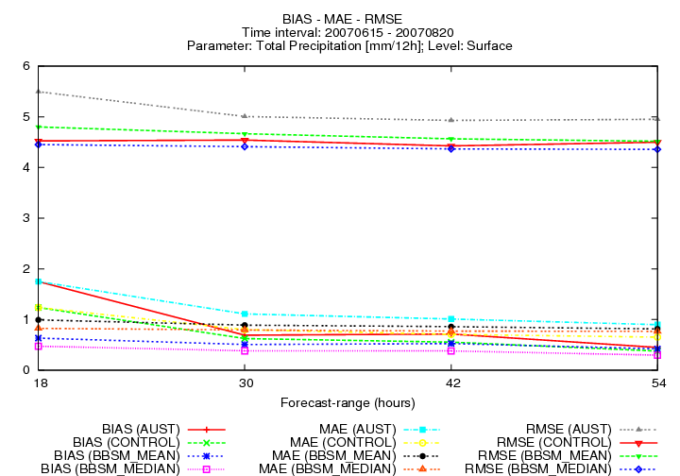
Like in figure 2.1, the figures 2.3 and 2.5 show the BIAS, MAE and RMSE for wind speed at 10m and temperature at 2m. Unlikely for temperature, which was better for ALADIN-AUSTRIA, for wind speed the performance of BBSM-MEAN is slightly better. Figures 2.4 and 2.6 (from a) to h) ) contains for wind speed at 10m and temperature at 2m the same scores like for precipitation in figure 2.2.

Fig. 2.1 Precipitation cumulated in 12 hours for ALADIN-AUSTRIA model (AUST), the mean (BBSM_MEAN) and median (BBSM_MEDIAN) of 16 members of BBSM: BIAS, MAE and RMSE for time period 15.06.2007 – 20.08.2007

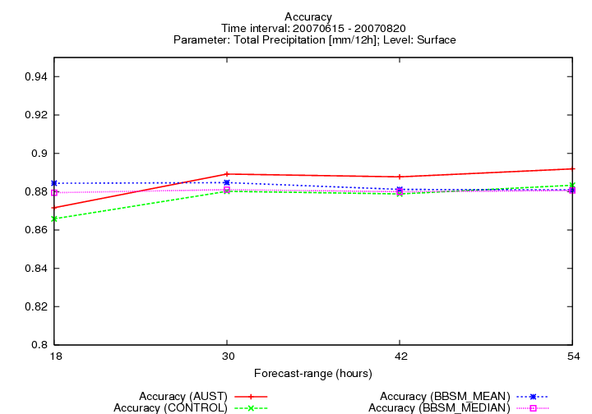
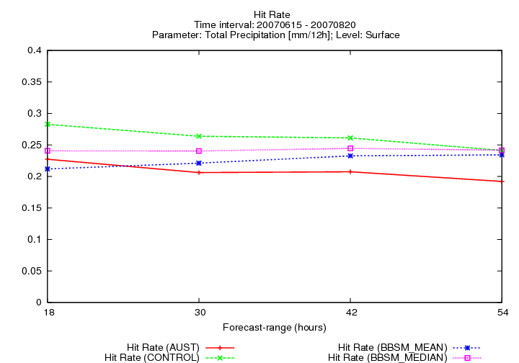

a) b)

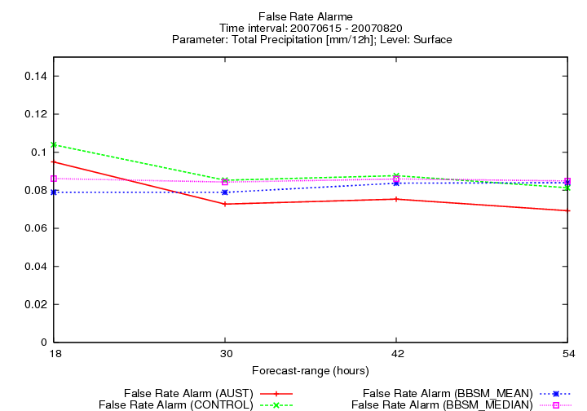
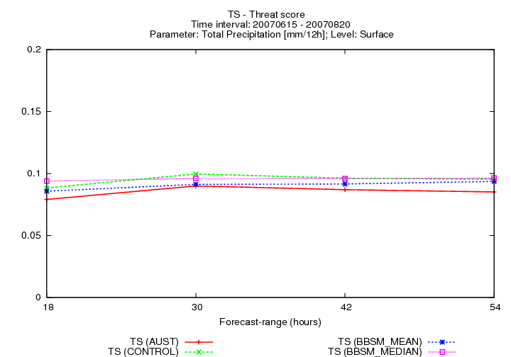

c) d)

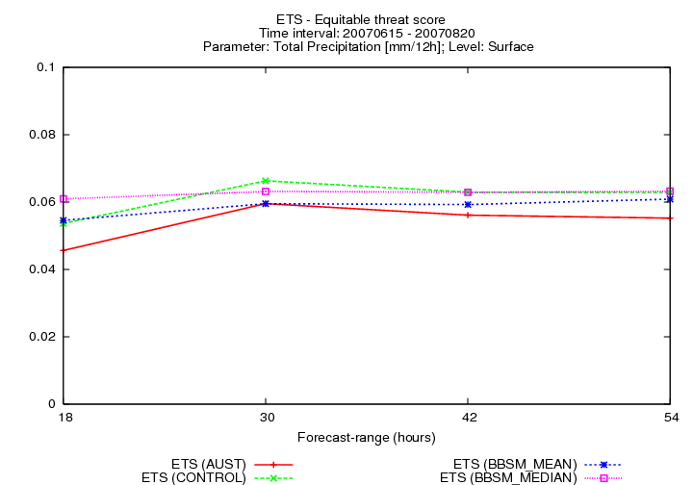
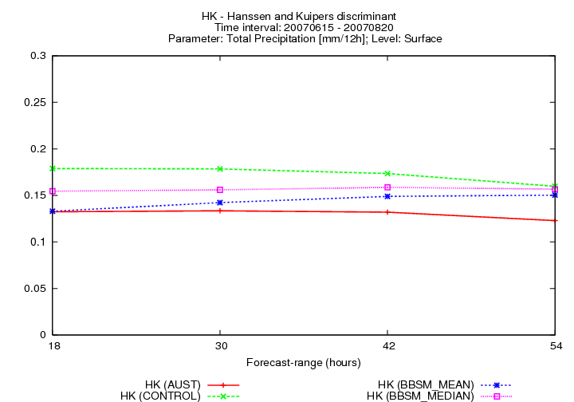

e) f)

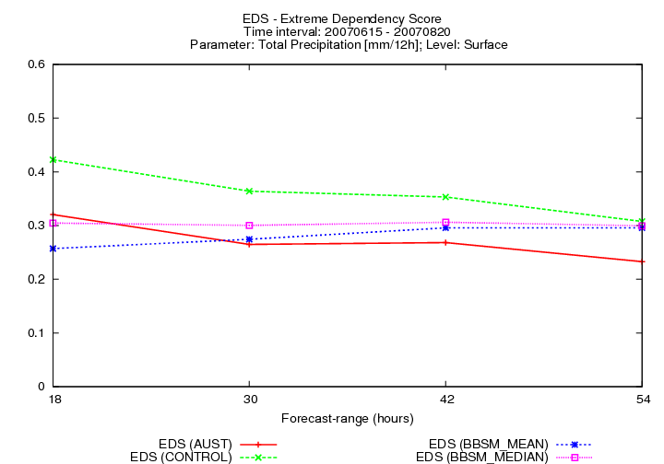
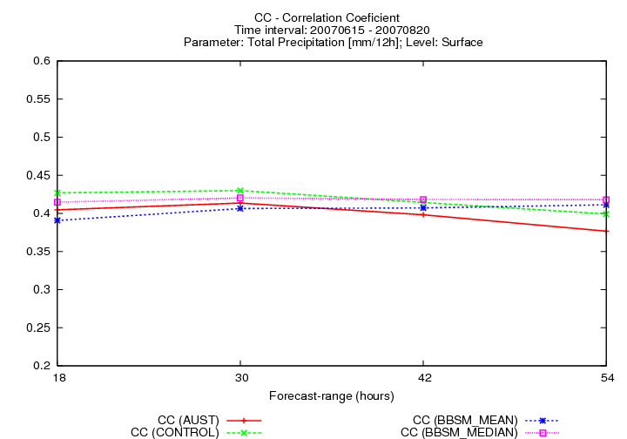

g) h)

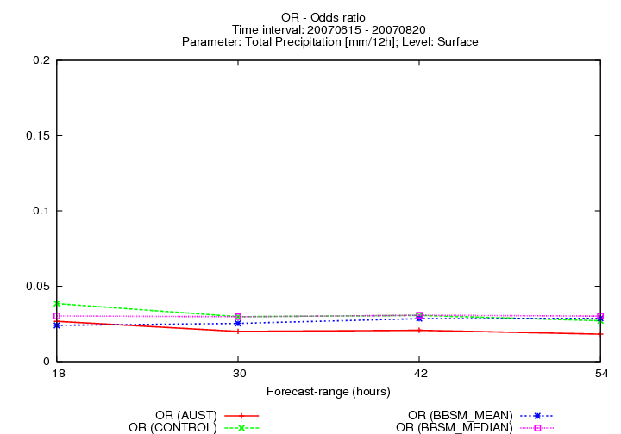

i)

Fig. 2.2 Precipitation cumulated in 12 hours: 15.06.2007 – 20.08.2007 for ALADIN-AUSTRIA model (AUST), the mean (BBSM_MEAN) and median (BBSM_MEDIAN) of 16 members of BBSM: Accuracy (a), Hit Rate (b), False Rate Alarm (c), Threat Score (d), Equitable Threat Score (e), Hanssen and Kuipers Score (f), Extreme Dependency Score (g), Correlation Coefficient (h), Odds ratio (i)

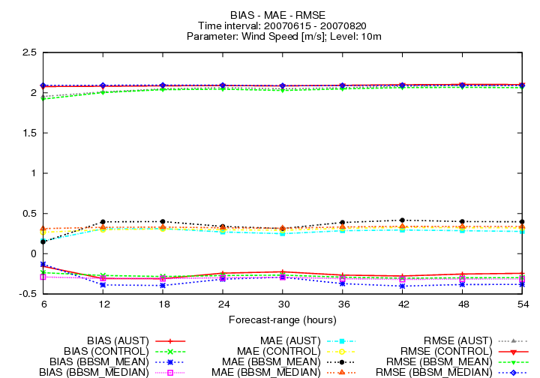

Fig. 2.3 BIAS, MAE and RMSE for wind at 10m: 15.06.2007 – 20.08.2007

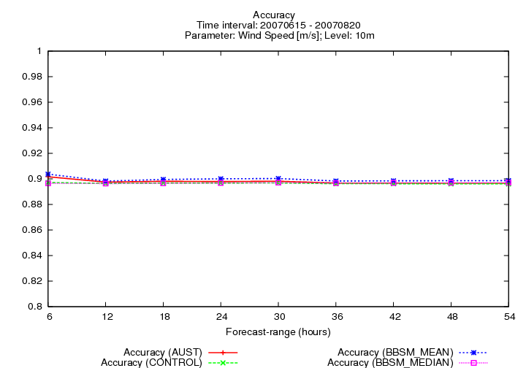
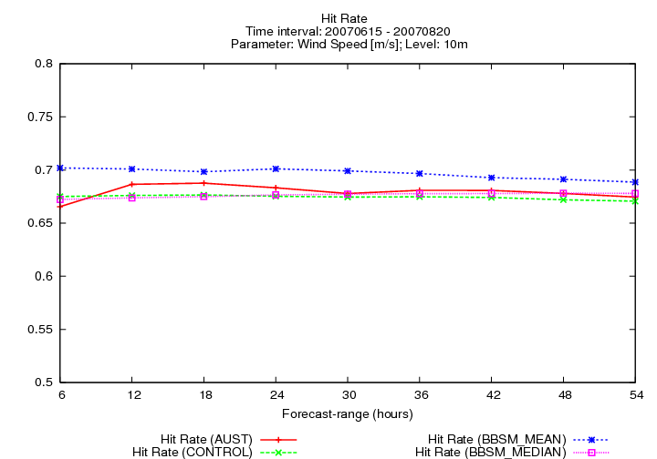

a) b)

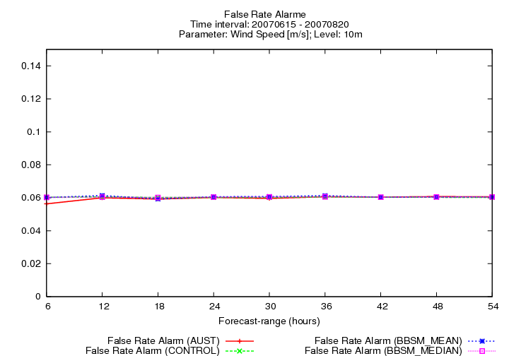
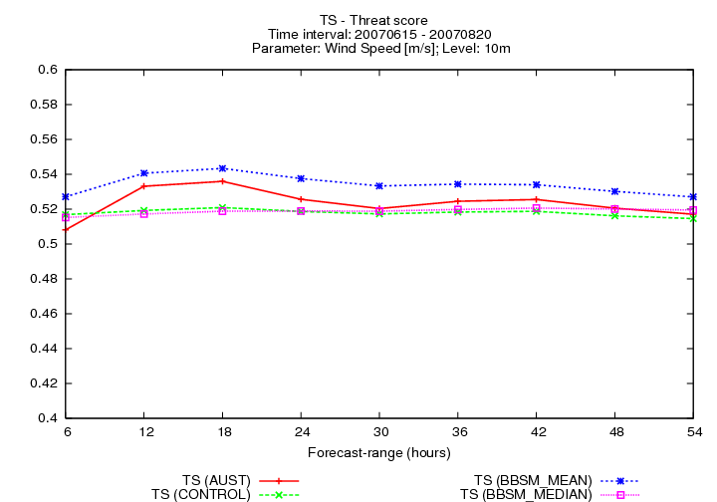

c) d)

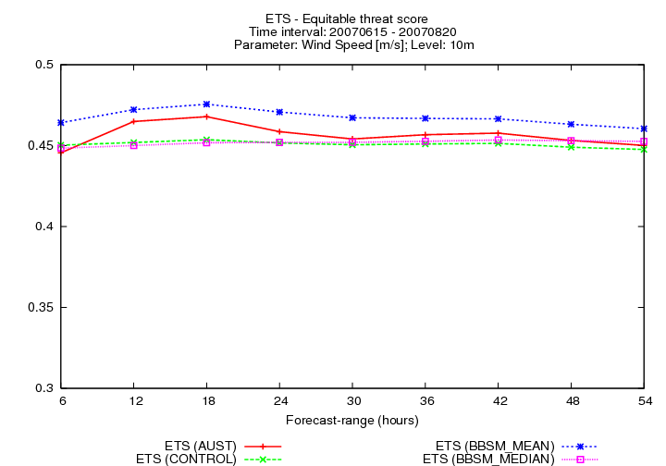
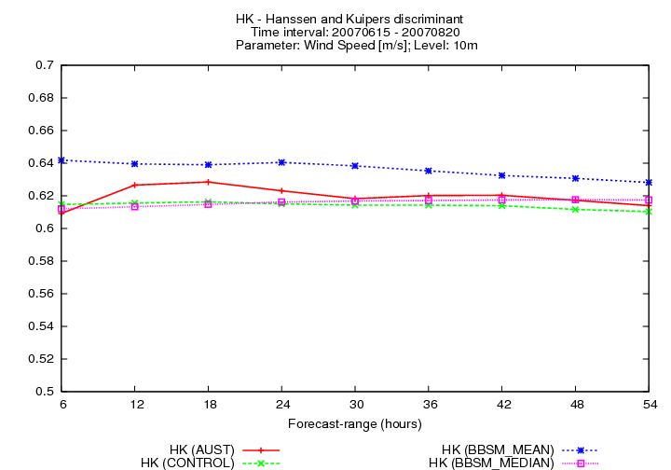

e) f)

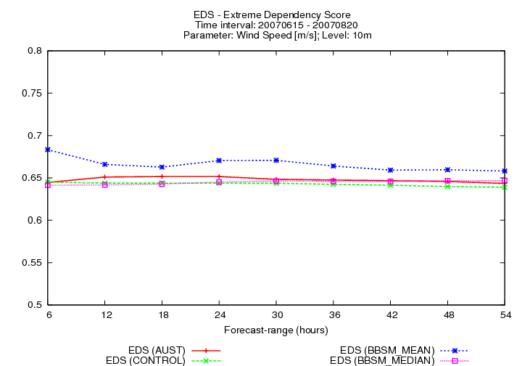
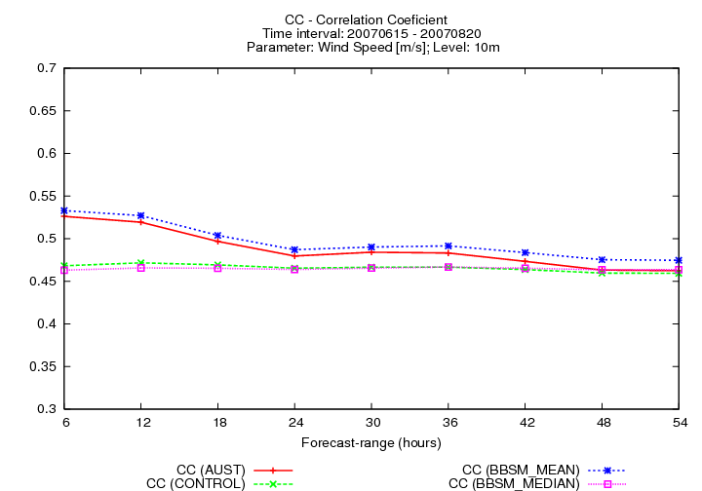

g) h)

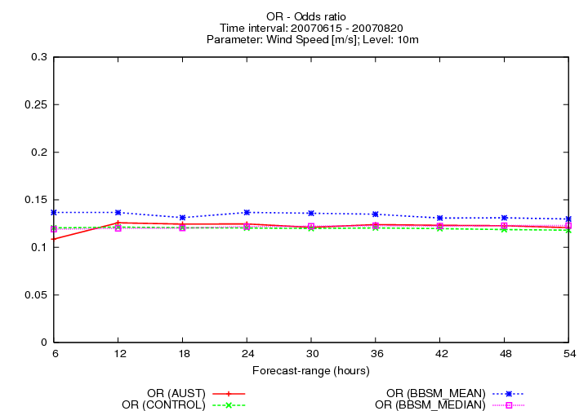

i)

Fig. 2.4 Wind speed at 10m: 15.06.2007 – 20.08.2007 for ALADIN-AUSTRIA model (AUST), the mean (BBSM_MEAN) and median (BBSM_MEDIAN) of 16 members of BBSM: Accuracy (a), Hit Rate (b), False Rate Alarm (c), Threat Score (d), Equitable Threat Score (e), Hanssen and Kuipers Score (f), Extreme Dependency Score (g), Correlation Coefficient (h)

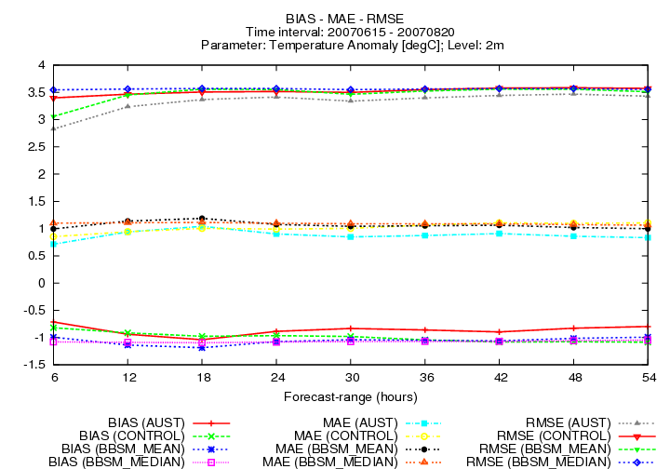

Fig. 2.5 BIAS, MAE and RMSE for temperature at 2 m: 15.06.2007 – 20.08.2007

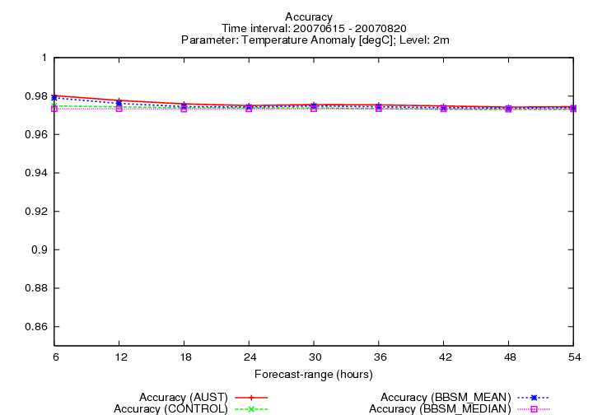
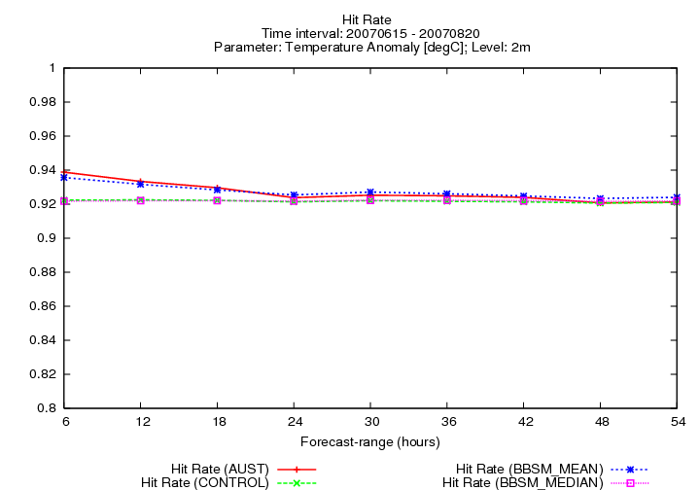

a) b)

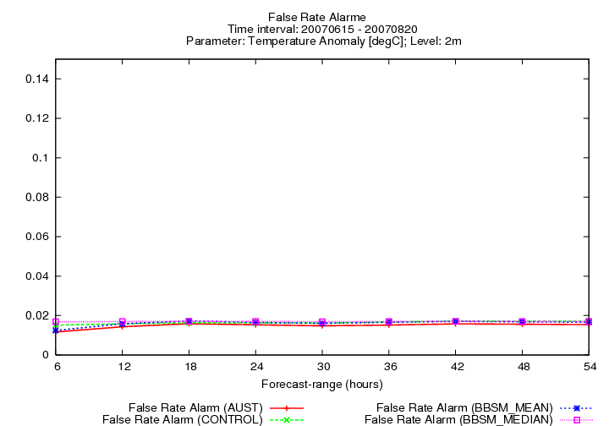
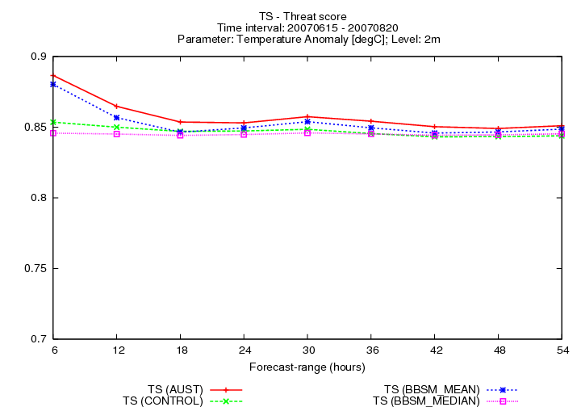

c) d)

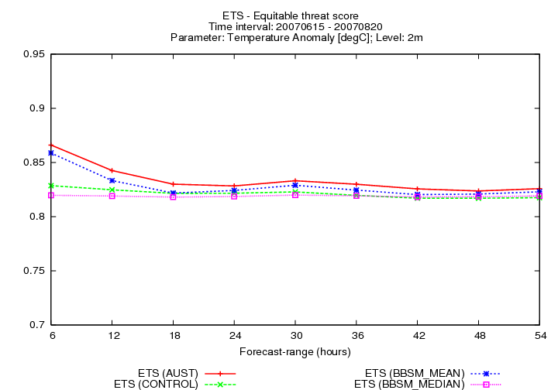
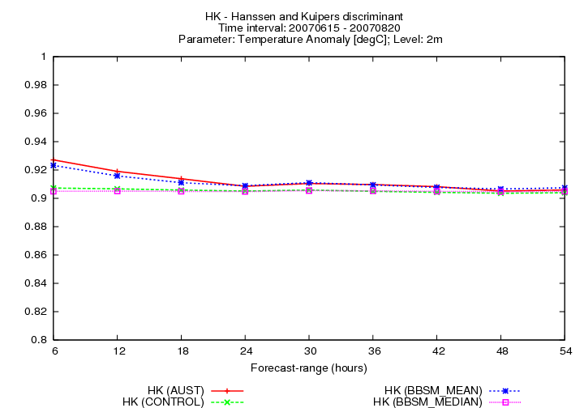

e) f)

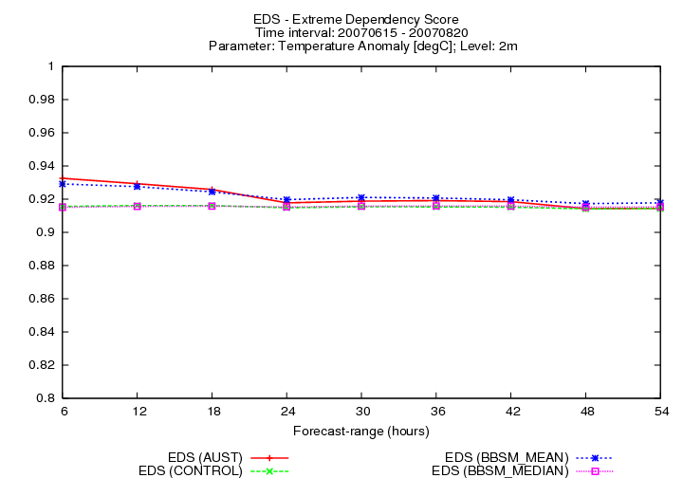
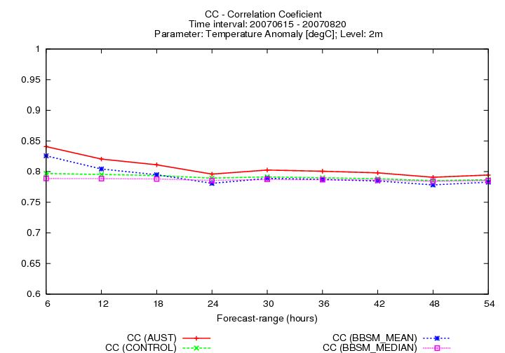

g) h)

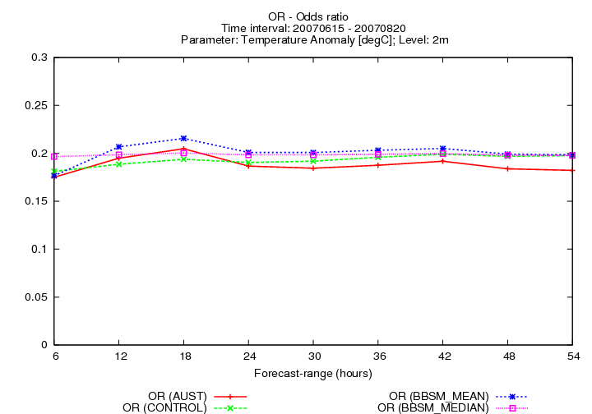

i)

Fig. 2.6 Temperature at 2m: 15.06.2007 – 20.08.2007 for ALADIN-AUSTRIA model (AUST), the mean (BBSM_MEAN) and median (BBSM_MEDIAN) of 16 members of BBSM: Accuracy (a), Hit Rate (b), False Rate Alarm (c), Threat Score (d), Equitable Threat Score (e), Hanssen and Kuipers Score (f), Extreme Dependency Score (g), Correlation Coefficient (h), Odds ration(i)

Acknowledgements:
I would like to thank to Wang Yong for guidance and patience during my stay at ZAMG. I am very gratefully to my colleague Christoph Wittmann for his constant help and hospitality. As well many thanks to Florian Weidle, Alexander Kann and all my colleagues from ZAMG.

