Study of calibration of ALADIN EPS precipitation forecast
using logistic regression

Lace stay, 27.10 – 20.11. 2009, ZAMG, Vienna
LOVRO KALIN

SUMMARY

This paper reports on my second Aladin stay in ZAMG, studying methods of calibration of EPS precipitation forecast. On the first stay in spring 2008 we applied logistic regression on a small set of ensemble forecasts – a method based on Hamill et al. (2007) - and gained improvement only for small thresholds (see previous report: http://www.rclace.eu/File/Predictability/2008/report.doc).

This time the dataset has been considerably enlarged, with almost 2 years of training data, and couple of months for validation data. Results show a significant increase of skill of calibrated forecast compared to the raw ones, and positive impact of calibration has been shifted to the higher thresholds. Still, the calibration fails for very high thresholds, and also when the duration of precipitation event is reduced, e.g. to 3hours. Also, the regression is mostly dependent on the mean of ensembles, and negligible for the ensemble spread. The quality and amount of data is still considered as the critical part, so further effort has to be made.

- Introduction and method.

As for deterministic ones, probability forecasts (ensemble forecast) also need statistical postprocessing to fit them to observation data. Short introduction and basic methodology are presented in the first report.

- Data.

Compared to first attempt, the dataset has been significantly increased. The training data covered almost 2 years (2008 and 2009), and the period of June to October 2009 has been used for validation (all point measurements for station Wien Hohe Warte).

- Results

First, the behavior of the calibration process has been investigated. Figure 1. presents regression coefficients for different lead times.

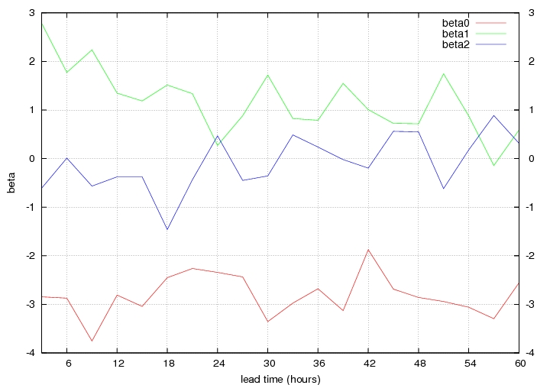

Figure 1. Coefficients of logistic regression for Aladin EPS precipiotation forecasts (RR>1mm/3hours), for station Wien (period 2008 to 2009)

Coefficients don’t show significant dependency (or decrease) towards the end of the forecasting range. Also, third coefficient, beta2, which shows the impact of the second predictor (ensemble spread) is oscilating around zero value. This means that the regression process is mostly dependent on the ensemble mean (beta1 term), and of course the free coefficient (beta0). This was expected, and in good agreement with experiences described in the literature (see Hamill and al (2007)).

This result suggested that larger duration of precipitation events (e.g. 24 hours) can be considered. This is important because for small durations the impact of the calibration has so far been negligible. This is due to numerous cases with zero forecast and zero precipitation, which led to extremely (non-realistic) low mean error of the forecasting system.

Figure 2 presents impact of calibration of 24hour precipitation event, for different thresholds. Brier score (i.e. mean square error in probability space) of raw and calibrated forecasts has been calculated.

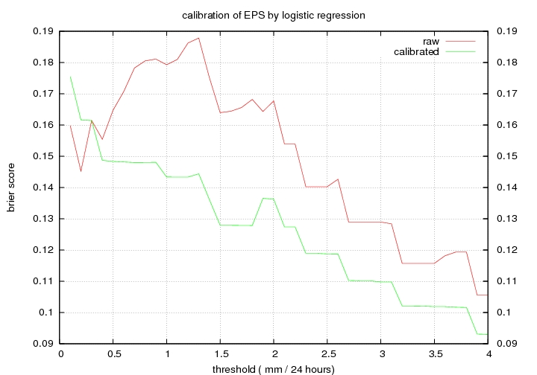

Figure 2. Brier score of Aladin EPS precipitation forecast for different thresholds (station Wien for period June to October 2009)

Various conclusions can be derived from this plot. First, there is a significant positive impact for thresholds from 0.5 to 4 mm / 24 hours. Unfortunately, for larger thresholds, the error of the calibrated forecast is similar or even higher than for raw forecast. This is probably due to insufficient training period, and also fact that in this range mean errors are very small (tend to zero). Also, raw forecast exhibits better skill for very small thresholds (less than 0.5 mm / 24 hours)

- Conclusions and prospects

Application of larger dataset enabled considerably skillful results of calibration of the forecasting system. Comparison to results obtained at the first stay show that the increase of the training period has significant positive impact to the calibration process. Still, numerous problems exist, such as behavior of the system in dependence of forecast range, duration of event and particularly for threshold of precipitation amount.

For the future work, impact of all these parameters should be investigated. For this purpose, and for the calibration success also, a need for a even larger dataset is present.

Vienna, 20.11. 2009.

