Study of calibration of ALADIN EPS precipitation forecast
using logistic regression

Lace stay, 29.3 – 25.4, ZAMG, Vienna
LOVRO KALIN

SUMMARY

For calibration of meteorological models, various techniques are proposed. Hamill et al. (2007) applied logistic regression to a large set of ECMWF precipitation ensemble reforecasts. This paper presents an effort to apply the same method to a small set of Aladin EPS short range precipitation forecasts. Preliminary results exhibit significant improvement only for smaller precipitation thresholds (less than 1 mm/6hours), probably due to a very small sample available. Further investigations still have to be done, but it is assumed that the increase of the sample size could give good calibration results even for the bigger precipitation thresholds.

- Introduction

There is a strong need for calibrating the ensemble forecasts, because the ensemble members inherit the deficiencies from the deterministic forecast. For example, if the deterministic model is biased, all individual ensemble members will exhibit the same bias, etc.

Various calibration techniques are proposed in the literature (Bayesian model averaging, analogue method etc.). For the 2m-temperature, nonhomogeneous Gaussian regression has been applied, with dramatic improvement.

Calibration of precipitation, due to it’s complex temporal and spatial distribution, seems to be more complicated. Based on efforts mostly made by Tom Hamill from NOAA Earth System Research Laboratory, we applied a logistic regression to a small set of Aladin EPS forecasts (Hamill et al. 2007).

- Forecast calibration

According to Hamill’s papers a logistic regression is a good choice for calibrating precipitation forecast, particularly considering relatively small data sample that is available in our case.

Logistic regression is represented by

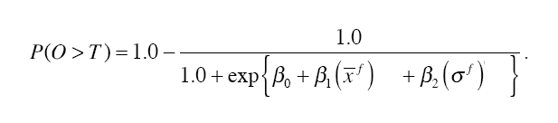

where P iz probability that precipitation O (predictand) will reach certain threshold T. In this case, the predictors are:

x ensemble mean
σ spread of ensemble (RMSE)

and β0, β1 and β2 are coefficients of regression, that have to be obtained.

It has to be noticed that such a fitting does not provide the full probability density function, but only the calibrated probability that a certain threshold will be exceeded.

A weighting function has also been proposed, in order to give more significance to cases with larger precipitation forecasts. We used the one described in Tom Hamill’s paper

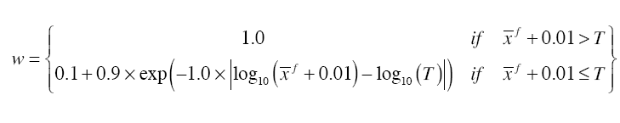

Still, the choice of the weighting function is quite arbitrary. Implications of its implementation will be discussed later, and have still to be investigated.

So input arguments are a series of measurements (if observed precipitation exceeds threshold then P=1, otherwise P=0), and pairs of forecasts representing ensemble mean and its spread.

Since fitting of the non-linear equation (by finding least squares) cannot be done analytically, an iterative method has to be applied.

We used

http://users.bigpond.net.au/amiller/logistic/logistic.f90

which requires also

http://users.bigpond.net.au/amiller/lsq/lsq.f90

- Data and technical description

At ZAMG, a set of Aladin EPS forecast data is stored, starting from June 2007. In order to keep the climatological consistency of the sample - see Hamill and Juras (2006) - a small seasonal subsample has been considered, covering summer of 2007 (June – September).

For the initial study, real data were used from synop reports, with 6-hour intervals. However, future work will be oriented to use of INCA analysis.

Aladin data is stored on zasmlpc1 machine (?). Grib files are located on
/mgruppe_data/aladin/laef_archiv/F_FOR_FMT/

Name of the file is
F_FOR_FMT _yyyymmddhh-LAEF-mm.grb

yyyy – year
mm - month
dd – day
hh – run of the model (00 or 12)
mm – member of the ensemble (00 – 18)
Main routine to extract grib files is

/daten2/mgruppe/mproj/kalin/data/eps/decode_eps_prec.ksh

- Kann) that uses fortran routine

/daten2/mgruppe/kann/LAEF_VERIFICATION/SRC/ Rd_RR_ensMember_on_Stat.f90

- Kann)

Fortran routines

/daten2/mgruppe/mproj/kalin/data/eps/rasporedi.f90 and
/daten2/mgruppe/mproj/kalin/data/eps/izracunaj.f90

(L. Kalin) call above routines to extract data for desired time interval, interpolate to the position of the station, and take the desired forecast lead time.

Synop data are located on

/laefinca/laef/observations4laef/

File names
F_OBS_FMT-yyyymmddhh-LAEF.txt.gz

Files are extracted by
/daten2/mgruppe/mproj/kalin/data/synop/odzipaj.f90

And then arranged to desired synop station and lead time by
/daten2/mgruppe/mproj/kalin/data/synop/razvrstaj.f90

(Kalin)

- Results

Testing sample was period from June to September 2007, for station Zagreb Maksimir (Croatia). 6-hour precipitation forecasts have been verified, taking different lead times.

Figure 1 presents Brier score for 12-18 UTC precipitation forecasts, for 5 different thresholds

Figure 1. Brier score for 6-hour precipitation (12 - 18 UTC)
for Zagreb, Jun - Sep 2007

Difference between raw forecast (green line) and calibrated by logistic regression (orange line) suggests that the improvement is significant for lower thresholds (0.1 and 0.3 mm), much less for medium one (1 mm), and for higher thresholds (3 mm and more) there is no improvement at all.

Figure 2 presents Brier score for the same part of the day (afternoon), but for the following day D2 (36-42 UTC). Compared to Figure 1, plot exhibits obviously similar pattern. This characteristic is in accordance with previous results of verification of raw forecasts, that showed very slow decrease of skill approaching end of forecasting range (D1, D2, D3).

Figure 2. Brier score for 6-hour precipitation (36 - 42 UTC)
for Zagreb, Jun - Sep 2007

Results for morning period forecast (Figure 3), however, exhibit different pattern, probably due to much smaller error (Brier score) of raw forecast. This is expected, particularly considering warm part of the year, when convective afternoon precipitation is frequent.

According to skill (Figure 4), it can be confirmed that the improvement is biggest for lower thresholds, when the raw forecast has negative skill. For higher thresholds, there is no significant improvement.

Figure 3. Brier score for 6-hour precipitation (24 - 30 UTC)
for Zagreb, Jun - Sep 2007

In terms of skill (Brier skill score) results are presented in Figure 4

Figure 4. Brier skill score for 6-hour precipitation (12 - 18 UTC)
for Zagreb, Jun - Sep 2007

For same forecasts, reliability diagrams can also be plotted (bellow).

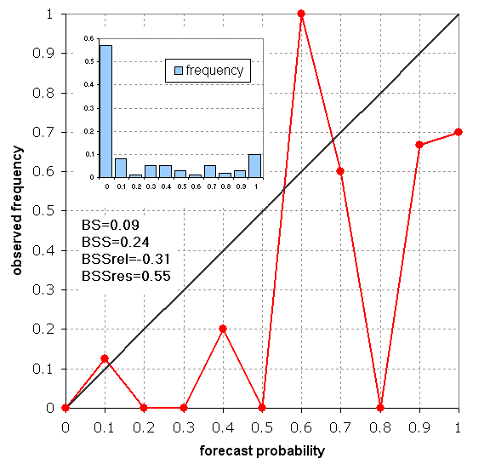
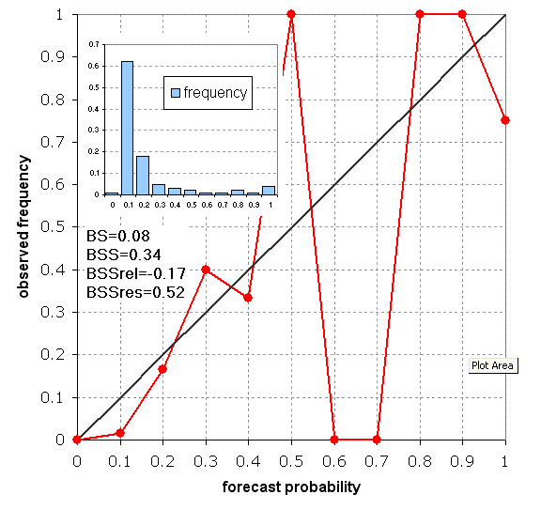
Figure 5 and Figure 6. Reliability plots for 1 mm threshold, for raw and calibrated forecasts, respectively (Zagreb, Jun - Sep 2007).

It can be noticed that the distribution of calibrated probability forecasts (bar plot) is much less U-shaped than the raw one. Therefore, calibration reduces sharpness of the forecasts, with lower frequency of 100% probability forecasts. However, forecasts up to 40%, that are most represented, are much better calibrated (red line closer to the diagonal).

Figure 7 and Figure 8. Decomposition of Brier score into reliability and resolution term for raw and calibrated forecast, respectively (Zagreb, Jun - Sep 2007)

If Brier score is decomposed to reliability and resolution (Wilks, 2006), it can be noticed that the improvement of the score (black line), as well as skill (red line) is more influenced by improvement of the reliability term (blue line) rather than improvement of the resolution term (light blue line). This confirms previous conclusion that calibrated forecasts are not much sharper, but they are more accurate.

5. Conclusion and future work

It is clear that the improvement is significant only for smaller thresholds (less than 1mm). According to Tom Hamill’s paper, this is mostly due to relatively small sample.

Therefore, future work should be focused mostly on the impact of the sample size to calibration results (including more seasons, clustering different stations etc.) We assume that the increase of the sample could give benefit for the bigger thresholds also.

Other features, such as significant daily variation, are close connected to characteristics of Aladin forecasting system, that has strong diurnal fluctuation of forecast bias. No significant impact of forecast range (between D+1 and D+2) has been noticed. Impact of the weighting function is still not very clear, so further investigation would be welcome.

Other known techniques (analog, BMA…) could also be applied and compared to linear regression.

6. References

Hamill, T. M., R. Hagedorn, and J. S. Whitaker, 2007: Probabilistic forecast calibration using ECMWF and GFS ensemble reforecasts. Part II: precipitation. Mon. Wea. Rev., submitted.

Wilks, D. S., 2006: Statistical Methods in the Atmospheric Sciences, 2nd Ed., Academic Press, 627 pp.

