LACE report

Initial perturbations created from ALADIN native singular vectors

Richard Mládek, mladek@chmi.cz

14.4. - 16.5. 2008
Stay in Hungarian Meteorological Service, Budapest
Supervised by András Horányi, Edit Hágel

Introduction
The work presented here is a direct continuation of the work on the development of ALADIN ensemble system based on its native singular vectors (SV) which was started two years ago [Mladek, 2006, 2007, Hagel, 2005-2007]. The preparation of the initial perturbations by combining ALADIN native SV with high resolution analysis was our aim. Various technical issues had to be tackled first. The most straightforward solution - French package for creation of initial perturbation was adopted. An estimate of the first guess of standard deviation was used instead of more proper analysis error estimate for the rescaling of the perturbations magnitude. In first approximation one single value for every vertical level and the whole domain has been used. Two ensemble runs were completed starting at 18 UTC, May 26, (one situation chosen from heavy rain case study; Mladek, 2007). Two sets of tuning coefficients which are used in French package for final rescaling were used in those runs- original one and one with all coefficients put equal to 1 (e.g. no additional tuning). The LACE verification package was used for evaluation of the results.

Technical work
The simple linear combination of the first 16 (optional) singular vectors is used in the package used in Meteo-France. There are combined in a way to obtain five maximally different perturbation fields which are added and subtracted to the analysis. It gives 11 members of ensemble (10 perturbed and one control). The coefficients used for linear combination are driven by the namelist and can be changed. Further technical description is at the end of this document.

Before the combination of the perturbations with the analysis additional rescaling is done as follows:
- All values are multiplied by empirically found tuning coefficients (there are equal to 4 for temperature and to 2 for wind components and surface pressure).
- Another multiplication by a suitable number is done for every model level, variable and the whole domain. The proper numbers are determined so that the final rescaled value of the perturbations in given locality doesn't exceed the value of the standard deviation of the first guess estimate. In that way we do not introduce too excessive artificial perturbations into the model analysis.

Because the package was used for global model outputs before some technical work related to the changes in the format of input files was done (reading and processing of ALADIN historical files is now possible instead of original ARPEGE ones). Also the reading and usage of the fields with standard deviation errors were changed. Those fields were originally in grib format (global coverage, reduced Gaussian mesh), now there are defined in the namelist because we have only one value for every vertical level and the whole domain at the moment. The prospective update of the reading procedure of the package is rather simple.

Test case
The singular vectors with 44 km horizontal resolution, 46 vertical levels, target time 24 hour and LACE domain were computed for the date May 26, 2006, 18UTC. Then two ensemble integrations starting from two sets of perturbed initial conditions prepared as described in previous chapter were run. First with the same tuning coefficients as in PEARP (equal to 4 for temperature and to 2 for the rest) is referred here as P312_1, second without additional tuning as P312_2. The forcing boundary conditions were kept the same unperturbed for all ensemble members to better explore purely the influence of local SV. The same test case integrations but based on original ARPEGE singular vectors downscaled by ALADIN model is labeled as HER1 further in text and figures.

The structure of singular vectors for the second experiment P312_2 is exactly the same as for first one, only all values are multiplied by the values of additional tuning constants. It follows directly from our procedure where only simple linear combination of first 16 SV is used for production of perturbed initial conditions.

The comparison between perturbations fields based on ALADIN resp. ARPEGE native SV is shown in Fig. 1-3 for temperature and wind components at model levels 18, 24, 30. Only the first of five used perturbations is shown (= 1th perturbed initial fields – analyses without perturbations). The character of differences between local and global SV is rather similar for other four perturbed fields. As everybody can see the local SVs have more pronounced maxima and are not so spread over the integration domain. The reason of more uniform ARPEGE SV coverage of the target area is only because a cut of their global structure is shown in the pictures in fact. The local SV perturbations can be found also below 33th vertical model level in contrary to global ones (not shown).

The main continuous verification statistics are presented in Fig. 4. The most striking is a lack of spread in ALADIN native SV ensemble which is even more pronounced for experiment P312_2 without additional tuning. The differences between the values of spread in global and local SVs based ensembles are increasing with forecast time due to the influence of forcing boundary conditions which help to sustain and develop the spread in the case of ARPEGE based SVs. Nevertheless it is not clear why the results are so different even in the first hours of integration. There is no strong evidence for such behavior from Fig. 1-3. The values of BIAS and RMSE are contrariwise rather similar for all three ensembles except of BIAS value for v-component in later validation times where HER1 is more distinctly better. Also percentages of outliers shown in Fig. 5 support our findings about a superiority of ARPEGE ensemble's results.

Future work

- Before starting the work on more situations it is necessary to find out the reasons of the poor results of our very first ensemble integration with ALADIN native SV. It might be helpful to made differences between the fields at the end of integration with and without perturbations to see the influence of perturbed initial conditions. There is a possibility that the perturbations based on linearly computed SV in ALADIN model on the local domain are more quickly “dissolved” during nonlinear integration of the full model then in the case of downscaled ARPEGE SVs.
- The next experiment can be a repeating of downscaling (HER1 experiment) but with the stable boundary conditions to see their influence in the chosen case. In future is supposed to use better analysis errors estimates based on ALADIN data assimilation results (3-D, e.g. geographically and vertically dependent).
- ECMWF package for preparation of perturbed initial conditions based on Gaussian sampling of the SV should be tried. Its source code is now available together with working compilation script on regatta as well.

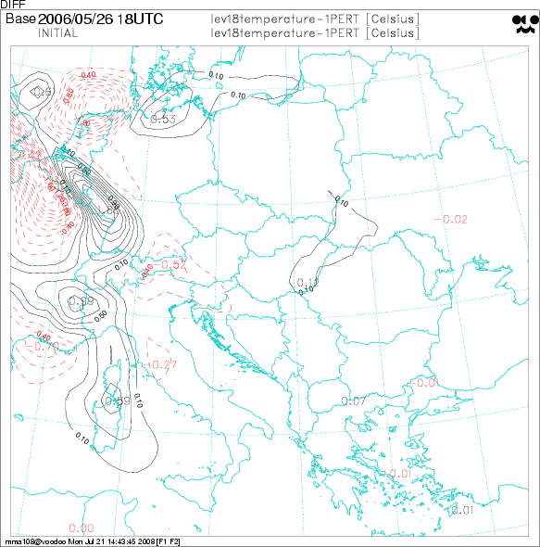 |  | 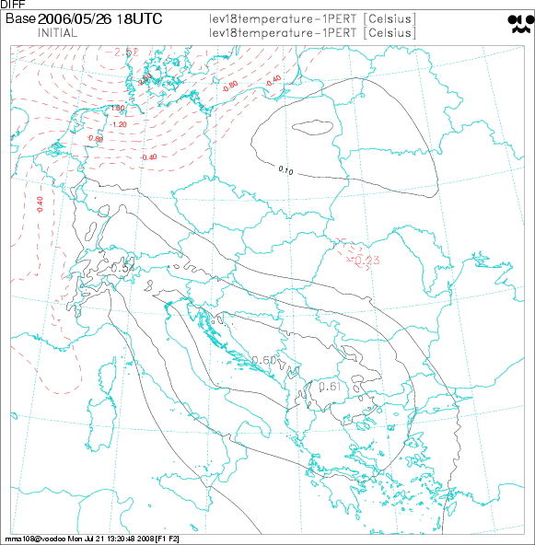
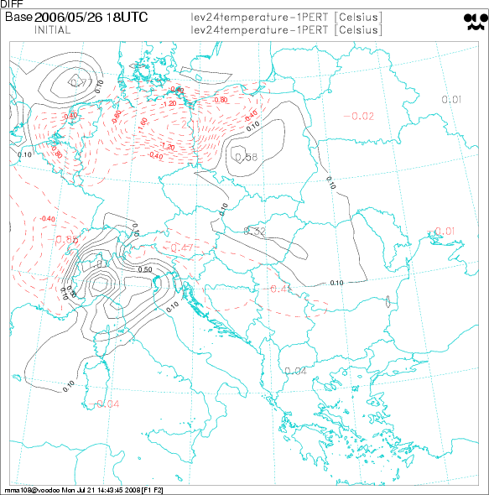 |  | 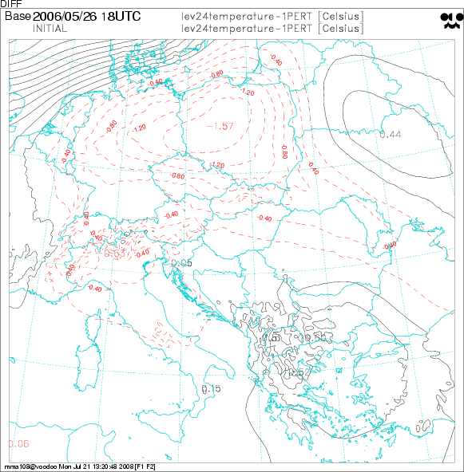
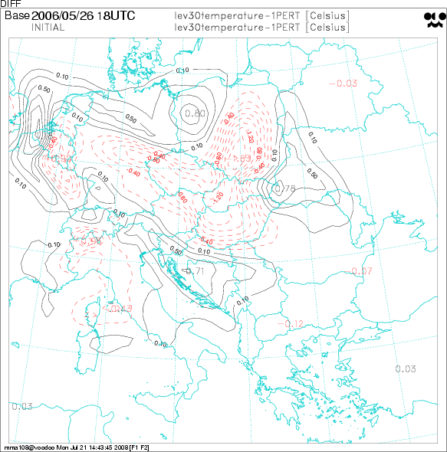 |  | 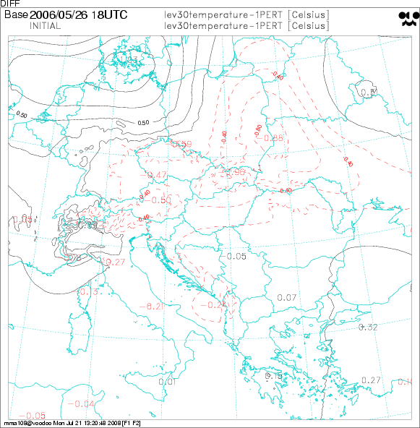
Fig. 1 Differences between first initial perturbed field and analysis for temperature and model levels 18, 24, 30. (ALADIN left, ARPEGE right)
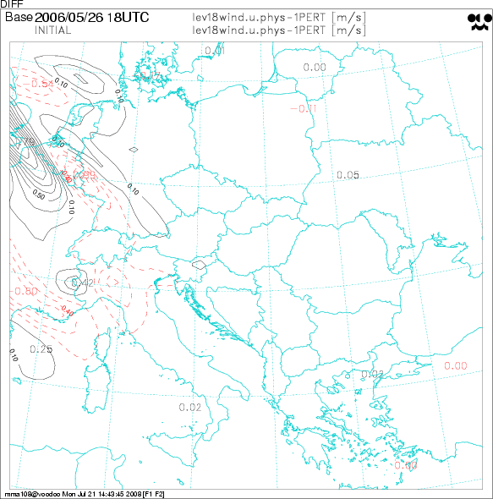 | 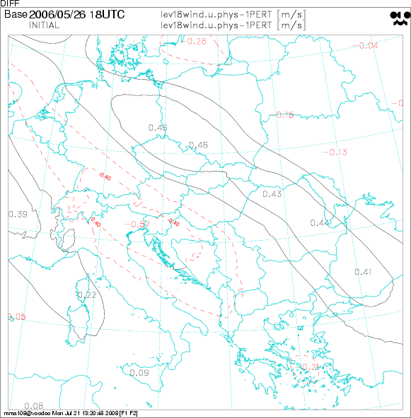
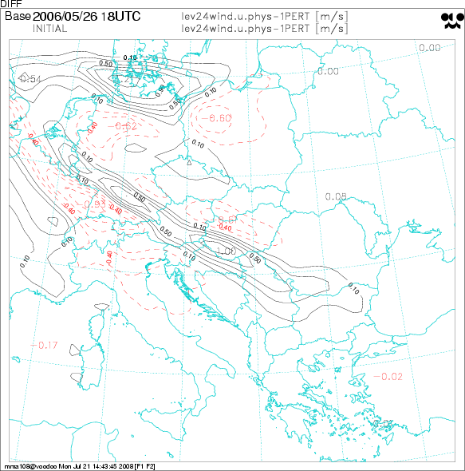 | 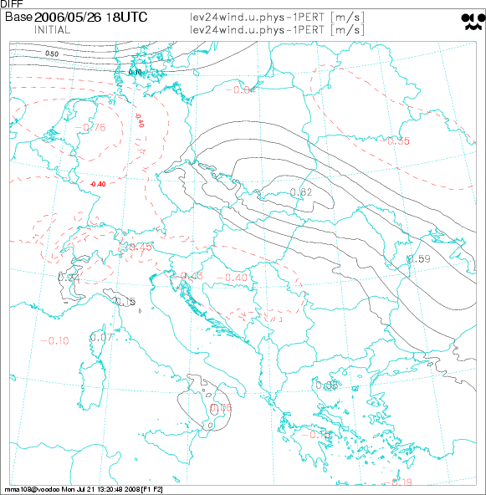
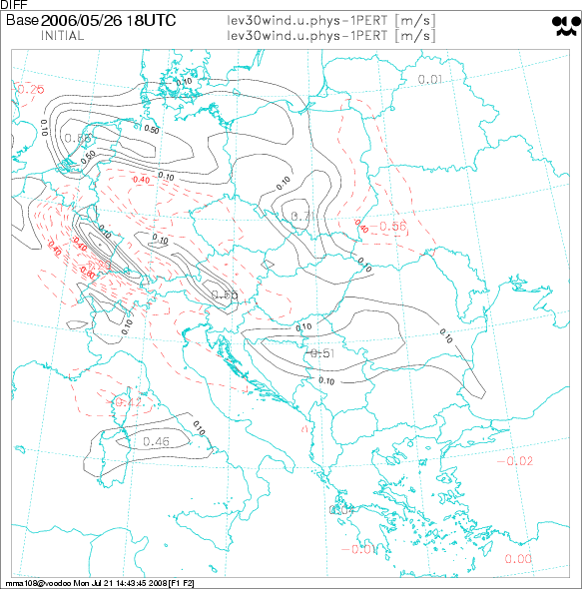 | 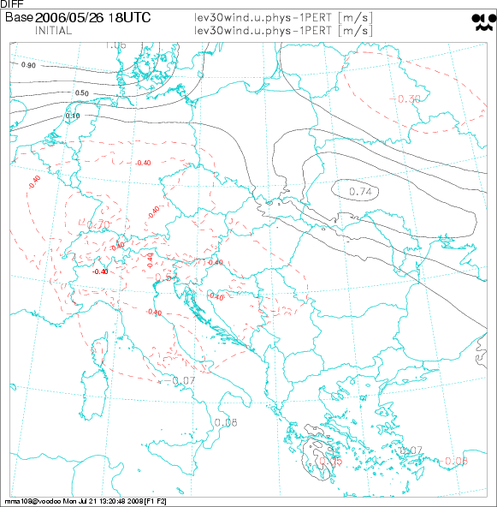
Fig. 2 Differences between first initial perturbed field and analysis for u-component and model levels 18, 24, 30. (ALADIN left, ARPEGE right)

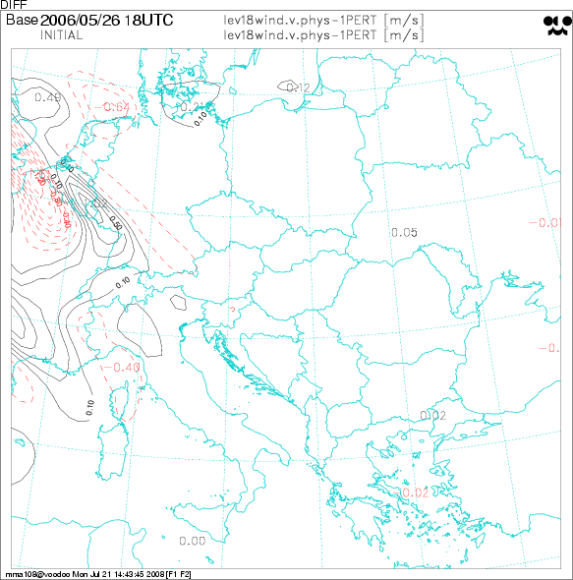 | 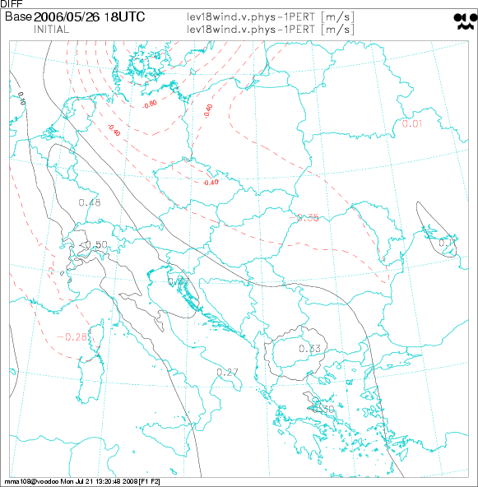
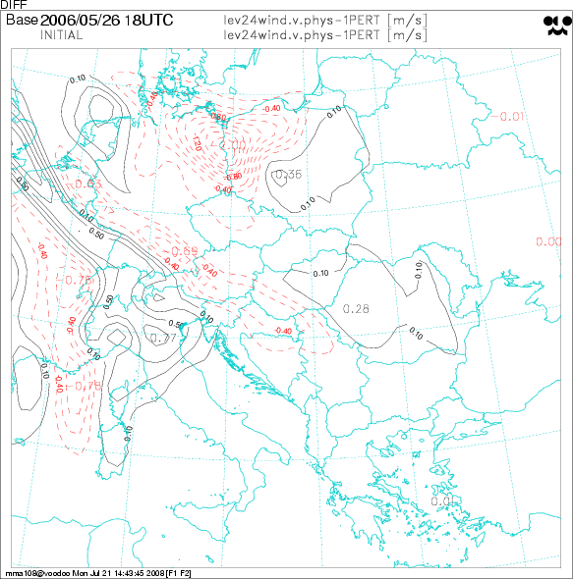 | 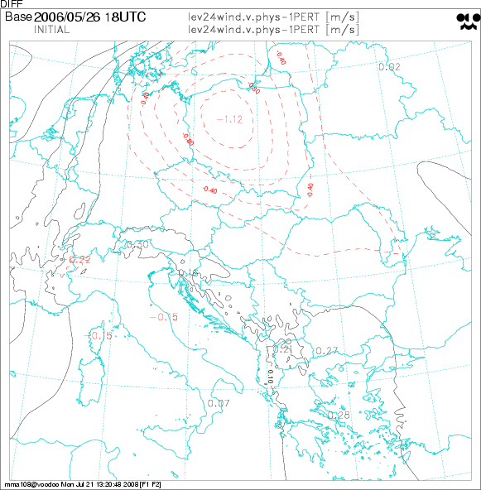
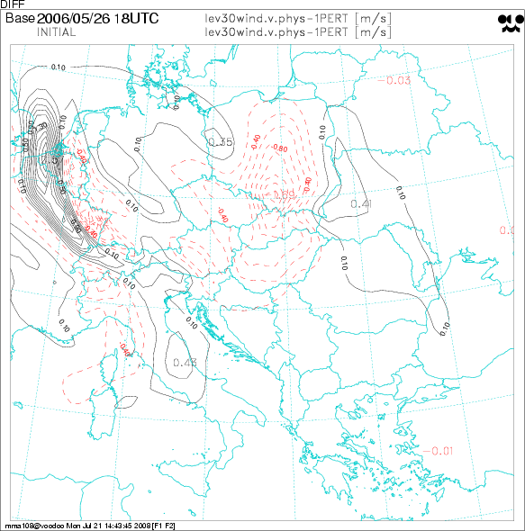 | 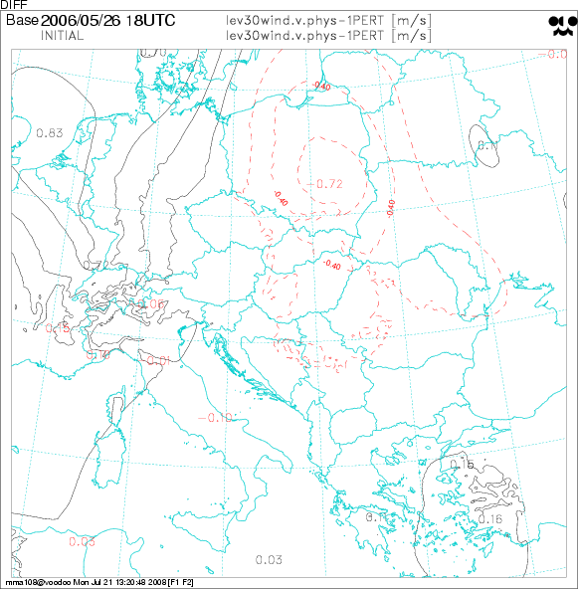
Fig. 3 Differences between first initial perturbed field and analysis for v-component and model levels 18, 24, 30. (ALADIN left, ARPEGE right)

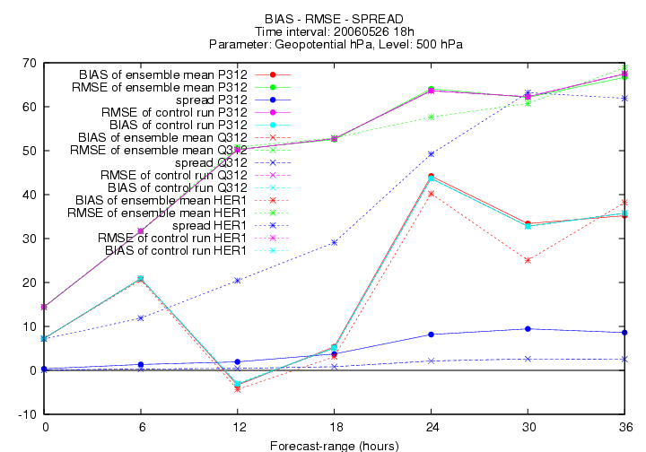 | 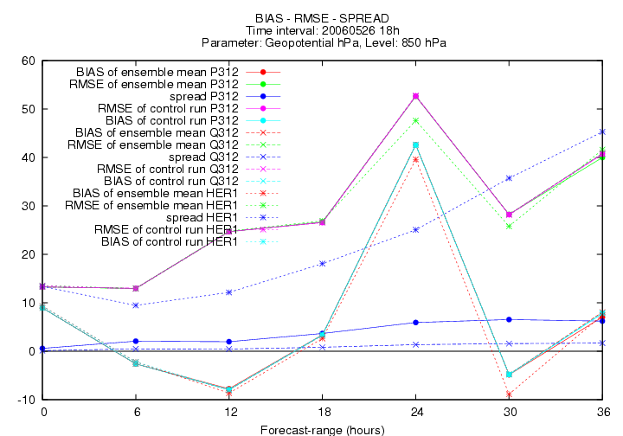
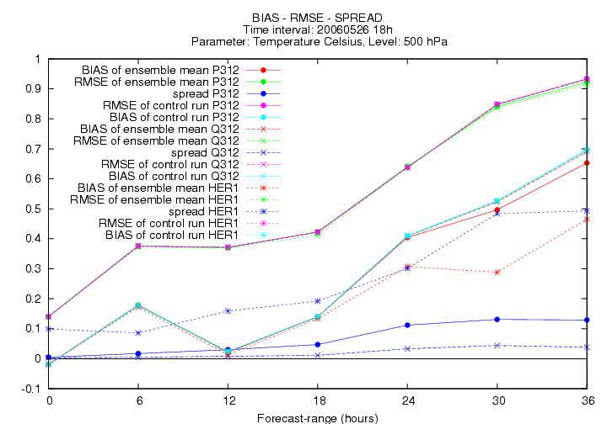 | 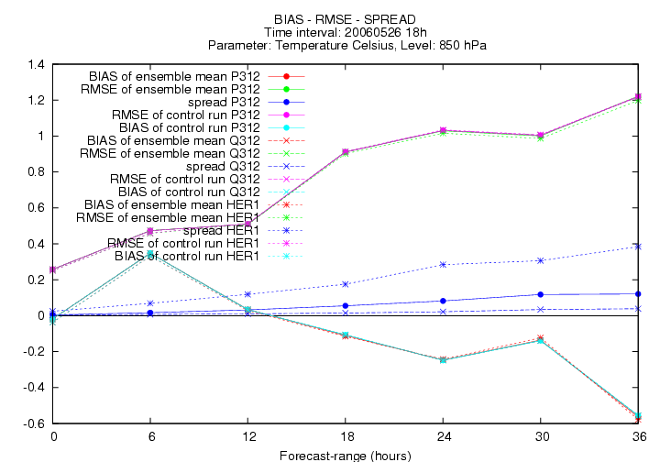
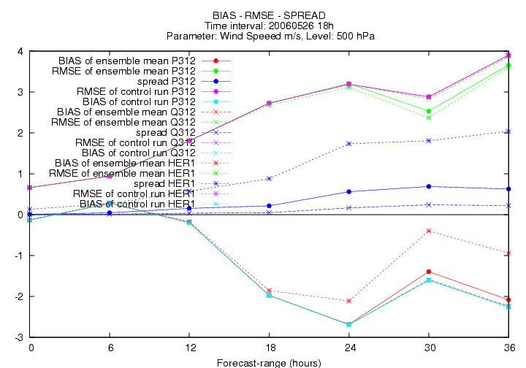 | 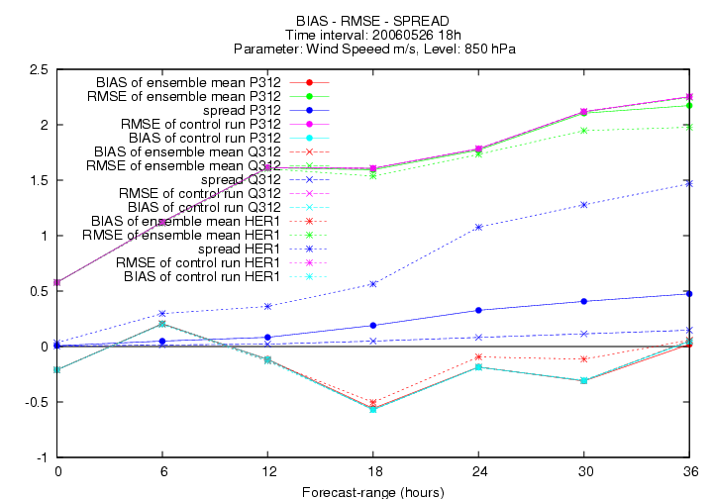
Fig. 4 Values of RMSE, BIAS and SPREAD of ensemble mean and control run. There are displayed the results of ALADIN native SV ensemble (P312 with tuning, Q312 without) and ARPEGE native SV ensemble downscaled by ALADIN model (HER1 experiment).

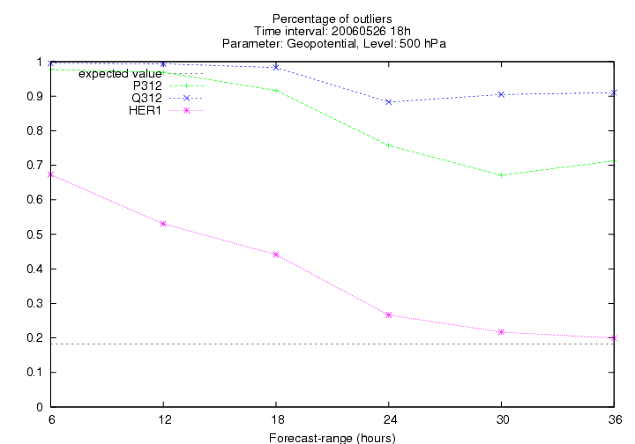 | 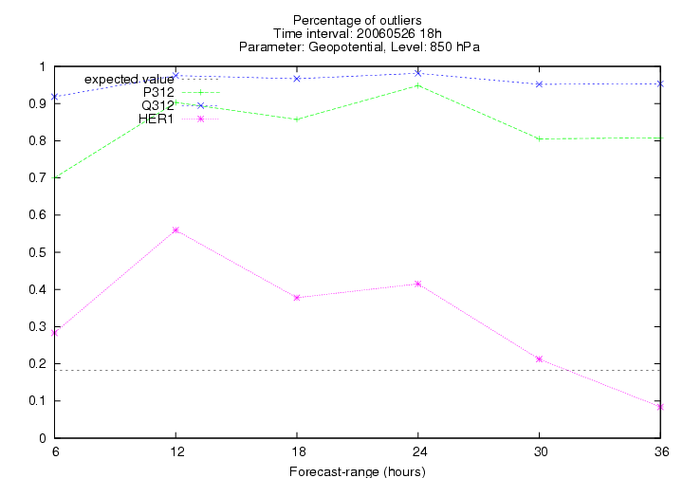
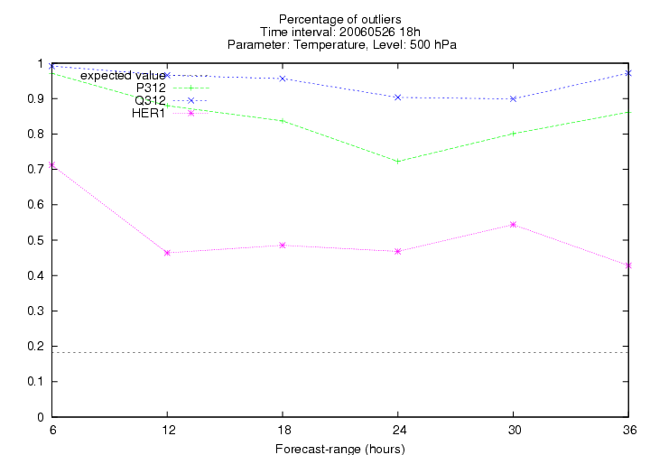 | 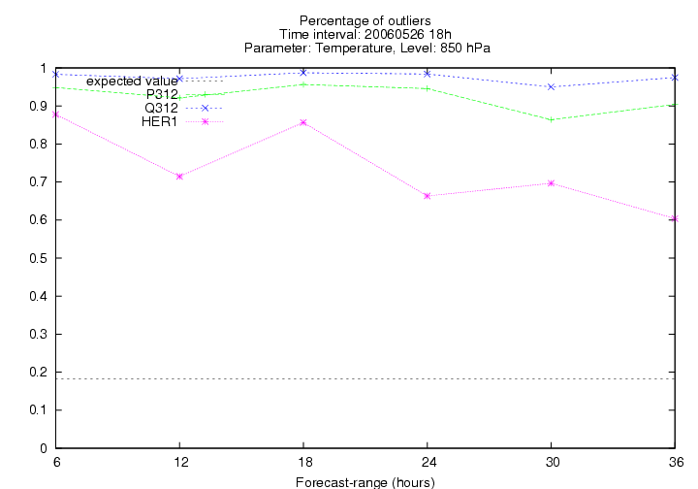
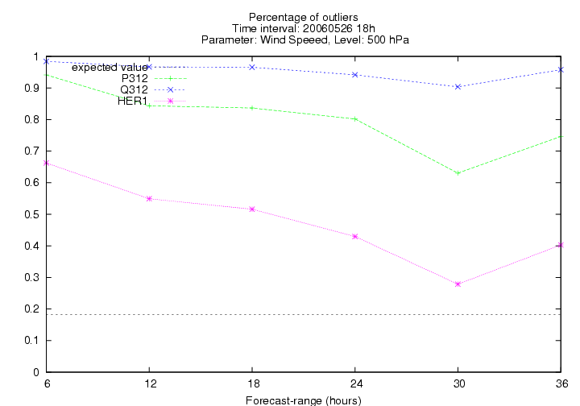 | 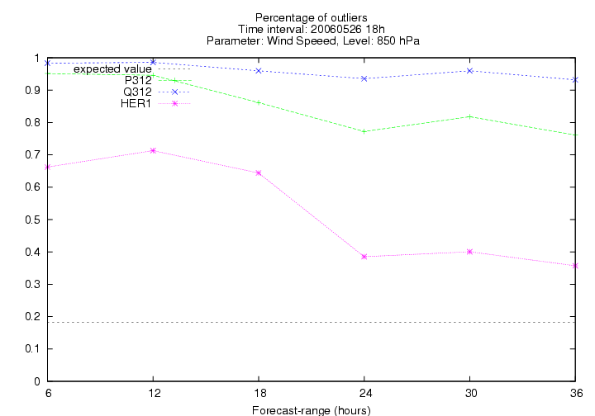
Fig. 5 Percentage of outliers for geopotential (1th row), temperature (2nd row) and wind speed ( 3rd row) on the level 500 (left) and 850 hPa (right).

Data & script locations

combi source on regatta:
/users/mladek/sv_ald/combi.ald/sx68/src_combi.ald.Prague.tar
final version of combi.ald developed on Praguer sx68
(facalc, combi.ald.. + example script how to use it)
- remarks: PCOEFF can be lower then 7 (restriction in PEARP not to have too small perturbations)

used input files on regatta:
/users/mladek/sv_ald/combi.ald/files

original combi code based on combi.cy32t0_op2.01
/users/mladek/sv_ald/combi.ald/tori
- remarks: now there is used a new version of combi with breeding included

Combi software pack (base version)
Combi pack is written in fortran 77 and is driven by namelist (see ex. at the end of the chapter). The creation of the perturbed initial condition is done in few steps:

- NMODVAL = 1
Combination of the analysis in a low resolution (ICLR_000) with computed singular vectors.
input: ICLR_000
SVARPE${SVID}+0000 ($SVID=1 .. number of input SV)
output: ICLR_00${IPERT} ($IPERT=1 .. number of perturbations)
- NMODVAL = 2
Low resolution files with perturbations (ICLR_00${IPERT}) are gribbed and STDE values are computed for every grid-point, vertical level and parameter. Then the suitable coefficient for rescaling of these STDE is searched for. This coefficient is determined so that the final rescaled value of the perturbations in given locality doesn't exceed the value of the standard deviation of the first guess estimate (sigma.grb file). The fields in sigma.grb must have the same vertical and horizontal resolution as the fields in ICLR files.
input: ICLR_00${IPERT}.grb ($IPERT=1 .. number of perturbations)
sigma.grb (STDE of the ARPEGE first guess estimate)
output: recomputed (rescaled) FA files ICLR_00${IPERT}
- NMODVAL = 3
The perturbations from 2nd step are added and subtracted to the input analysis in high resolution. So one gets 2*$IPERT + 1 numbers for the final ensemble.
input: ICFC_000 (arpege analysis)
ICHR_00${IPERT} ($IPERT=1 .. number of perturbations)
output: ICFC_00${IEPSNUM} (${IEPSNUM}=1, 2*$IPERT + 1)

namelist example (with comments):

&NAMMOD
nmod=1 !NMODVALUE see above
/
&NAMENS
nbpert=5, !number of perturbations
nblev=1,1,1,1,1, !not used
nblevl=1,46,46,46,46, !number of vert.levels for each patrameter
!(PRESSION, FONC.COURANT, POT.VITESSE, HUMI.SPECIFI,
! TEMPERATURE)
nbvect=16, !number of SVs
ldbg=.true.,
/
&NAMOPTI
NECH=00, !starting hour
zmul(1,1)=1, !coefficients for linear combination of SVs
zmul(2,1)=1,
...
&NAMMASQAUE !setup for masking procedure (to mask only area of interest -
! 0 elsewhere)
latin1=78000,
lonin1=-102000,
latin2=21000,
lonin2=45000,
gridin=1500,
latout1=90000,
lonout1=0,
latout2=-90000,
lonout2=358500,
gridout=1500,
/
&NAMSTAT
rcoeffmax=32, !maximal value of rescaling coefficient
RCT=4., !tuning coefficient for T
RCU=2., !tuning coefficient for u-winf
RCV=2., !tuning coefficient for v-wind
RCP=2., !tuning coefficient for geopotential
/

Combi software pack (new version)
In accordance with the changes mentioned in the first chapter new namelist parameters were introduced:

&NAMMOD
rmulti=23 !possibility to use your own rescaling coefficient
&NAMEA
KLEVEA=49, !number of vertical levels where first guess values (from
!ALADIN 3-D) are defined for T, U, V, G
ZAEA(0)=0., !coefficients for computation of KLEVEA pressure levels
!(PLEV_EA(JX)=ZAEA(JX)+ZBEA(JX)*ZPREF)
1359.140782,
2605.019833,
...
ZBEA(0)=0., !coefficients for computation of KLEVEA pressure levels
.0000000000,
.0024113345,
...
ZTEA(1)=0.37550, !first guess values (from ALADIN 3-D) for T
0.38094,
0.34372,
...
ZUEA(1)=0.89577, !first guess values (from ALADIN 3-D) for wind comp.
0.66974,
0.76061,
...
ZHEA(1)=0.93870, !first guess values (from ALADIN 3-D) for RH
0.85985,
0.84189,
...
ZPEA=0.614650, !first guess values (from ALADIN 3-D) for G
/

References

- Hágel Edit, Horányi András: Sensitivity experiments of global singular vectors at the Hungarian Meteorological Service, ALADIN Newsletter 29, 2006,(http://www.cnrm.meteo.fr/aladin/newsletters/news29/N29WEB/HAGEL_HORANYI.pdf)

- Hágel Edit, Horányi András: Computation of Aladin singular vectors: Very first results, Vienna meeting 2006, (http://hirlam.org/open/publications/HLworkshops/GLAMEPS200611/Becs_ALADIN_SVfinal.ppt)

- Mládek: Singular vectors in ALADIN model, LACE report, 2007

- Mládek: Downscaling of ARPEGE global ensembles (PEARP) by ALADIN model - heavy rain case study, ALADIN Newsletter 33, 2007

