IMPLEMENTATION OF IMPROVED METHODS AND UPGRADING THE ALADIN – LAEF SYSTEM

Report of LACE stay from 01.07.2008 – 31.07.2008 at SHMU, Bratislava, Slovakia

Alexander Kann
Central Institute For Meteorology and Geodynamics
Vienna, Austria

- Motivation
- General considerations
- Implemented methods for
  - Surface perturbation
  - Upper Air perturbation
  - Physics perturbation
- Post-processing
- Logical switches and flexibility
- Time schedule
- First results
- Outlook

- Motivation

Since spring 2007, ALADIN-LAEF is running operationally at hpce (ECMWF). Basically, it consists of a LAM-EPS system constructed by dynamical downscaling of the first 16 ECMWF EPS members.
During Martin Bellus’ LACE stay in Vienna, ZAMG, he implemented an experimental setup with improved methods that address LAM-specific perturbations. Results have shown that a combination of surface perturbation, upper-air perturbation and multiphysics improves the quality of ALADIN-LAEF significantly (Bellus, 2008).
The goal of the stay at SHMU was to implement these improved methods into the operational frame at hpce (ECMWF).

- General considerations

It was decided to keep the existing modular frame of the operational script and to write functions with the new methods into. This should guarantee a full functionality with additional flexibility. The existing operational script has been installed on another user in order to avoid collisions and allowing for secure testing. As a next step, unnecessary features that are (or will be) not used any more are removed. This purged script is forming the basis for implementing new features which will be described in the following.

- Implemented Methods

3 types of LAM orientated perturbation schemes that are reflecting the error sources in a reasonable way are implemented within the new ALADIN-LAEF system: Surface perturbation, the perturbation of upper level fields and perturbations in physics. The impact of perturbed LBCs are not treated separately up to now, couplings from ECMWF EPS (SV Vectors) are still used.
In the following, the full bunch of methods will be denoted by BBSM (Breeding – Blending – Surface Perturbation – Multiphysics).

- Upper level perturbation

The Breeding method, originally developed at NCEP (Tot and Kalnay, 1997), forms the basis for LAM generated initial conditions of upper level fields. Shortly, Breeding tries to simulate the uncertainty in observations by rescaling nonlinear perturbations.

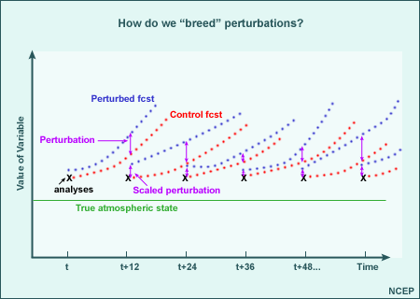

Fig. 1: Breeding method (taken from http://www.meted.ucar.edu/nwp/pcu1/ensemble/frameset.htm)

The difference of a pair of 12h-forecast is rescaled and then added and subtracted from the control analysis, respectively. Thus, two new initial conditions are generated for the model integration. This breeding cycle is repeated for the full set of ensemble members leading to a new set of initial conditions. In the current implementation, 3D fields of temperature, specific humidity and wind as well as surface pressure are perturbed.
The final breeding files are further blended with the ECMWF analyses in order to avoid inconsistency between initial and boundary conditions. Theoretical considerations concerning the blending technique can be found in Bellus (2008) and Derkova and Bellus (2007). Generally spoken, the spectral blending method combines large scale perturbations from the global model (singular vectors) with the small scale features provided by the limited area model (breeding vectors). Fig. 2 shows kinetic energy spectra which confirm the theory that for small wave numbers it is converging to ECMWF and for large wave numbers to the limited are model ALADIN. Moreover, the combined analyses should be more consistent with the lateral boundary conditions (which are taken directly from ECMWF EPS) while keeping the properties of the breeding method.
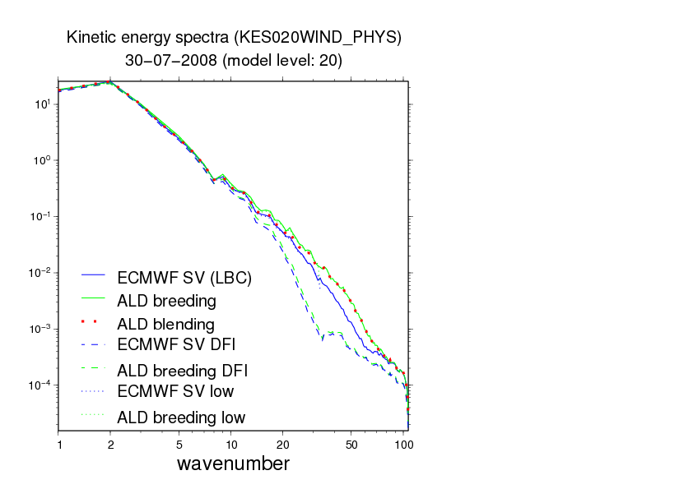

Figure 2: Kinetic energy spectra for member 15 and model level 20.

- Surface perturbation

The basic concept for perturbing the surface fields is rather straightforward. The surface fields of all ECMWF EPS members are replaced by the corresponding Arpege surface. Consequently, all new EPS members have the same surface initial condition. After 12 hours integration, a new set of 16 perturbed surface fields is derived, driven by Arpege surface and the 16 ECMWF EPS boundary conditions. These 16 new sets of surface fields are used for the next (= 12 hours later) model run as initial conditions at the surface. They are replacing the surface fields, which contain the files after the breeding-blending cycle. An additional degree of consistency is obtained due to the fact that the integration itself is done using time-lagged couplings, which fit to the “non-cycled” surface perturbation.

- Multiphysics

In order to simulate the uncertainty in model physics, the 16 EPS members are generated by using different physics parameterization and schemes.
The following executables and physics, respectively, are used for the perturbed ensemble members:

Member 01: Aladin cy32t2 with namelist settings simulating cy25
Member 02: Aladin cy32t2 with namelist settings simulating cy25, CAPE closure and new tuning
Member 03: Aladin cy32t2, Lopez, TKE+Noarome+Bougeault
Member 04: Aladin cy32t1, 3MT
Member 05: Aladin cy32t2, Lopez
Member 06: Aladin cy32t2, Lopez, CAPE closure and new tuning
Member 07: Aladin cy32t2, Lopez, TKE+Noarome+Bougeault, CAPE closure and new tuning
Member 08: Alaro, operational settings
Member 09: Aladin cy32t2, Lopez, TKE+Arome+Bougeault
Member 10: Aladin cy32t2, Lopez, TKE+Arome+Bougeault, CAPE closure and new tuning
Member 11: Aladin cy32t2, Lopez, TKE+Arome+Smith
Member 12: Aladin cy32t2, Lopez, TKE+Arome+Smith, CAPE closure and new tuning
Member 13: Aladin cy32t2, Lopez, TKE+Noarome+Smith
Member 14: Aladin cy32t2, Lopez, TKE+Noarome+Smith, CAPE closure and new tuning
Member 15: Aladin cy32t1, 3MT, tuning 1
Member 16: Aladin cy32t1, 3MT, tuning 2

- Post-processing

In the current operational implementation Fullpos Files are sent via ftp to ZAMG, where subsequent post-processing procedures are performed.
The new design includes the automatic creation of GRIB Files including fields that are frequently used but not available from Fullpos (i.e. total precipitation, etc.). Therefore, the gribeuse routines are installed at hpce and introduced into the system.
Furthermore, an additional script is prepared for automatic archiving ALADIN-LAEF Gribfiles into MARS archive. The GRIB Files have to be reorganized using ECMWF style (including local extensions and Grib table 128) in order to fit to MARS definitions. The script is ready to use and to be implemented into the new SMS suite. Before operational archiving, some issues have to be discussed like a new definition of class, etc.

- Logical switches

The following switches determine the behavior of the operational system of ALADIN – LAEF.

TIMECRIT=0 # 1: running under time critical environment
TRANSLAEF=0 # 1: transfer data to ZAMG using llsubmit
RESTAMO=1 # 1: check control file to avoid re-running of finished parts
VERBOSE=1 # 1: set -x in all subroutines
JUSTLBC=0 # 1: just produce LBC for next time lagged run
SURFINTEGRATION=0 # 1: Do the integration for surface perturbation
SURFPERTURB=0 # 1: Do the surface perturbation
BREDCYCLING=0 # 1: Do Breeding Cycling
BREDPERTURB=0 # 1: Do Breeding Perturbation
COLD_START=0 # 1: Do Cold-Start for Breeding Cycling
BLENDING=0 # 1: Blend ALADIN with ECMWF EPS
MULTIPHYSICS_4_INTEGRATION=0 # 1: Using Multiphysics for ALADIN-LAEF integration
MULTIPHYSICS_4_BREEDING=0 # 1: Using Multiphysics for breeding cycling
MULTIPHYSICS_4_SFCINT=0 # 1: Using Multiphysics for non-cycling integration for surface perturbation

Additional security is obtained by checking the requested input files before integration. Consequently, if one part of the system fails, the procedure is able to continue by using input files without the perturbation that failed. Practically, e.g. if the surface perturbation fails – regardless of the reason – the initial files containing breeding – blending only are used. The “lowest” choice in the hierarchy, dynamical downscaling of ECMWF EPS, is used if none of the perturbations of BBSM was successfully carried out (or alternatively, if none of them was requested).

- Operational time schedule

The stepwise structure using dependencies allows for optimization in a time-critical mode.
The following steps are carried out chronologically (blocks of 4 members are done in parallel):

- MARS retrieval of analyses of EPS members
- e901 of analysis files
- e927 of analysis files
- Breeding perturbation
- Blending
  - Members 1 – 4
  - Members 5 – 8
  - Members 9 – 12
  - Members 13 – 16
- Surface perturbation
- Integration (e001), post-processing (FA to GRIB) and transmission to ZAMG
  - Members 1 – 4
  - Members 5 – 8
  - Members 9 – 12
  - Members 13 – 16

The steps 9 to 13 are preparing input files for the next model run and therefore not that time-critical:

- MARS retrieval of forecasts of EPS members
- e901 of forecast files
  - Members 1 – 4
  - Members 5 – 8
  - Members 9 – 12
  - Members 13 – 16

- e927 of forecast files
  - Members 1 – 4
  - Members 5 – 8
  - Members 9 – 12
  - Members 13 – 16

- Exchanging surface from ARPEGE into ECMWF – EPS members
- Short-range forecast (+12h) for Surface Perturbation
- Short-range forecast (+12h) for Breeding Cycling

- First results

The following charts compare some operational products against the new system, obtained by BBSM.

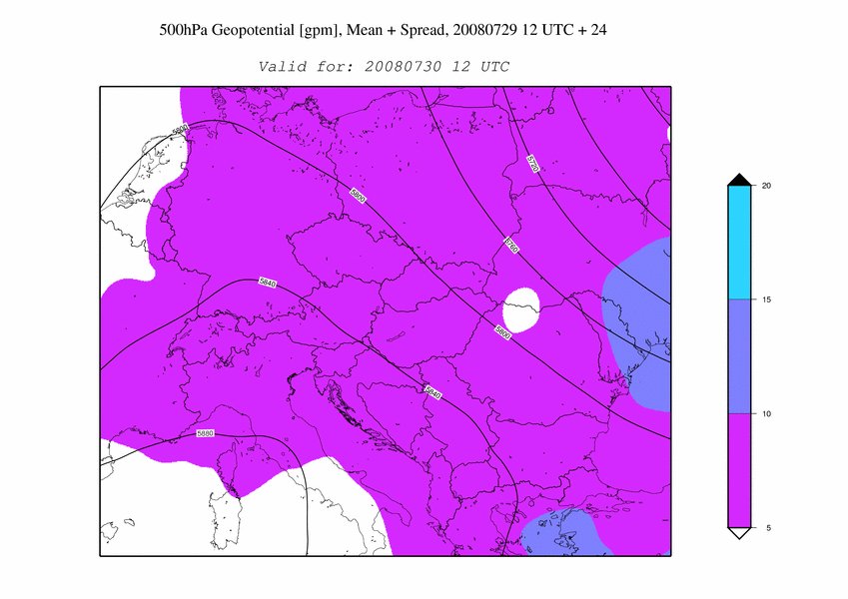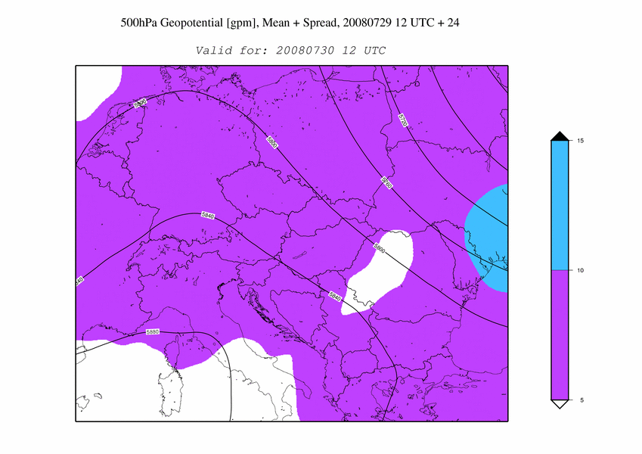
Fig. 3: PHI 500hPa Mean + Spread, 20080729, 12 UTC + 24h. Left: OPER, Right: BBSM

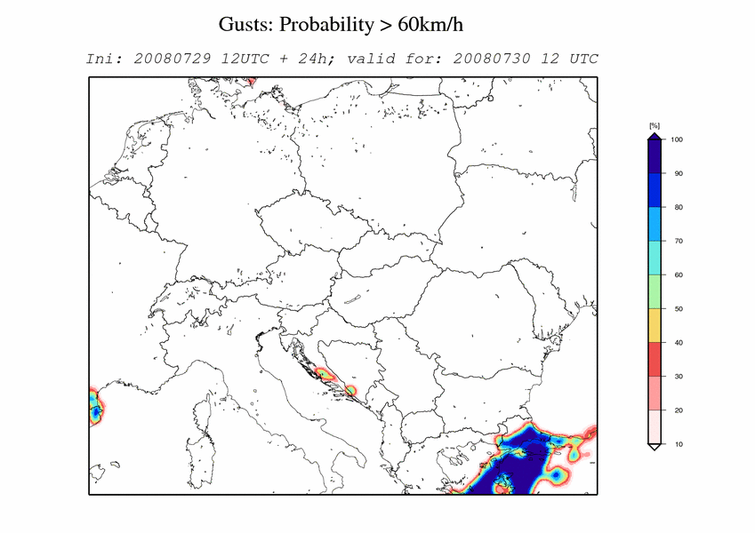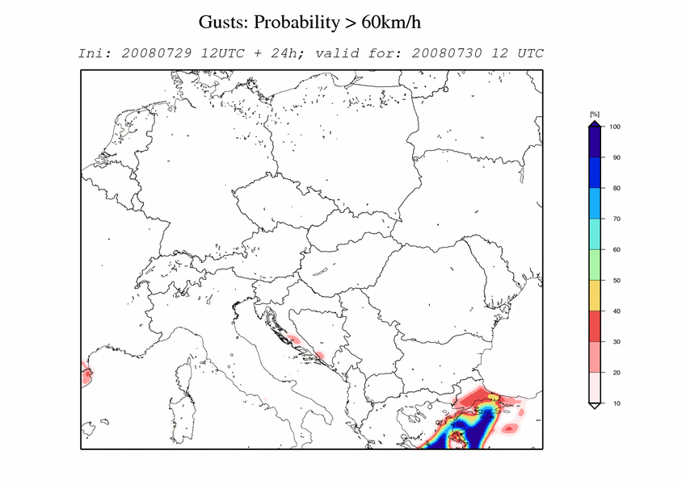
Fig. 4: Gusts, Probability > 60km/h, 20080729, 12 UTC, valid for +21h to +24h. Left: OPER, Right: BBSM

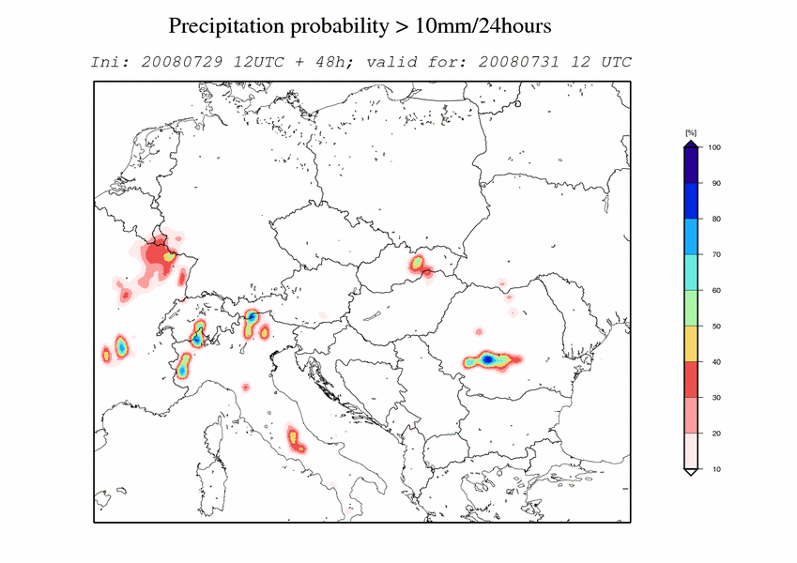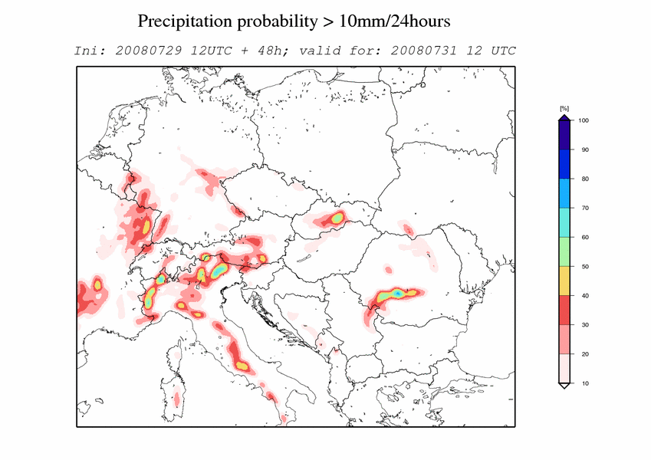
Fig. 5: Precipitation, Probability > 10mm/24h, 20080729, 12 UTC + 48h. Left: OPER, Right: BBSM

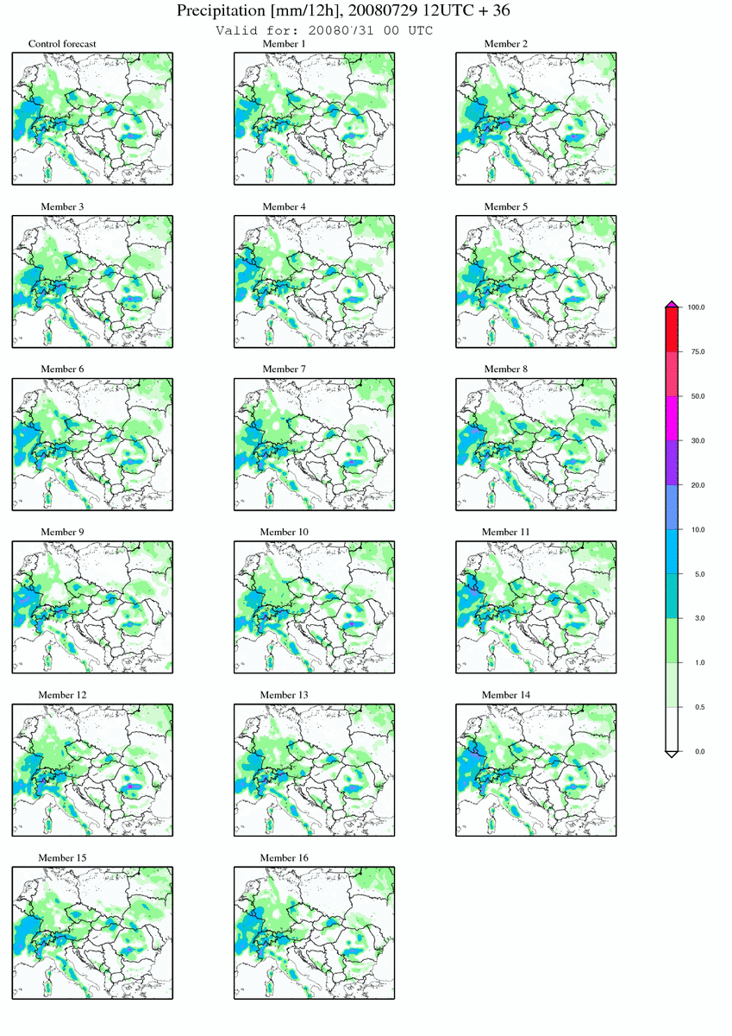
Fig. 6: 12 hours accumulated precipitation, post stamps, 20080729, 12 UTC + 48h. OPER
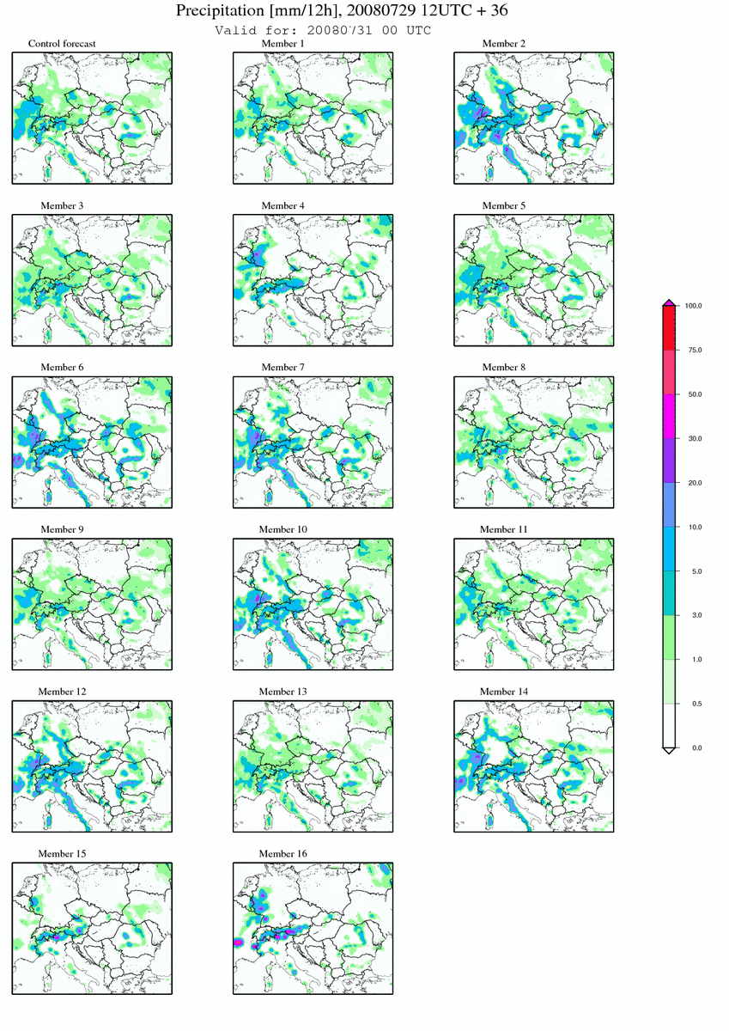
Fig. 7: 12 hours accumulated precipitation, post stamps, 20080729, 12 UTC + 48h. BBSM

- Outlook/To do

From technical point of view, it is planned to change from time critical option 1 to option 2, therefore a SMS suite has to be set up. This allows for better control by administrators and additional system stability.

The script that produces “MARS friendly” GRIB Files is ready to use, but probably needs short adaptation concerning the GRIB extension that will be used in the final version. However, this change or addition should be rather straightforward and simple to implement.

Concerning the quality of the new ALADIN – LAEF system, it should be studied if a tuning of the namelist settings or other physical options could provide further improvements.

Acknowledgement

I want to thank all colleagues from SHMU for their kind hospitality and especially Martin Belluš for his assistance and the collaboration during the stay.

References

Belluš, Martin, 2008: Combination of large scale initial conditions uncertainty with small scale initial perturbations obtained by breeding cycling using blending technique in LAEF experiments. Report on stay at ZAMG, 11/02 – 21/03/2008, Vienna, Austria.

Derková, M. and M. Belluš, 2007: Various applications of the blending by digital filter technique in the ALADIN weather prediction system. Meteorologický časopis, 10, 2007.

Toth, Z., and E. Kalnay, 1997: Ensemble forecasting at NCEP and the breeding method. Mon. Wea. Rev., 127, 3297-3318.

