Work On the Common Verification Package for Evaluation of Ensemble Forecasts

Report: RC-LACE stay in Bratislava, SHMU, 01.08.2007 to 31.08.2007

Alexander Kann
Central Institute For Meteorology and Geodynamics
Vienna, Austria

- Introduction

The work on the verification package has been started by Edith Hagel in summer 2006 and continued by Richard Mladek in autumn 2006.

The main idea of the package was to create a powerful, easy to use and flexible verification software, that provides all necessary scores including their visualization. It should be portable to every Unix/Linux platform and usable by arbitrary ensemble datasets.

This report describes the relevant changes and additions to the verification package, which have been carried out during the one month stay. For the full historical development of the software, see the reports from Edith Hagel (Hagel, 2006) and Richard Mladek (Mladek, 2006).

A full description of the verification software will be given in the documentation v3.0.

- Modifications in the shell scripts and fortran codes

The verification package was slightly re-designed and extended in order to offer a user-friendly and flexible way of handling the software. Thus, and due to methodological reasons, it now consists of two stand-alone, analogous parts, which are independent from each other: A verification part of the upper level parameters and a verification part of the surface parameters. Both parts are to be run separately.

Both parts are activated by a controlling shell script (MasterVerification.job for the upper level parameters and MasterVerification_Surface.job for the surface parameters). The control script contains all the settings that are obligatory for running the software. The user has to edit only this driving script in order to control the characteristics of the software. The control script calls the actual, main part of the software, which executes the calculation routines, averaging procedures and plotting scripts (DoVerification.job for the upper level parameters and DoSurfaceVerification.job for the surface parameters). These scripts automatically write a namelist which contains the keys necessary to use the fortran routines for decoding the data and to calculate the verification scores. They perform a final averaging over the given time range and visualize the verification results (if requested by the user).

- Verification of surface parameters

One major task of this working stay was to implement the evaluation of surface parameters, which should – by definition - be verified against observations. Therefore, observation files are generated including synoptic reports of precipitation, temperature, relative humidity (or dewpoint temperature), mean sea level pressure and 10m wind components. The format of the observation files is defined as follows:

Observation File Names: F_OBS_FMT-yyyymmddhh-LAEF.txt.gz

Format of the Files is ASCII:

loop over all SYNOP stations inside the verification domain:

stat-id, longitude [degree], latitude [degree], height [m], date [yyyymmddhh]
MSL-Pressure [Pa], 2m Temperature [K], 2m Dewpoint [K], U10m [m/s], V10m [m/s], Precipitation [mm], time-range-indicator-for-Precip []
.
stat-id, longitude [degree], latitude [degree], height [m], date [yyyymmddhh]
MSL-Pressure [Pa], 2m Temperature [K], 2m Dewpoint [K], U10m [m/s], V10m [m/s], Precipitation [mm], time-range-indicator-for-Precip []
.
.
.
.
.
.

Note: time-range-indicator-for-Precip:
1=6 hourly, 2=12 hourly, 3=18 hourly, 4=24 hourly, 5=1 hourly, 6=2 hourly, 7=3 hourly, 8=9 hourly, 9=15 hourly.

Missing values are indicated with -999.
Precipitation with value -0.1 means 'no precipitation'
Precipitation with value 0.0 means precipitation traces (not measurable)

Providing these observation files, a program extracting the relevant data from the local data bench and writing the output format above has been written. As this code is deeply linked to the local data bench, it is hardly portable and therefore not part of the package.

- New features in the Verification package

- Up to now, the software was hard-coded by the limit of 10 ensemble members. It has been re-written in order to be able to be run with an arbitrary set of ensemble members. There is no limitation concerning the number of ensemble members in the new software version any more.

- New verification scores are added to the system:

The Ranked Probability Score (RPS) is widely used to verify multi-category probability forecasts and is defined as:

$$\text{RPS}=\sum_{k=1}^{K}{{\left(Y_{k}−O_{k}\right)}^{2}}$$

$Y_{k}$ and $O_{k}$ denote the k-component of the forecast and observation vector Y and O such that it equals one if k occurs and zero otherwise.
The RPS has a range from zero to one and is negatively orientated (the lower the value the better the forecast). For the special case of only two classes (eg. Rain/no rain) the Ranked Probability Score reduces to the Brier Score.

Like the Brier Score, a skill score (Ranked Probability Skill Score, RPSS) can be created using the well known formula:

$$\text{RPSS}=1−\frac{\text{RPS}}{{\text{RPS}}_{\text{Re}f}}$$

The Continuous Ranked Probability Score (RPSS) is the generalized form of the discrete ranked probability score, simulating the mean over all possible thresholds:

Let the variable $x$ be denoted the parameter of interest, for instance 2m temperature or 10m wind speed. If the PDF forecast by an ensemble system is given by $ρ\left(x\right)$ and $x_{a}$ is the value that currently occurs, then the CRPS expresses the distance between the probabilistic forecast $ρ$ and the “truth” $x_{a}$ (Hersbach, 2000):
$$\text{CRPS}\left(P,x_{a}\right)=\int_{−∞}^{∞}{{\left[P\left(x\right)−P_{a}\left(x\right)\right]}^{2}\text{dx}}$$
The cumulative distributions $P$ and $P_{a}$ can be written as:
$P\left(x\right)=\int{ρ\left(y\right)\text{dy}}$ ;$P_{a}\left(x\right)=H\left(x−x_{a}\right)$, where $H\left(x\right)=\left\{\begin{matrix}0 \\ 1\end{matrix}\right.\begin{matrix}\text{for} x < 0 \\ \text{for} x ≥ 0\end{matrix}$ is the Heaviside function.

The CRPS compares the overall distribution to observation and generalizes the mean absolute error, to which it converges in case of a deterministic forecast.

Again, a corresponding skill score is incorporated to the verification package, too:

$$\text{CRPSS}=1−\frac{\text{CRPS}}{{\text{CRPS}}_{\text{Re}f}}$$

- In order to generalize the calculation of skill scores, it is possible now to choose any deterministic forecast as a reference. Especially in case of short-range ensemble forecasting it has been shown that using climatology is not the best benchmark. So the software allows using any deterministic forecast as a reference, eg. Aladin, ECMWF, etc, while the possibility of using persistency as a reference is kept.

- The plotting scripts are adapted in order to deal with surface parameters automatically.

- Software is adapted to deal with missing forecasts automatically.

- Software is adapted to deal with missing observations automatically.

- Software is adapted to deal with precipitation types that have to be summed for total precipitation automatically.

- Daily climatologic data have been post-processed from ERA-40 data and re-written to GRIB output format in order to be used straight forward as a reference for skill score calculations or for the work with anomaly based thresholds.

- In order to verify surface variables against observations, the forecasts have to be interpolated onto the observation’s location. As different methods are depending on the user’s requirements, one is able to select the interpolation method by setting a parameter key in the control script (eg. bilinear, nearest grid point, mean value of neighboring grid points).

- Summary

The Verification Package is an easy-to-use, flexible and rather powerful tool to verify EPS systems. The modular configuration that is controllable by logical switches offers the possibility to choose specific scores, parameters, references and background data according to the customers’ options and/or data availability.
As the package consists of shell scripts, fortran routines and gnuplot scripts, it is easily portable on any Unix machine without the need of commercial software.
The verification of surface parameters and upper level parameters is separated at a high level as they partly require different treatments (for instance field verification vs. verification at stations’ locations). Nevertheless, the handling of the driving scripts is analogous in both cases and therefore easy to manage.

The control scripts MasterVerification.job and MasterVerification_Surface.job are designed as follows:

- Settings related to the main executions of the verification (keys for calculating daily scores, further processing and plotting)
- Settings related to (skill) score computations (keys for Brier Score, Ranked Probability Score, Continuous Ranked Probability Score and their corresponding skill scores).
- Settings related to the type of (verifying) data (e.g. ASCII for surface parameters or GRIB for upper air fields)
- Settings related to the experiment to be verified (e.g. name of exp., number of ensemble members, levels, etc.)
- Settings related to date and time
- Settings related to the internal GRIB codes (for forecast data and maybe for analyses data)
- Parameter settings to be verified
- Settings related to basic score computations including threshold depending scores
- Settings related to the determination of thresholds
- Settings related to plotting procedures (determining the scores to be visualized).
- Directory/file names settings

The scripts DoVerification.job and DoSurfaceVerification.job are called in order to perform the main tasks, calculating the daily scores, averaging over a given period and calling the plotting procedures if requested.
Finally, the output files with the averaged and daily scores are stored in the predefined output directory in ASCII format and their corresponding plots as postscript files and png-files.

- Further developments/improvements

- It could be worth considering re-writing some parts of the package in order to speed up the CPU time of the whole procedure.
- In order to compare different EPS systems (e.g. LAEF vs. PEPS) directly to each other, it would be necessary to write some plotting scripts visualizing the scores for different systems in one picture (e.g. Bias, RMSE, Talagrand diagram, Outliers, etc.).

- Acknowledgements

I would like to thank all the colleagues at SHMU for their hospitality, my special thanks go to Martin Bellus and Jozef Vivoda for their kind assistance during the stay.

ANNEX: Exemplary plots of upper level parameters
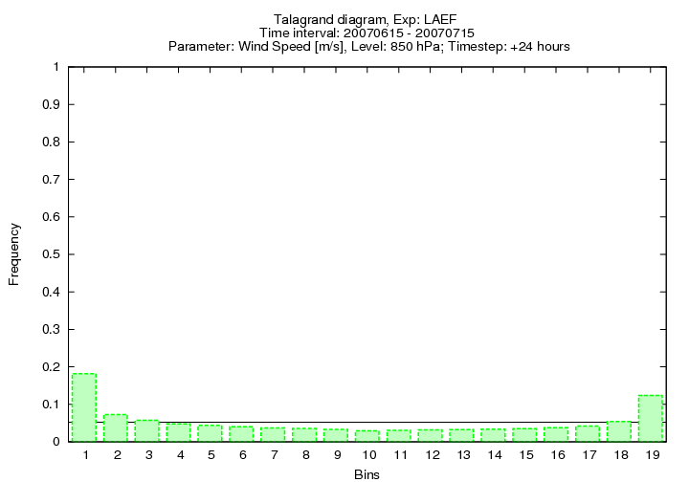

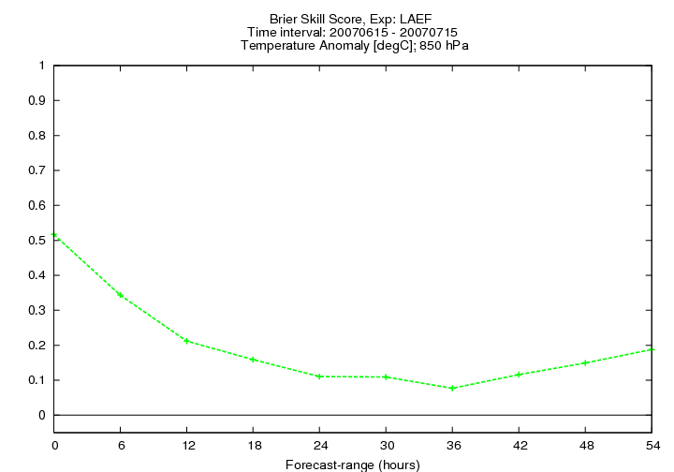

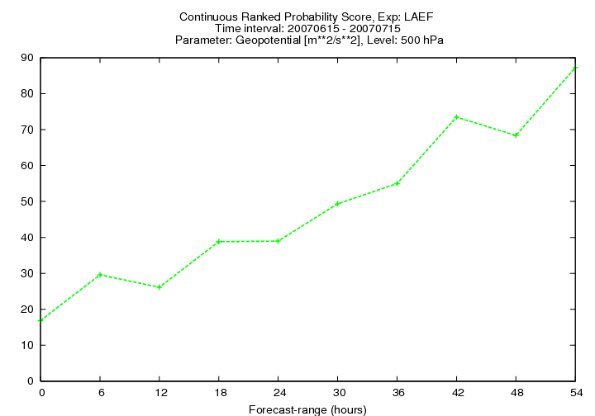

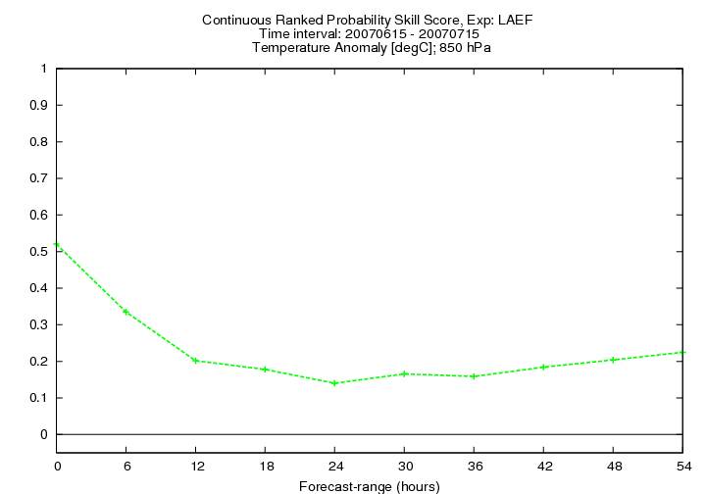

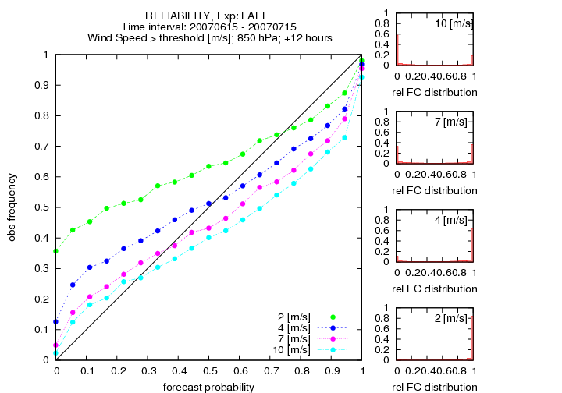

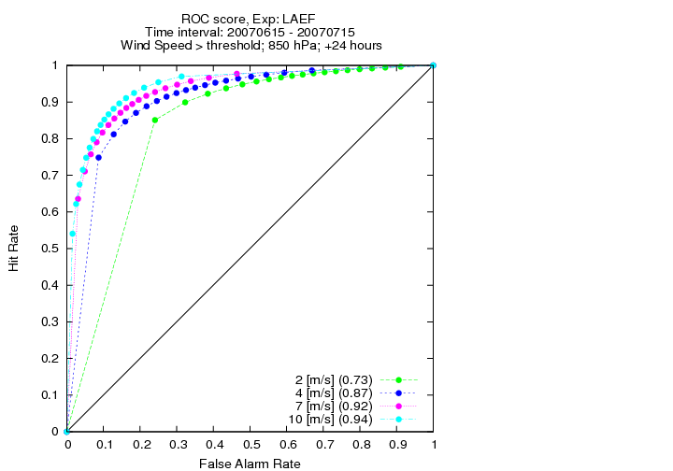

ANNEX: Exemplary plots of surface parameters

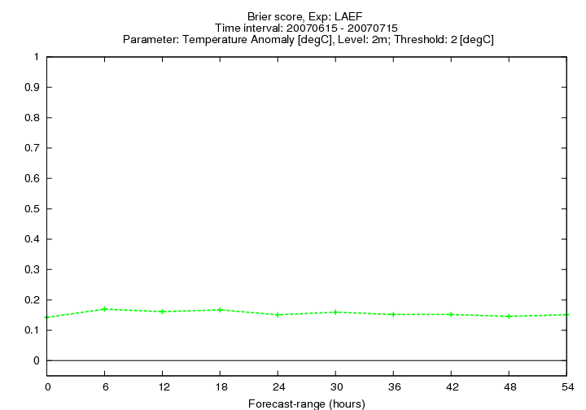

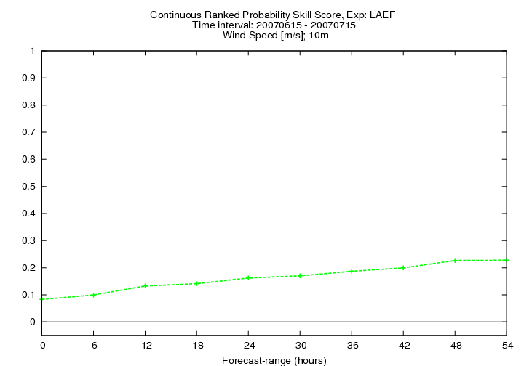

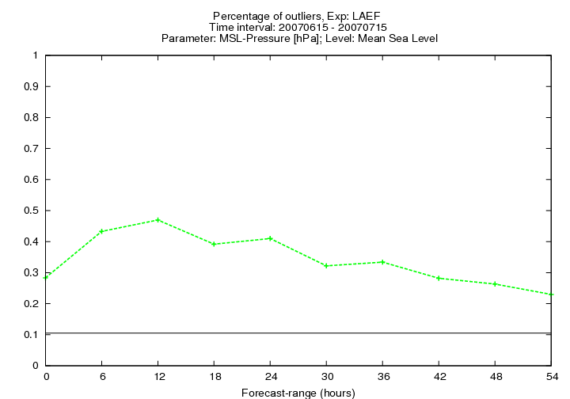

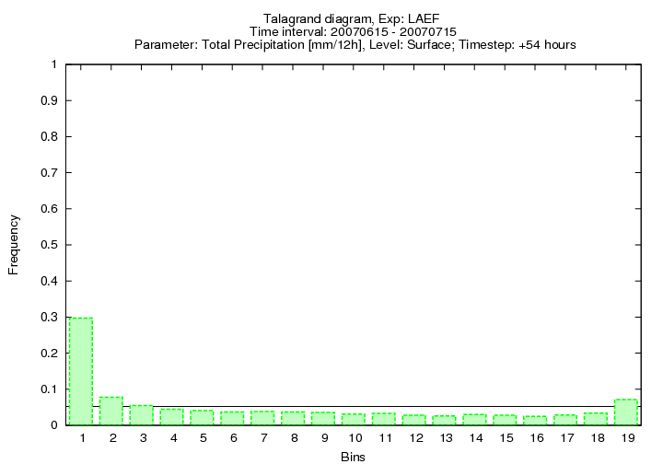

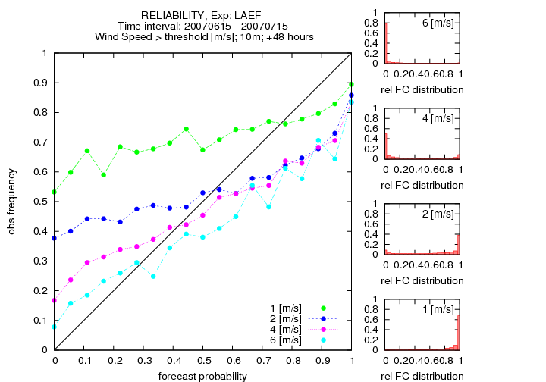

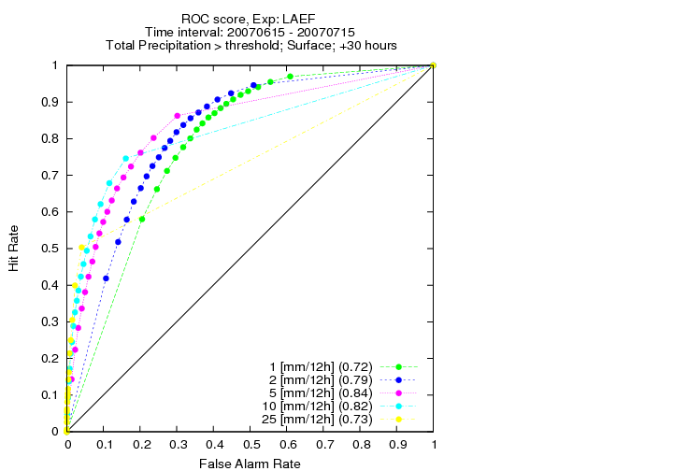

Hersbach, Hans, 2000: Decomposition of the continuous ranked probability score for ensemble prediction systems. Weather And Forecasting Vol. 15, 559 – 570.

Hagel, E.: Report on work in Vienna on the common verification package. Report on stay at ZAMG, 2006.

Mladek, R.: Work on the Common Verification Package for the evaluation of ensemble forecasts. Report on stay at ZAMG, 2007.

