Analyses of numerical experiment about physics in ALADIN model
Guoqiang Xu Yong Wang
CAMS/CMA ZAMG

1.Accumulated precipitation
Fig.1(a,b,c,d,e,f) are the daily observation precipitation and the numerical simulations of rainfall, with different cumulus parameterization and microphysics schemes on 19th September 1999 respectively. On the 19th (see Fig.1a), the accumulated observation precipitation maxima are located on the France slopes of the Maritime Alps, Lago Maggiore and Massif Central. Comparing the observation and simulations (seeing Fig.1a,b,c,d,e,f), generally, all simulations capture those features, but some differences between observation and simulations are found. These differences are mainly following: weak rainfall maxima on the Massif Central and on the France slopes of the Maritime Alps, stronger rainfall related to Apennines and in Piedmont area. Simultaneously, we can note that the differences of one numerical experiment are not complete consistent with the other experiments. That is to say that the precipitation of numerical simulation presents some differences with the different physics schemes. In Massif Central, the simulated rainfalls of exp. y634, y634 and y640, with the more rainfall, are a little better than exp. y631 and y636. Exp. y634 with the obvious maximum is the best and y636 is the worst with no maximum in all numerical experiments. In the France slopes of the Maritime Alps, exp. y640 with the most precipitation is close to the observation and the y631 is the worst with the weakest rainfall in all experiments. In the Apennines related region, precipitations of y634 and y635 is weaker than the other experiments, on the other hand, exp. y634 and y635 are better than the others in this region. In Piedmont area, exp. y636 is similar to the observation and others present more rainfall.

Fig.2(a,b,c,d,e,f) are the same as Fig.1 but for 20th September 1999 . During the second day 20th (Fig.2a), the observation strong rain belt more than 75 mm was found on the southern foothills of the Alps, with maxima over Lago Maggiore, in Dolomites and the strongest in Carnic Alps in north-eastern Italy. The features of rainfall patterns and area of simulated precipitations are similar to the observation, a strong rainfall zone is recognizable on the southern slopes of Italy Alps. However, the precipitation differences between observation and simulations exist yet. The main differences in the all simulations are following: (a)the rainfall maximums are missed over Lago Maggior, in Dolomites and in the Carnic Alps in the simulations. The simulation failure of the strongest rainfall maximum in the Carnic region northeastern Italy and an overestimation on south side of the Apennines can’t be investigated due to lack the humidity radiosoundings in those two regions. (b)An underestimation on the lee side of the Swiss Alps has been found in the all simulations. (c) except the exp. y631, the rainfall simulations are overestimated on the lee side of north of the Alps in Bavaria around.
In general, the simulations have recognized the major features of the mesoscale structure, but after a detailed look, many disagreements with the observation exist, especially in the region with complex topography. Some rainfall differences between the numerical experiments with different physics schemes are found in the simulations.

In order to get some objective criteria for validation, statistics have been computed between the observation and simulations. From Fig.3, we can see that the models of exp.y631, y634, y635 and y636 are drier than the reality on the first day 19th , but exp.y640 is a little moister than reality. On the second day 20th, all experiment models are moister than reality, including a little moister in exp.y634 and y635. On the both days, there are quite high correlations which indicate the nice agreement between the simulations and observation in pattern, seeing Fig.4. The simulations of y631, y635, y636 and y640 on the 20th are better than the simulations on the 19th, but exp. y634 on 19th is better than on 20th. The simulated rainfall are also evaluated by computing skill scores, e.g. bias and ETS over some thresholds. Table 1 summarizes the results. The results demonstrate that the model has difficulties to simulate the strong rainfall over 50 mm. In general, the scores of simulation on 20th higher than them on 19th, the exp.y634 is the best experiment in all simulations during the MAP IOP2B. That is a very interesting things, it need to be investigated in the future.
Fig.3 The biases of the simulations during the MAP IOP2b

Fig.4 The correlation coefficients between simulations and observation during MAP IOP2b

stat_y631_TT_1909
ETS: 0.474 0.434 0.292 0.257 0.146 0.000 1.000 1.000
bias: 1.231 1.157 1.208 0.430 0.250 0.095 0.000 0.000

stat_y634_TT_1909
ETS: 0.448 0.396 0.362 0.483 0.311 0.107 1.000 1.000
bias: 1.109 1.038 0.987 0.711 0.433 0.429 0.000 0.000

stat_y635_TT_1909
ETS: 0.428 0.379 0.334 0.421 0.251 0.081 1.000 1.000
bias: 1.083 0.950 0.917 0.628 0.367 0.238 0.000 0.000

stat_y636_TT_1909
ETS: 0.420 0.395 0.288 0.279 0.240 0.042 1.000 1.000
bias: 1.235 1.149 1.086 0.421 0.333 0.143 0.000 0.000

stat_y640_TT_1909
ETS: 0.511 0.430 0.341 0.354 0.325 0.123 0.000 0.000
bias: 1.212 1.155 1.139 0.694 0.517 0.667 1.600 0.500

FOR 24-48 hour rainfall forecast
stat_y631_TT_2009
ETS: 0.326 0.337 0.444 0.467 0.301 0.317 0.000 1.000
bias: 1.386 1.615 1.566 0.902 0.533 0.370 0.077 0.000

stat_y634_TT_2009
BIAS= 0.31 MAE= 8.13 RMSE= 15.36 SDE= 15.36 COR= 0.79
ETS: 0.405 0.464 0.459 0.504 0.418 0.138 0.000 1.000
bias: 1.121 1.180 1.117 0.935 0.817 0.741 0.462 0.000

stat_y635_TT_2009
ETS: 0.416 0.473 0.486 0.492 0.398 0.142 0.000 1.000
bias: 1.096 1.117 1.140 0.959 0.767 0.704 0.308 0.000

stat_y636_TT_2009
ETS: 0.387 0.374 0.428 0.505 0.272 0.000 1.000 1.000
bias: 1.355 1.635 1.468 0.911 0.433 0.074 0.000 0.000

stat_y640_TT_2009
ETS: 0.360 0.388 0.468 0.447 0.423 0.244 0.070 1.000
bias: 1.319 1.413 1.343 0.927 0.750 0.481 0.154 0.000
Table1: ETS and Bias of statistics for the 24h accumulated precipitation with different numerical experiments

2. Preliminary analysis of convective and large scale rainfall
In order to find some information of precipitation of cumulus and large scale, the correlation coefficients and biases between observation and simulated rainfalls of cumulus and large scale have been computed respectively. From Fig:5 and Fig.6, on the 19th, the correlation coefficients of cumulus and large scale rainfall are comparative quantitative grades, the biases of cumulus are less than the large scale rainfall for 1-3 mm. That is to mean that large scale rainfall as important as convective precipitation on the first day 19th. On the other hand, the contribution of cumulus and large scale rainfall are almost equivalent for total precipitation, although convective rainfalls are a little less than large scales. However, some changes occur on the second day 20th, the correlation coefficients of large scale rainfall are more than them of convective rainfall obviously for 12-29%, meanwhile, the biases of large scale rainfall from –3.68 in y635 to –1.15 in y631 much more than them of cumulus with under –9.4 mm. So conclusion can be found that large scale precipitation take the major contribution and convective rainfall is secondary to total precipitation on the second day 20th.

Fig.5: Correlation coefficients between convective/largescale rainfall and observation during MAP IOP2b

Fig.6: Biases of convective/largescale rainfall during MAP IOP2b

3.Time evolution of the rainfall in different regions
To validate the precipitation simulations in details, we divide the western side of Po Vally into three areas Lago Maggiore, Central Po Vally and Piedmont Area represented in Fig. 1b, which are different topographic characteristics. The temporal evolution of the rain averaged over those areas is shown in Fig.7. In Lago Maggiore area, the simulations generalize the rainfall well compared with the observation in both days, remarkable are the slightly overestimation of the precipitation maximum in exp.y640, y641 and y634 on the second day. In the Central Po Vally area, the simulations have the similar performance with the observation, the exp. y634 and y635 are somewhat better than others on the first day and the exp. y640 and y641 are closer the reality than others on the second day. In Piedmont Area, the simulations overestimate the precipitation with the maximums temporal shift in first day; however, the simulations underestimate the rainfall during the second day.
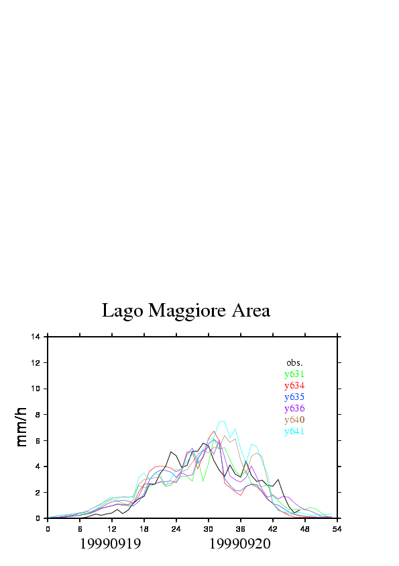
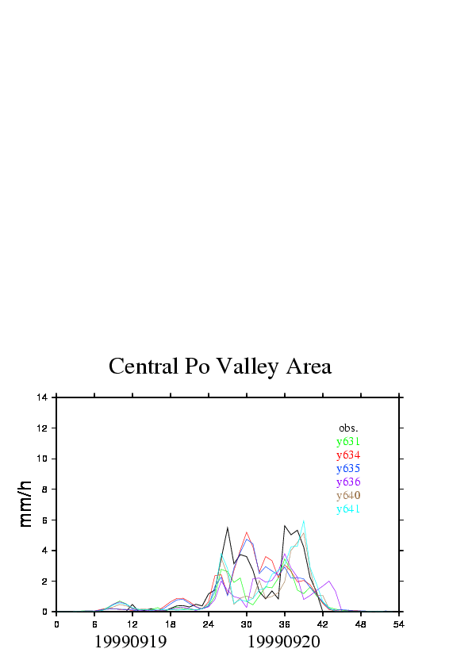
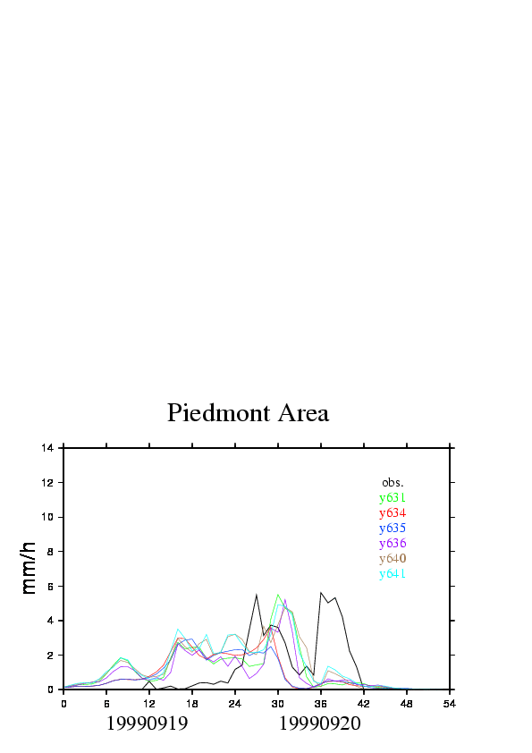
Fig.7: Time evolution of the hourly rainfall over the areas Lago Maggiore, Central Po Valley and Piedmont

4. Wind analysis
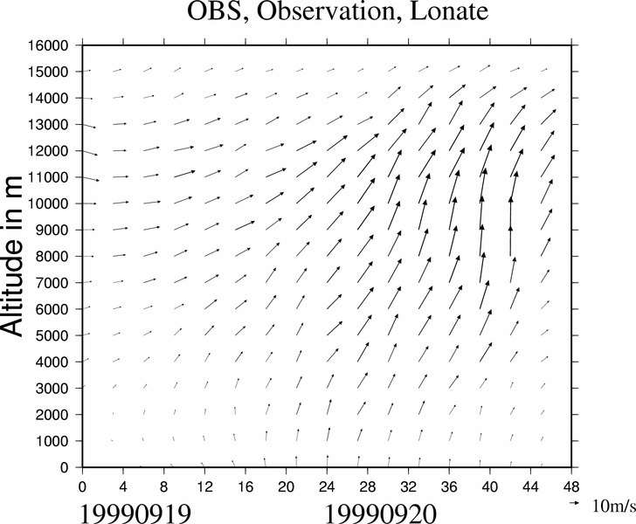
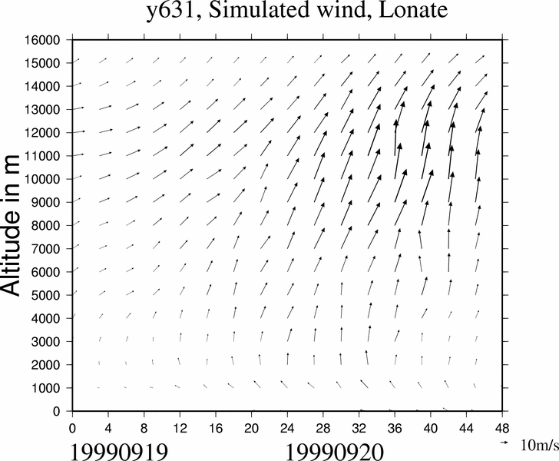
Fig.8(a,b,c,d,f,g) are the time-height cross section of wind of obsevation and simulations at Lonate respectively. In general, observed and simulated wind features compare well. The main differences between observed and simulated winds are that (1) during the 19 September morning, the observed wind direction above 5000 m is westerly or southwesterly by westerly , however, the simulated wind directions are mainly southwesterly; (2) from 2000 UTC 19th to 2000 UTC 20th September, the observed wind below 1000 m is southerly compare with the simulated winds southeasterly and the observed wind intensity is stronger than the simulations at the surface; (3) the simulated upper-leyel jets are overestimated compared with observation after 20th morning September, the simulated jets of the exp.y634 and y635 are close to the observation relatively in all experiments.
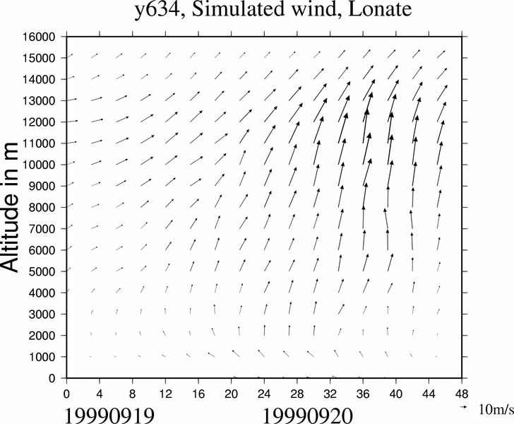
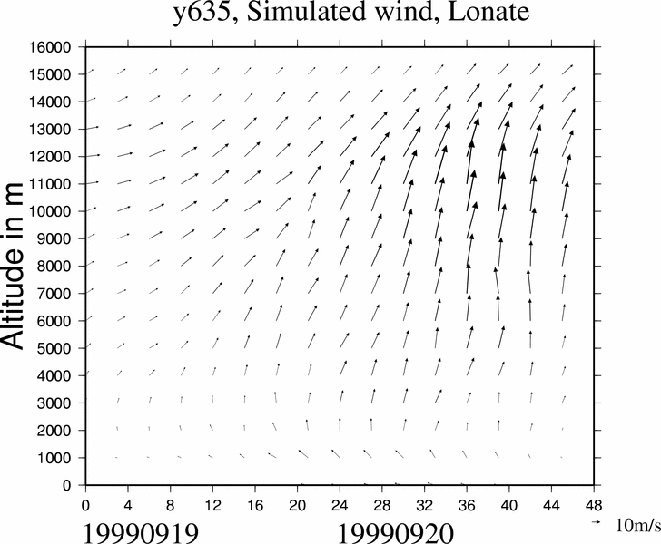
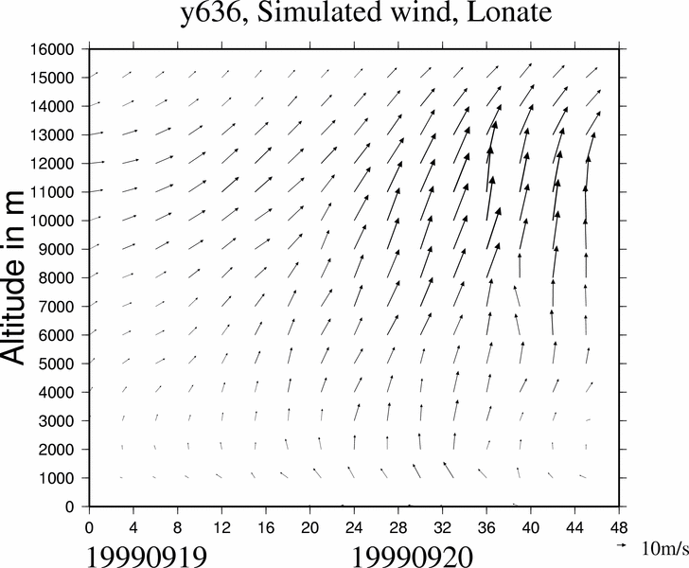
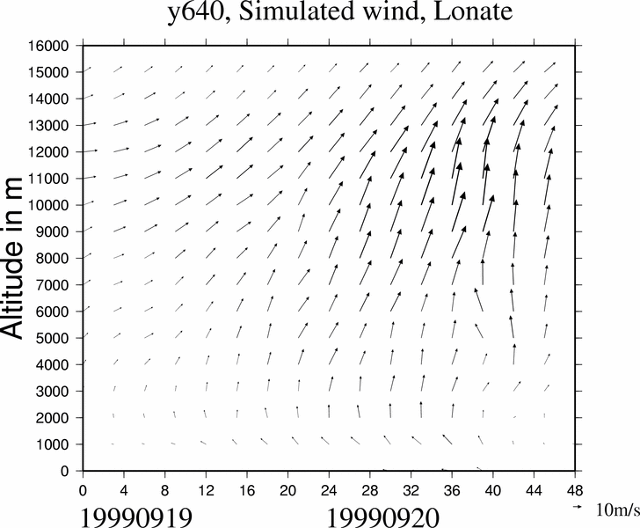
Fig.8: Time-height cross section of wind of obsevation and simulations at Lonate
5.Convection
Fig 9 shows radar-derived precipitation rate from the Monte Lema radar and the corresponding simulations of the convective rain rate. The deep convection occured late on 20th September along the southeast-facing slopes of the Alps (see Fig.9a), no simulations has so strong convective activities in the region as in the observation, rather weak convection on the top of the mountain. The simulated rainfall areas take some shifting in location compare with the observation. The simulations of y636 and y631 are closer the left convection region of observations than other simulations and the y636 is better than y31. However, the simulations of y635 and y634 are closer the right convection region of observation than others and the y635 is better than y634. Taking a overview of all experiments generally, y635 maybe the best experiment in convection simulation for this case.
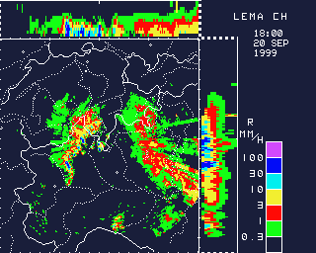
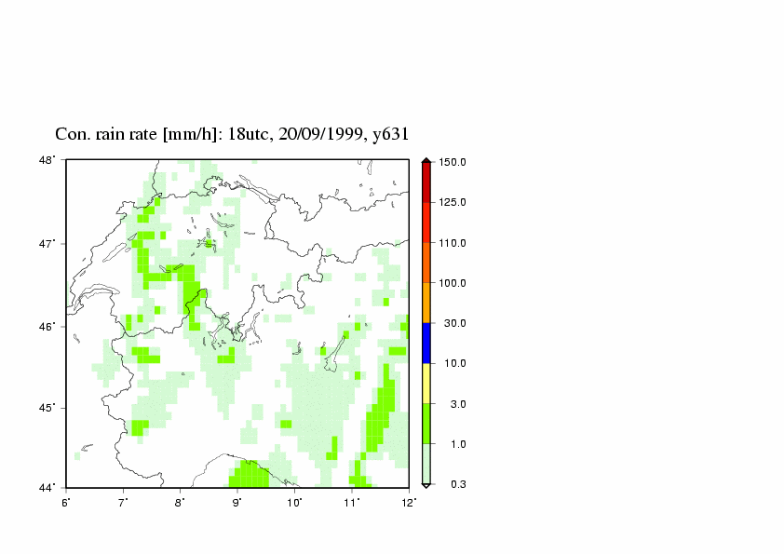
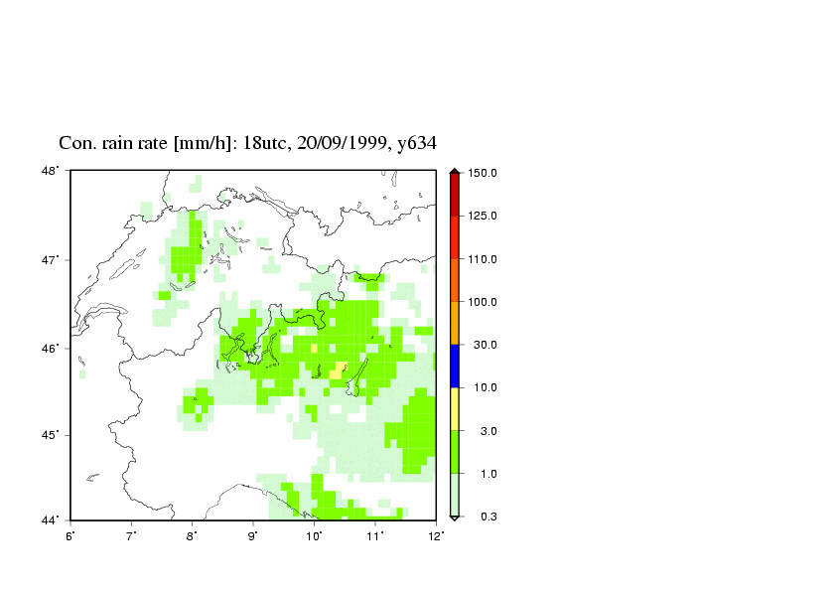
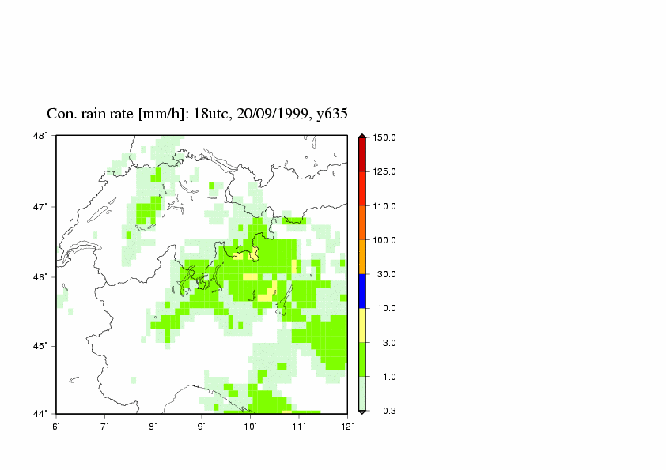
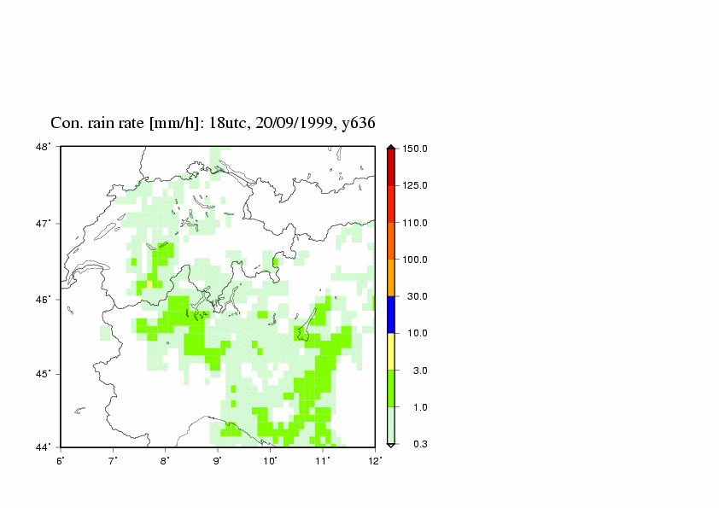
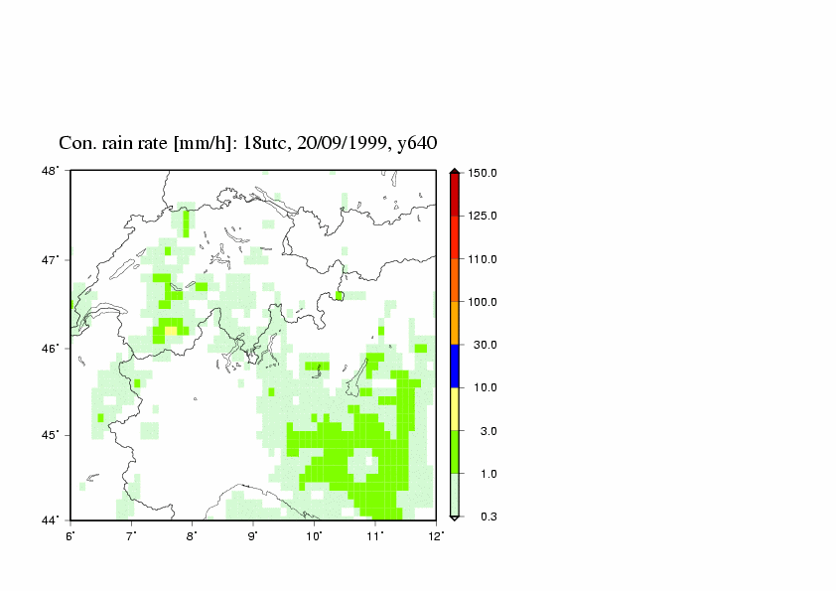
Fig.9: Radar-derived precipitation rate from the Monte Lema radar valid at 18UTC on 20 Semptember 1999 and the simulations of convective rain rate

6. Discussion and summary
Numerical simulations of the MAP IOP2b, the most intense rainfall case in the MAP SOP, are carried out with the ALADIN model by using different physics schemes of cloud and precipitation. The main conclusion of this case study are summarized in the following items:
- In general, the simulations have recognized the major features of the mesoscale structure, but many disagreements with the observation exist, especially in the region with complex topography. Some rainfall differences between the numerical experiments with different physics schemes are found in the simulations.
- The scores of simulation on 20th higher than them on 19th, the exp.y634 is the best experiment in all simulations during the MAP IOP2B.
- The contribution of cumulus and large scale rainfall are almost equivalent for total on the first day. However, large scale precipitation take the major contribution and convective rainfall is secondary to total precipitation on the second day 20th.
- The simulations generalize the rainfall well compared with the observation over Lago Maggiore area in both days. The simulations of other areas are not as good as Lago Maggiore area.
- In most respects, observed and simulated wind features compare well.
- In general, the y635 maybe the best experiment in convection simulation for this case.

There maybe some deficiencies in the ALADIN model to this case simulations. They are following:
- The model has difficulties to simulate the strong rainfall.
- Problems have been found related with complex topography in the simulation, especially in the lee side of the Alps.
- It is not very clear the interaction between schemes of convective parameterization and largescale precipitation in the model.
- The simulated upper-level jet intensities are stronger than the observation and the simulated surfaces wind intensities are weaker than the observation during the second day 20th.
- The simulated rainfall rates are rather weak and their rainfall areas take some shifting in location compare with the observation.

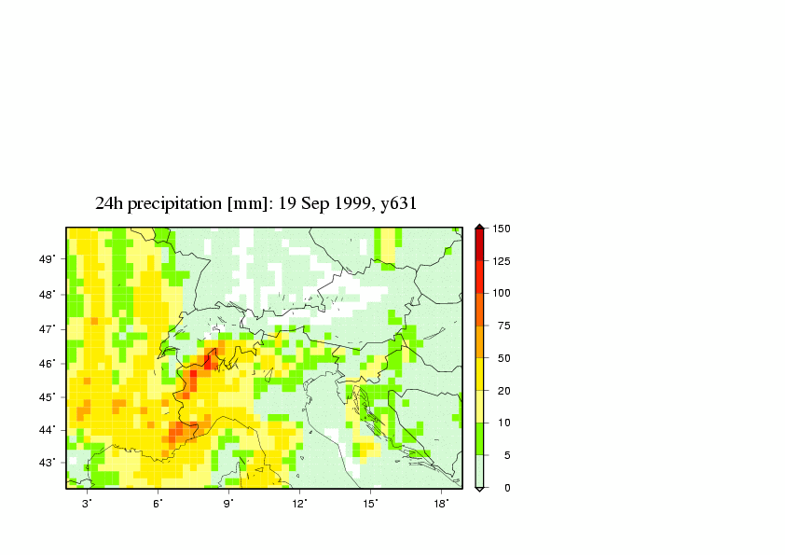
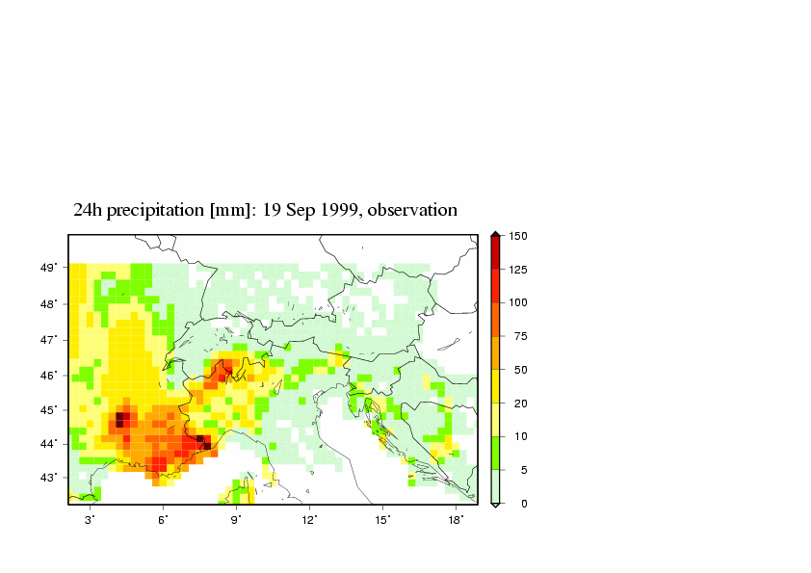
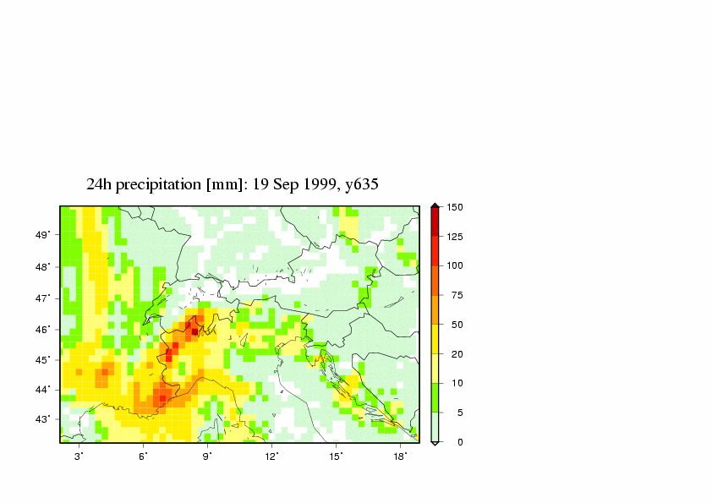
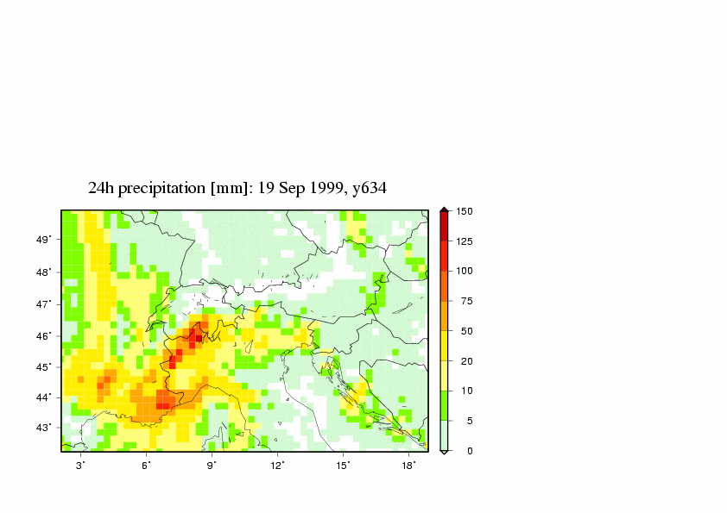
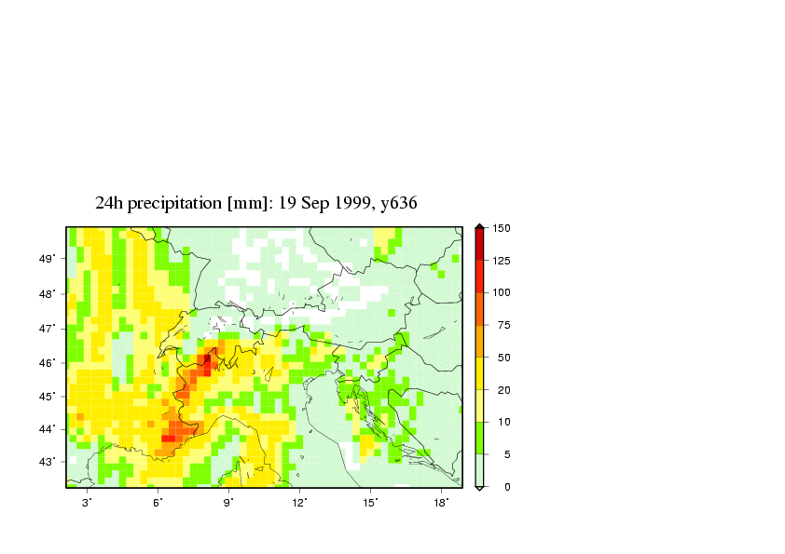
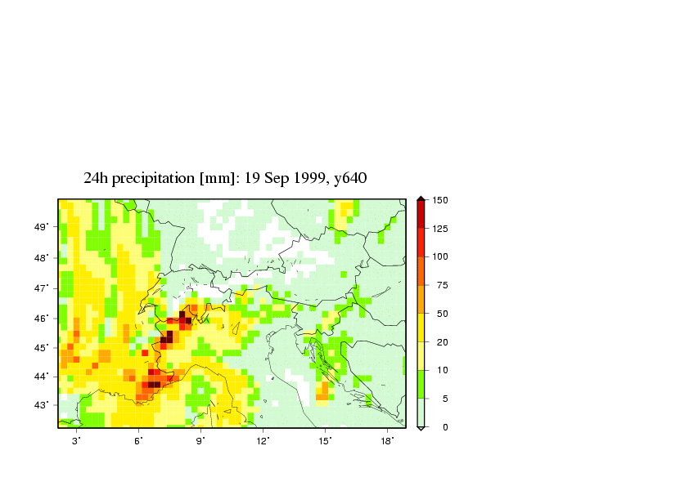
Fig.1: Daily precipitation of observation and the simulations with different experiments on 19th September 1999

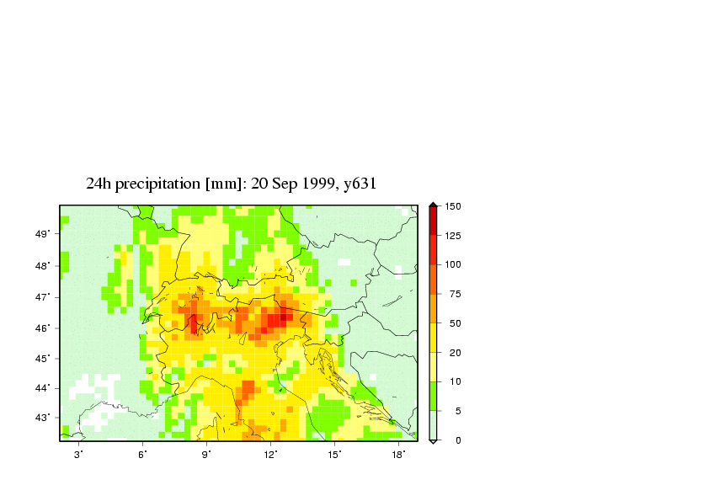
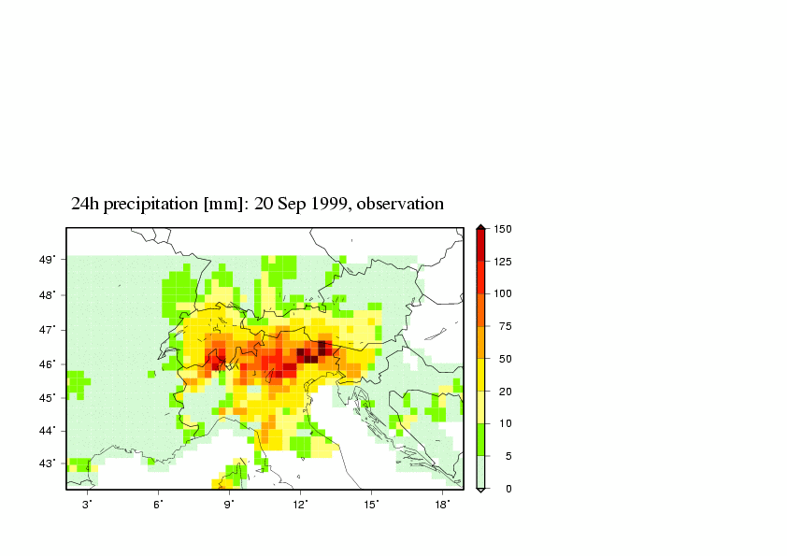
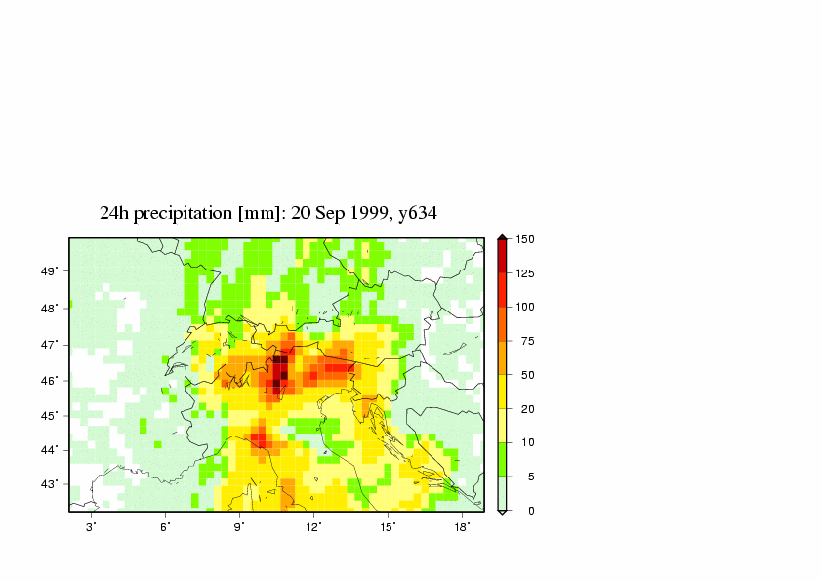
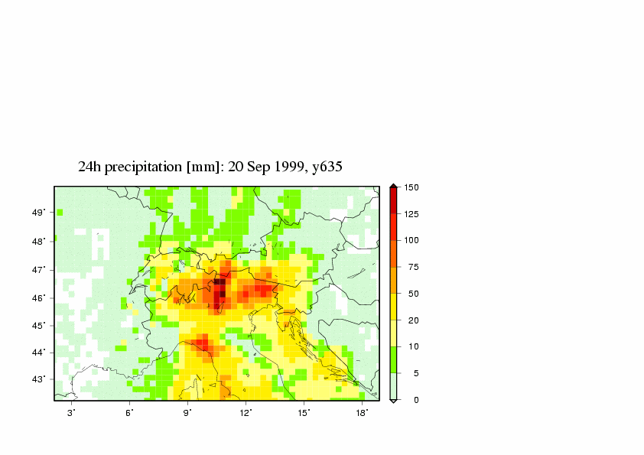
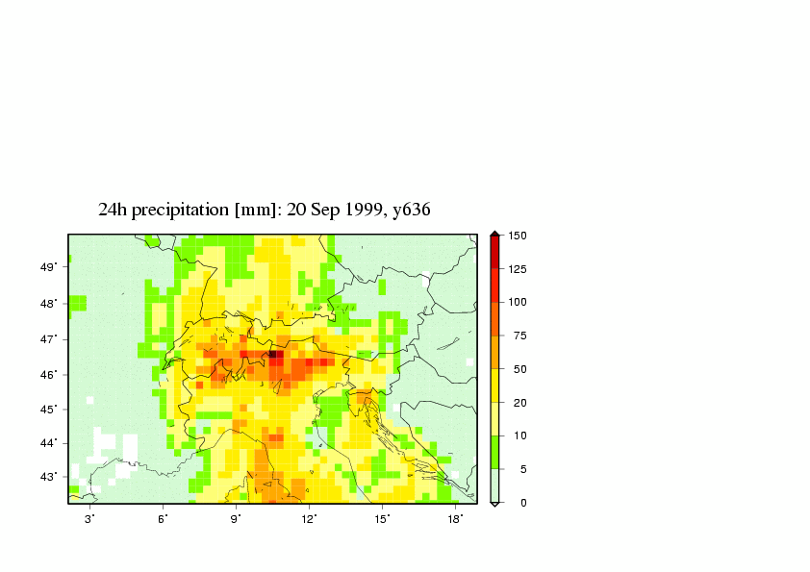
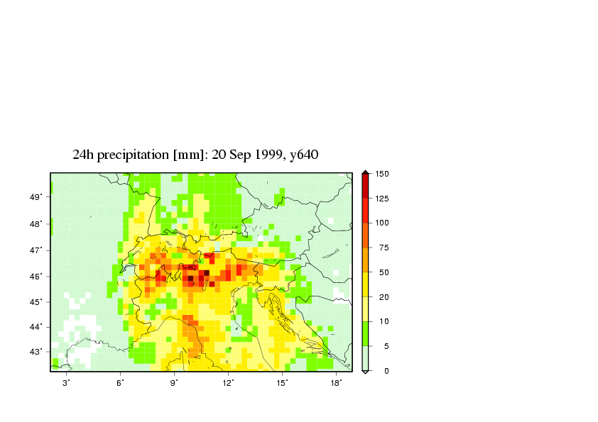
Fig.2: Same as the Fig.1 but for 20th Sept. 1999

