Report on RC LACE Data Manager Activity

For the period of
1st April - 30st September, 2006

Prepared by Sándor Kertész
22th September, 2006

1. Investigation of the feasibility of the exchange and usage of more dense SYNOP data between the LACE Members. The first task is to explore the volume and location of the additional SYNOP data. Then these data will be used in data assimilation experiments this autumn in Budapest (in the framework of the Data Assimilation WG). DM will provide the required data environment for the experiments: collect the necessary SYNOP data for the selected test periods from the RC LACE Members and put them into the DA observation database.

 | Plans (01.04.-31.12.) | Facts (up to now)
Realization | Budapest | Budapest
Estimated efforts | 0.5 PM | 0.25 PM
Contributors | S. Kertész | S. Kertész
Schedule | May + September | May - August

Based on the information provided by the LACE Members I have created a status document about the spatial distribution of non-GTS and GTS SYNOP reports available in the LACE countries. It turned out that there are a significant number of local SYNOP reports in Austria and in the Czech Republic, and to a less extent in Croatia and Slovakia. Therefore it seems that it is worth running DA experiments to see the impact of these additional SYNOP observations. In the DA WG plans these experiments were planned for this autumn in Budapest. I agreed with the DA WG leader and selected a 10-day test period for which LACE Members were asked to provide the necessary local SYNOP observations. For the time being I have only received the data from the Czech Republic and Slovakia. As soon as all the data will be available I will prepare the necessary ODBs to carry out the relevant DA experiments.

2. ODB related activities

- Help in the configuration and usage of ODB and ODB related applications at RC LACE members’ site.
- Co-ordination in the use, visualization and de-coding of observations.
- Preparation and maintenance of a documentation about observation usage in the ALADIN data assimilation system based on CY30. The documentation will contain the description of data formats, data decoding techniques and the involved softwares. The first version of the document will be available by mid-autumn.

 | Plans (01.04.-31.12.) | Facts (up to now)
Realization | Budapest | Budapest
Estimated efforts | 1.5 PM | 0.25 PM
Contributors | S. Kertész | S. Kertész
Schedule | Continuous work | Continuous work

I took part in the organization of the ODB training held at Budapest in June and I helped Sami Saarinen (the author of ODB) to set up his ODB software environment to prepare demos. During this training I got in-depth knowledge of the standalone ODB software package that will serve as a basic ODB tool for each LACE member who intends to use observations.

As for the co-ordination, I am just setting up an ODB mailing list for LACE. I agreed with Sami Saarinen that I would act as an ODB contact point of LACE and he will inform me about the latest releases and developments and help to solve the emerging problems.

The work on the observation usage documentation will be probably shifted to the beginning of the next year since I need more time to work on the observation monitor system than I expected originally.

3. Development and maintenance of an interactive web-based observation monitoring system for the ALADIN variational data assimilation systems (3D-VAR, 3D-FGAT). The system will allow visualizing the location, status and departure statistics of the different observation types for a given analysis date or for a selected set of analysis dates. Continuous extension of the system to include more diagnostic tools and new observation types. First export package of the software will be available in September.

 | Plans (01.04.-31.12.) | Facts (up to now)
Realization | Budapest | Budapest
Estimated efforts | 1.5 PM | 2 PM
Contributors | S. Kertész | S. Kertész
Schedule | Continuous work | Continuous work

I put heavy efforts into this development and a prototype has already been working at HMS. This prototype is based on a set of ASCII files that were created from ODB. I chose this solution because the direct use of ODB from my applications seemed too difficult at the beginning of the developments. As a result, only a limited number of data flags from ODB are available in the system. However, during the 3DVAR/ODB training in June in Budapest I got know the standalone ODB package and I realized the way I could implement a system fully based on ODB. Thus I started to design and develop an altered system that could use ODB directly and exploit the information content of various observation flags by implementing new visualization and statistics types. Due to this extra work the first version of the system will be available later than I originally expected, probably only at the beginning of the next year.

The structure of the system can be seen on Figure 1. Some of its components are already working in the prototype version. This prototype version is able to handle given analysis dates or a series analyses dates. Statistics are computed for report and data status, and for observation-guess and observation-analysis departures. As for the graphical products, various types are available: maps (2D, 3D), profiles, time-series, time-height cross sections, observation usage charts. Batch mode runs and data browsing through a web interface are both possible. Figure 2 illustrates the graphical capabilities of the system.

The full system, apart from the direct ODB usage, will be completed with many new advanced features:
- new graphical (histograms, time distribution charts) and statistical (J_{o} values, residuals) types
- automatic report generation based on user-specified criteria
- separate monitoring of each SYNOP and TEMP stations to perform local blacklisting that can be used in the local data assimilation runs
- capability for the easy comparison of data assimilation experiments.

Compute statistics (C++)
ODB
ODB
ODB
ODB
Rendering (Perl, GMT, ODB applications)
Web interface
(PHP, on-the-fly visualization)
Automatic report generation
Batch mode runs (for research)
Local blacklisting information
Set of ASCII files
Data assimilation

Figure 1. The structure of the observation monitoring system

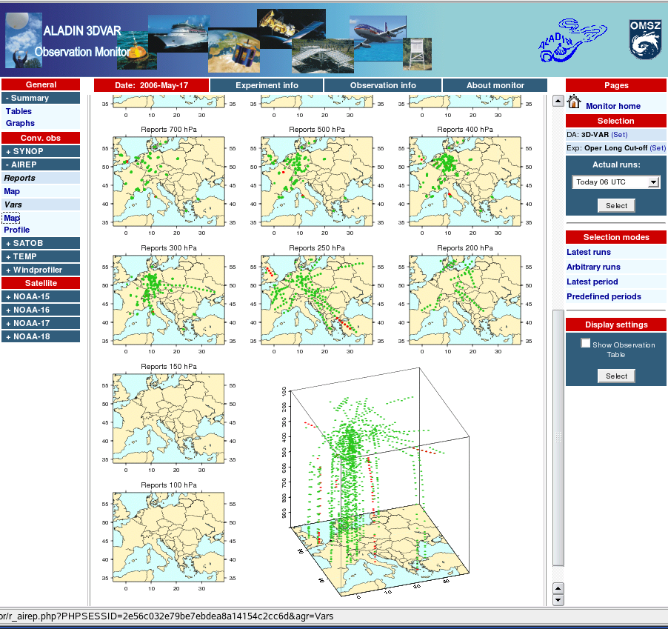
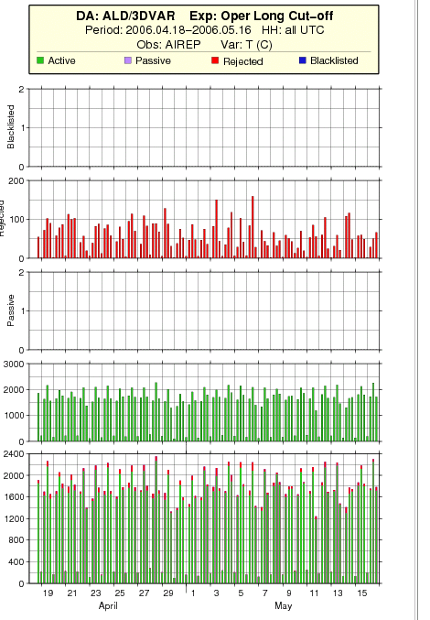
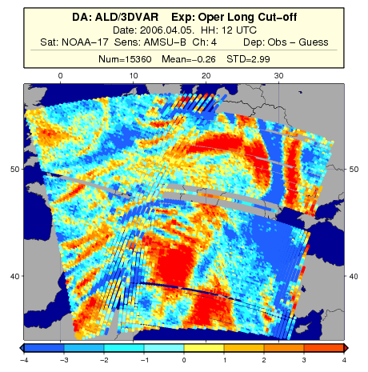
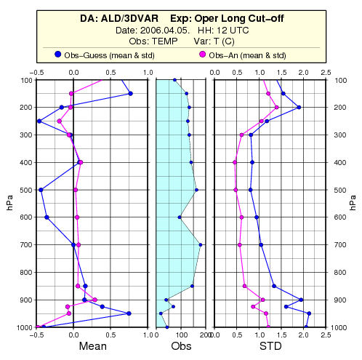
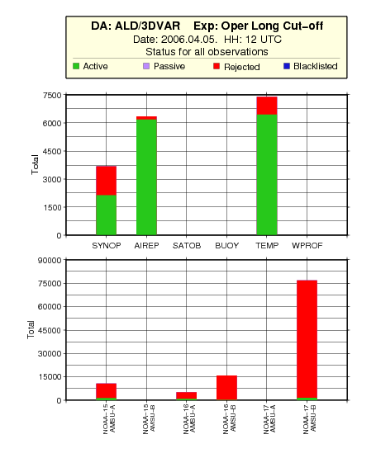
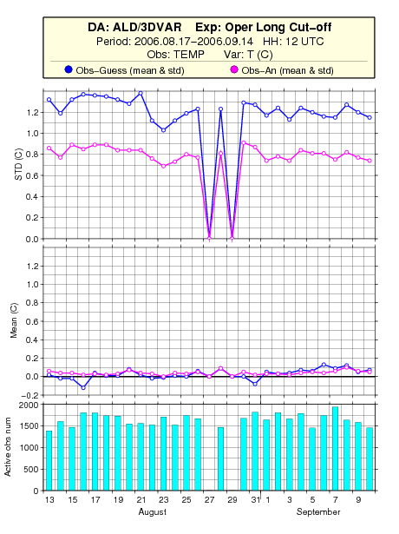

Figure 2. Snapshot of the web interface and some of the graphical products of the observation monitoring system

4. Acting as Technical Co-ordinator for the ECMWF Special Project for "Coupling of ALADIN and AROME models to boundary conditions from ECMWF and ERA model data". The aim of the project is the preparation of ECMWF LBC files for ALADIN and AROME at ECMWF's site. The main task of TC is to provide a suitable script environment and users guide for the preparation of the required LBCs at ECMWF’s site. This activity is closely related to the work of the Data Assimilation and Predictability WGs

 | Plans (01.04.-31.12.) | Facts (up to now)
Realization | Budapest | Budapest
Estimated efforts | 1.5 PM | 1 PM
Contributors | S. Kertész | S. Kertész
Schedule | Summer 2006 | Spring 2006

I have created a comprehensive users guide for beginners about how to work on the ECMWF HPCF system. I have also created demo scripts on HPCF to produce BCs for ALADIN using the T511, T799 deterministic IFS forecasts and ERA-40 re-analyses. The structure and the usage of the scripts are explained in detail in a separate document. Both documents are available at the RC LACE web site (please see the section: Private->Local Manuals). The ongoing activity related to this project is the porting of the scripts to the new supercomputer of ECMWF, the preparation of a demo script to produce BCs from the EPS forecasts and naturally the upgrade of the documentation.

