LACE Steering Committee meeting
Budapest, 6-7 September 2012

First information

VENUE

The meeting will be held in the headquarters of the Hungarian Meteorological Service.

Országos Metetorológiai Szolgálat (OMSZ)

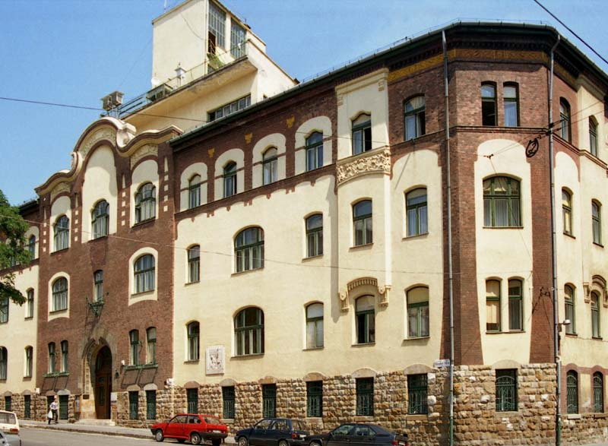

Address: 1024 Budapest, Kitaibel Pál utca 1
www.met.hu

HOTEL LOCATION

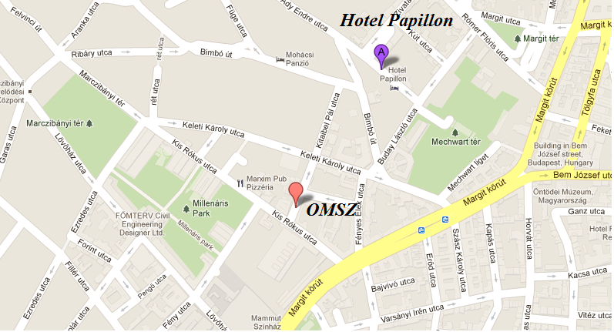

ACCOMODATION
Accommodation is possible in Hotel Papillon where we have 14 rooms booked for the 6 September. It is 36 EUR/night (ONLY 5 single room) and 46 EUR/night (double room) including breakfast. The hotel is 10 minutes walking distance from OMSZ.

You have to reserve your room until the deadline of 31st August in the hotel. Please refer to OMSZ when booking your room. In case you would like to stay longer, please inform Roger Randriamampianina as soon as possible.

http://www.hotelpapillon.hu/

TRANSPORT IN BUDAPEST

Some useful travel hints:
At most of the underground stations you can find a board with a map of Budapest with street names and public transport lines. In Hungarian, ‘ut’ or ‘utca’ means ‘street’, ‘ter’ means ‘square’. Please note that in Budapest there are two types of buses: faster ones are marked by E(express) letter (173E).
You can find useful information on the homepage of the Budapest Transport Company:
http://www.bkv.hu/en/

I. From the Airport to your hotel

Some useful travel hints:
At most of the underground stations you can find a board with a map of Budapest with street names and public transport lines. In Hungarian, ‘ut’ or ‘utca’ means ‘street’, ‘ter’ means ‘square’. Please note that in Budapest there are two types of buses: faster ones are marked by E(express) letter (173E).
You can find useful information on the homepage of the Budapest Transport Company:
http://www.bkv.hu/en/

I. From the Airport to your hotel

Budapest international airport is Budapest-Liszt Ferenc Airport2, which has two terminals (Terminal 2A and 2B), are located quite close. Terminal 2A is Schengen-Airport, therefore you will most probably arrive there, because the Ferihegy 2B is the non-Shengen Airport.

- The easiest method to get to your hotel, and this is what we strongly recommend to those who come by plane, is to take a shuttle bus called AIRPORT MINIBUS. It is a 0-24h service which costs about 3200 HUF/person (roundtrip ticket 5500 HUF) within the territory of Budapest.
No tipping needed. You just give them your address and this service takes you to your destination. Check-in desks for the Minibus service are located in the baggage reclaim areas, and in the arrival hall, where you can also find exchange bureaus.
More information: http://www.airportshuttle.hu/en

- Another possibility is the FIX-PRICE TAXI. For details, see the homepage: http://www.bud.hu/english/passengers/access_and_parking/by_taxi

- Another possibility is PUBLIC TRANSPORT. One ticket costs around 300 HUF. In general, whenever you change from one vehicle to the other, you should validate a new ticket. You can change lines within the metro network (metro lines 1, 2 or 3) with the same ticket. You can buy cheaper tickets in coupon book or card for couple of days.
In any case, first you should take bus No 200E from the airport, to the direction ‘Kobanya-Kispest’. At the ‘Kobanya-Kispest’, the terminal of bus No 200E, take the underground line M3 (this is its terminal).

To Papillon Hotel, take off at the station ‘Nyugati pályaudvar’ and take the tram 4 or 6 in the direction ‘Széll Kálmán tér’. This tram takes you on the Margit körút. Take off at the station ‘Mechwart liget’. You can walk from ‘Mechwart liget’ to your hotel.

II. From the train station to your hotel

If you arrive by train, you may arrive at two railway stations.

1) From Budapest-Keleti Train Station
From here, you should take the underground line M2, in the direction of ‘Deli pu.’. Take off at ‘Szell Kalman tér’. From here, take the tram 4 or 6 until ‘Mechwart liget’. Take off the tram, and you can walk from here to your hotel.

2) If you arrive to the other railway-station (Budapest-Nyugati Train Station)

Take the tram 4 or 6 in the direction ‘Széll Kálmán tér’. This tram takes you on the Margit körút. Take off at the station ‘Mechwart liget’. You can walk from ‘Mechwart liget’ to your hotel.

TOURIST INFO
http://www.gotohungary.co.uk
http://www.budapestinfo.org

