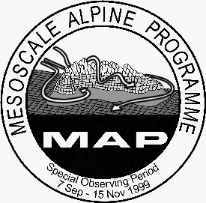


MAP D-PHASE
A Forecast Demonstration Project within WWRP

Call for Papers and Second Announcement of the
First MAP D-PHASE Scientific Meeting
6-8 November 2006, Vienna, Austria

MAP D-PHASE (Demonstration of Probabilistic Hydrological and Atmospheric Simulation of Flood Events in the Alpine Region) aims at demonstrating improved understanding and state-of-the-art forecasting of processes related to heavy precipitation induced by the Mesoscale Alpine Programme (MAP). As a Forecast Demonstration Project (FDP) of the World Weather Research Programme this will be realised in true forecast mode and including all components of an end-to-end forecasting system and with a pre-defined evaluation protocol. For the first D-PHASE Meeting, contributions are invited dealing with all components of this forecasting system, showing previous experience with parts of, or the entire forecasting chain, plans for the demonstration period and specific technical or conceptual achievements. Topics include
- Probabilistic atmospheric and hydrological modelling
- Perturbations in high-resolution atmospheric and hydrological models
- New generation of high-resolution NWP models
- Hydrological modelling and verification
- Verification of ensemble forecasts
- Object oriented and grid point verification
- Nowcasting related to heavy orographically induced precipitation
- Cost/loss analysis and societal impact
- Needs and experience of forecasters and (end) users
- Case studies in heavy precipitation and flood forecasting

Call for papers:
Contributions dealing with the topics listed above are welcome. Presenters are asked to submit a short abstract via the online submission form at

http://www.meteorologie.at/dphase_call_for_papers.htm

Deadline for abstract submission is 10 July 2006

Further Information & Contact:
More details including venue and hotel information will shortly become available at the websites: http://www.map.meteoswiss.ch/map-doc/dphase/dphase_info.htm and http://www.meteorologie.at/dphase_info.htm (website of the Austrian Meteorological Society) or contact by email: manfred.dorninger@univie.ac.at

