Request for Contact points and forecast data provision for the SRNWP- Verification Programme

Introduction

The Met Office was approved as the responsible member for the EUMETNET SRNWP Verification programme agreed at the 35th EUMETNET council meeting.

The first deliverable D1 is an intercomparison of the SRNWP Consortia reference models as detailed at ANNEX2. Currently the Met Office processes gridded model precipitation forecasts from 5 centres, supplied in GRIB1 via ftp, and verifies these against British Isles radar composite estimates. This letter is to request confirmation of

- Contact points for each consortia

  - Met Office
    - Clive Wilson
    - Marion Mittermaier, metoffice.gov.uk

  - ALADIN
    - Joël Stein, meteo.fr

  - COSMO
    - Francis Schubiger, meteoswiss.ch
    - Ulrich Damrath, dwd.de

  - HIRLAM
    - Carl Fortelius, fmi.fi

  - ALADIN-LACE
    - Dijana Klaric, cirus.dhz.hr

- Identification of the forecast data providers.

I have nominated the contact persons below as responsible for the technical provision of the data feeds, except where known otherwise. If there are more suitable names for the responsible person please let me know.

  - NAE 12km Unified Model – Met Office
    - Responsible person – Rob Darvell, metoffice.gov.uk

  - ALADIN- France – MeteoFrance
    - Responsible person - Joël Stein
  - COSMO – DWD
    - Responsible person – Ulrich Damrath
  - HIRLAM reference – FMI
    - Responsible person – Carl Fortelius
  - ALADIN-LACE - may be added later

- Indication of participating verification centres besides the Met Office

At present only the Met Office has agreed to verify all the forecasts. The intercomparison would benefit from another centre verifying them independently, as proposed in the programme.

Definition of the required parameters, forecast steps and formats

Parameters
- Mean sea level pressure
- 2m Temperature
- 2m relative humidity
- 10m winds
- Total precipitation ( snow and rain, convective and stratiform combined)

Domains
Model native grid domain minus extension zones

Forecasts
00 UTC

Steps
+00, +06, ... , +42, +48
Precipitation accumulations +00 to +06, +06 to +12,….., +42 to +48

Format

GRIB1

Proposed method of data transfer

Forecasts will be exchanged monthly in a tar file. The initial request is for June 2009. The preferred method of transfer is via ftp “pull” by the Met Office. Please advise Rob Darvell, metoffice.gov.uk on technical details how to access servers.

Monthly tar files of forecasts for January through to July 2009 will be required after the successful verification of the June 2009 data. Please can you prepare these.

ANNEX2

Technical details of an operational model intercomparison (Deliverable D1)

A2.1 Models to be compared
The verification and the comparison are principally open to all the operational versions of the ALADIN, HIRLAM, COSMO and Unified Model of the Participating Members.
In this first step, the model intercomparison will be limited to:
- The North Atlantic - Europe (NAE) version of the Unified Model run by the Met Office
- The HIRLAM reference version, as run by the Finnish Meteorological Institute
- The ALADIN-France model run by Meteo-France and possibly an ALADIN-LACE reference run so that ALADIN products may be compared over a larger domain
- The European area version of the COSMO model as run by Deutscher Wetterdienst (DWD).
Only the 00 UTC forecasts will be verified. The forecast range will be 48 hours. The 12 UTC forecasts may be added later.

A2.2 Forecast delivery
The fields of the parameters to be verified will be sent to the Responsible Member at the end of each calendar month. within 48-hour of the nominal data time. This is to allow the verification tasks to be included within operational schedules.

Forecast fields of the parameters to be verified will eventually be delivered in the format of the common model output that the EUMETNET Interoperability Project will define. The interface programme will be developed by the Project Interoperability. However in the interim it is proposed to use GRIB1 format.

The model outputs for all the parameters to be verified (precipitation excepted) are requested from T+0 to T+48h, at 6h intervals. For precipitation, accumulated precipitation for the 8 time intervals (+0/+6), ... , (+42/+48) are needed.

A2.3 Verification domain
For model intercomparison, verification will be made over the largest possible common domain of the participating models, excluding lateral boundary and extension zones.

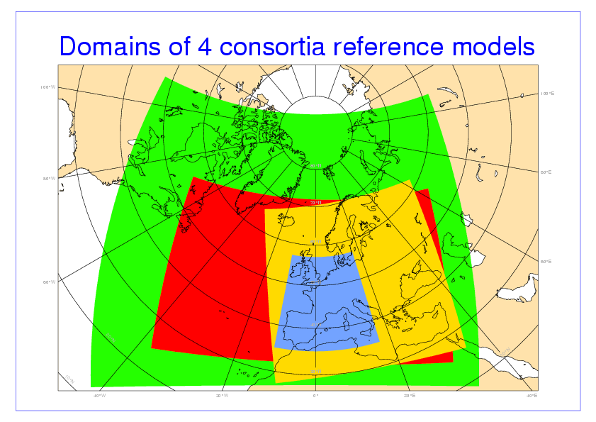

A2.4 Types of observation to be used
The forecasts will be compared against SYNOP station reports. In addition, radar estimates of surface precipitation will later be considered as an alternative or complement to SYNOP station reports of precipitation totals. The use of the radar composites developed for operational production in the frame of the OPERA Programme will be the preferred choice.

A2.5 Verification methods

Each verifying centre will use its own package. It will be a mandatory requirement that the methods and observations used, including the quality control employed, will be documented and provided to all participating centres. As far as is practical, differences between methods and approaches will be minimised by agreement between the centres. Where there is a reasonable choice between alternative approaches comparison of the verification of the same model forecast by the different centres may yield important insights in the strengths of each choice.

The model forecasts (apart from precipitation) will be projected onto the synoptic stations’ locations. This may be nearest grid point or by bilinear interpolation. Height adjustments will also be used. Precipitation forecasts, radar estimates and precipitation reported in SYNOPs will be area-meaned to a common coarsest resolution rotated latitude-longitude grid.

A2.6 Scores and forecast variables to be verified
- For the variables mean sea level pressure, temperature and wind speed, the scores to be produced are bias, root mean square error and skill score (with respect to persistence).

- For the norm of the wind vector difference, the scores to be produced are the root mean square error and the skill score (with respect to persistence)

- For all the above variables, the scores will be computed every 6 hours, i.e. for +00, +06, ... , +42, +48.

- The ECMWF high-resolution analyses will be used for persistence in order to allow a fair common reference.

- For precipitation, the scores to be produced are frequency bias, equitable threat score (ETS), log-odds ratio and the Peirce (Hansen-Kuipers) skill score against persistence.

- 6-, 12- and 24-hourly accumulated total precipitation will be verified.

Geographical distributions and time-series, as well as monthly, seasonal and yearly means will be produced for all the scores of all the parameters verified.

It would also be desirable, for the variables mean sea level pressure, temperature, wind speed and norm of the wind vector difference, the monthly means of the bias and root mean square error will be computed at each individual station for the hours +36 and +48.

A2.7 Dissemination of results
All the verification results of the model intercomparison will be published on the EUMETNET portal under password protection.

Participating Members to this Project will be entitled to receive the password.

A2.8 Addition of other models including high resolution models

After stage 1 has been established and the verification results and methods reconciled, it is straightforward to expand the comparison to include more centres’ models (deliverable D2). This could either be through an expanded exchange of model forecasts between the additional centres and the verifying centres, or, more likely, a comparison done within consortia of their models against the reference model of the 4 consortia. This will not always be possible due to the limited regional domains of some models, as there will be no common area.

