New findings about the orographic ‘chimney problem’ in ALADIN-NH dynamical core and tentative conclusions for the code policy

J.-F. Geleyn, 10/10/05

I) Summing up past discoveries:
The so-called ‘chimney problem’ (unrealistic vertical velocities at the top of mountain ranges) has been with us since the beginning of the work on the NH version of ALADIN. It did not receive too high priority though, because there were many other problems to be solved more urgently (and which were indeed solved).
When it became one of the prominent remaining problems, it was diagnosed as a consequence of some interaction between the semi-Lagrangian algorithm, the choice of ‘d’ as vertical-velocity-related prognostic variable and the bottom boundary condition (kinematic rule). This problem is hereafter referred to as “SL chimney problem”. Out of this ‘triangle’ of interacting points, two solutions emerged to cure the most evident manifestation of the problem:
- the LGWADV advective treatment of ‘w’ rather than ‘d’ in the semi-Lagrangian scheme prepared by Chris and extended by Jozef to d3 and d4 baseline prognostic variables for the non-extrapolating 2TL SL scheme;
- the LRDBBC truly semi-Lagrangian handling of the bottom boundary condition prepared by Radmila and Petra, working for any ‘d’ and any SL option.
Both methods seemed to cure the problem, each one having its advantages and disadvantages. But then Jan found out that there was a residual ‘chimney signature’ in the Eulerian case. Thus a new source of ‘chimney patterns’, independent on the advection scheme, was discovered. This chimney disappeared when horizontal diffusion was switched off. For this reason, this problem is referred to as “HD chimney problem”. The HD chimney case was analysed by Pierre using the linear model: it was shown that when casting equations with vertical divergence, the horizontal diffusion operator creates a chimney while this is not the case if equations are cast with vertical velocity. But this result was not correctly interpreted. Instead of noticing that the hook lies once more in the consistency between the horizontal diffusion application and the kinematic rule, easily controlled when working directly everywhere with ‘w’, it was (wrongly) believed that the problem does not happen when the semi-Lagrangian advection of ‘w’ is used (while the spectral part still uses a divergence form).
Radmila confirmed the misinterpretation and showed that the problem was intrinsic to the horizontal diffusion being applied on the spectral space variable ‘d’ without doing simultaneously anything on the bottom boundary equation to restore the validity of the kinematic rule on diffused fields. Jan further showed that it would be possible to overcome this difficulty by working in the space of spectral coefficients, but that this involved replacing (for some part of the computations) the transform method by that of the interaction coefficients. Since such a step would involve a kind of mini-revolution in the IFS/ARPEGE code, it was decided to first look at potential alternatives. Meanwhile, the belief that the ‘HD-chimney problem’ did not exist with the semi-Lagrangian advection of ‘w’ apparently continued to thrive.
In between, the SLHD (semi-Lagrangian horizontal diffusion) method has become mature enough for operational use (hydrostatic or non-hydrostatic). In its ‘purest’ version it would replace all spectral horizontal diffusion by an internal modification of the semi-Lagrangian calculations and would thus automatically become the best candidate to eliminate the ‘HD-chimney problem’, by transferring it to the already solved basic ‘SL-chimney syndrome’. However SLHD cannot work properly without two remaining spectral horizontal diffusion computations (so-called ‘reduced’ and ‘supporting’) and the question of its potential for solving the ‘HD-chimney problem’ was therefore an open one.

II) The very recent study by Miklos and Radmila:
This study was performed in the 2D vertical plane model using the non-linear non-hydrostatic mountain wave case. Six tests were performed that are recapitulated in the table below:
- A = no diffusion => no chimney
- B = spectral diffusion + LGWADV => strong chimney
- C = spectral diffusion + LRDBBC => strong chimney
- D = grid-point-only SLHD => hardly any chimney
- E = SLHD (including reduced + supporting HD on all variables) => moderate chimney
- F = like E, except no supporting diffusion on ‘d’ => very weak chimney

 | A | B | C | D | E | F
Experiment N° | R010 | R013 | R012 | R018 | R016 | R019
Advection of ‘w’, LGWADV | - | X | - | - | - | -
Semi-Lag. BBC, LRDBBC | X | - | X | X | X | X
Classical sp. HDIFF | - | X | X | - | - | -
Grid-Point SLHD | - | - | - | X | X | X
Reduced sp. SLHD | - | - | - | - | X | X
Supporting sp. SLHD (D,ζ) | - | - | - | - | X | X
Supporting sp. SLHD (d) | - | - | - | - | X

General experimental set-up

Geometry:
- regular grid in the y/z plane : δy=200m, δz=300m
- C+I zone of 128 points, I zone of 14 points
- quadratic grid
- 100 vertical levels, sigma coordinate

Orography:
- bell-shaped mountain
- height = 1000 m
- half-width = 1000 m
- position = 32nd gridpoint

Atmosphere:
- Temperature profile of constant Brunt-Vaisala frequency = 0.01 Hz, until the tropopause
- Isothermal above the tropopause - 30 levels
- Sea level temperature = 293 K
- Sea level pressure = 101325 Pa
- V wind = constant 10 m/s

The corresponding figures are appended at the end of this text

III) Some tentative conclusions:

1) Using SLHD should be recommended for NH runs
If one is interested in suppressing quasi totally the ‘chimney syndrome’, the most relevant combination is surely the one of experiment F (available by namelist choices since Cy29t2 and soon automatic in Cy30). In the AROME-type cases, SLHD also offers the advantage to allow some smoothing to be applied on the prognostic variables staying in grid-point space (moisture). Therefore in the IFS/ARPEGE/ALADIN software basis, the SLHD functionality is expected to become a key ingredient for meso-scale applications.

2) About LRDBBC and LGWADV functionalities
As mentioned above, the LGWADV functionality consists in using the ‘w’ variable for the SL computations, instead of a vertical divergence form ‘d’. This option has been initially proposed, and coded, for solving the SL-chimney problem, before the alternative functionality LRDBBC was found and proposed.
The LRDBBC option is much simpler in terms of code, since it only involves (very locally) the formulation of the lower BBC. The LGWADV option is more heavy, though it already contains a simplification (or approximation): the half-level trajectories for ‘w’ are obtained by vertical interpolation of full-levels trajectories instead of being obtained by a complete trajectory calculation. An un-approximated version of LGWADV would be even more heavy not only in terms of code, but also in terms of computational cost, due to the necessary duplication of trajectory computations.
Both options LRDBBC and LGWADV appear to be successful in solving the specific SL chimney problem. There is therefore an uncertainty about the relevance of keeping these two schemes side to side in the code, and the simpler LRDBBC code should logically be privileged at first glance. However, it is agreed with Jozef that it is too soon to take the decision to remove the LGWADV option from the code because, so far, this option is the only available one allowing a correct modelling of so-called ‘bubble test cases’ at metric resolution. In view of further work on bubble cases, the LGWADV option should be kept in the code, at least as a benchmark option for comparison with possible other proposals, or as a safety solution if no other cure is ever found for problems encountered at metric scales.

3) Code interactions for SLHD and LGWADV functionalities
The SLHD scheme (which, let us recall it, consists in a flow-dependent local modification of SL interpolators) is currently coded only for modifying full-levels interpolators, and therefore this scheme is only able to act on ‘d’ variables, and not on the (half level) ‘w’ variable. Extension of SLHD to the LGWADV scheme would thus require a further development, which would rise open issues: (i) would it be possible to build this extension on the current approximated LGWADV scheme, or would the implementation of the un-approximated scheme become a compulsory step for this extension? (ii) is the extension of SLHD to LGWADV a purely technical code matter, or might it lead to hidden problems?

4) Code interactions for LGWADV (used with ‘d3’ and ‘d4’ variables) and time schemes
Using the LGWADV scheme together with a ‘d’-type spectral variable (d0, d3 or d4) requires a transformation from the explicit guess w*(t+dt, F) to the d-type variable at the end of the grid-point computations. When the only viable spectral variables d3 or d4 are used, this transform in turn requires the knowledge of similar explicit guesses for every prognostic variable since the explicit guess of δφ is needed. Although obviously possible from the scientific point of view, this is not easy to perform in general, due to the code architecture of the SL-SI scheme, because for each variable, the explicit tendency is in general mixed with linear terms to be interpolated, for efficiency reasons. However, in case of a pure (i.e. non-decentred) 2-TL non-extrapolating (2-TLNE) time scheme, the transform does not rise any problem, specifically because with this scheme, there are no linear terms to interpolate (and therefore no mixture of terms). This is the reason why the LGWADV scheme is coded only for the SL 2-TL NE scheme. The extension of LGWADV to other time-schemes would be very cumbersome from the code point of view. This is partly why it was decided to prefer the development of LRDBBC. Then there was no time and also not enough motivation to complete the development of LGWADV to work with any SL time-scheme.

5) Final remarks
One can see that very likely there is no serious blocking point due to scientific reasons for extending the scope of the LGWADV scheme. But the full blown LGWADV option would become technically and algorithmically quite heavy.
As resulting from the above, the LGWADV option should be maintained in the code for a limited amount of “research” options (SL 2-TL, without SLHD, …) to serve as a benchmark, but it should not be a-priori considered as an operational target. From this point of view, efforts in trying to improve the current formulation (with ‘d’ variable in grid-point) at metric scales should be privileged.
In addition, the serial of tests reported above seem to prove with near certainty that the remaining bubble issue (anyhow with a small impact compared to the ‘chimney’ one) is completely decoupled from the ‘chimney’ one (it happens over a flat surface, while the link between orography and ‘chimney’ is now fully explained). Since the ‘chimney syndrome’ happens in real cases and also at scales corresponding to the ALARO and AROME ones, it seems that our forthcoming tests would benefit from concentrating as soon as possible on the above proposed ‘F-solution’, namely in real-cases and pre-routine applications with these tools.
Experiment A

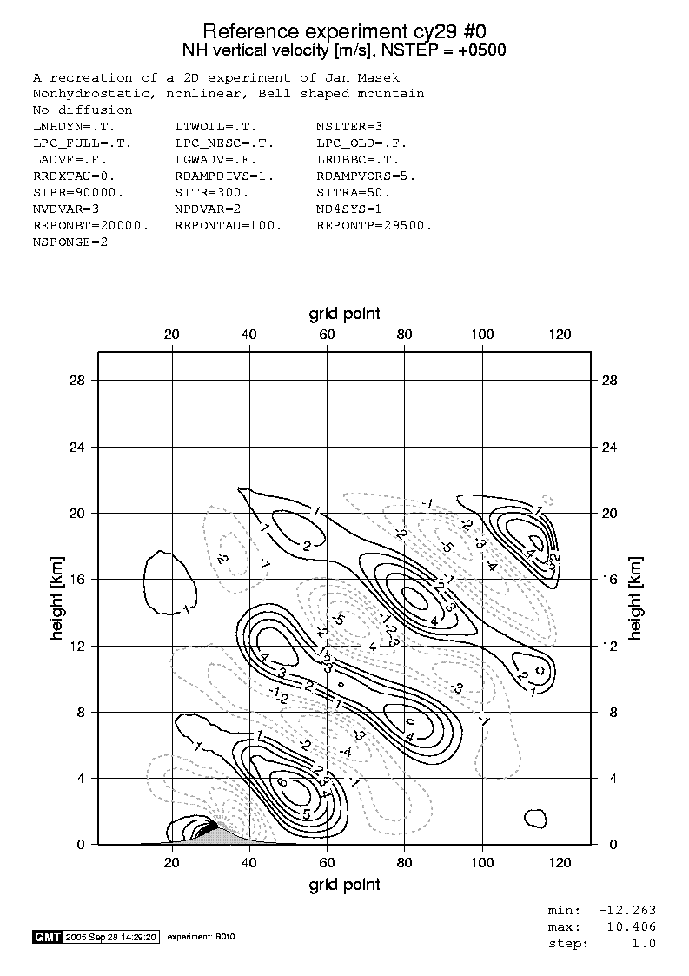
Experiment B

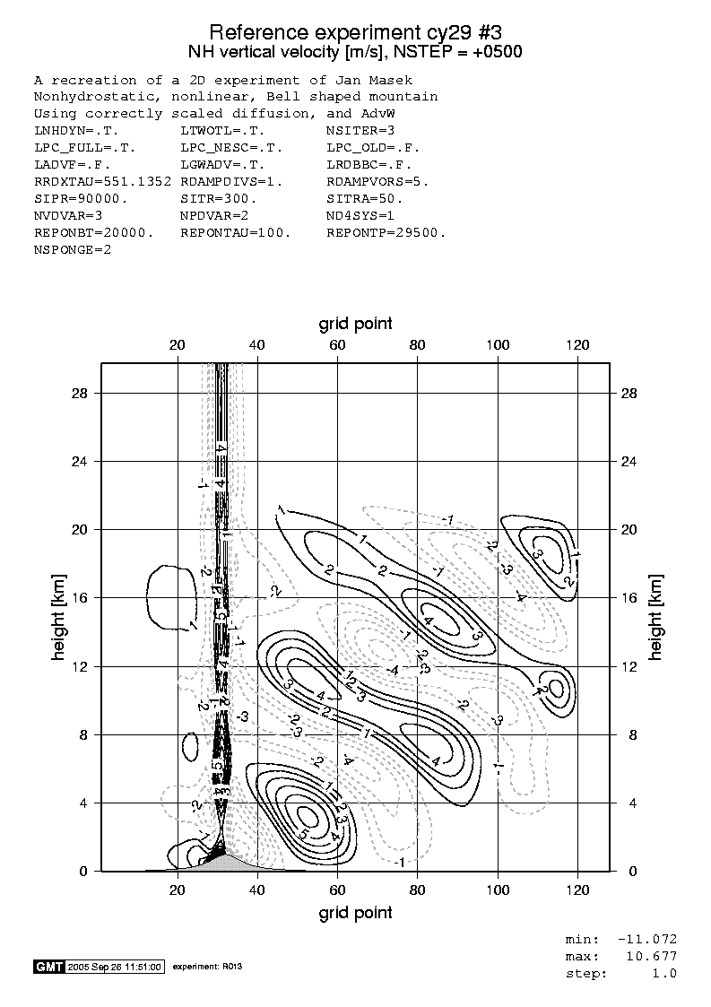
Experiment C

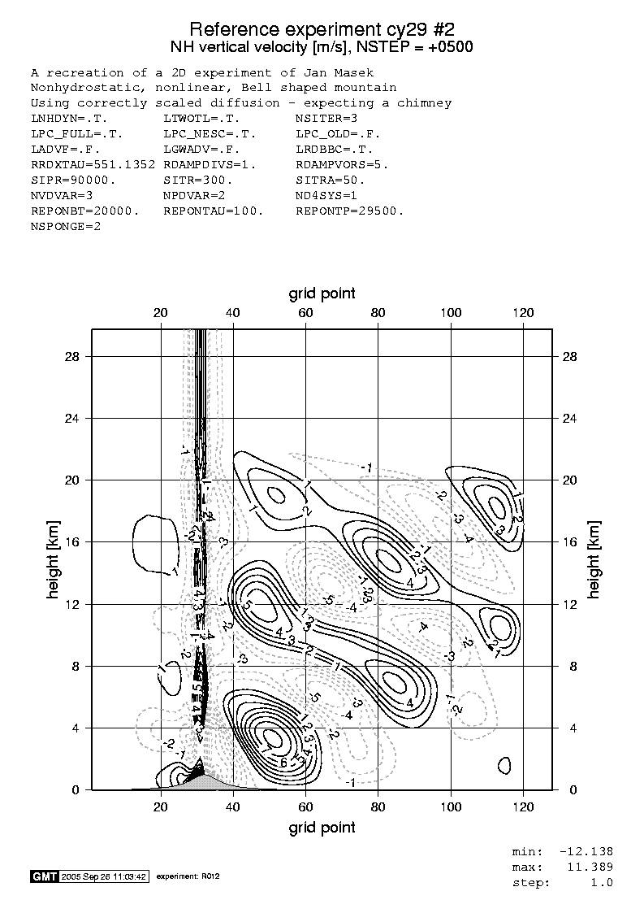
Experiment D

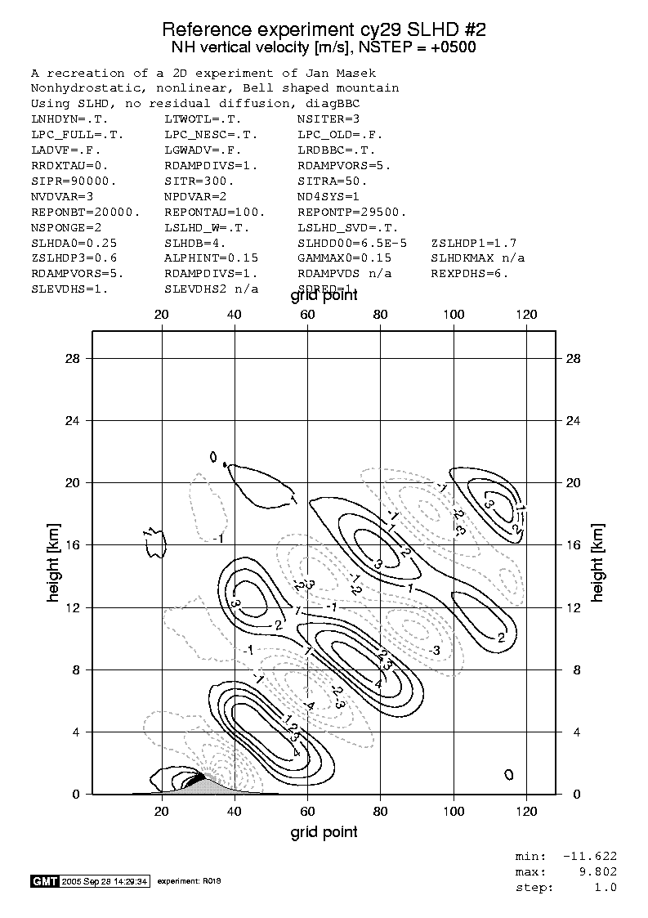
Experiment E

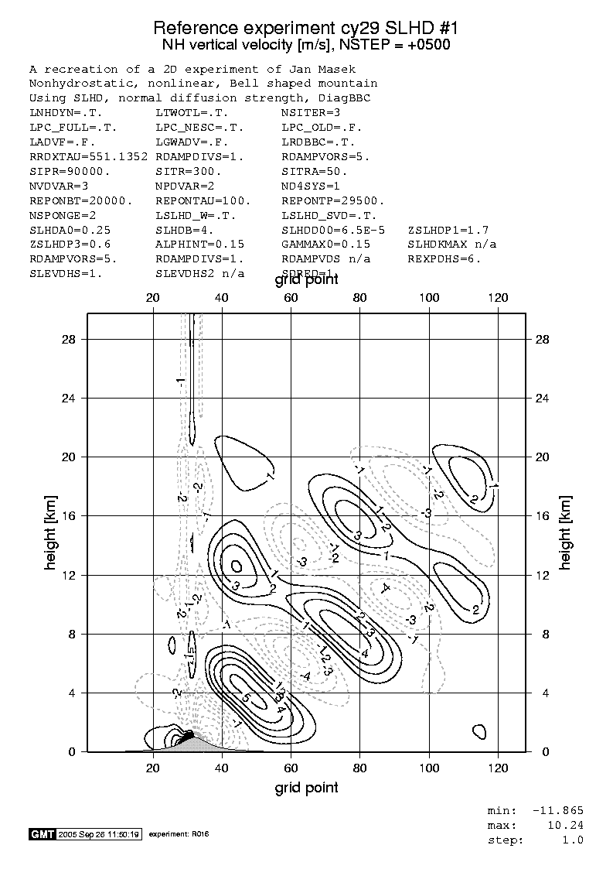
Experiment F

