Large positive bias in very cold conditions in Slovakia

Mariska Derkova

General description
At the end of January/beginning of February 2006 the large area of the high pressure over Central Europe (see the weather map on fog case) caused very low night minimum temperatures below -25deg. in Slovakia, (similarly in neighbouring countries, personal communication). Slovakia was covered by snow during this period. The minimum temperatures were not very well predicted by the model, with the error sometimes exceeding 15deg (see figure 1).
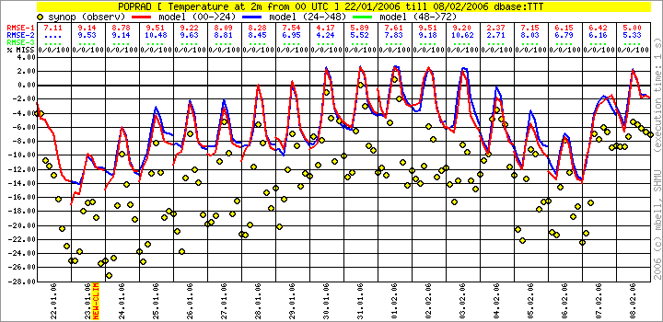
Figure 1: the observed and modeled 2m temperature for the Poprad-Ganovce station. Observations with yelow circles, 0-24h forecast with red line, 24-48h forecast in blue. The model forecast is already corrected for the differences between real and model orography.
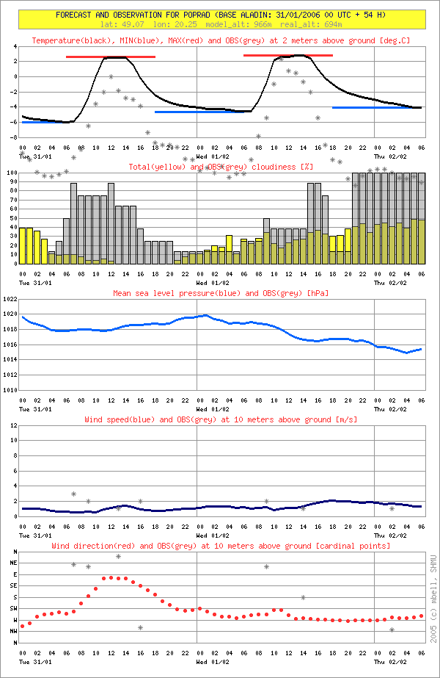
Figure 2: verification of meteogram for the same station, forecast from 31/01/2006 00UTC. It can be seen that the wind speed is predicted well, as well as the cloudiness during the night.
The vertical profile of the temperature shows the inversion layer predicted by the model, which however starts from warmer surface than observed. Thus the layer warmer than 0 deg. is more thick, and warmer than observed.
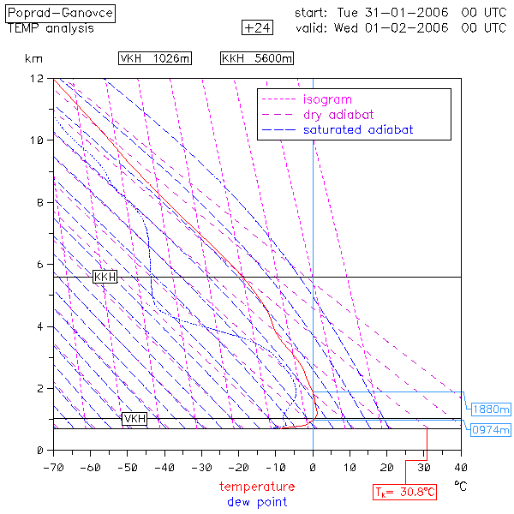
Figure 3: The vertical profile of temperature (TEMP), valid on 01/02/2006 00UTC.
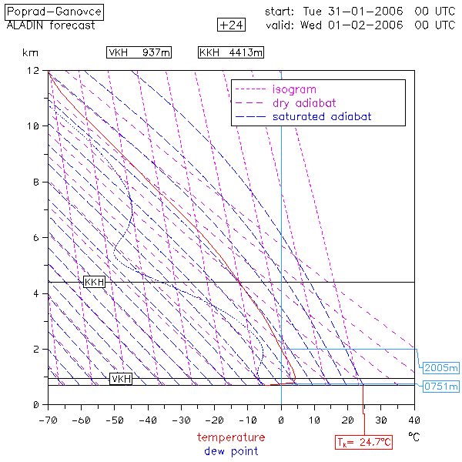
Figure 4: The same as previous figure, but foreasted by ALADIN/SHMU.
The time cross-section of the vertical profile of temperature and temperature gradient confirm, that the inversion layer, although cought well, was not thick enough in ALADIN forecast. The structure of the wind field was well captured.
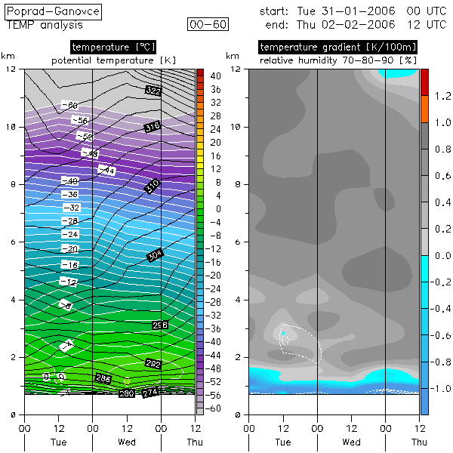
Figure 5: The time cross-section of the vertical profile of temperature and temperature gradient for Poprad-Ganovce station, as measured between 31/01/2006 00 UTC and 02/02/2006 12UTC.
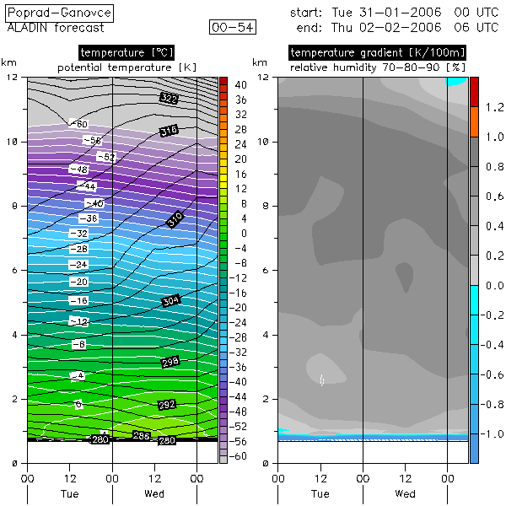
Figure 6: The same as previous figure, but as predicted by ALADIN/SHMU.
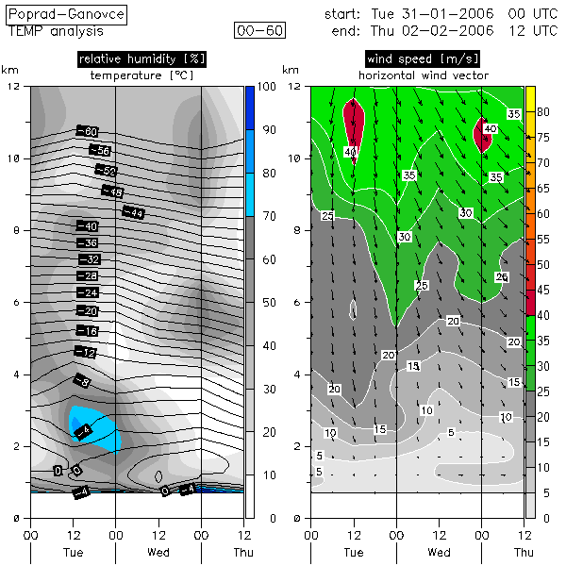
Figure 7: The same as figure 5, but for the relative humidity and the wind field.
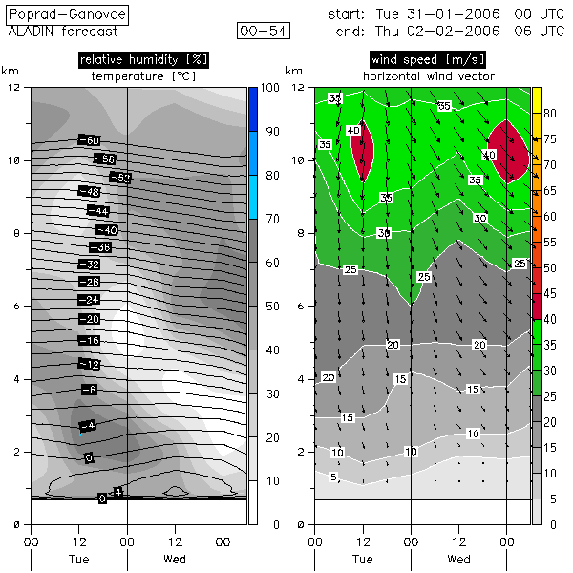
Figure 8: The same as previous figure, but as predicted by ALADIN/SHMU.

