LACE Working Group for Data
Assimilation: Report for 2007

Gergely Bölöni
13 March, 2008

Contents

1 Introduction 1
2 Progress in research topics 1
2.1 Algorithmic aspects 1
2.3 Cycling 2
2.4 Observations 4
2.5 Surface 6
3 Summary of means 7
4 Presentation of the results 9

1 Introduction
This paper is a report of the work realized in 2007 within the LACE working group for data assimilation.

- Progress in research topics
  - Algorithmic aspects
- Tests with a 1st version 4DVAR
Description: As the TL/AD of the SL advection is ready since the end of 2006, all the basic elements are available for testing a first version 4DVAR in ALADIN. The original aim was to test the TL/AD dynamics and learn about the 4DVAR code implemented in ARPEGE.
Realization: Finally the work focused on the validation of the TL/AD code through sensitivity tests (conf. 801). The dynamical part was found to work fine on CY32T3. In addition to earlier ALADIN 801 runs the TL/AD version of the Semi-Lagrangian scheme was also tested and it was proved that it increases the efficiency. The two TL/AD physics packages available in the ALADIN code (Buizza’s and Janiskova’s physiscs) were also tested. The simpler Buizza’s package was working fine though some bug is supposed to be present in the Janiskova’s physics.
Efforts: 1.5/1.5 p x m
Contributors: Filip Vana (CZ)
Documentation: A preliminary version is available on the LACE webpage.

- Tests with CONGRAD minimizer
Description: The goal was to compare the efficiency of the CONGRAD minimizer with M1QN3.
Realization: Comparisons were done first based on one single case, which indicated a cheaper convergence to the needed minimum in case of the CONGRAD method. This was then supported by statistics over a 14 days period. However the gain in CPU is relatively small.
Efforts: 0.5/0.5 p x m
Contributors: Gergely Bölöni (HU)
Documentation: in the ALADIN Newsletter No. 31

- Background error covariance computations
Description: CZ and RO plans to derive B matrices for their domains.
Realization: In CZ, standard and lagged NMC B matrices were computed, in RO the needed software has been implemented but no computations took place. In HU ensemble B statistics were recomputed based on the actual operational cycle (CY30T1).
Efforts: 1 p x m (CZ), 0.5 p x m (HU), 0.25 p x m (RO)
Contributors: Alena Trojáková (CZ), Gergely Bölöni (HU), Simona Stefanescu (RO)
Documntation: Not available.

- Tuning of error variances of the analysis system
Description: HU and RO plan “a posteriori” tuning of the background and observation error variances. In HU a vertically uniform tuning has been done last year for the background error variances, which should be followed by a height dependent tuning.
Realization: The earlier uniform tuning has been implemented operationally in HU. No new tuning has been done yet.
Efforts: 0/2 p x m (HU), 0/3 p x m (RO)
Contributors:
Documentation: Not available.

- 3DVAR installation and validation
Description: The goal is to prepare a local 3DVAR installation either for operational or experimental use.
Realization:
CZ: BATOR, ODBTOOLS, ALDODB (002, 131) validated (CY32T1)
CRO: BATOR, ODBTOOLS, ALDODB (only 002) validated (CY32T3)
RO: BATOR, ODBTOOLS, ALDODB installed but not validated (CY32T3)
Efforts: 6 p x m (CRO), 1 p x m (CZ), 0.5/1 p x m (RO)
Contributors: Tomislav Kovacic and Antonio Stanesic (CRO), Alena Trojáková (CZ), Iulia Ibanescu and Cornel Soci (RO)
Documentation: Not available yet.

  - Cycling

- Assimilation experiments using ECMWF LBC
Description: The original goal was to use ECMWF LBC data in an assimilation cycle after the promising results in the dynamical adaptation setup. As realized in the meantime, for the 00 UTC run one can’t use the fresh ECMWF LBCs but those of the 18 UTC run from the previous day only (stream SCDA). The tests then were done both for dynamical adaptation and assimilation cycling taking into account this “operational constraint”.
Realization: In a 3DVAR assimilation cycle the forecast scores slightly improve if the SCDA data are used instead of the 00 UTC ARPEGE LBCs. In a dynamical adaptation setup the results are somewhat better if ARPEGE 00 UTC LBCs are used (instead of the SCDA data).
Efforts: 2/2 p x m
Contributors: Sándor Kertész (HU)
Documentation: available in the ALADIN Newsletter no. 32

- Experiments with 3D-FGAT
Description: 3D-FGAT comparisons with 3DVAR were started in 2006 in HMS. The first goal was to compare how the FGAT compares with 3DVAR in case of using the ALADIN/HU operational observation database (SYNOPs, AMDARs and AMSU-A and B radiances can be used in several timeslots). The FGAT experiments are to be completed with the SEVIRI data, which is a source of high-resolution information in high frequency.
Realization: Not done.
Efforts: 0/3 p x m
Contributors: Sándor Kertész (HU)
Documentation: Not available.

- Experiments with 3DVAR RUC
Description: RUC (Rapide Update Cycle) can be imagined as relatively simple and cheap approach for using high frequency data. The aim was to run a 3h frequent ALADIN 3DVAR cycle in comparison with the usual 6-hour 3DVAR cycle.
Realization: 3 and 1-hour RUC experiments have been run using all the operational data sources at HMS (TEMP, SYNOP, AMDAR, ATOVS/AMSU-A and B, GEOWIND). Among these ATOVS, AMDAR and SYNOP data were used in an increased frequency due to the RUC setup. The first results are very promising concerning the 3-hour RUC scores compared with those of the reference 6 hour cycling.
Efforts: 1.5/1.5 p x m
Contributors: Sándor Kertész (HU), Benedikt Strajnar (SLO)
Documentation: The report is available on the LACE webpage.

- Implementation of upper air blending
Description: SK and CRO had an interest to implement operational DFI blending cycles.
Realization: DF blending has been implemented operationally in SK. An improvement in the localization of precipitation has been found with respect to the dynamical adaptation setup. In CRO no work was done in this field.
Efforts: 0 p x m (CRO), 1/1 p x m (SK)
Contributors: Maria Derková (SK), Martin Bellus (SK), Jan Masek (SK), Tomislav Kovacic (CRO)
Documentation: An article is available on the LACE webpage about the work in SK.

  - Observations

- ODB installation
Description: ODB installation is an essential basis for any local data assimilation. It includes the installation and validation of BATOR and ODBTOOLS, and the feeding of BATOR with data. These validation works have been planned in CRO, CZ, RO and SLO.
Realization:
CRO: feed ODB with SYNOP and TEMP data, BATOR and ODBTOOLS validated (CY32T3)
CZ: feed ODB with SYNOP, TEMP, SEVIRI data, BATOR and ODBTOOLS validated (CY32T1)
RO: BATOR and ODBTOOLS installed but not validated (CY32T3)
SLO: BATOR and ODBTOOLS installed but not validated (CY32T1)
Efforts: 6 p x m (CRO), 0.5/2 p x m (RO), 1.5/1.5 p x m (SLO)
Contributors: Tomislav Kovacic (CRO), Iulia Ibanescu and Cornel Soci (RO), Jure Cedilnik and Benedikt Strajnar (SLO)
Documentation: Not available.

- Assimilation of SEVIRI data
Description: SEVIRI data proved to be a useful source of information in the ALADIN/FR 3DVAR. Attempts to use these data are made inside LACE as well. Local data pre-processing and bias correction issues were tackled at the end of 2006 at HMS. A continuation of the work at HMS was focusing mostly on impact studies and the evaluation of the importance of this data type. CHMI will start to set up local 3DVAR tests with a special emphasis on the use of SEVIRI data. There is an interest as well in Croatia to set up a local 3DVAR assimilation using these data.
Realization: In the frame of a stay (Alena Trojáková) in Budapest, impact studies were carried out as well as a tuning of the observation error variances took place. SEVIRI data have a similar impact to those of high-resolution ATOVS data. Some deterioration of the forecasts was found near the surface due to SEVIRI data assimilation.
Efforts: 2/2 p x m (HU), 1 p x m (CZ), 0 p x m (CRO)
Contributors: Roger Randriamampianina (HU), Alena Trojáková (CZ)
Documentation: a preliminary report is available from Alena Trojáková

- Assimilation of radar data
Description: LACE contributes to the common ALADIN plans for radar reflectivity assimilation.
Realization: Information to be collected from Marian Jurasek.
Efforts: ?/1 p x m
Contributors: Marian Jurasek (SK)
Documentation: ?

- Assimilation of non-GTS SYNOPs
Description: Assimilation experiments have been run using all the available non-GTS SYNOPs from the LACE countries expecting that these can add some valuable information to a local analysis.
Realization: After collecting the data from all the countries the experiments have been successfully run. The impact of the extra data is however neutral. (This work has been part of the LACE DM’s work.)
Efforts: 2/2 p x m
Contributors: Sándor Kertész (HU)
Documntation: available on the LACE webpage.

- Assimilation of SYNOP T2m, RH2m
Description: The use of these measurements is thought to be dangerous because of the presently used background error structure functions, which project the low level increments to the high troposphere. In ALADIN/FR, these data are used together with SEVIRI data. As SEVIRI provides high-resolution increments mostly in the altitude, it decreases the impact of unrealistic increments coming from SYNOPs. On the other hand 2m SYNOP measurements may improve the PBL increments provided by SEVIRI data.
Realization: As a first step a case study has been selected as a basis for testing T2m RH2m and SEVIRI data together. Checking of increment cross-sections, visual verification of charts and contingency tables for precipitation were performed. According to the contingency tables an improvement was found in the precipitation forecast when using together T2m, RH2m and the SEVIRI data. As a second step, the T2m + RH2m + SEVIRI experiment has been run for a longer period (1 month) too. The contingency tables computed on this longer run mostly supported the previous results.
Efforts: 2/2 p x m
Contributors: Gergely Bölöni (HU), Alena Trojaková (CZ)
Documentation: A preliminary report is available from Alena Trojáková or Gergely Bölöni.

- Assimilation of ground based GPS data
Description: This data type contains information about humidity. GPS are assimilated in ARPEGE and ALADIN/FR operationally. There is a strong interest to work in this field at the Czech Academy of Sciences. So far we plan to collect information about this work through CHMI.
Realization: Not done.
Efforts: 0 p x m
Contributors: Krystof Eben and co. (CZ)
Documentation: Not available.

  - Surface

- Tests with CANARI
Description: It is a common opinion that a high-resolution surface assimilation will be essential in the future but there is no strategy within LACE to work on it. CANARI OI seems to be a good starting point (it even became operational in ALADIN/CZ) for training staff for longer term actions.
Realization: In CZ the maintenance of the CANARI surface has been continued and the suite has been ported to CY32T1. It has been validated in HU as well (CY30T1) and a parallel suite is planned soon. A workshop has been organized at HMS on surface assimilation with two main purposes. On one hand it has been a kick-off for forming a LACE strategy on surface assimilation, on the other hand a training took place about CANARI OI for HIRLAM and ALADIN staff in order to ease local installations.
Efforts: 1 p x m (CZ), 0 p x m (CRO), 1.5/1.5 p x m (HU), 0 p x m (RO), 0 p x m (SLO)
Contributors: Tomislav Kovacic and Antonio Stanesic (CRO), Alena Trojáková and Radmila Brozková (CZ), Jure Cedilnik (SLO), Gergely Bölöni (HU)
Documentation: Not available yet.

- Summary of means

The following table summarizes the efforts and support so far in 2007. Some information are still missing. Consequently only an estimated total effort is given (0 is counted if there is a question mark). Workshops and the corresponding support are also listed in Table 2.

Topic | Efforts | LACE support | Status

Algorithmic aspects
Tests with a 1st version 4DVAR | 1.5/1.5 p x m | None | Finished
Tests with the CONGRAD minimizer | 0.5/0.5 p xm | None | Finished
Background error covariance computations | - CZ: 1 p x m  - HU: 0.5/0 p x m  - RO: 0.25/5 p x m | None | CZ: Finished  HU: Finished  RO: Not done
Tuning of error variances in the analysis system | - HU: 0/2 p x m  - RO: 0/3 p x m | None | Not done
3DVAR installation and validation | - CRO: 6 p x m  - CZ: 1 p x m  - RO: 0.5/1 p x m | None | CRO: On the way  CZ: Finished  RO: Not done

Cycling
Assimilation experiments using ECMWF LBC | 2/2 p x m | None | Finished
Experiments with 3D-FGAT | 0/3 p x m | None | Not done
Experiments with 3DVAR RUC | 2/2 p x m | 1 p x m | Finished
Implementation of upper air blending | - CRO: 0 p x m  - SK: 1/1 p x m | None | CRO: Not done  SK: Finished

Observations
ODB installation | - CRO: 6.5 p x m  - RO: 0.5/2 p x m  - SLO: 1.5/1.5 p x m | None | CRO: Finished  RO: On the way  SLO: Finished
Assimilation of SEVIRI data | - HU: 2/2 p x m  - CRO: ? p x m  - CZ: 2 p x m | 1 p x m | HU: Finished  CRO: Not done  CZ: On the way
Assimilation of radar data | ?/2 p x m | None | ?
Assimilation of non-GTS SYNOPs | 2/2 p x m | None | Finished
Assimilation of SYNOP T2m, RH2m | 1.5/1.5 p x m | 1.5 p x m | Finished
Assimilation of GPS data | 0/2 p x m | None | Not done
Surface
Tests with CANARI | - CRO: 0 p x m  - CZ: 1 p x m  - HU: 1.5/1.5 p x m  - RO: 0/3 p x m  - SLO: 0 p x m | None | CRO: Not done  HU: On the way  RO: Not done
Summary | 35/37.5 p x m | 3.5  p x m

Table 1: summary of means for 2007

Workshops | Participants | LACE support
SRNWP data assimilation workshop | Marián Jurasek  Sándor Kertész  Simona Stefanescu  Alena Trojáková | 2/2 p x m
AAA surface assimilation workshop | Francois Bouyssel (teacher)  Gergely Bölöni  Jure Cedilnik  Simona Enculescu  Tomislav Kovacic  Sabine Leroch  Jean-Francois Mahfouf (teacher)  Antonio Stanesic  Benedikt Strajnar  Alena Trojáková | ~0.5/0.25 p x m

Table 2: Data assimilation workshops in 2007

- Presentation of the results

- Tests with a 1st version 4DVAR
No graphical presentation of the results is done. A summary about the realization can be read in the first part of this report. More details can be found in the preliminary report of Filip Vana (available on the LACE webpage).

- Tests with CONGRAD minimizer
First tests consisted in running 3DVAR analyses with both the M1QN3 and the CONGRAD method using the same background and observations (SYNOP and TEMP) for a single date. These proved that CONGRAD reaches the “needed minimum” somewhat faster (35% gain in CPU compared to M1QN3). The “needed minimum” (Jmin oper) was chosen as the one reached by the present operational 3DVAR in ALADIN/HU at the given date. The gain is coming from the fact that CONGRAD needs much less iterations (45) than M1QN3 (70) in order to reach the “Jmin oper” value. (Fig. 1).
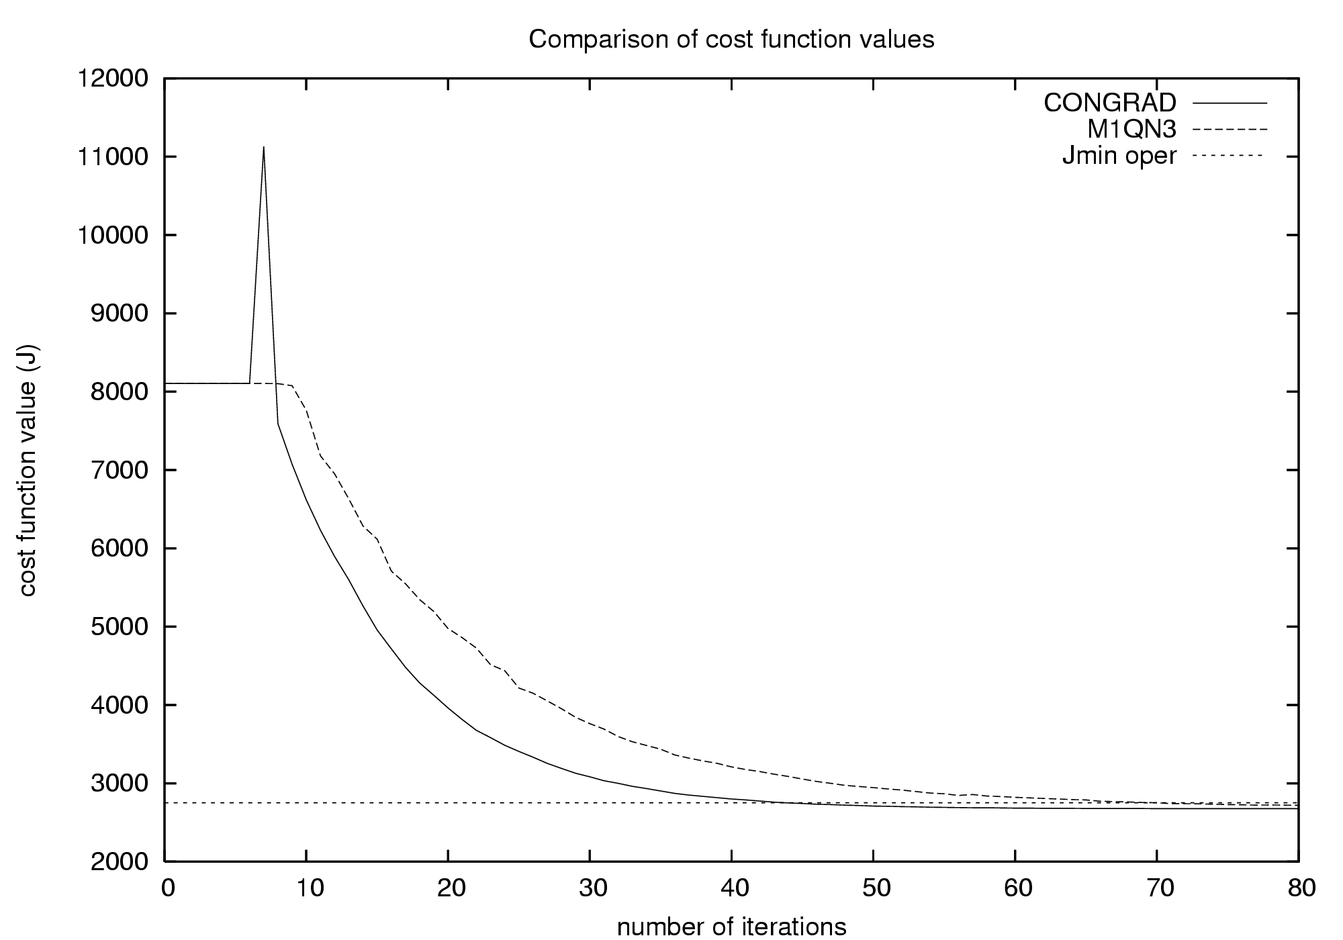

Fig. 1: Value of the cost funtion during the minimization. Jmin oper stands for the „needed minimum”

Following this first experiment, statistics were computed on the CPU use of the 2 methods for a 14 days period, which supported the 35% gain. In the former operational setup of ALADIN/HU (the full minimization takes 9-10 minutes), the 35% gain means 2-3 minutes gain in CPU.

- Background error covariance computations
Standard and lagged NMC background error statistics were computed in CHMI for the ALADIN/CZ domain. First diagnostics are in coherence with the earlier experience: lagged statistics imply decreased spatial scales of the background error correlations (Fig. 2).
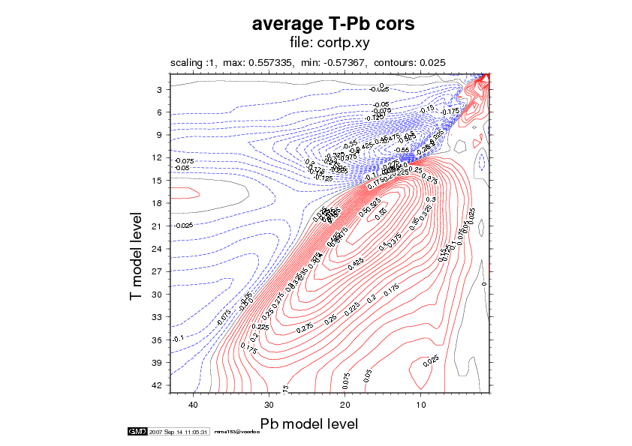
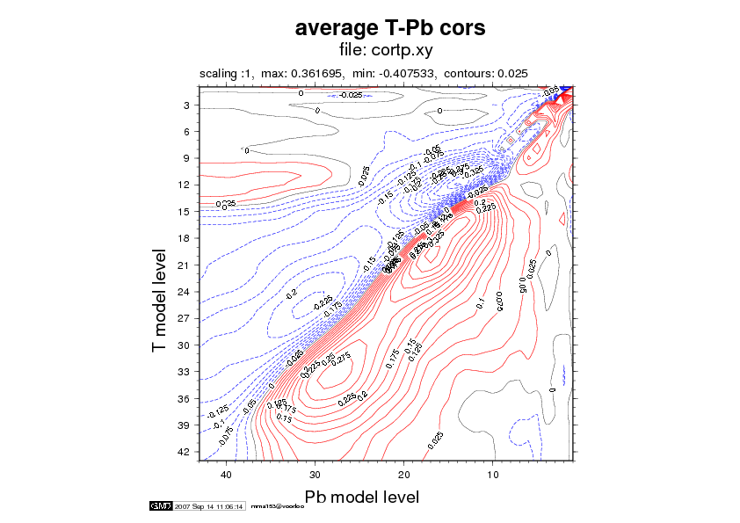

Fig. 2: Vertical correlation matrices of temperature and (vorticity balanced) geopotential. Left: standard NMC, Right: lagged NMC

In Hungary, ensemble background errors were recomputed based on the operational cycle (CY30T1). These were introduced to the operational use together with a tuning of the background error variances carried out in 2006. The new B statistics were in a parallel suite for a one-month period in June-July. The results are shown on Fig. 3.

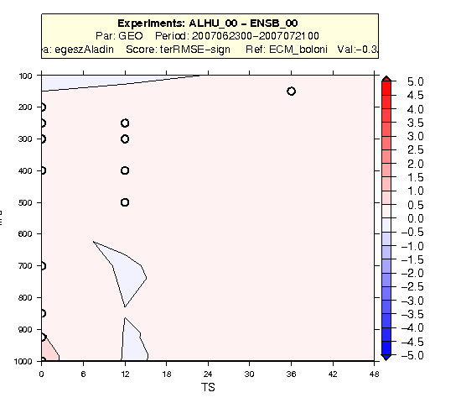
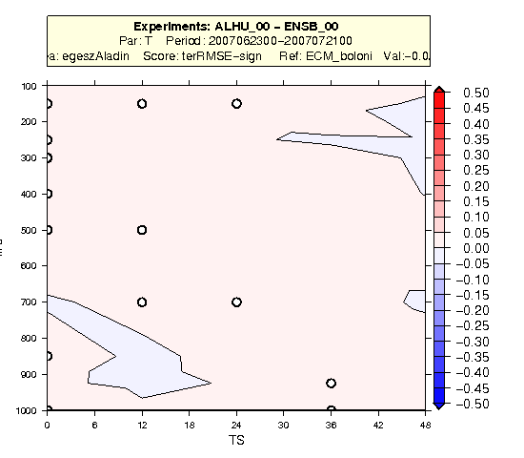

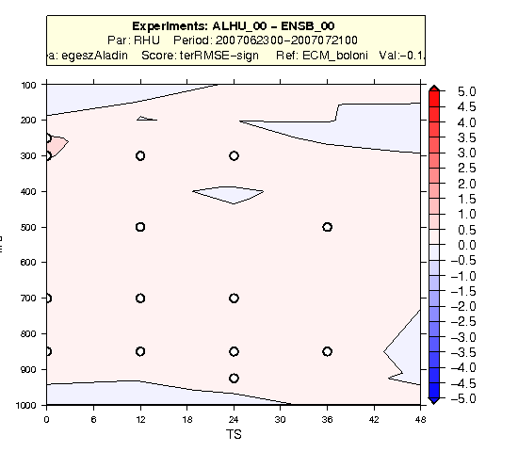

Fig. 3: 00UTC RMSE differences of the actual operational model (ALHU) using a standard NMC B matrix and the one in parallel suite (ENSB) using an ensemble B matrix (REDNMC=1.3). The small circles indicate statistical significance.

- Tuning of error variances of the analysis system
No results.

- 3DVAR installation and validation
No graphical presentation of the results.

- Assimilation experiments using ECMWF LBC
The use of ECMWF LBCs (T799) were investigated both from experimental and operational context. In an experimental context, for a past period for instance, one has access to all the ECMWF LBC data through MARS so coupling files from ARPEGE and IFS can be used from exactly the same runs. In an operational context one can’t use the freshest ECMWF LBCs at 00 UTC (due to the longer 4DVAR window in ECMWF than in ARPEGE) but only those from the previous run, which is the 18 UTC run of the previous day (SCDA). In the operational context both dynamical adaptation and assimilation experiments have been run.

→ As a first conclusion, previous results were supported that one should not use the ECMWF surface fields as initial conditions (this happens only in a dynamical adaptation setup) because the initialisation of ISBA fields derived from the ECMWF surface fields is not efficient (Fig. 4).
T2 RMSE
T2 BIAS
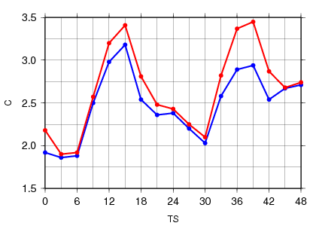
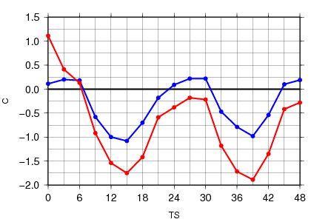

Fig. 4: T2m RMSE and BIAS scores using ECMWF LBC data. Red: surface initial conditions from ECMWF, Blue: surface initial conditions from ARPEGE

The solution is either to overwrite the surface fields by those of the actual ARPEGE analysis or to run a local surface (CANARI) analysis.

→ In the experimental context the use ECMWF LBCs improves the forecasts significantly except for humidity in the very altitude. (Fig. 5). These tests were done only for dynamical adaptation.
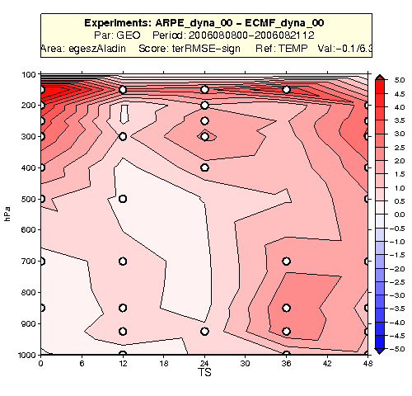
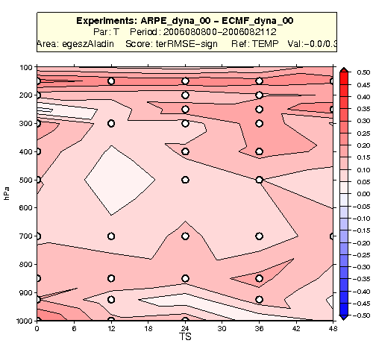

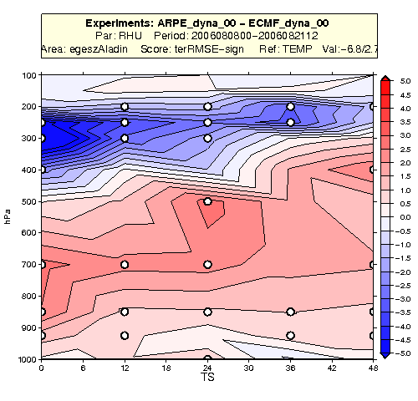
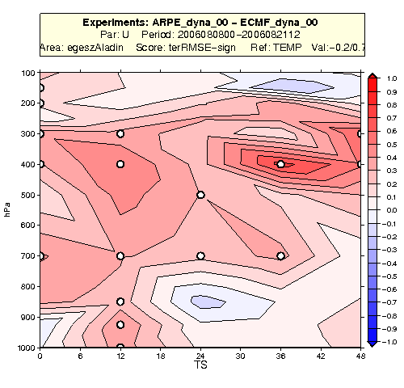

Fig. 5: RMSE differences of dynamical adaptation runs using ECMWF LBC (ECMF_dyna_00) and ARPEGE LBC (ARPE_dyna_00) in the experimental context. Small circles indicate statistical significance.

→ In the operational context the use of ARPEGE LBCs is a bit more beneficial than the use of the ECMWF SCDA LBCs if one runs a dynamical adaptation. Examples are shown for wind and RHU on Fig. 6.
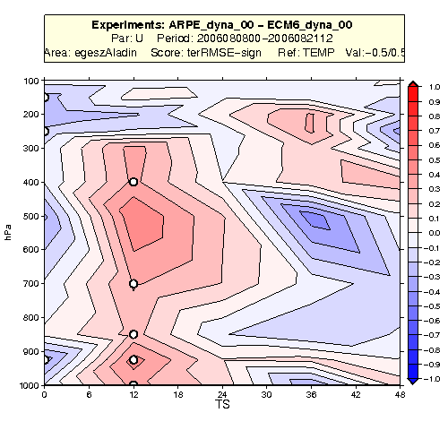
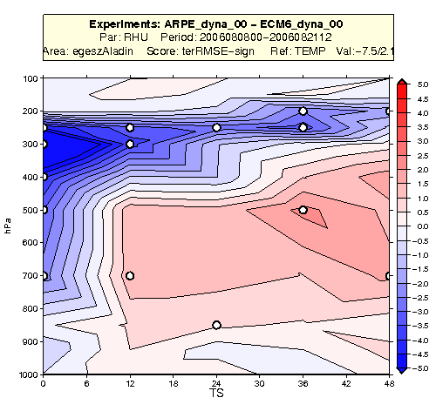

Fig. 6: RMSE differences of dynamical adaptation runs using ECMWF SCDA LBC (ECM6_dyna_00) and ARPEGE LBC (ARPE_dyna_00) in the operational context. Small circles indicate statistical significance.

→ In the operational context the use of ECMWF SCDA LBCs gives somewhat better results than the use of ARPEGE LBCs if while running a data assimilation cycle. Examples are shown for wind and RHU on Fig. 7.
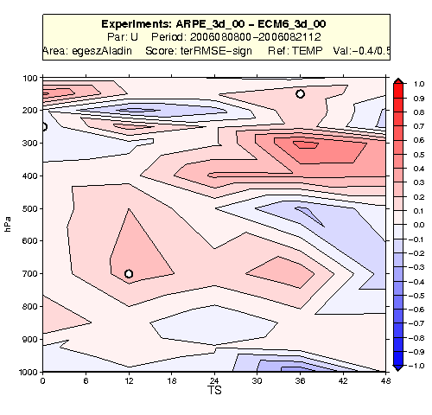
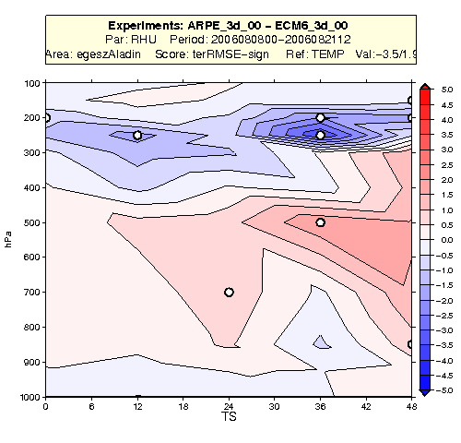

Fig. 7: RMSE differences of assimilation cycle runs using ECMWF SCDA LBC (ECM6_3d_00) and ARPEGE LBC (ARPE_3d_00) in the operational context. Small circles indicate statistical significance.

- Experiments with 3D-FGAT
No results.

- Experiments with 3DVAR RUC
RUC (Rapide Update Cycle) can be imagined as an alternative (and maybe the cheapest) approach for using high frequency data. The aim was to run a 3h frequent ALADIN 3DVAR cycle in comparison with the usual 6-hour 3DVAR cycle. The extra information in RUC compared to the usual 6-hour cycling is that:
- more SYNOP data can be used
- there is a smaller error in the innovation vector due to the shorter observation window
Otherwise, the same amount of data is assimilated as in a normal 6-hour cycle. Below, results from the 3-hour RUC (RUC3_3d_00) are presented only as the 1-hour RUC was just evaluated rather briefly so far. There were 2 references used in the RUC experiments with different observation usage. The first one was an equivalent of the operational 6-hour cycle (ARPE_3d_00) and the second one used the observations in the same manner as the 3-hour RUC but still doing a 6h cycle (RUC6_3d_00). The observation settings of these experiments are detailed below:

Exp\Obs | AMDAR | AMV | Sat. Radiances | SYNOP
RUC3_3d_00 | +/- 1.5h window | Used | All (+/-1.5 h) | 3h frequency
RUC6_3d_00 | +/- 1.5h window | Used | All (+/- 3h) | 6h frequency
ARPE_3d_00 | +/- 1h  window | Not used | No NOAA15 AMSU-B (+/- 3h) | 6h frequency

From the cross comparison of RUC3 with RUC6 and ARPE, the following conclusions can be made:
→ RUC3 is better than RUC6, which is an indication that a more frequent cycle is better if it can use more frequent observational data (Fig.8).
→ ARPE is better than RUC6 (not shown), which comes from the different observation usage (eg. from the use of erroneous NOAA-15 AMSU-B channels in RUC6 or from the use of AMV data).
→ For wind and temperature RUC3 is better than ARPE, but for humidity the contrary is true. As the observation usage is different in these experiments it is hard to say from which source this differences come. These results are shown on Fig. 9.

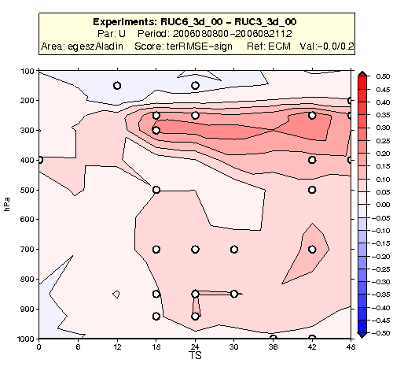
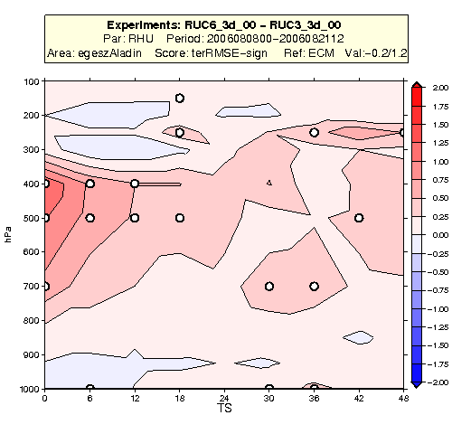

Fig. 8: RMSE differences of RUC3 and RUC6. Left: wind, Right: RHU. Small circles indicate statistical significance.
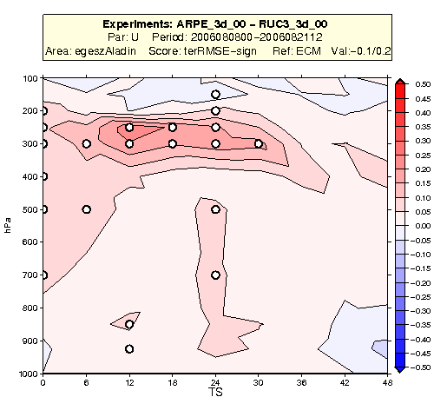
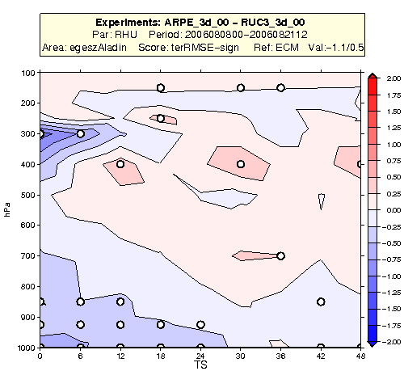

Fig. 9: RMSE differences of RUC3 and ARPE. Left: wind, Right: RHU. Small circles indicate statistical significance

In summary the RUC3-RUC6 comparison suggests that the approach to increase the analysis frequency is promising. On the other hand, future experiments should account to measure the spin-up in the 3h first guesses and also to try to figure out if the present background errors are appropriate to represent the errors of these short-range forecasts.

- Implementation of upper air blending
DF blending of the upper-air fields has been implemented operationally in Slovakia. In the test phase case studies have been carried out. The main conclusion is that a better localization of the precipitation is obtained with the DF blending suite than with the dynamical adaptation setup (Fig. 10).

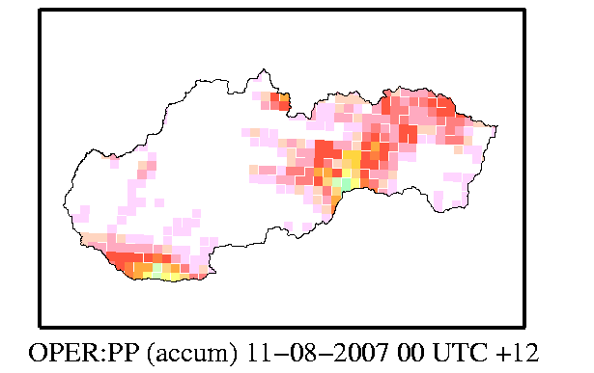
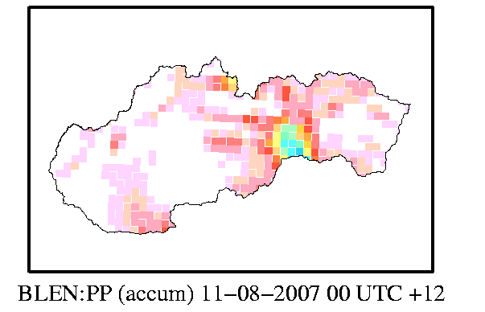

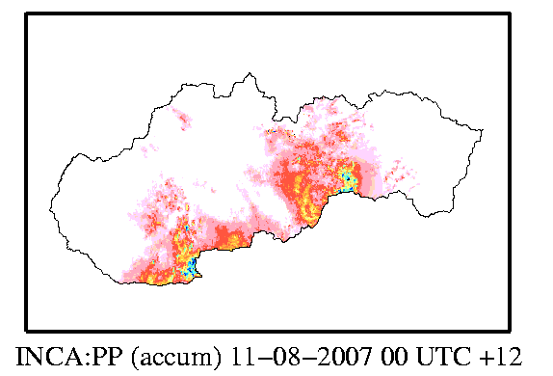

Fig. 10: Simulated precipitation by dynamical adaptation (top left), DF blending (top right) compared with the INCA analysis

So far the surface fields are initialized by the interpolated ARPEGE analysis in the DF blending suite.
- ODB installation
No graphical presentation of the results.

- Assimilation of SEVIRI data
By the end of 2006 preliminary experiments showed that SEVIRI data have a mixed impact in the ALADIN/HU system with a similar order of magnitude as the ATOVS/AMSU-B and AMSU-A data (a detailed report is available on the LACE website). At the beginning of 2007, on one hand, these experiments have been revistited with some bug corrections (wrong extraction of SYNOP, TEMP and ATOVS/AMSU-B data in the previous tests), but the results remain similar. On the other hand, several experiments were performed to improve the background and observation error statistics in the system. Below, some results are demonstrated on RHU 700hPa scores, where the model was compared to ARPEGE analyses. It should be mentioned that other variables behave differently and the comparison against observations can also give different results.
→ It was recognized that in the French system, an ensemble B matrix was used when the SEVIRI data were implemented. If one assumes that the error variances are correctly set in the French system, either an ensemble B should be used, or the observation error variances should be reduced for the SEVIRI data in order to keep the same ratio between the background and observation errors (as the background error variances are smaller in an ensemble B than in a NMC one). While using the ensemble B matrix, indeed an improvement of the scores can be seen. This is shown for humidity on 700hPa on Fig. 11.
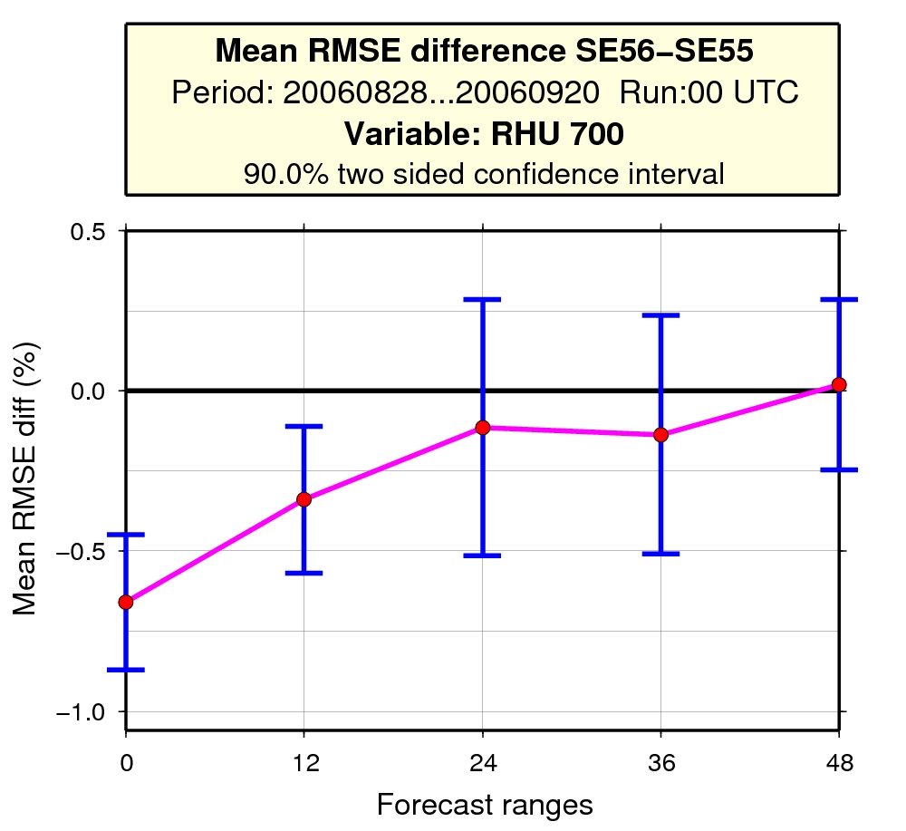

Fig. 11: RMSE difference score for RHU on 700hPa. SE55: exp using SEVIRI + NMC B matrix, SE56: exp using SEVIRI + ensemble B matrix. The vertical bars denote significance if they do not cross the 0 line.
On the other hand, changing the B matrix was not enough to show a clear positive impact of the SEVIRI data themselves.
→ For the same purpose to find a good ratio of the background and observation error variances, the observation error variances were further tuned (first with an intuitive tuning and then following the method of “covariance of residuals” proposed by Désroziers et al. The impact of the SEVIRI data in this configuration can be seen on Fig. 12.
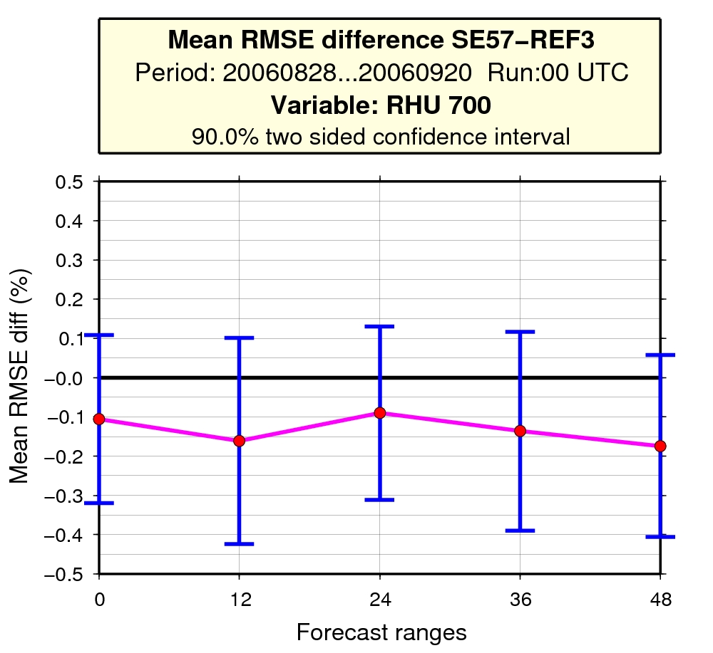

Fig. 12: RMSE difference score for RHU on 700hPa. SE57: exp using SEVIRI + ensemble B matrix + tuning of observation errors, REF3: reference (no SEVIRI) using an ensemble B matrix. The vertical bars denote significance if they do not cross the 0 line.

On the top of these experiments relevant for the presently operational ALADIN/HU, another test was carried out to assess the impact of SEVIRI data on the top of SYNOP and TEMP observations. The goal of this test was to prepare a kind of guideline about the importance of the observations being present in the system. The impact of the SEVIRI data turned out to be similar to those of ATOVS, AMDAR and AMV(GEOWIND) data together (Fig. 13). Finally one should mention that a deterioration of the RHU scores is present on 2m due to the SEVIRI data (Fig. 14). One idea to explain this is that fake increments may be produced near the surface due to wrong vertical increment propagation implied by the B matrix, however this intuition was not examined.

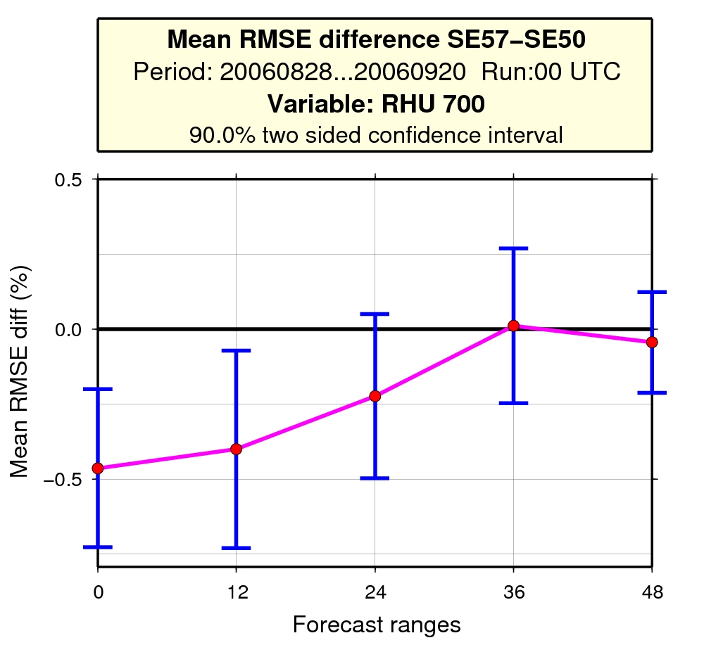
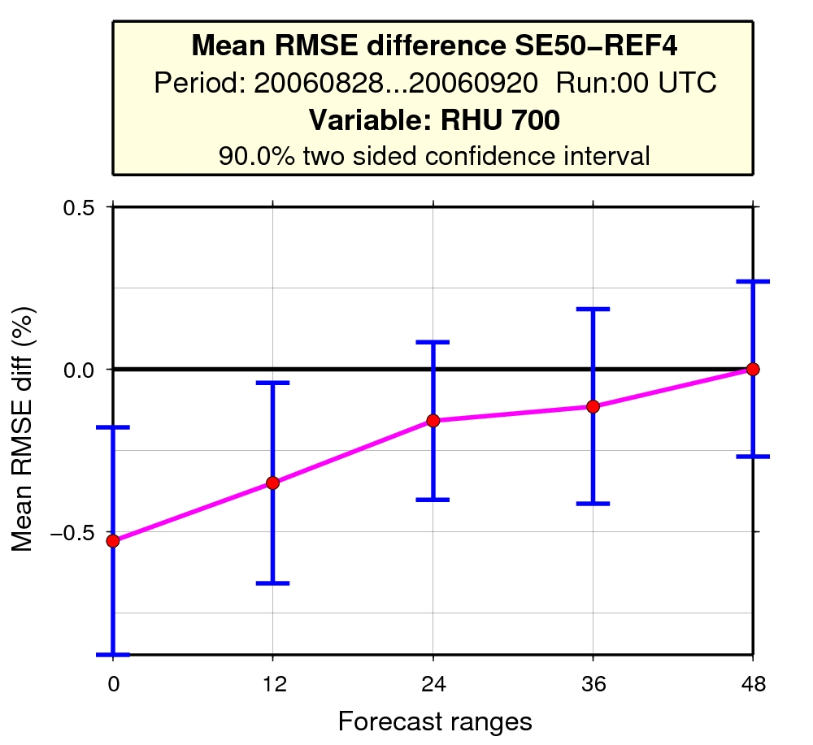

Fig. 13: RMSE difference score for RHU on 700hPa. The vertical bars denote significance if they do not cross the 0 line.
REF4: exp using SYNOP + TEMP
SE57: exp using SEVIRI + SYNOP + TEMP + ATOVS + AMV(GEOWIND) + AMDAR
SE50: exp using SEVIRI + SYNOP + TEMP

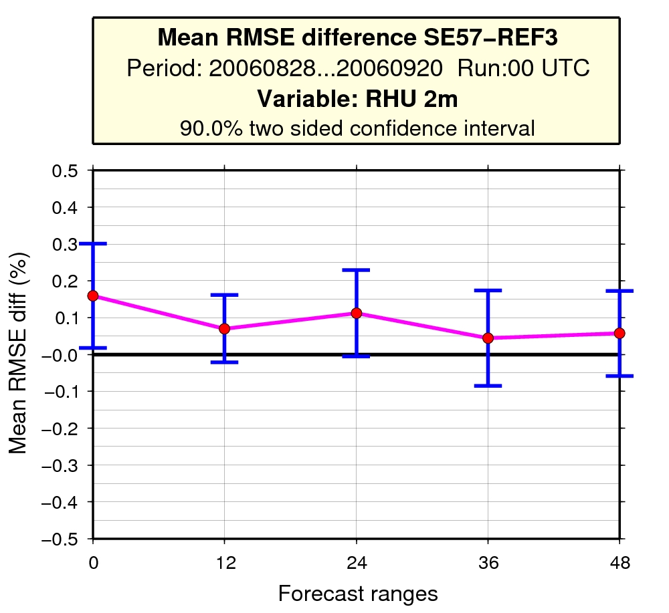

Fig. 14: RMSE difference score for RHU on 700hPa. The vertical bars denote significance if they do not cross the 0 line.
REF3: exp using SYNOP + TEMP + ATOVS + AMV(GEOWIND) + AMDAR
SE57: exp using SEVIRI + SYNOP + TEMP + ATOVS + AMV(GEOWIND) + AMDAR

- Assimilation of radar data
No information.

- Assimilation of non-GTS SYNOPs
The impact of non-GTS SYNOP data were investigated on the top of the presently used operational observations in ALADIN/HU. The study was done in 2 steps. In the first step only Ps data have been assimilated from SYNOPs, in the second step also 2m RHU and T were analyzed. In both case neutral impact of the extra data was found. The reason for the neutral results is supposed to be on one hand that the SYNOP data were not used for surface assimilation (the interpolated ARPEGE surface analysis is was taken in the experiments) but only for upper air assimilation. Another reason can be that the extra non-GTS data are located mostly in areas where the observation density is already quite high, so they do not have much added information. No graphics are shown here but a detailed report is on the LACE website.

- Assimilation of SYNOP T2m, RH2m
The impact of SYNOP T and RH data were tested together with SEVIRI radiances in 3 different experiments based on a case study first.
- Reference + SEVIRI
- Reference + SYNOP T and RH
- Reference + SYNOP T and RH + SEVIRI
No significant differences were found in upper air parameters. The 2m scores have been improved in both of the experiments where 2m T and RH have been used but only for the analysis and for very short forecast range (6h). According to contingency tables, experiment 3. was the best in forecasting precipitation. These results were also supported by a longer period run (Figure 15 and 16.). For the 1 month run, upper air scores against ECMWF analysis have also been improved in a small extent if SYNOP T and RH 2m + SEVIRI were added to the reference setup.

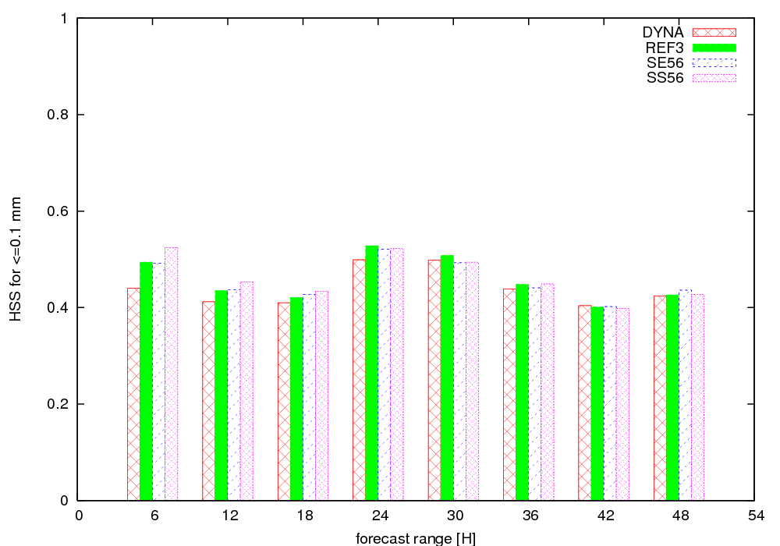

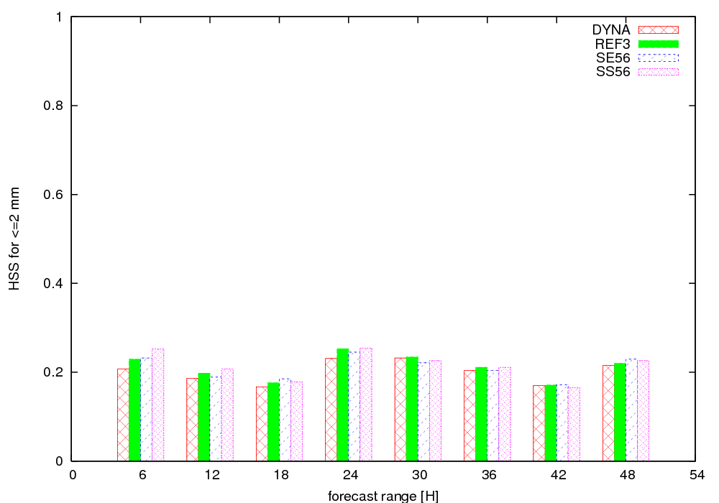
Fig. 15: Heidke Skill Scores (HSS) for precipitation amount 0 < x < 0.1 mm (top) and
0.1 mm < x < 2 mm (bottom). The score is as better as higher. DYNA: dynamical adaptation, REF3: reference run (without SEVIRI and SYNOP t and RH), SE56: Reference + SEVIRI, SS56: Reference + SEVIRI + SYNOP T and RH
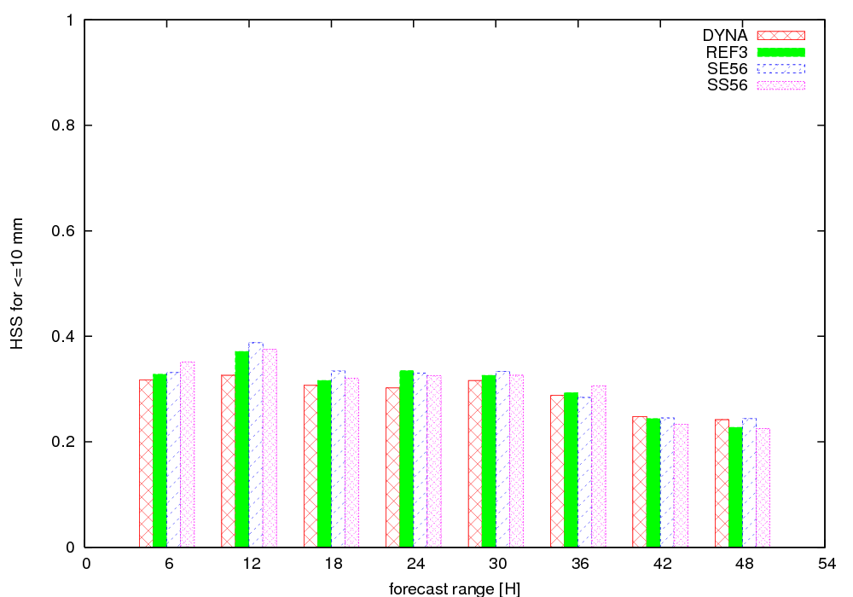

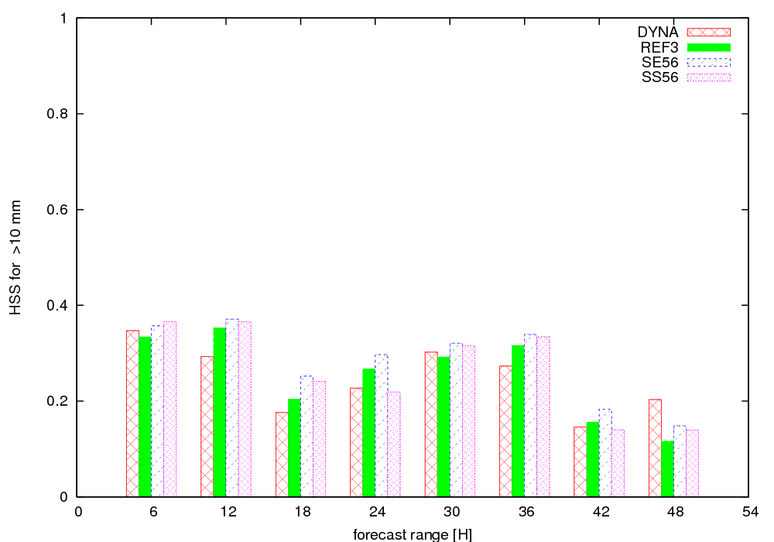
Fig. 15: Heidke Skill Scores (HSS) for precipitation amount 2 < x < 10 mm (top) and
10 mm < x (bottom). The score is as better as higher. DYNA: dynamical adaptation, REF3: reference run (without SEVIRI and SYNOP t and RH), SE56: Reference + SEVIRI, SS56: Reference + SEVIRI + SYNOP T and RH
- Assimilation of GPS data
No results.

- Tests with CANARI
No graphical presentation of the results.

