Overview of ALADIN data assimilation activities
at Slovenian Environment Agency (ARSO)

January – August 2013

Benedikt Strajnar, Jure Cedilnik

29 August 2013

Summary

In the first half of 2013, DA activities at ARSO were focused on validation of assimilation cycle (mostly during the winter and related to snow and surface temperatures), Mode-S data assimilation and migration to model cycle 36 (still in progress).

Table 1: Summary of DA related activities at ARSO (Jan - Aug 2013) in person/months.

Project/staff | Benedikt Strajnar (pm) | Jure Cedilnik (pm) | Total (pm)
Mode-S data assimilation | 2 | 0 | 2
Validation and improvements of operational assimilation cycle | 1 | 1 | 2
Upgrade to cy36 | 0.5 | 1 | 1.5
total | 3.5 | 2 | 5.5

Validation in improvements of operational assimilation cycle

During winter 2012/2013, significant biases in 2 m temperatures were experienced over Slovenia in all ALADIN model forecasts and also for other models. It was found out that a large contribution to this observed biases came from discrepancies between modeled and observed snow cover (see Fig. 1 for snow cover evolutions). Especially problematic were periods with rapid snow melt (in case of excessive snow amounts in the model). It was also discovered that significant differences in ground water existed between the assimilation cycle and LBC (ARPEGE).
In order to mitigate the effects of missing snow analysis, the following modifications were applied to the operational suite:
- 1 step of snow analysis with CANARI was performed at the end of January to remove excessive snow amounts (see the discrepancy between black line and observations on January 30 in Fig.1)
- fit to observations in analysis was improved by increasing forecast-error covariances (REDNMC increased from 1.3 to 1.6)
- weak relaxation to climatology for ground fields in CANARI was re-introduced (RCLIMCA=0.045)
It can be concluded that implementation of snow assimilation is needed and should be a high-priority task.

Figure 1: Surface snow content in kg/m2 (models) or snow depth in cm (observations) evolutions at Ljubljana station between 1 December 2012 and 1 March 2012.

Mode-S data assimilation

A comparison with radiosonde and AMDAR observations (already carried out during 2012) showed a good quality of Mode-S MRAR aircraft observations. Based on this findings, the potential for data assimilation was further studied in the first half of 2013. The behavior of Mode-S data in local data assimilation system was investigated over the period from 2 August 2012 till 29 September 2012. The assimilation cycle was similar to the one used for operational, except that the analysis frequency is increased to 3 hours (so-called RUC mode). Experimental (EXP, including Mode-S) and reference (REF) cycles were run to enable fair comparison.

Pre-processing and quality control

Raw Mode-S data are too dense (in space and time) to be used directly in the model. A pre-processing procedure is therefore considered to somewhat smooth the data but to still preserve the good spatial resolution. A simple averaging is applied to the raw data over 4 consecutive time steps (12 s) during ascent or descent, and 16 time steps (1 minute) during flights at constant altitudes. Observations with high roll angle (larger than 3 degrees) are rejected due to possibly inaccurate wind measurement. In the first assimilation experiment for the period of the same two months (results will not be shown here), a number of aircraft with suspiciously high biases was discovered. Based on their data assimilation statistics (mean observation - guess difference), they were rejected in the further experiments. The exact rejection criterion is the following: all the aircraft lying beyond the 1.5 IQR (inter-quartile range) of all differences were regarded as outliers and rejected. Such a blacklisting procedure is used for EXP and REF experiments presented here.

The quality control was further revisited. A 2-year comparison of all Mode-S measurements with operational ALADIN analysis has been carried out and statistics for each aircraft in the data set were computed. Instead of blacklisting, a white list of aircraft with observations of good quality will be used in the future. This approach is more appropriate for operational use, because it prevents new aircraft (with possibly erroneous observations) to enter the assimilation process automatically.

Impact on analysis

Mode-S observations have quite a significant impact to the local analysis. In Fig. 2, such a case (for 7
September 6 UTC) is demonstrated. According to Mode-S observations, there was a weak temperature inversion over the location of Ljubljana airport near the pressure level of 800 hPa. This feature was not present in the first guesses of REF or EXP, but is to some extent described in the EXP analysis. Also, below the inversion the forecast wind were too strong compared to Mode-S wind observations (see the layer between 800 and 900 hPa in right part of Fig. 2.

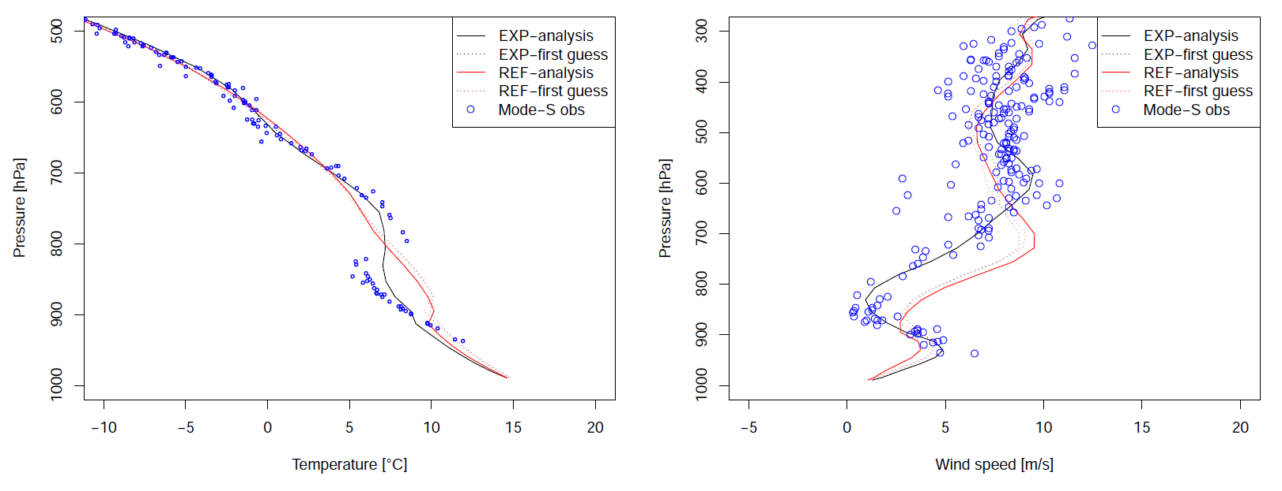
Figure 2: Left: Vertical profile of temperature above Ljubljana airport at 7 September 2012 6 UTC. Shown are first guess(dotted) and analysis (full line) of experimental cycle EXP (black) and reference cycle REF (red). Mode-S observations, used for EXP analysis, are plotted as blue circles. Right: vertical profile of wind speed for the same point.

Impact on forecast scores

The main conventional upper-air information for ALADIN assimilation cycle is based on aircraft (AMDAR) observations, which are rarely available near(at) Ljubljana airport. With the usage of Mode S data, the spatial coverage in lower atmosphere was therefore locally significantly improved. The assimilation experiments were carried out from 2 August 2012 till 29 September 2012. Based on the verification against Mode S observations in the 270 km radius around Ljubljana airport, there was a systematically positive impact on wind forecasts till around T+3 hours of the forecast. For temperature forecasts, it could be observed that Mode S assimilation in a NWP model decreases systematic errors (bias) in the first hours of forecasts. Mode S data assimilation systematically improves temperature analysis and forecasts up to T+4 hours in the free atmosphere, but also up to T+12 hours near the surface. No significant degradations can be observed due to assimilated Mode S data. It can be concluded that collected data from Mode S radar improves short-range forecasts and nowcasting.

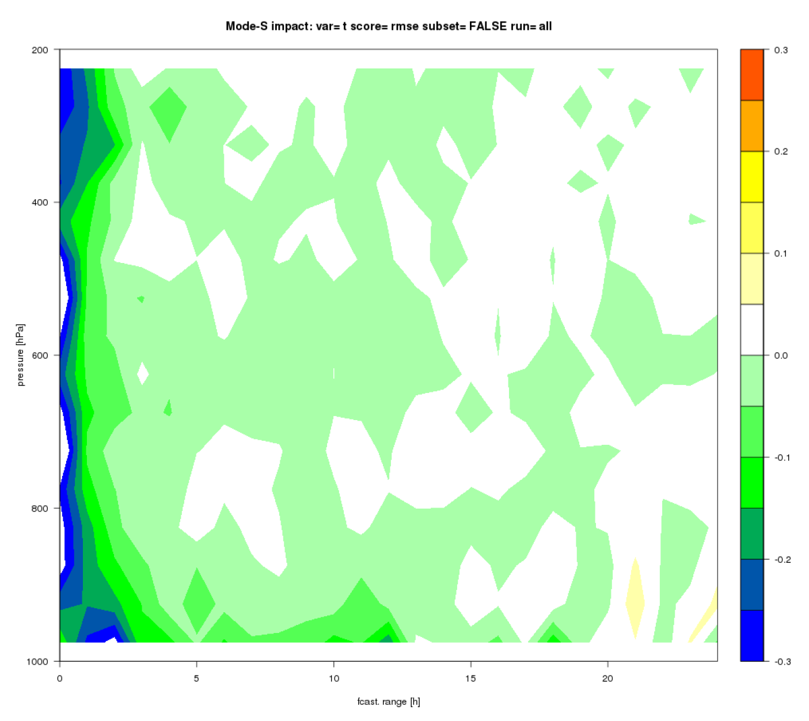
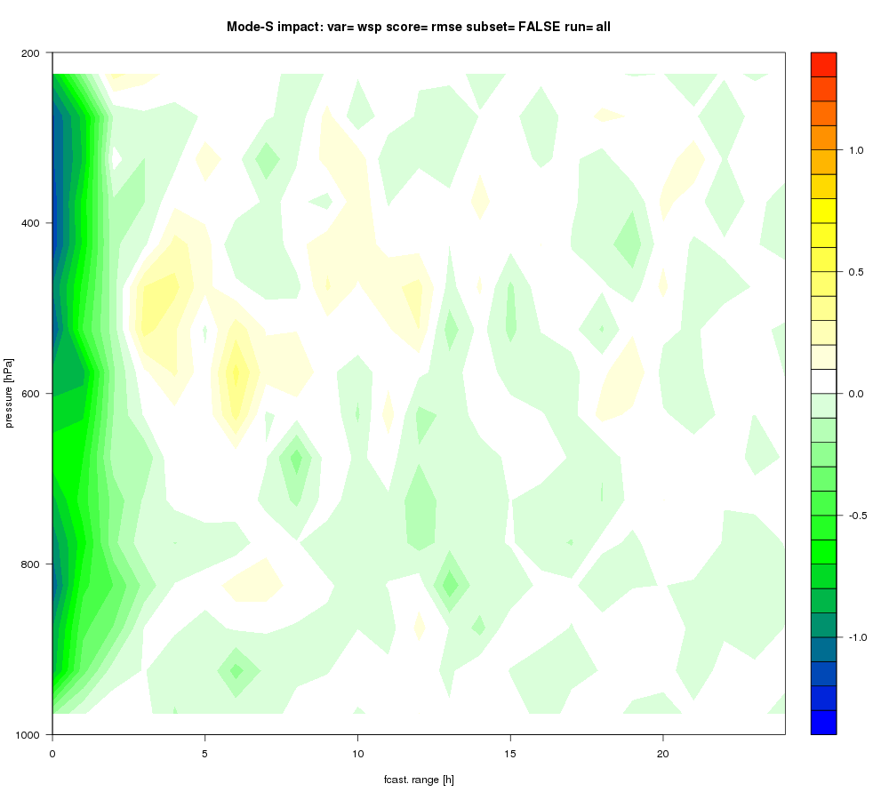

Temperature(left) and wind speed(right) RMSE reduction (EXP - REF). Verification is against all Mode-S observations. Green and blue colors indicate improvements.

