Data assimilation activities at ZAMG (Austria)

Stefan Schneider, Florian Meier and Xin Yan



Operational Implementation

Setup of pre-operational 3D-Var and CANARI assimilation cycle
A pre-operational assimilation cycle (long and short cut off) on the ALADIN-Austria domain (9.6 km T89 L60, 300x270 GP) is running at ZAMG four times daily since July 2009. 3D-Var and CANARI running parallel using the same first guess and their results are merged afterwards. The system uses ALADIN CY32t1 code (assimilation) and CY35t1 code (forecasts). The CANARI surface assimilation uses regularly observation data (T2m, RH2m) from the ZAMG local database which includes very dense observations over Austria (about 260 Austrian stations) and OPLACE data as backup. The 3D-Var system uses OPLACE observation data regularly and the local database, which includes only SYNOP, TEMP and AMDAR data, as backup. Since December 2009 the SYNOP observations for 3D-Var are also taken regularly from the local database.
Table 1: Assimilated data in 3D-Var
Observation type | assimilated fields until 12/2009 | assimilated fields since 01/2010
SYNOP | Φ | Φ,T2m, RH2m
AMDAR/AIRREPORT | U,V | U,V,T
TEMP | T,U,V,Q (03 UTC soundings Graz, Linz, Innsbruck, Ljubljana not used) | T,U,V,Q,Φ, (03 UTC soundings added to 06 UTC analysis step)
GEOWIND | U,V | U,V
WINDPROFILER | U,V ( completely rejected) | U,V (completely rejected)
NOAA-AMSUA | Radiance | Radiance
NOAA-AMSUB | Radiance | Radiance

Incidents and crashes of the cycling
Since September 2009 the cycling runs mostly without severe disturbances. Crashes by corrupt or missing observation files occurring at some days during summer 2009 can be avoided now by automatically re-running BATOR and using the backup observation data in case of corrupt obsoul files. Problems were also caused by different and too long waiting limits for long and short cutoff. This led to missing first guess files from long cutoff cycle due to delay. In consequence the cycle broke down several times. Other incidents were caused by not assimilation specific problems with the file system on ZAMG-NEC.

Results
The pre-operational version of 3D-Var+CANARI is verified against the operational run (interpolated ARPEGE initial data) and observations (SYNOP stations over Austria, sounding stations and INCA analyses). Verification of T2m shows very similar results compared to the operational run without additional assimilation (see Fig. 1). For low terrain SYNOP stations (Fig. 1a, b) the negative bias but also MAE and RMSE are slightly worse in 3D-Var+CANARI. The negative bias is larger at night but the difference to the operational run is larger around noon. For the higher situated SYNOP stations (Fig. 1c, d), the RMSE and MAE of operational and 3D-Var+CANARI simulations are almost the same. The negative bias during night is larger in 3D-Var+CANARI, but during day the positive bias is reduced. Furthermore an improvement can be seen during the first three hours lead time. The relative humidity (RH2m) is generally slightly worse simulated in 3D-Var+CANARI (Fig. 2). The positive bias is larger. The differences are larger for the higher situated stations and larger around noon than during night time. Generally the assimilation system leads to slightly too cold and too wet near surface conditions. Another interesting fact is the much more extended snow covered area in 3D-Var+CANARI compared to the operational run especially in late December (not shown).
Verification against sounding stations of the 12UTC runs (Fig. 3, 4) shows a slightly higher bias for 3D-Var+CANARI compared to the operational run above 850hPa for temperature and wind (Fig. 3a-c). The results are slightly better for relative humidity (Fig. 3e, f) and wind +48h (Fig. 3d). The RMSE is slightly higher for all variables in 3D-Var+CANARI compared to the operational run. However, the overall differences between operational run and 3D-Var+CANARI are quite small.
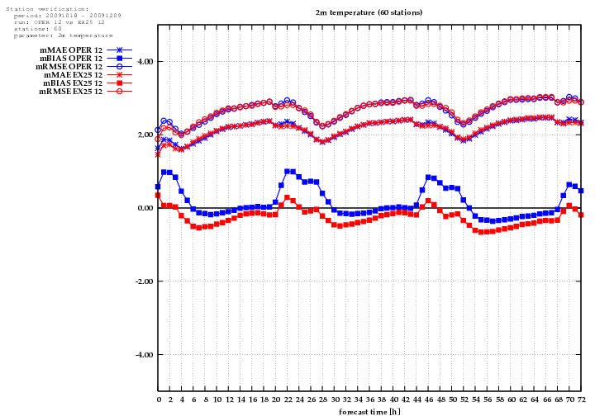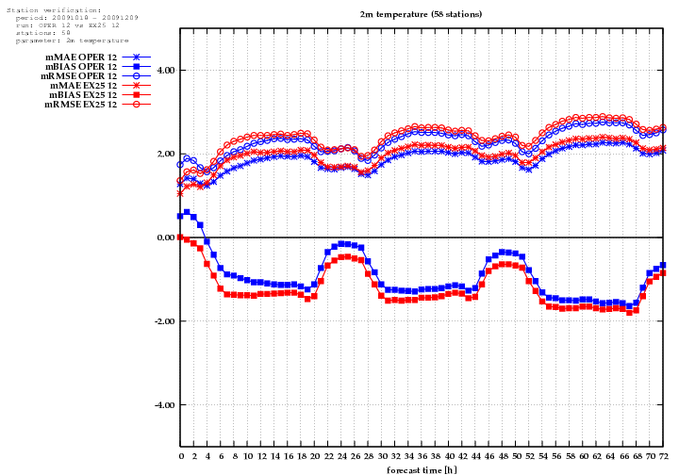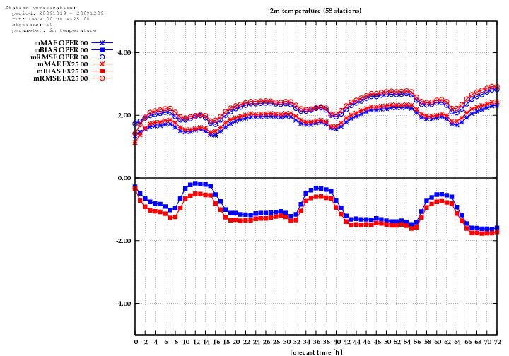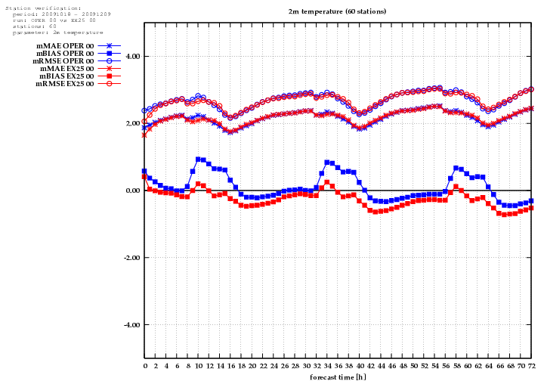
a)
b)
d)
c)
Figure 1: Verification of T2m for the period 2009-10-18 to 2009-12-09: Bias (squares), MAE (crosses), RMSE (open circles) against lead time. 3D-Var+Canari pre-operational (red) and operational run without assimilation (blue). a) 00UTC runs verified against 60 Austrian stations below 500m. b) as a) but 12UTC runs. c) as a) but 60 stations between 500m and 1000m above sea level. d) as c) but 12UTC runs.

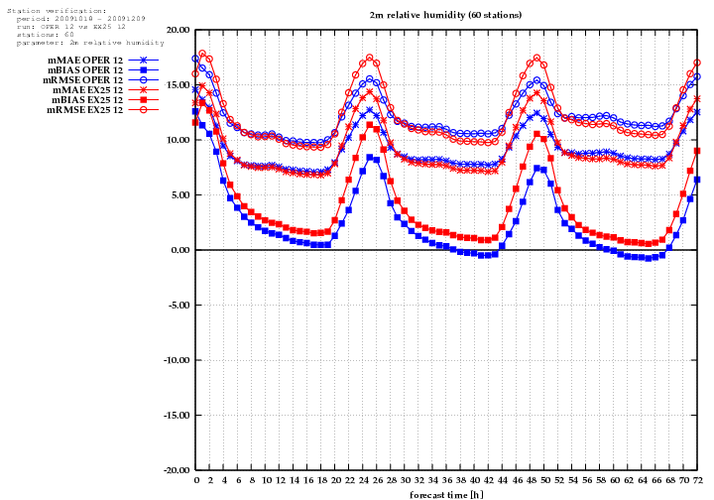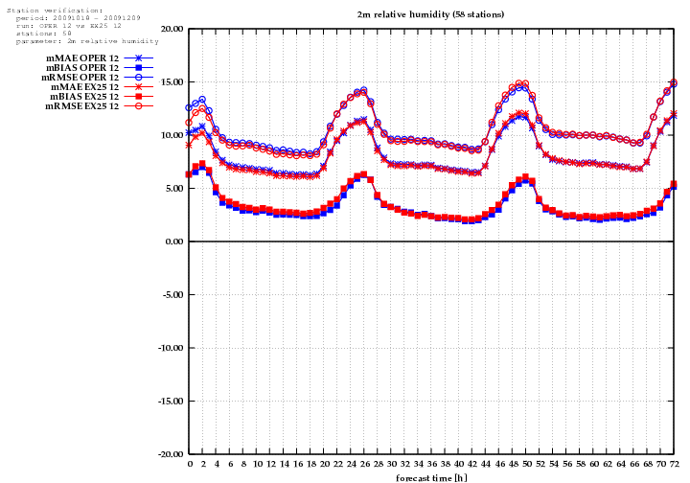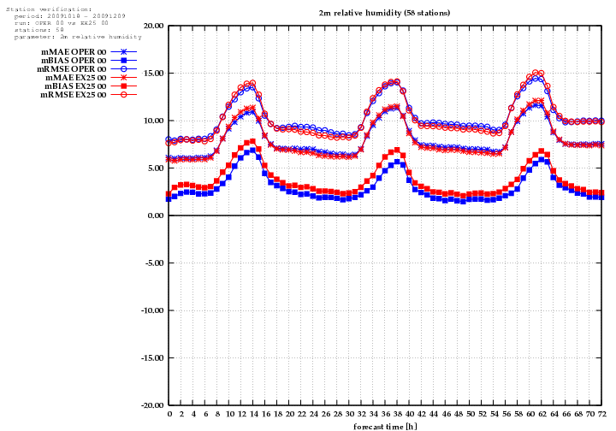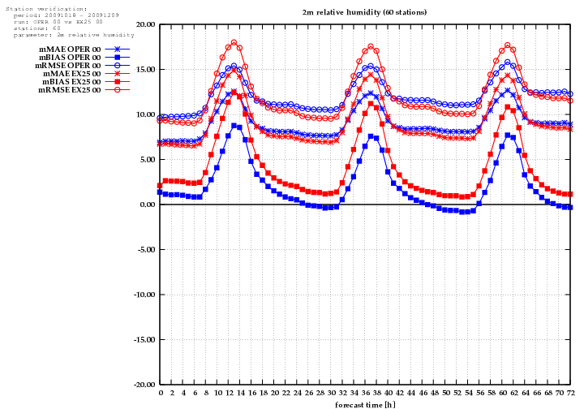
a)
b)
d)
c)
Figure 2: As Fig. 1 but for relative humidity (RH2m).

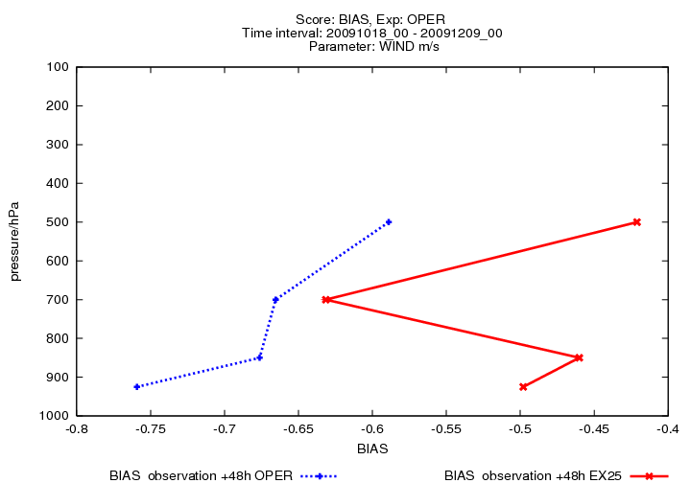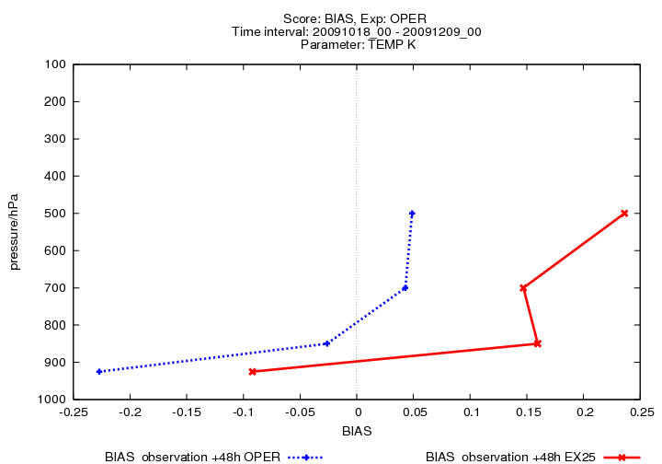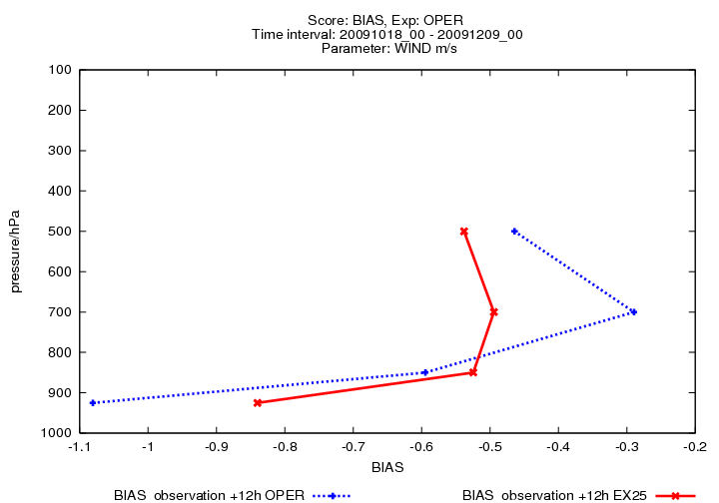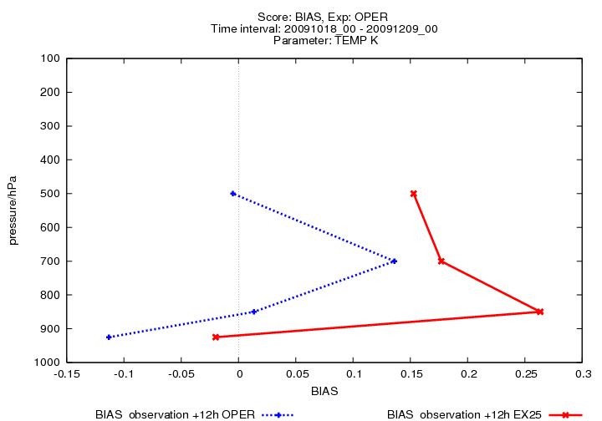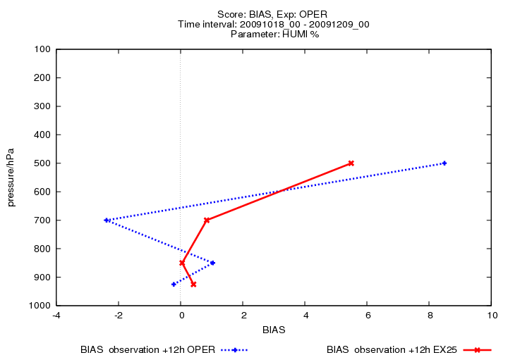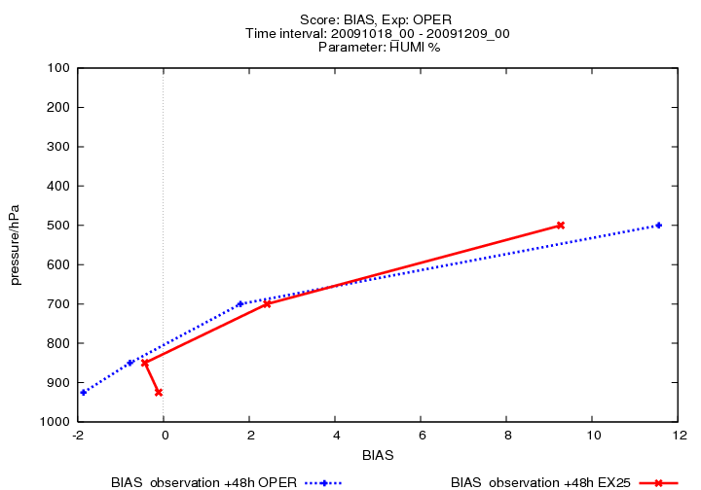
a)
d)
c)
e)
f)
b)
Figure 3: Verification against observations from 4 sounding stations surrounding Austria and at Vienna for the period 2009-10-18 to 2009-12-09: CANARI+3D-Var (red), operational run without additional assimilation (blue) 12UTC runs. Bias (abscissa) against pressure height is displayed. 12h lead time (left; a,c,e) and 48h lead time (right; b,d,f). Parameters are: temperature in K (top a,b), wind in m/s (middle c,d) and relative humidity in % (bottom e,f). Take care of the different scaling of the x-coordinates.

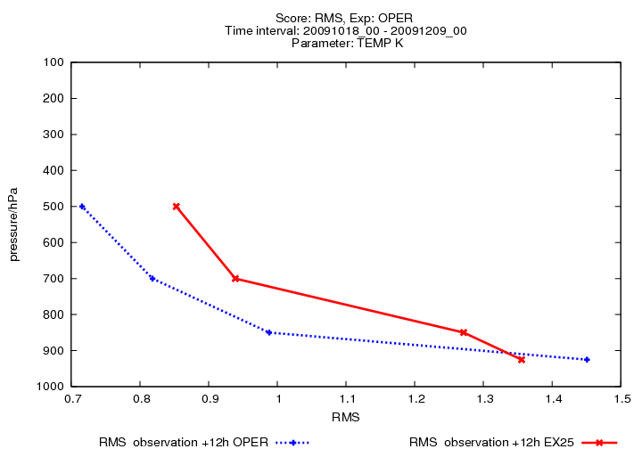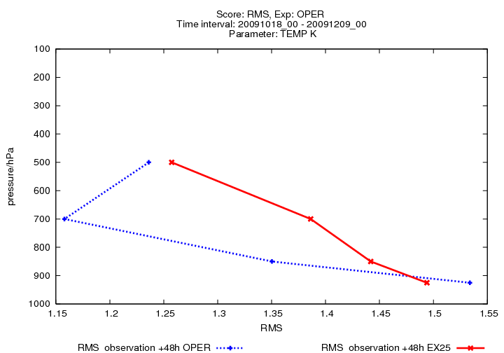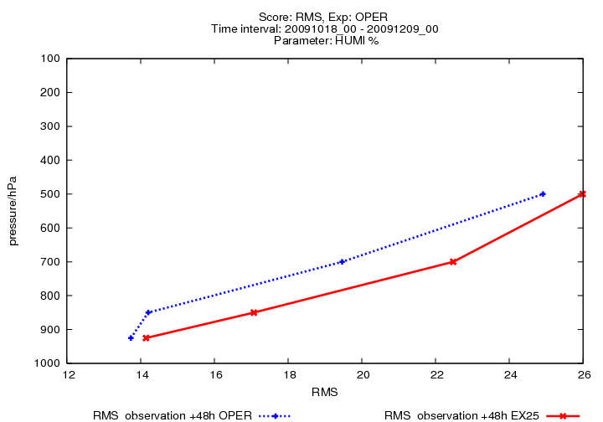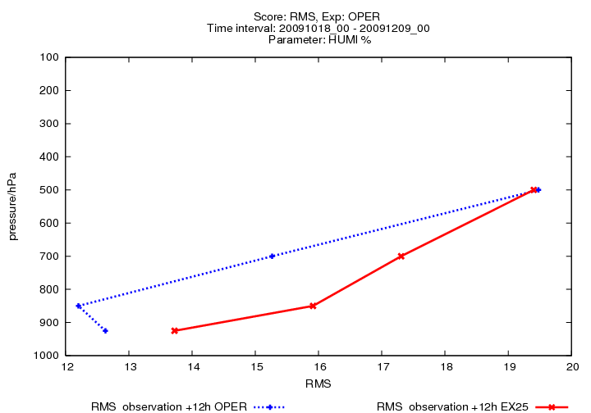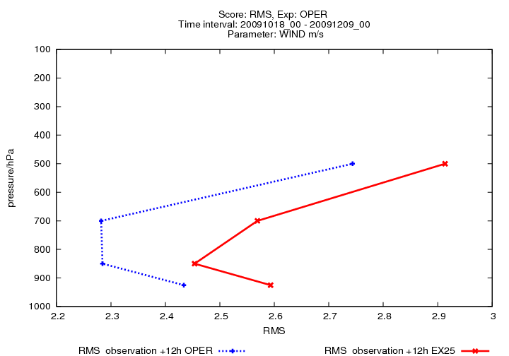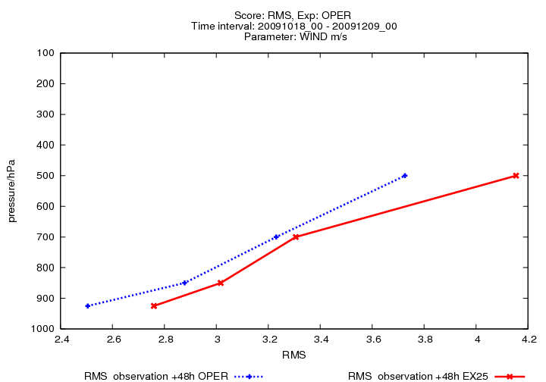
a)
b)
d)
c)
e)
f)
Figure 4: As Fig. 3 but RMS against pressure height.

Monitoring of 3D-Var
The LACE data monitoring software version 2, which was developed by Hungarian meteorologists, and is distributed by the LACE webpage, was successfully installed at ZAMG in December 2009. The necessary ODB input data are extracted regularly by MANDALAY and stored for the pre-operational long cut off runs. The monitoring is correctly working at ZAMG since 11th January 2010. For an example see Fig. 5.
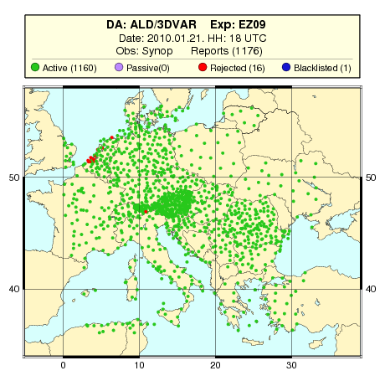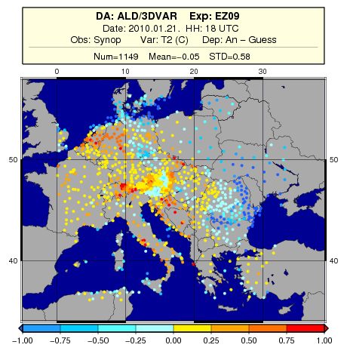
Figure 5: Example of the LACE monitoring software output for 3D-Var+CANARI experiment. Used SYNOP stations (left), T2m analysis minus guess of 3D-Var before blending with CANARI (right) at 2010-01-21 18 UTC.

Further plans
Due to the less convincing results of 3D-Var at ZAMG, there is further need for improvement. The number of assimilated observations increased (see table 1) and should further increase by using additional observation systems. Unfortunately, some sounding stations especially over Austria and Slovenia observe at 03 UTC, which is disadvantageous for a 6h cycle of 3D-Var. An additional analysis step at 03 UTC could possibly improve the overall analysis quality. The background error statistics should be tuned: As a first step the namelist variable “REDNMC” in namelist “NAMJG” is modified in the range from 1.0 to 0.7. A more sophisticated and variable specific tuning (errgrib, B-Matrix) should be envisaged. To use more satellite data and the newest version of bias correction an upgrade from CY32t1 to newer versions could be useful. The relatively coarse vertical resolution of ALADIN-Austria in low levels compared to other LACE domains might be optimised by shifting or adding vertical levels.

1.6 Investigation of the optimal order of the two assimilation systems (3D-Var and CANARI)
The order of running 3D-Var and CANARI during the assimilation cycle could have some impact on the results. Therefore an additional experiment was implemented at ZAMG where CANARI surface assimilation used the output of 3D-Var as first guess. This experiment (serial hereafter) ran about one month parallel to the pre-operational version (parallel hereafter). An experiment where 3D-Var uses CANARI output as first guess was prepared but did not run so far due to limited computer resources and limitations in maintaining several cycles at the same time. The verification of the experiments showed that the difference between “serial” and “parallel” is nearly negligible (Fig. 6). The bias is slightly higher in the “serial” version especially for small lead times and 12 UTC run RH2m (Fig. 6d). Although for some grid points mainly outside of Austria at single analysis steps larger deviations occurred, a significant impact on forecast quality by switching between the two versions of assimilation should therefore not be expected. It should be mentioned that T2m was not assimilated in the 3D-Var part of these two experiments.
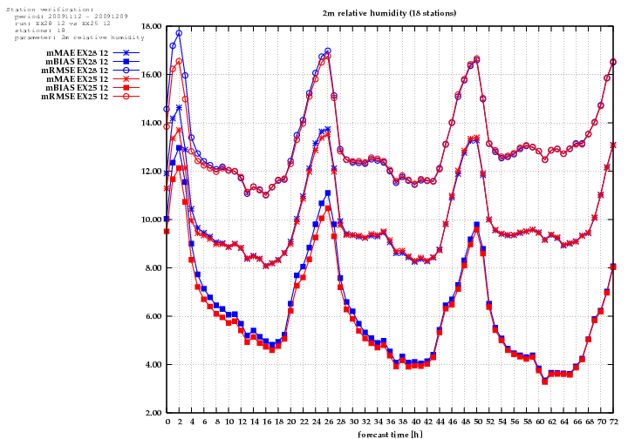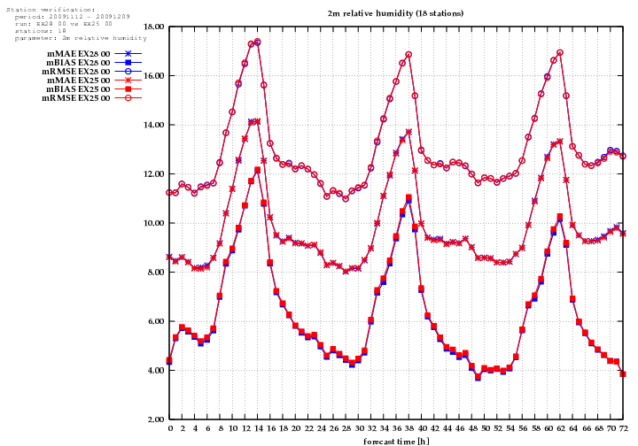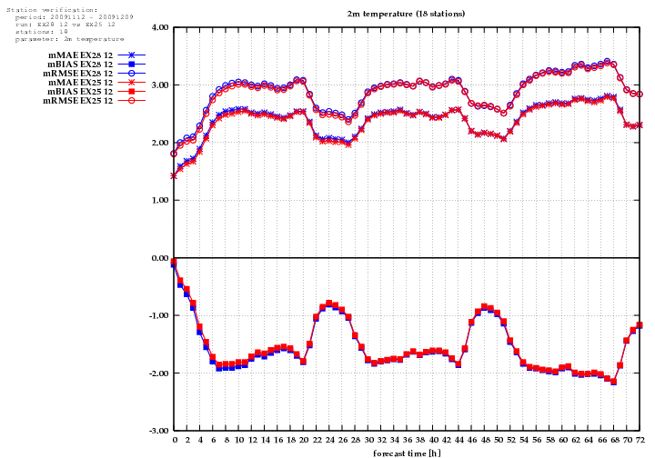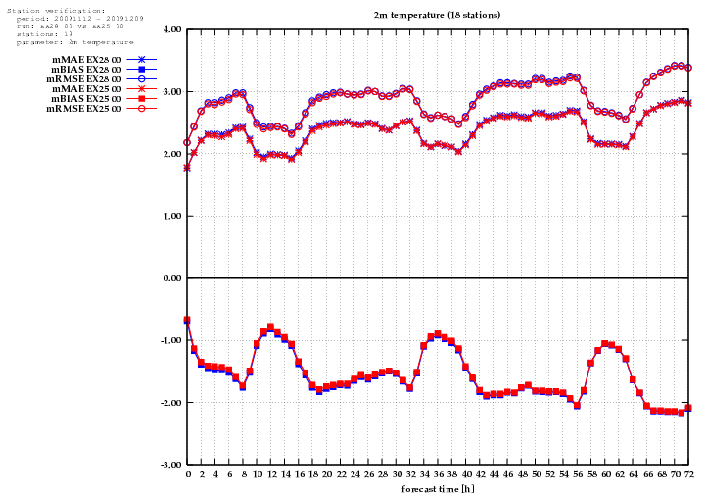
a)
b)
d)
c)
Figure 6: Verification of T2m (top; a,b) and RH2m (bottom c,d) for the period 2009-11-12 to 2009-12-09: Bias (squares), MAE (crosses), RMSE (open circles) against lead time. 3D-Var+Canari “parallel” (red) and “serial” (blue). a), c) 00 UTC runs verified against 18 Austrian stations. b), d) 12 UTC runs verified against the same 18 stations.

Long-term research topics

Soil moisture assimilation with SURFEX (Stefan Schneider)

Validation of ASCAT Soil Moisture Products
ASCAT soil moisture products have been, until now, mainly compared with ERS scatterometer derived surface soil moisture values, showing that the two satellites agree well, which suggested a good quality of the ASCAT surface soil moisture product. Nevertheless, it is desirable to compare ASCAT data also with other data sources. Investigations by ZAMG concerning this topic hark back to ASCAT data delivered since May 2009, using the most recent retrieval algorithm. For verification purposes, ALADIN soil moisture forecasts of the upper soil layer (soil depth ~1cm) are compared to the ASCAT soil moisture measurements (valid for the uppermost 0.5-2cm). To compare both data sources on the same grid, ASCAT data have been interpolated from the 25km grid to the 9.6km grid of ALADIN with an inverse distance weighting algorithm for the whole ALADIN-AUSTRIA domain. ASCAT data are not available at a particular time each day, so ASCAT data from a time window of six hours are compared to the 9hourly forecast of the 00UTC- and 12UTC-run of the model.
Comparisons of soil moisture measurements and forecasts for the upper soil moisture have been computed for several months (June to October 2009). Results are displayed in Figure 7. For each month, two regression lines are drawn in the graph. Dashed lines (index “noflags”) indicate comparisons the quality flags (WMO code 40005 and 40006) of TU Wien were not taken into account for. Solid lines (index “flagsused”) are indicating comparisons using these quality flags. This means that ASCAT measurements were not taken into account if any of the quality flags was set ≠0. It can be seen that for all 5 months investigated the agreement between ALADIN and ASCAT is better when the quality flags are used. This indicates that the flags are a valuable help for high quality ASCAT measurements. Unfortunately, there is one undesirable effect of the quality control: the amount of ASCAT measurements is reduced by ~90%, resulting in rather sparse soil moisture coverage for Europe, which makes them nearly useless for assimilation purposes. To identify more details of the distribution of soil moisture values, histograms for 10 days time periods have been created (not shown). Only grid points providing values for both ALADIN and ASCAT are used for the comparison, TU Wien quality flags have been considered. The distributions are quite different, especially for dry conditions. The (local) maximum at ~30kg/m2 for ALADIN has no equivalent in the ASCAT distribution, while very dry soils are missing in the ALADIN distribution (due to ALADIN model physic).
It is planned to compare these findings to investigations at European test sites like SMOSMANIA and to in situ soil moisture measurements in Austria.
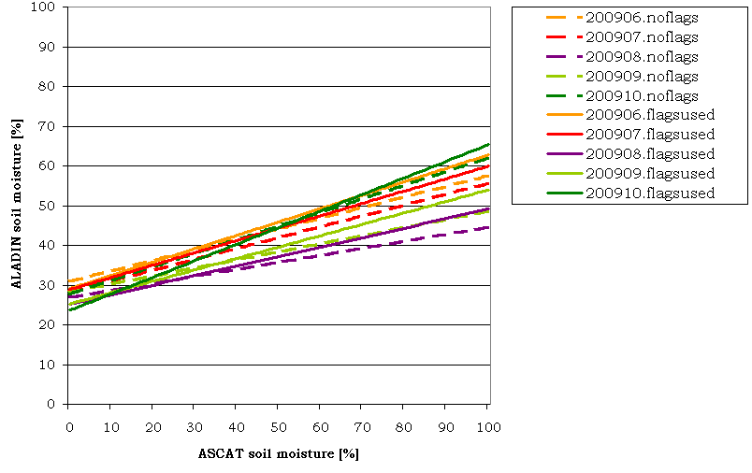
Figure 7: Regression lines for ALADIN (ordinate) vs. ASCAT (abscissa) soil moisture values.

NWP soil moisture Data Assimilation
SURFEX with the Extended Kalman Filter approach has been installed and tested in cooperation with Météo-France at ZAMG. Using this package, it is now possible to assimilate ASCAT soil moisture data in the regional NWP model ALADIN, operated at ZAMG, both for real time applications and for historical case studies. Furthermore, the debiasing method of Drusch et al. (2005), called CDF matching, has been implemented for the pre-processing of the satellite measurements and is in operational use now. The approach of Scipal et al. (2008) was tested too. Unfortunately, long time series of satellite data are necessary to determine the transfer function for this method, which are not jet available for ASCAT.
- Debiasing
ASCAT measurements are interpolated to the ALADIN grid (inverse distance weighting approach), debiased using the CDF matching method and accumulated to ASCII-files (containing data of one hour) in operational mode at ZAMG. For debiasing, several regression lines have been tested, e.g. the ones displayed in Figure 8. There are some significant differences which can be explained by – on the average – drier and moisture conditions for Europe. To find out a way to determine the best regression line for each actual measurement will be a main goal of further investigations.
Figure 8: 5th order polynomial regression lines for several 10day-periods. Positive values on the ordinate indicate that ALADIN is moister than ASCAT and vice versa.
- Assimilation
To test the effect of additional superficial soil moisture data assimilation on the quality of the model output, historical forecasts are recalculated, using the operational version of ALADIN (cy35t1) with the additional SURFEX module. The summer months of 2009 have been defined as testing period for the comparison. There have been many interesting synoptical situations with convective events and as well as flooding events which will be investigated. To quantify the benefit of the data assimilation, several verification tools are used. They are based on point-wise verification with in situ measurements of automatic weather stations (TAWES) in Austria; furthermore SAL (Wernli et al., 2008) is implemented in the verification tool to determine the impact of the assimilation on the precipitation distribution of the forecasts.
Figure 9 displays results for the forecasted 2m temperature for 58 stations in the Austrian lowlands (all stations are situated below 500m). Mean statistical measures for forecasts up to 48 hours of 13 consecutive 12UTC-runs from May 25th to June 6th 2009 are plotted. Large differences can be seen for the bias which is clearly reduced for this case study due to soil moisture assimilation. MAE and RMSE are slightly reduced for most of the forecast range, indicating that the data assimilation is useful for this special case. This is of course a promising result for further studies.
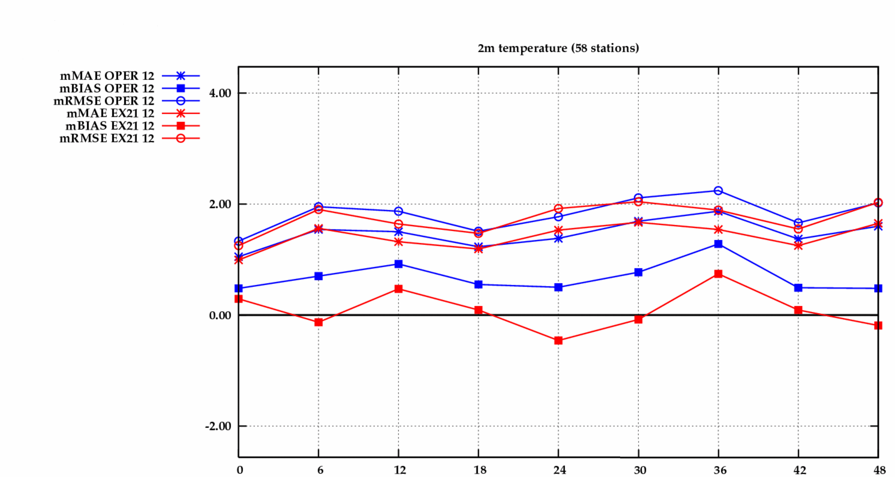
Figure 9: Verification of 2m temperature at 58 automatic weather stations in Austria (situated below 500m) for all 12UTC ALADIN forecasts from May 25th to June 6th 2009, without (blue) and with (red) SURFEX data assimilation. The ordinate gives the mean bias, RMSE and MAE in Kelvin; the abscissa indicates the forecast range in hours.

GPS assimilation (Xin Yan)

Assimilation of Ground based GPS zenith total delay (ZTD) inside ALADIN/Austria
There are 2 objectives of this research topic:
1) To implement technically the assimilation of ZTD observations into ALADIN/Austria.
2) To conduct three experiments to investigate the impact of assimilating high density Austrian GPS ZTD data (provided by the Technical University of Vienna) on weather forecast, especially for extreme cases in the mountain region.
Cycle 32T1 is used for the assimilation.
First objective deals with the following issues:
1) To prepare the proper format of ZTD so that BATOR can read it.
The format is obsoul, below is an example of such obsoul file containing ZTD information from 3 stations, valid for 20080326 18UTC (it can be merged using the obsoul_merge.pl tool to yield one big obsoul together with the other oplace data. Then this big obsoul file will be fed into BATOR).
20080326 18
17 1 1003110 46.352 14.474 'BLEITUAT' 20080326 180000 490.6 1 11111 0 128 60.0 1.00000E
-03 2.210220 2147483647
17 1 1003110 47.040 15.294 'GRAZTUAT' 20080326 180000 491.1 1 11111 0 128 60.0 1.00000E
-03 2.213980 2147483647
17 1 1003110 46.362 14.191 'KLAGTUAT' 20080326 180000 452.6 1 11111 0 128 60.0 1.00000E
-03 2.221800 2147483647
2) Perform 1 observation trying experiment to see whether screening and analysis reads the ODB correctly and give reasonable results.
3) If 1) and 2) are ok, then time for some quality control and bias correction for the input ZTD data. This step is following the same method done in Arpege and ALADIN at MF for GPS ZTD assimilation (see documentation http://www.cnrm.meteo.fr/gmapdoc/IMG/pdf_gpssol_procedure_entree_4.pdf). One-month Fg_departure (ZTD observations – ZTD background ) time series (obtained by 1 month screening) is used to calculate all the statistics and a list (called list_gpssol) is generated containing only the proper stations which are suitable for entering the BATOR procedure. Together obtained is the bias for each selected station. Then a procedure called “pregpssol” will read in all the arrived ZTD data and the list, the output is the obsoul file which only contains the right station with bias corrected ZTD values. Then this obsoul file is ready to enter BATOR (see Fig. 10).
List_gpssol
1 big obsoul file with all the ZTD data
1 big obsoul file with only ZTD data from the selected station. Bias corrected.
Pregpssol.x
Merge_obsoul.pl
Obsoul.conv with all Oplace data inside
Figure 10: Process steps of the assimilation.

Second objective consists of conducting 3 cycling experiments for the selected case study:
1) assimilate only OPLACE data
2) add E-GVAP network data ( Sparse European coverage ZTD data)
3) add Austrian local high density GPS ZTD data

So far, the first objective has been completed.

Timetable
who | what | how much(Aug-Dec)
Florian Meier | pre-operational/monitoring/”serial” experiment | 2,5/1,5/1 months
Stefan Schneider | SURFEX assimilation | 3 months
Xin Yan | GPS ZTD assimilation | 2 months

reference list:

Drusch, M., Wood, E.F., Gao, H. (2005): Observation operators for the direct assimilation of TRMM microwave imager retrieved soil moisture. Geophys. Res. Lett., 32, L15403, doi:10.1029/2005GL023623.
Scipal, K., Drusch, M., Wagner, W. (2008): Assimilation of a ERS scatterometer derived soil moisture index in the ECMWF numerical weather prediction system. Advances in Water Resources, 31: 1101-1112.
Wernli, H., Paulat, M., Hagen, M., Frei, C. (2008): SAL – A Novel Quality Measure for the Verification of Quantitative Precipitation Forecasts. Mon. Wea. Rev., 136: 4470-4487, doi:10.1175/2008MWR2415.1.

