Data assimilation activities at HMS in 2009

03/02/2010
Gergely Bölöni and László Kullmann

T1.3: Upgrade the monitoring system at HMS: develop regular monitoring reports for

LACE members, prepare documentation

- A software to generate monitoring reports in PDF format (about 60 figures for the previous 30 days) is prepared. The automatic dissemination of the monitoring reports started in November.

T1.4: Upgrade the preprocessing system at HMS: include new observation types, optimization of data formats

- Direct reading of BUFR ATOVS (NOAA and METOP) and AMV (MSG) data has been tested by DM and Hungarian staff. Also a tool to merge and split tools by time-slots has been developed by DM, which is essential for distribution through OPLACE.
- OPLACE is being migrated to another server that will work as the primary system, while the present application (on the HMS SGI supercomputer) will serve as backup
The BUFR data will be put to OPLACE first in parallel with OBSOUL data for testing and then they will replace entirely OBSOUL (for these data types).

T2.4: Maintenance of the data assimilation system: update with new observation types and follow research and developments

Cycle: We have switched from CY33T1 (from CY30T1) with the operational suite (both assimilation and forecast configurations) by the end of June 2009. The validation went smoothly but the assimilation script had to be drastically cleaned (because of the coding of LAMFLAG inside BATOR), which took quite long time.

- Preprocessing: OPLACE is now used operationally at HMS to prepare observation input files for our assimilation suite (since June 2009). We have an agreement with our IT department to improve the treatment of the raw input data for OPLACE for a better reliability. This basically means that all the raw input data will be stored on the same server (presently they are available by several NFS mounts).

- Observation use: SEVIRI and SYNOP T and RH data are used operationally in the atmospheric 3DVAR since the end of June 2009. Only water vapor channels are used from the SEVIRI radiances, which is the same setting as in Météo France. The impact is positive for the 2m fields (mostly RH) while it is quite neutral in the altitude. The 2m scores are shown on Fig. 1 and 2.

- Variational bias correction: The variational bias correction (VARBC) was tested on a 10 day period in August 2009. Unlike in Météo France the coefficients for bias correction for all the used satellites channels were cycled within the ALADIN 3DVAR. A 5 day coldstart of VARBC was applied before the verification period. Results are neutral for the 2m fields. In the upper air, VARBC implies some reduction of the bias for wind and humidity but strangely for temperature the bias is increased. An example is shown in Fig 3 for 700 hPa.

T3.2: Evaluation of the FGAT/RUC assimilation in comparison with the actual operational assimilation at HMS on a regular basis
The RUC 3-h cycling has been put in a parallel suite in the operational environment of HU for a 4 weeks period (03-27.12.2009). The results are still under evaluation. Verification against ECMWF analysis already shows that there is a degradation in the humidity scores (other variables are slightly improved). Verification against observations is being prepared. One possible reason for the unexpected degradation is the unproper use of VARBC in 3h cycling but it has to be tested out (earlier RUC tests were always done with static bias correction of satellite data).

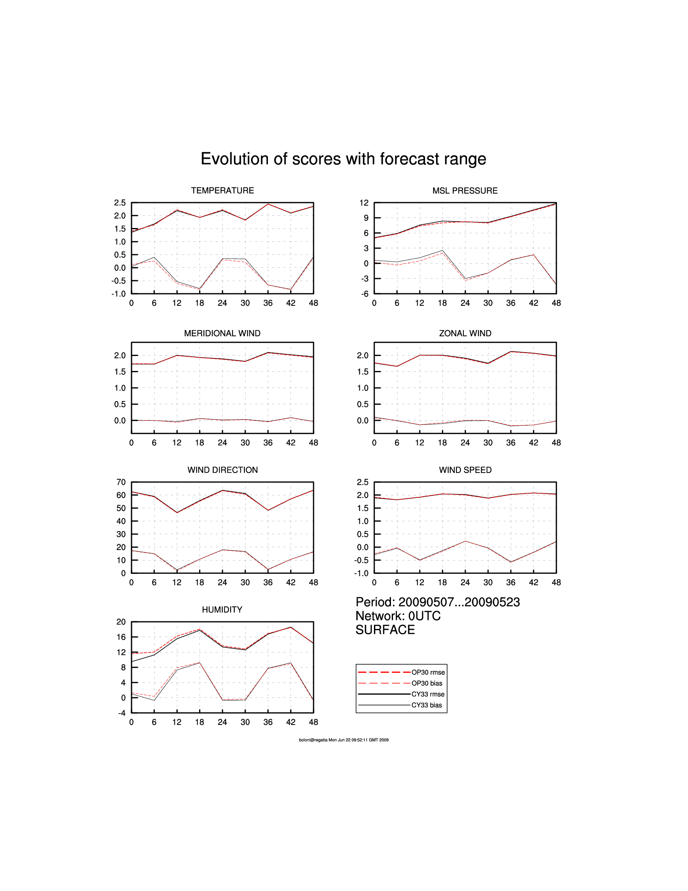
Fig. 1: rmse and bias scores from 00 UTC runs for 2m comparing the former operational run (OP30) and the parallel suite using CY33T1, OPLACE, SEVIRI and SYNOP T and RH data (CY33)

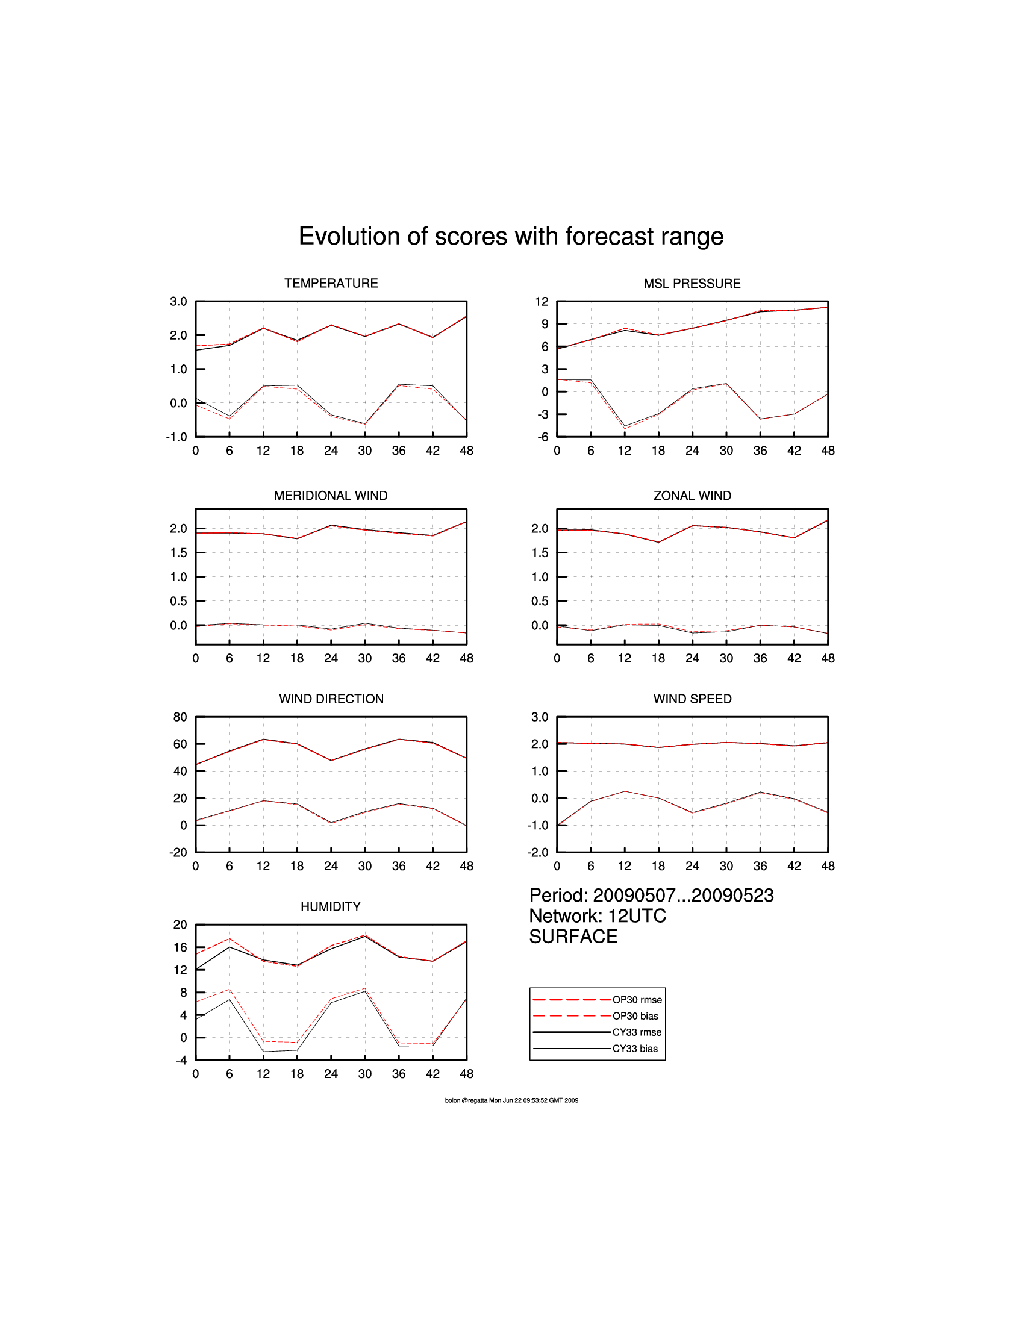
Fig. 2: rmse and bias scores from 12 UTC runs for 2m comparing the former operational run (OP30) and the parallel suite using CY33T1, OPLACE, SEVIRI and SYNOP T and RH data (CY33)
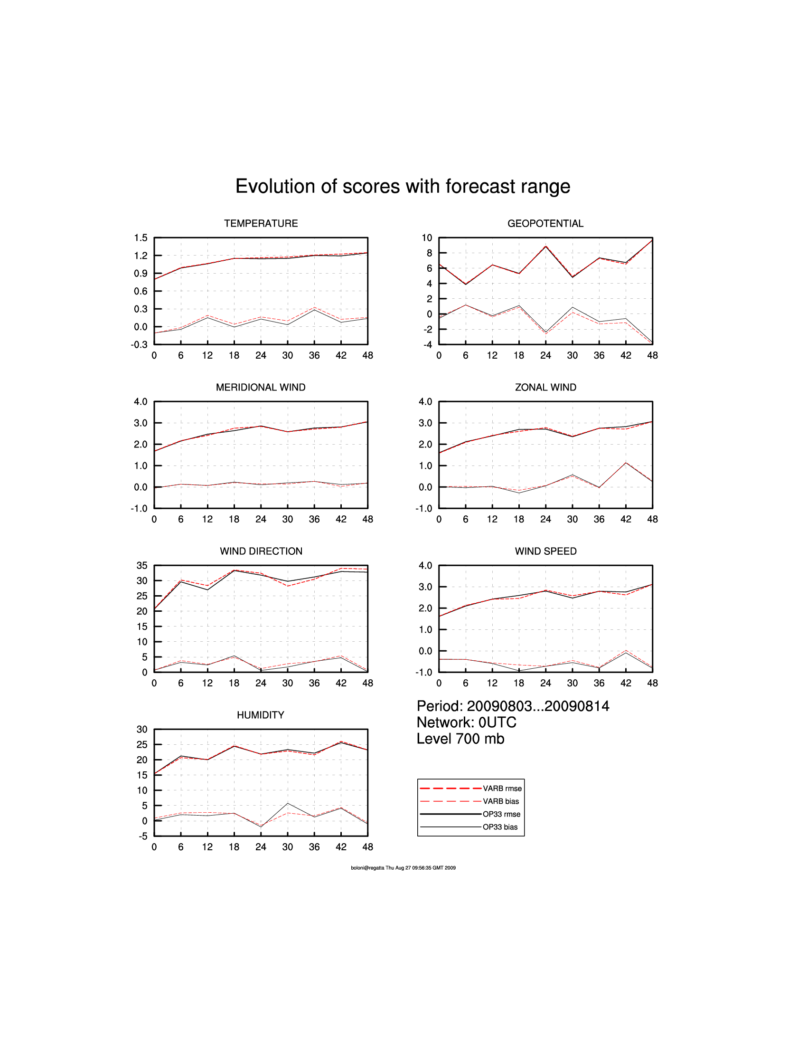

Fig. 3: rmse and bias scores from 00 UTC runs for 700 hPa comparing the present operational run (OP33) and the parallel suite using Variational Bias correction (VARBB)

