Data assimilation activities at ZAMG (Austria)

3DVar test run and tuning (by Xin Yan)

A parallel suite was successfully set up to run an experiment with 3DVAR assimilation over a test period (March 2009). Some properties and results are summarised here:

- B matrix calculation: 22 February 2008 – 12 April 2008 (in total 100 samples of differences also see report of last year)

- Period of parallel run: March 2009

- Cycle: CY32T1 (assimilation) CY35T1 (forecast) long and short cutoff cycle

- Domain and resolution: ALADIN Austria domain (300x270 grid points, 9.6 km T89 L60).

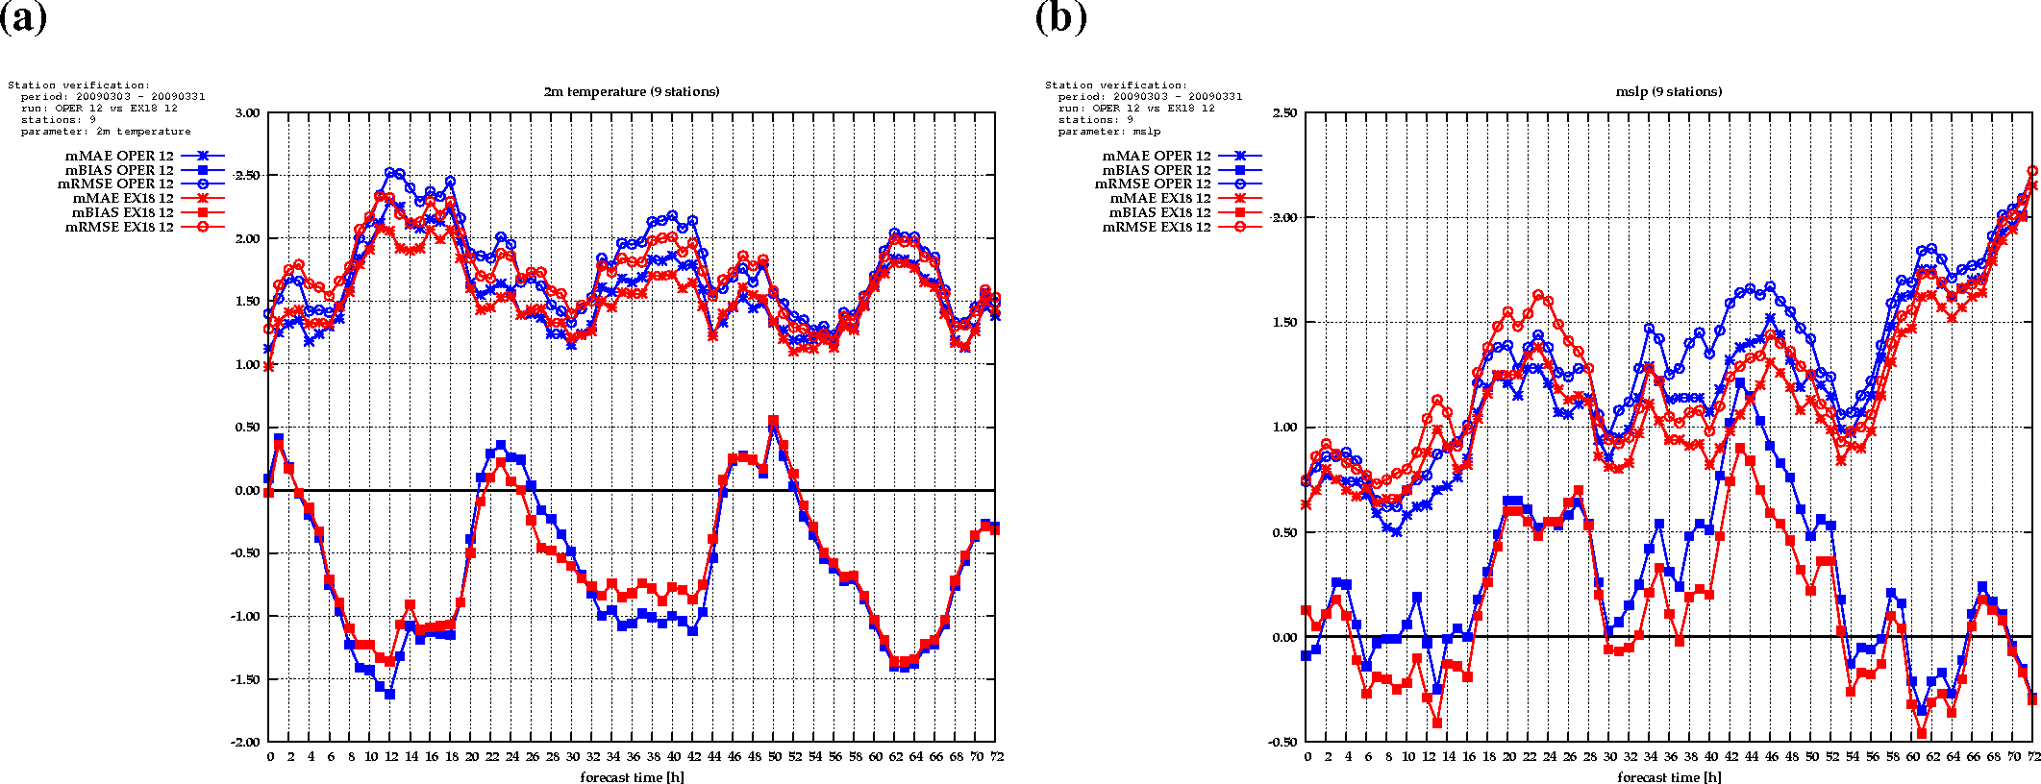
- Results: The results of the 3DVar test run are compared to the operational ALADIN Austria (OPER), which uses just the interpolated ARPEGE analysis without any additional data assimilation as initial condition. The verification is done against radio soundings over Europe (upper air) and 9 weather stations on the ground (T2m, SLP) which are spread over Austria. There is a slight reduction of T2m bias and RMSE especially at night and also a slight improvement of mean sea level pressure forecast compared to the run without assimilation (Fig. 1) The impact of the current 3DVar system on the upper air fields (geopotential, temperature, relative humidity and wind on standard pressure levels) is almost negligible (see Fig. 2, 3).

Fig 1: Results of 3DVar assimilation (March 2009) 3DVar (red) and operational run without assimilation (blue). Bias (full squares), RMSE (open circles) and mean error (crosses) verified against 9 SYNOP stations over Austria. a) T2m, b) MSLP. 12 UTC runs.

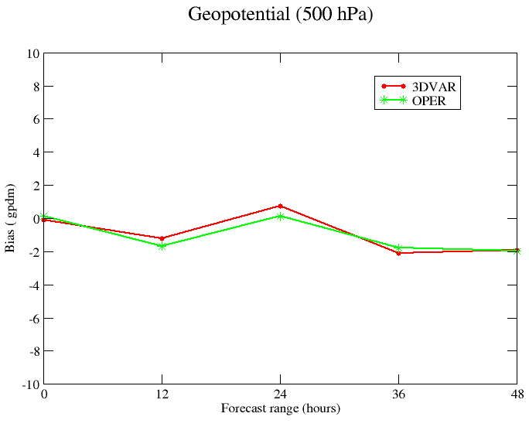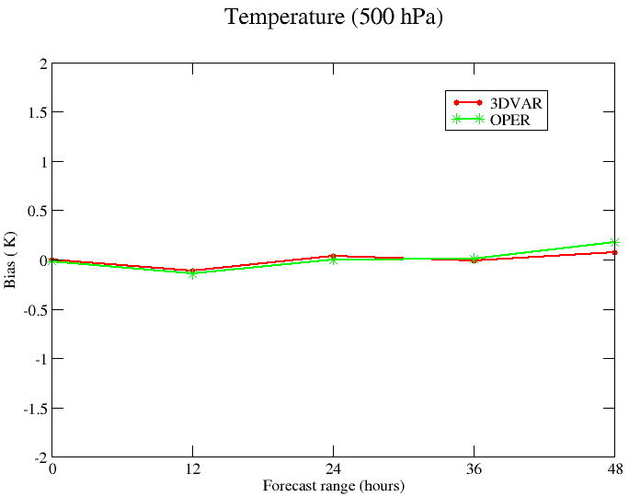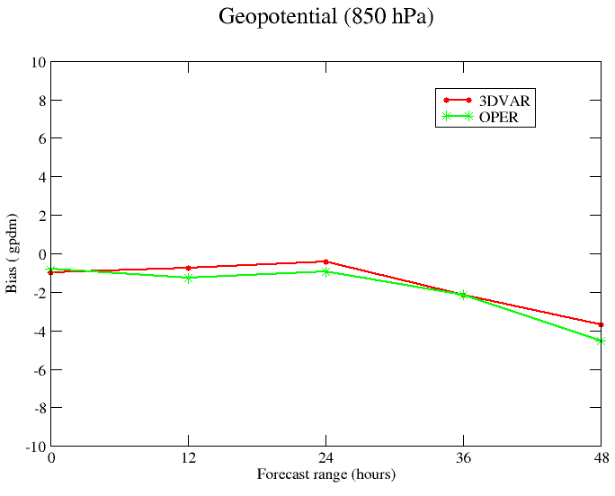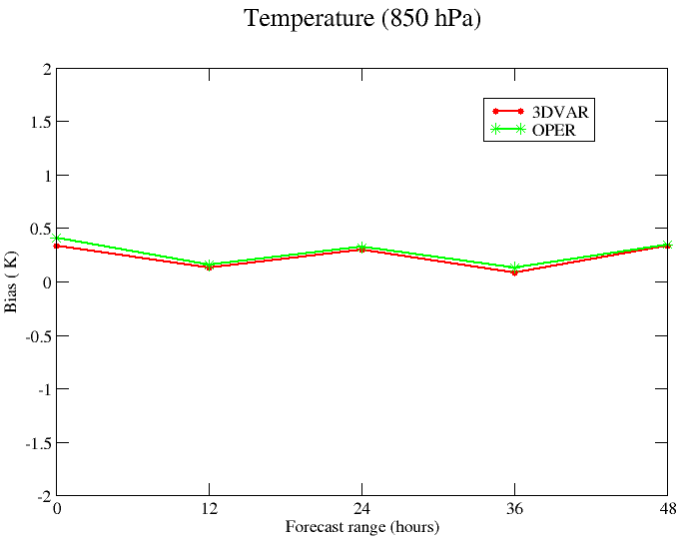
a)
b)
c)
d)

Fig 2: Results of 3DVar assimilation (March 2009) 3DVar (red) and operational run without assimilation (green). Bias compared to radio soundings over Europe. 12 UTC runs.

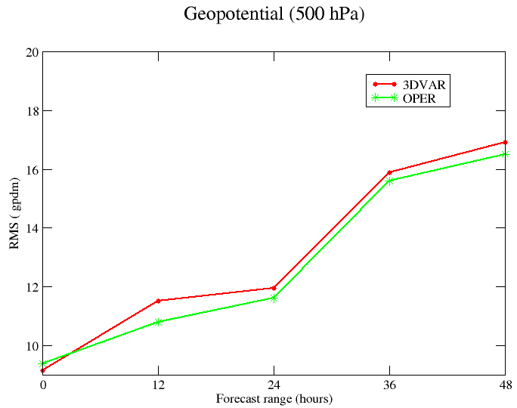
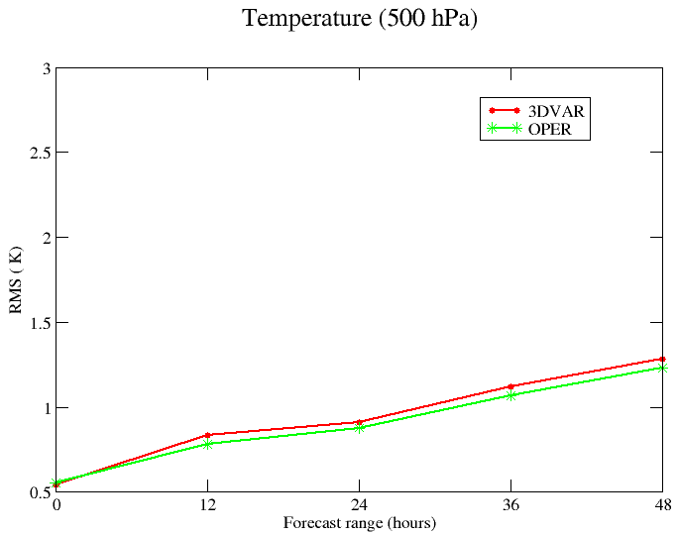
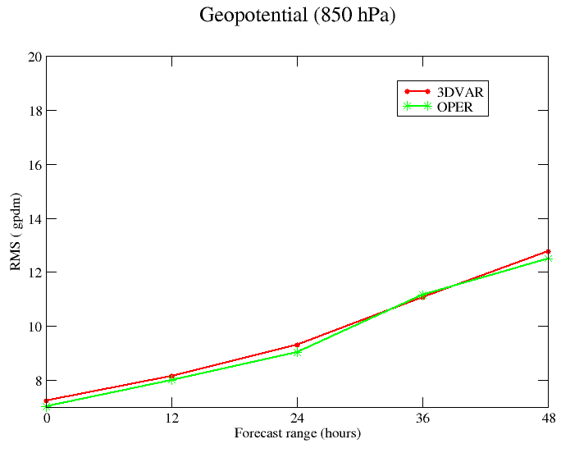
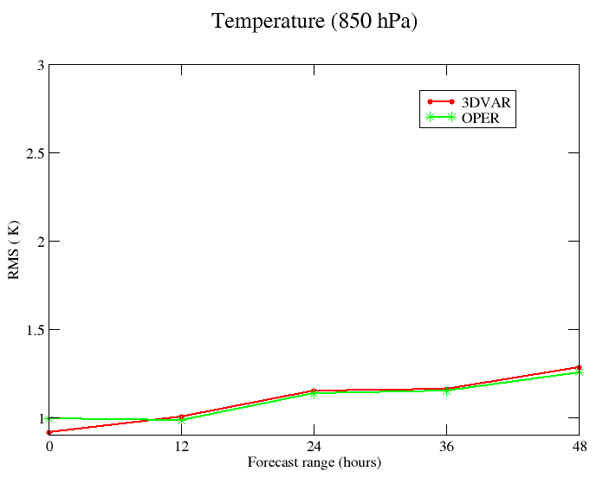
a)
b)
c)
d)
Fig 3: As Fig. 2 but RMSE
Tuning:
- Data thinning (done during screening): Meanwhile thinning of data in the 3DVar system is successfully implemented at ZAMG. This thinning setting follows the HMS settings and is applied on Amdar data and satellite data. The main feature of this new setting is to allow more (about 9 times more) satellite AMSU observations to enter the minimization. In order to do so, a modest is applied for cycle before 33T1. After cycle 33T1, it is enough to set LAMSUB_FULL=.TRUE. More about the thinning settings, see the relevant topic on the lace forum http://www.rclace.eu/forum/viewtopic.php?f=37&t=143 . Results: impact is slightly positive compared to the version without new thinning settings.
- Bias correction: VarBC was planned to be tested but due to the fact that this feature is not available in cycle lower than 33T1, classic bias correction file taken from HMS is used.
- Blacklisting: Both blacklisting methods suggested by the rclace post http://www.rclace.eu/forum/viewtopic.php?f=37&t=136 have been implemented. Still the settings follow the HMS settings. Results: impact is small

- Setup of a pre-operational CANARI-OI+3DVAR assimilation cycle (by Sabine Leroch, Florian Meier, Christoph Wittmann and Xin Yan)

A parallel suite was successfully set up which includes a combined 3DVar and CANARI OI assimilation in a pre-operational environment. Different to the setup at Météo France both parts of the assimilation run parallel using a 6h ALADIN forecast as first guess. The resulting analyses are finally merged by blending (Fig. 4).

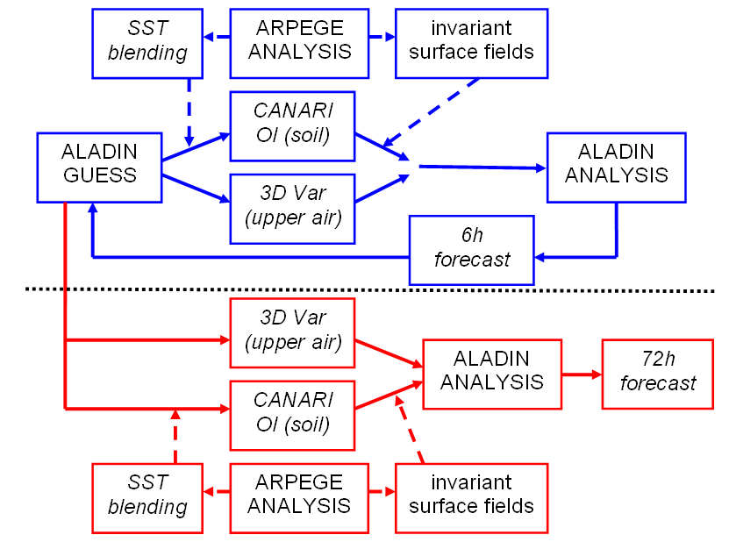

Fig 4: Schematic of assimilation cycle at ZAMG long cutoff (blue) and short cutoff (red)

Cycle: CY32T1 (assimilation cycle) and CY35T1 (forecast)

- Cycling: 6hourly assimilation including long cutoff cycle to calculate first guess and short cutoff cycle to calculate 72 h forecast. CANARI OI (soil moisture and soil temperature) and 3D-VAR (upper air) running parallel and finally the results are merged to generate new ALADIN analysis.
- Used observations: 3DVAR: OPLACE obsoul-files (long and short cutoff) including SYNOP, TEMP, AMDAR, EUROPROFILER and AMSU-A/B data. CANARI: ZAMG database including SYNOP data over Europe and in addition also TAWES station data (partially automatically weather stations) over Austria.

- Domain and resolution: ALADIN AUSTRIA domain (300x270 grid points, 9.6 km T89 L60).

- Period: 01 June to 31 June 2009 and 12 July 2009 until now.

- Further remarks: SST and surface fields, which are not affected by the assimilation, are replaced by values of interpolated ARPEGE analysis. Some difficulties to maintain a stable cycling are caused by the different arrival of the observations and coupling files (the latter arrive mostly later) such that several breaks and waiting cycles are needed in the run script.
- Results: The impact of the assimilation system on the upper air fields is very small (Fig. 5). However, some bias reduction of the geopotential forecasts (about 1 gpdm) and relative humidity forecasts (about 1%) can be detected, while the RMSE is quite similar to the operational forecasts or even slightly worse. The 2m temperature and relative humidity are only very slightly better than in OPER at night especially after 48h lead time and even worse around noon (Fig. 6). The worse results than for 3DVAR only and CANARI only assimilation can be caused by the different periods of investigation and a worse dynamical balance in the combined assimilation system.

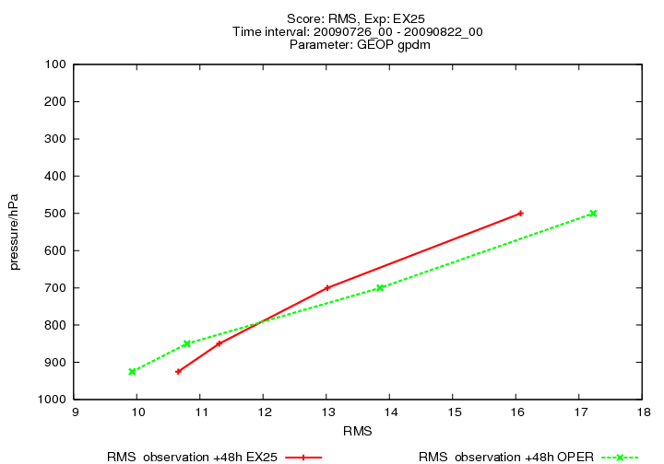
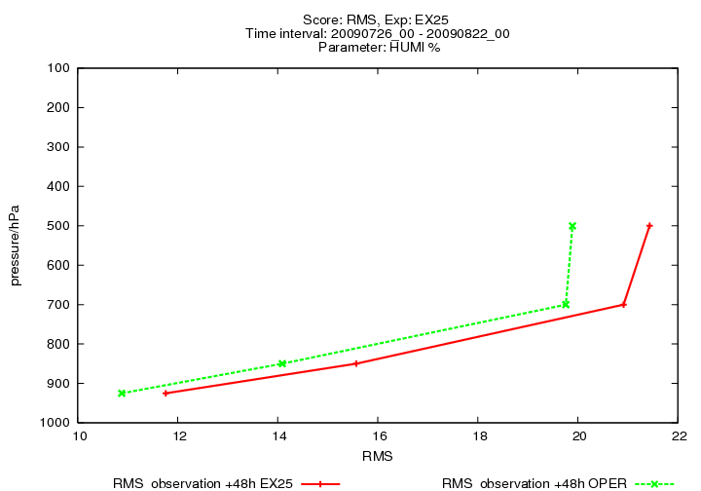
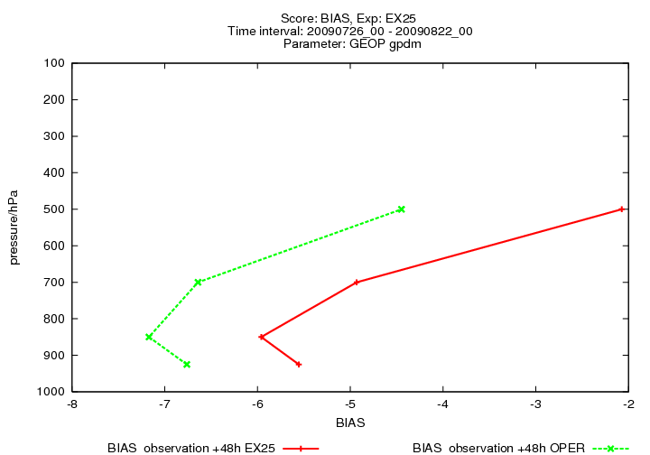
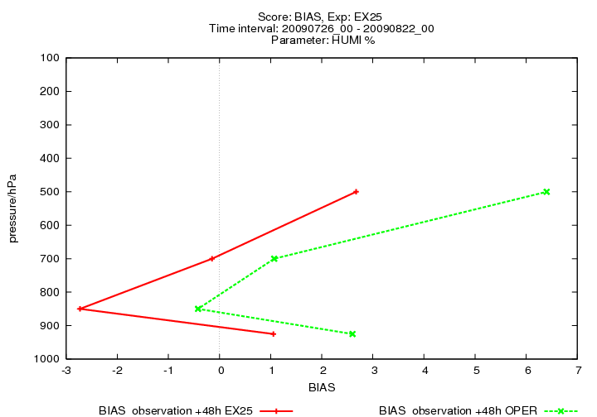
(a)
(c)
(b)
(d)

Fig 5: Results of 3DVar + CANARI OI assimilation (26 July – 22 August 2009)
48 h forecasts verified against radio soundings over Central Europe.
Runs with assimilation (red) and operational forecasts without own assimilation (green).
Vertical section of bias (top) and RMSE (bottom); geopotential (left) and relative humidity (right).
00 UTC and 12 UTC runs.

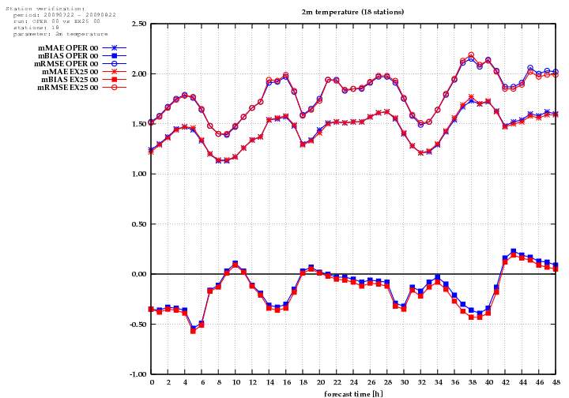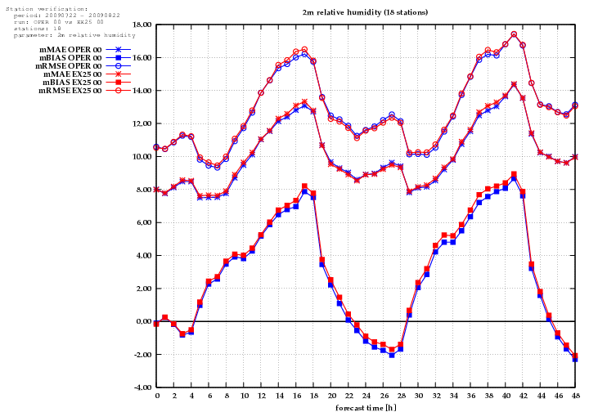

Fig 6: Results of 3DVar + CANARI OI assimilation (22 July – 22 August 2009)
Verification against 18 SYNOP stations over Austria.
T2m (left) and relative humidity 2m (right). OPER without DA (blue). Bias (full squares), RMSE (open circles) and mean error (crosses). 00 UTC runs.

3. CANARI OI test runs (by Sabine Leroch and Florian Meier)
A parallel suite was set up to run a CANARI OI assimilation cycle for the surface parameters. Two experiments were implemented: One uses the SYNOP observations of the PPLACE obsoul files (long cutoff) and the other one uses SYNOP and TAWES observations of the ZAMG database. This means that the density of observations is much higher over Austria (more than 200 additional observations) in the latter one.

- Period of parallel runs: April 2009 until today

- Cycle: CY32T1 (assimilation) CY35T1 (forecast)

- Domain and resolution: ALADIN Austria domain (300x270 grid points, 9.6 km T89 L60).

- Results: The results of the CANARI OI test runs are compared to the operational ALADIN Austria run. All these simulations are verified against 16 SYNOP stations in Austria (T2m) and radio soundings over Central Europe (upper air). The impact of CANARI on the upper air fields is very small (not shown here). The bias and RMSE of T2m is reduced especially at night with CANARI OI (Fig. 7a, c). Some additional improvement over Austria occurred if the denser observation network (with TAWES stations) is used (Fig. 7b, d).

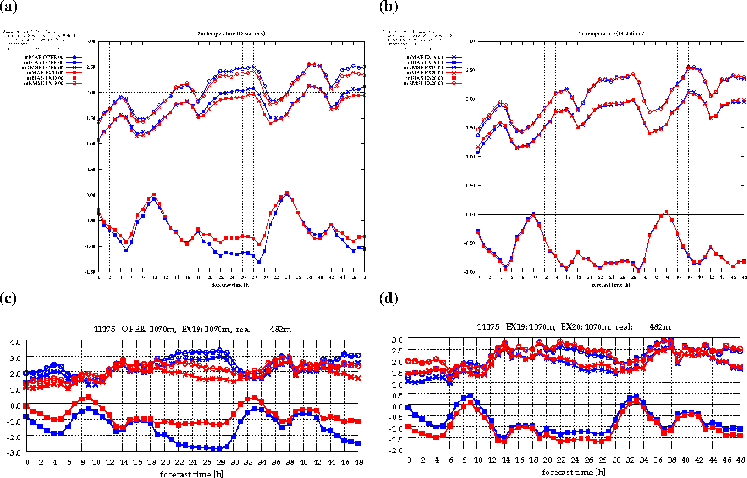

Fig 7: Verification of T2m from 01 May to 24 May 2009: Mean over 18 Austrian SYNOP stations (top), Austrian SYNOP station Bruck a. d. Mur (bottom). Left: operational run (blue) and run with CANARI SYNOP+TAWES (red). Right: CANARI PPLACE (red) and CANARI SYNOP+TAWES (blue). Bias (full squares), RMSE (open circles) and mean error (crosses).

3. ASCAT soil moisture data assimilation with SURFEX EKF (by Stefan Schneider)

The land surface analysis scheme based on the Extended Kalman Filter (EKF), included in the SURFEX offline version v4.8 (provided by Météo France) has been installed recently at ZAMG. The aim of the project is the assimilation of ASCAT soil moisture data in the surface analysis to improve ALADIN forecasts of precipitation and severe weather.

Results:
So far, the debiasing of ASCAT data has been carried out. It is following the CDF method described in Drusch et al. (2005), using operational model data from the ALADIN Austria domain (300x270 grid points, 9.6 km T89 L60). First results (Fig. 8) show a good agreement with findings of Mahfouf (2008), who used ALADIN France and ERS (predecessor of ASCAT) data.
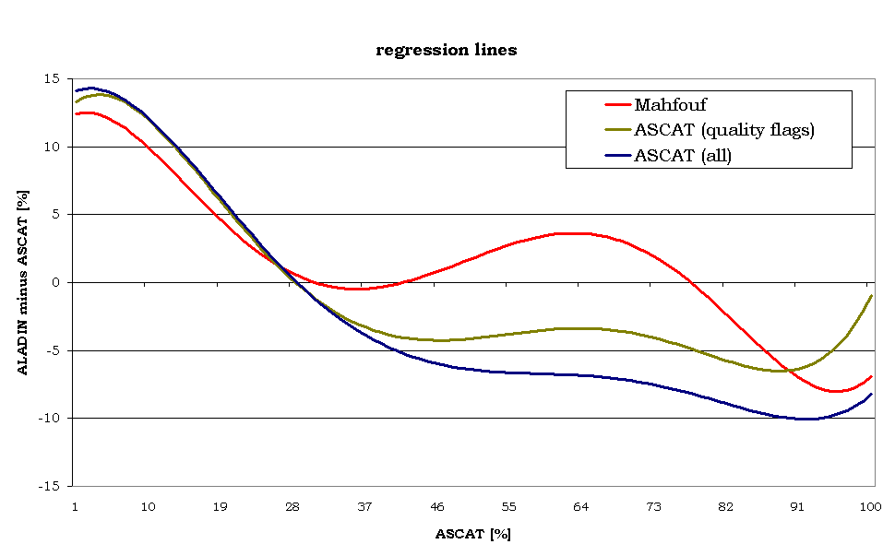
Fig. 8: A 5th order polynomial fit has been done for ASCAT measurements (abscissa) and the difference between ALADIN and ASCAT on ALADIN grid points (ordinate) to receive an analytical bias correction. Red: Regression line of Mahfouf (2008) for ALADIN France and ERS data of 2006. Green: Regression line for ALADIN Austria and ASCAT in June 2009, excluding all ASCAT measurements with a quality flag in the original data set. Blue: Regression line for ALADIN Austria and ASCAT in June 2009, using all ASCAT measurements.

The resulting regression lines will be used to debias ASCAT measurements before they are used for assimilation.

Drusch, M., E. F. Wood, and H. Gao (2005), Observation operators for the direct assimilation of TRMM microwave imager retrieved soil moisture, Geophys. Res. Lett., 32, L15403, doi:10.1029/2005GL023623.
Mahfouf, J.-F. (2008), On the use of ERS surface soil moisture for land data assimilation: Preliminary evaluation against ALADIN surface soil moisture.

