Status report : B matrix validation in ZAMG
    - Xin YAN

Task: Generating B matrix for ALADIN/Austria domain
Method: Ensemble (difference samples generated by ensemble method)
Period: 2008022200 - 2008041100 (in total 100 samples of differences)
Cycle: 32T1

Technical difficulties: Adapting the scripts used from scalar machine to vector machine

1.Use 1 CPU instead of 8 CPUs when making the differences of forecast (since at the end of modified cnt3.F90, the writing statement allows only 1CPU to access the file at a time. Thus using 8 CPUs in the mpi parameter configuration will produce a much smaller difference file with only 1/8 of data written inside)

2.The FORTRAN compiling command at the end of festat, diacov and diabal should use the right options in order to interpret the real number as 8 bytes and integer number as 4 bytes. Difference files were written by modified cnt3.F90 with such format. Incorrect compiling option will result the error in reading the difference files that are in binary format.

3. Adding of subroutine deflev60 in festat. Since there is 60 level in ALADIN/Austria model.

Results:

We have compared our B matrix diagnostic outputs with the Hungarian ones. The main difference between the B matrix diagnostic results from Austria and Hungary lies in the upper level features. This is due to that Hungary uses 49 levels instead of 60 which are used by Austria model. It can be seen from the following two examples that the cross-covariance structures for the low levels are quite similar for the two models. These low levels are rather on the same average heights in ALADIN/Austria and ALADIN/Hungary and the extra levels of ALADIN/Austria are mostly above 25 km (Fig 3). Extra features appear in the Austrian forecast error covariances due to the high levels, such as the covariances between low level specific humidity and high level (unbalanced) temperature (bottom-right corner of Fig. 1.1)

Examples of diagnostic plots:
Vertical covariance of specific humidity and unbalanced temperature in ALADIN/Austria domain (Fig1.1) and in ALADIN/Hungary domain (Fig1.2)

Vertical covariance of temperature and unbalanced divergence in ALADIN/Austria domain (Fig2.1) and in ALADIN/Hungary domain (Fig2.2)

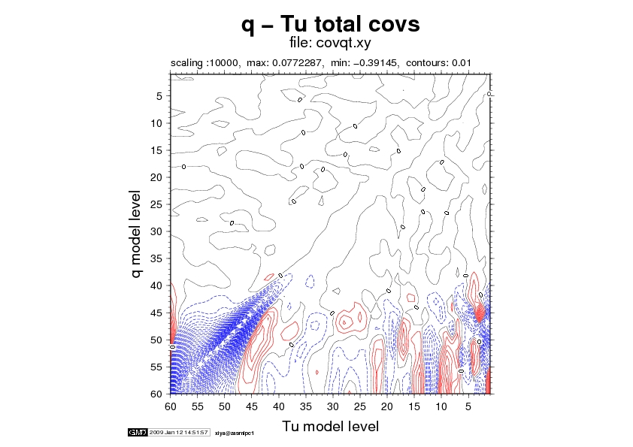
Fig1.1 AT example
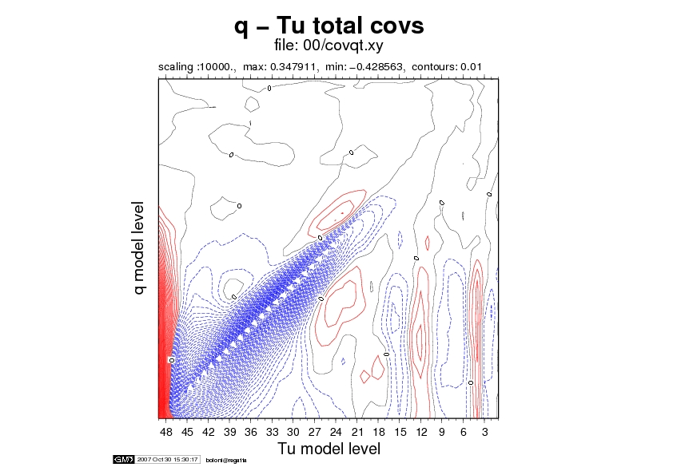

Fig 1.2 HU example

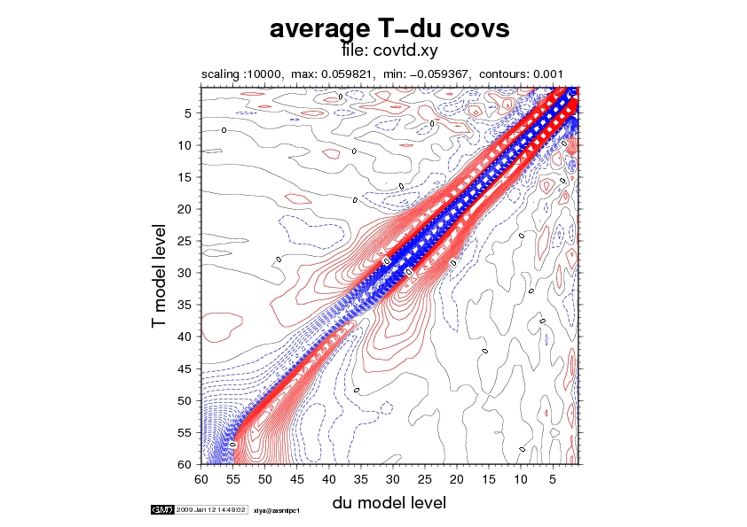
Fig 2.1 AT example

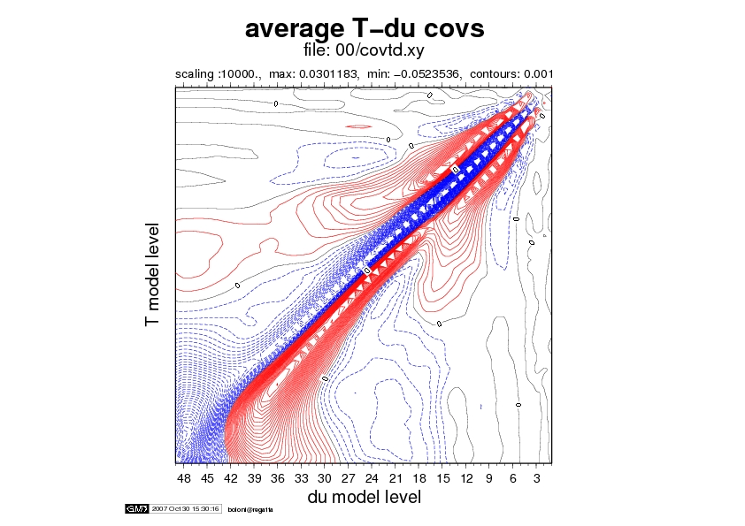

Fig2.2 HU example

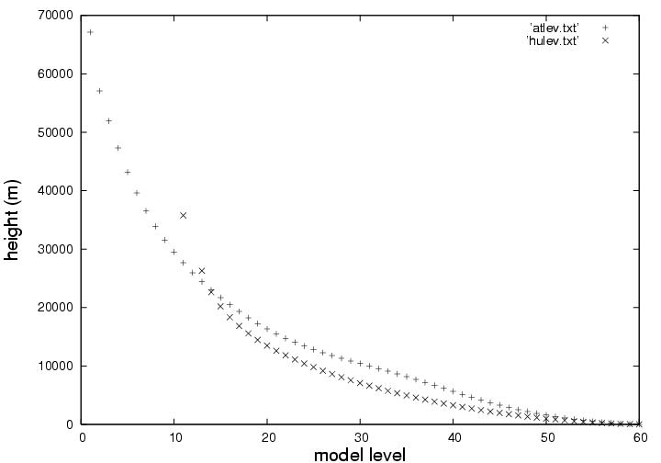

Fig 3: Model height in ALADIN/HU and ALADIN/AT (provided by G.Boloni)

