RC LACE Report on data assimilation:
2008

Gergely Bölöni
06 March, 2009

Content

1. Introduction 1
2. Executive summary 1
3. Project report 2
4. Long-term research topics 6
5. Appendix 1 (Project deliverable D1) 9
6. Appendix 2 (Project deliverable D6) 15
7. Appendix 3 (Recent results within the long term research topics) 29

1. Introduction

According to the new planning practice of LACE, the work has been structured in two different classes. On the one hand a project was prepared with a strict definition of operational deliverables and a clear specification of needed resources on a 2-3 year time scale. On the other hand long-term research topics were described, which were not in the state of delivering operational benefits during the next 2-3 years but rather on the 3-5 year time scale. This report also consists of two parts. The first part describes the achievements in the frame of the projects (operational deliverables), the second part describes the progress in the long term research topics.

2. Executive summary

This section describes the total sum of used human resources (projects and long-term research topics) during 2008. Table 1 gives an overview about the ratio of planned and used resources as a breakdown by countries.

 | AU | CZ | HR | HU | RO | SI | SK | Total
Projects | 4.5/4 | 7/7 | 4/4 | 8/8 | 0/4 | 2.5/4 | 0/4 | 26 / 35
Long term research topics | 0/0 | 1.5/3 | 0/0 | 3/3 | 0/0 | 3/3 | 1/1 | 8.5/10
Total | 4.5 /4 | 8.5/10 | 4/4 | 11/11 | 0/4 | 5.5/7 | 1/5 | 34.5/45

Table 1: Used/planned resources (person.months) for data assimilation during

2008 as a breakdown by countries

3. Project report

Project name: Development of an operational data assimilation system for LACE
Responsible person: Gergely Bölöni
Responsible Center: HMS

3.1 Relevant deliverables

Figure 1 shows the schedule of deliverables in the project (taken from the project plan). This reflects that the relevant deliverables for the year 2008 are D1 and D6, which are detailed below:

Jan 2008
Jan 2009
Jan 2010
Jan 2011
Task 1
D1
D2
D3
D4
D5
Task 2
D6
D7
Task 3
D8
D9
D10
Jul 2009
Jul 2010

Figure 1: Schedule of deliverables

- D1: Software for observation preprocessing for data assimilation at HMS (GTS and EUMETCAST data). Daily distribution of preprocessed data to LACE members (end of 2008).
- D6: Reports on installation and validation of 3DVAR (upper air) and CANARI OI (surface) analysis systems in LACE centers (end of 2008).

3.2 Status summary

D1: The software for common observation preprocessing (OPLACE) has been prepared (November-December 2008). All GTS and EUMETCAST data are processed hourly. The data are accessible to all LACE members since the 19 December 2008 through an ftp server of HMS. The detailed technical description of OPLACE can be found in Appendix 1.

D6: This deliverable relies mostly on the local staff in each member country. Considering the present status of the local staffs it is estimated that there will be no problem to deliver this work in CZ and HR and HU. AU and SI will deliver the work partly (only surface assimilation) due to not satisfactory manpower. RO and SK will not be able to deliver anything from this work due to the lack of staff.

3.3 Corresponding tasks

The corresponding working tasks to D1 and D6 deliverables are listed in Table 1. They are also explained and the work on each subtask is reported in this section.

Deliverable | Task | Needed subtasks
D1 | Task 1 | T1.1, T1.2
D6 | Task 2 | T2.1, T2.2

Table 1: Tasks corresponding to the actual deliverables

Task 1: Centralized preprocessing and monitoring of observations for data assimilation
In order to avoid duplication of work on data preprocessing a centralized preprocessing system is to be created at HMS. The plan is to do the central preprocessing in the highest amount possible but keeping the freedom of using different ALADIN/ODB (ODB: Observational Data Base) cycles in the centers. This compromise results in the central preparation of all the input observation files (ASCII, BUFR, GRIB) for the program called BATOR, which prepares the ODB database. The BATOR program is regularly maintained as a part of the ARPEGE/ALADIN code, consequently it can be relatively easily installed and validated. Concerning the source of the data, on the short term (2008-2009) only the GTS and EUMETCAST data are planned to process. It is only starting from 2010, that we will consider an exchange of national non-GTS radar and SYNOP data. It should be kept in mind that a central data preprocessing will possibly be useful for HIRLAM countries too. However this plan does not contain common actions yet with HIRLAM, we should consider either an entirely common centralized preprocessing system or at least a common strategy for defining the preprocessing data flow and formats.

T1.1: Improve reliability of the present preprocessing and monitoring system at HMS
Description: A good starting point for the centralized preprocessing system is the one already used operationally at HMS. However, with the increasing responsibility of reliable data distribution, the present system requires some improvement. It would include a possible simplification of data flow (changes of formats) and an improvement of the local monitoring of the data preparation process (automatic warnings if a subset of data is not available or the preprocessing failed).
Realization: A 2 weeks kick-off stay (12/09-28/09/2008) has been organized in Budapest for the DM and the Hungarian staff. Within this stay, proposals were made for the cut-off strategy, for the data formats for delivery and a tool was developed to merge and split up ASCII observation packages. These proposals have been realized in practice during October-December 2008 with some modifications locally at HMS and with a remote work of DM on the HMS computers. The common preprocessing started in a regular manner in December under the name OPLACE and the data are accessible for all LACE members since the 19th of December.
Documentation: A report about the kick-off working week is available from Alena Trojáková (DM). A technical description of OPLACE is attached to this report (Appendix 1) and is available on the LACE forum.
Resources: 4/4 p.m.
Staff: László Szabó (2/2 p.m), Gergely Bölöni (1/1 p.m), DM (1/1 p.m.)
Schedule: 2008/2

T1.2: Setup technical means for data distribution
Description: A decision had to be taken about an appropriate technical way for the data distribution. Some organizational work had to be done with the IT department of HMS to realize the idea.
Realization: It was decided that the partners download the preprocessed observations via Ftp from HMS. In November 2008, an Ftp server (kindly provided by the IT team of HMS) has been established for the OPLACE data distribution outside the HMS firewall.
Documentation: A technical description of OPLACE is attached to this report (Appendix 1) and is available on the LACE forum.
Resources: 1/1 p.m
Staff: Gergely Bölöni (1/1 p.m)
Schedule: 2008/2

Task 2: Installation of atmospheric (3DVAR) and surface (CANARI OI) analysis systems in LACE centers
The concept is to run data assimilation in each center separately in order to prepare the analysis right on the local model grid and in order to leave some freedom in the choice of the operational setup of the data assimilation system (i.e. blending with a global analysis, choice of the background error covariances, etc.). To achieve this, first of all, it is essential to compute background error covariances for each operational domain and to install and validate all the configurations of the ARPEGE/ALADIN software, which are needed in data assimilation. As a second step an assimilation cycle is to be set up, which runs on a regular basis giving a comparison with the actual operational model. Last but not least, a continuous work is required for the scientific maintenance of the data assimilation system (update with new observation types, application of results coming from research and development).

T2.1: Computation of background errors on local domains
Description: The computation of background errors requires a set of forecast differences created with one of the sampling methods (NMC, lagged-NMC or Ensemble method) according to the local preferences. These forecast differences are the inputs for the software for the computation of the background error covariance matrix, which should be installed and validated in each center.
Realization: local work (using the helpdesk on the RC LACE forum). Presently, local B matrices are computed for the AU, CZ, HR and HU domains.
Documentation: There is an installation package and its description prepared on the RC LACE forum. Reports on the B computations are attached to this report (Appendix 2).
Resources: 3/7 p.m
Staff: Gergely Bölöni (1/1 p.m), Kristian Horvath (1/1 p.m), Alena Trojáková (1/1 p.m),
Xin Yan (1/1 p.m), Mirela Niculae (0/1 p.m), Benedikt Strajnar (0/1 p.m),
SK colleague (0/1 p.m)
Schedule: 2008/1,2

T2.2: Installation and validation of needed model configurations for data assimilation
Description: As the input observations are required in ODB format in the ALADIN software, a tool for data conversion is to be installed and validated (BATOR). The inputs for BATOR are created and disseminated through the centralized preprocessing system described in Task 1. The BATOR program is part of the ALADIN software and beside data conversion it performs blacklisting and setting up of observation errors. Atmospheric and surface data assimilation in ALADIN requires the installation and validation of 3 further model configurations: conf. 002 (QC of observations for variational analysis), conf. 131 (variational analysis) and conf. 701 (optimum interpolation for the surface).
Realization: local work (using the helpdesk on the RC LACE forum). Presently the complete assimilation (002, 131 and 701) works in CZ, HR and HU. The atmospheric assimilation till screening (002 but not 131) and the surface assimilation (701) already works in AU. The surface assimilation (701 alone) works in AU and SI.
Documentation: Reports on the installation and validation work are compiled in Appendix 2.
Resources: 14/23 p.m
Staff: Gergely Bölöni (3/3 p.m), Tomislav Kovacic (1.5/1.5 p.m), Antonio Stanesic
(1.5/1.5 p.m), Alena Trojáková (3/3 p.m), Sabine Leroch (3/3 p.m), Xin Yan (0.5/0)
RO no staff! (0/3 p.m), Jure Cedilnik (1/1.5 p.m), Benedikt Strajnar (1.5/1.5 p.m),
SK no staff! (0/3 p.m), DM (2/2)
Schedule: 2008/1,2

Tasks/members | AU | CZ | HR | HU | RO | SI | SK
T1.1 | 0/0 | 1/1 | 0/0 | 3 /3 | 0/0 | 0/0 | 0/0
T1.2 | 0/0 | 0/0 | 0/0 | 1/1 | 0/0 | 0/0 | 0/0
T2.1 | 1/1 | 1/1 | 1/1 | 1/1 | 0/1 | 0/1 | 0/1
T2.2 | 3.5/3 | 5/5 | 3/3 | 3/3 | 0/3 | 2.5/3 | 0/3
Total | 4.5/4 | 7/7 | 4/4 | 8/8 | 0/4 | 2.5/4 | 0/4

Table 2: Used/planned resources as a breakdown of subtasks and LACE member countries

Persons | T1.1 | T1.2 | T2.1 | T2.2 | Total
Leroch (AU) | 0/0 | 0/0 | 0/0 | 3/3 | 3 /4
Yan (AU) | 0/0 | 0/0 | 1/0 | 0.5/0 | 1.5/0
Trojáková (CZ) | 0/0 | 0/0 | 1/1 | 3/3 | 4/4
Data Manager (CZ) | 1/1 | 0/0 | 0/0 | 2/2 | 3/3
Horvath (HR) | 0/0 | 0/0 | 1/1 | 0/0 | 1/1
Kovacic (HR) | 0/0 | 0/0 | 0/0 | 1.5/1.5 | 1.5/1.5
Stanesic (HR) | 0/0 | 0/0 | 0/0 | 1.5/1.5 | 1.5/1.5
Bölöni (HU) | 1/1 | 1/1 | 1/1 | 3/3 | 6/6
Szabó (HU) | 2/2 | 0/0 | 0/0 | 0/0 | 2/2
No staff (RO) | 0/0 | 0/0 | 0/1 | 0/3 | 0/4
Cedilnik (SI) | 0/0 | 0/0 | 0/0 | 1/1.5 | 1/1.5
Strajnar (SI) | 0/0 | 0/0 | 0/1 | 1.5/1.5 | 1.5/2.5
No staff (SK) | 0/0 | 0/0 | 0/1 | 0/3 | 0/4

Table 3: Used/planned resources in 2008 as a breakdown of subtasks and contributing persons

4. Long-term research topics

Topic 1: Development of ALADIN 4DVAR
Description: The development of ALADIN 4DVAR for meso-scales is very important for the long-term. LACE will contribute most probably to the design of a first version ALADIN 4DVAR prototype and to the improvement of the simplified (tangent-linear and adjoint) physics. An intensive cooperation is foreseen here with Meteo-France and HIRLAM.
Realization: stay in Toulouse
Documentation: not available yet
Resources: 1.5/3 p.m (1.5 p.m stays / year at MF paid by MF)
Staff: Filip Vana (1.5/1.5 p.m), Alena Trojáková (0/1.5 p.m.)
Schedule: Sept – Oct 2008

Topic 2: Research on background error modeling
Description: On one hand the research will focus on the time variability (or flow dependency) of background errors. This will be tackled mostly by the development of an ETKF (Ensemble Transform Kalman Filter) system, which enables to evolve the background error covariance matrix in time. It would be beneficial to compare ETKF with EnsVar (Ensemble Variational Assimilation), which is the strategy chosen at Meteo France. Beside the time variability, the spatial variability of background errors will also be in the scope of this research. A member of the Slovenian team started already a work on the grid-point representation of background error variances (instead of the presently used spectral representation), which will presumably continue. A close cooperation with Meteo France is expected on both issues.
Realization: A stay in Toulouse (Benedikt Strajnar) has been completed related to the use of horizontally variable background error standard deviations in the ALADIN 3DVAR. An intensive 1.5 work has been completed in Budapest on the validation of the ETKF (Edit Adamcsek and Gergely Bölöni).
Documentation: A report is available on the RC LACE webpage both about the Toulouse stay and the local work in Bp.
Resources: 4.5/4.5 p.m (1.5 p.m stays / year at MF paid by LACE)
Staff: Gergely Bölöni (1/1 p.m), Edit Adamcsek (2/2 p.m), Benedikt Strajnar (1.5/1.5 p.m)
Schedule: Jun-Dec 2008

Topic 3: Research on surface assimilation
Description: With the leadership of Meteo France, a surface assimilation scheme is being developed based on a simplified Extended Kalman Filter. This scheme will be incorporated into the externalized surface scheme (SURFEX) and will be capable for using also satellite-based inputs on the top of 2m observations. LACE will contribute to the work through preparation of specific inputs for EKF combining Land SAF (Satellite Application Facilities) and ECOCLIMAP data. A part of the work will also account for validation of NWP models using the same data. Another important component of this topic is to prepare for the technical switch to SURFEX, which is expected by the end of 2009 or during 2010. This switch will imply changes in the surface data assimilation even if the EKF assimilation will not be ready for operational use. Namely, a substitution of the present scheme coded under CANARI (conf. 701) will be needed. The reimplementation of the present surface analysis scheme is already being implemented in SURFEX to this end in Meteo France. Our aim is to get experience with the surface assimilation through SURFEX before the switch to SURFEX will happen.
Realization: stay in Toulouse, work on the assimilation of Land SAF data with the new EKF method
Documentation: available on the LACE webpage
Resources: 1.5/1.5 p.m
Staff: Jure Cedilnik (1.5/1.5 p.m)
Schedule: Sept-Oct 2008

Topic 4: Research on radar reflectivity assimilation
Description: Meteo France is developing a facility for the assimilation of radar reflectivities in the ALADIN variational analysis. LACE is contributing to this research through the development of the quality control.
Realization: stay in Toulouse
Documentation: available on the ERAD 2008 website
Resources: 1/1 p.m
Staff: Marian Jurasek (1/1 p.m)
Schedule: June 2008

 | AU | CZ | HR | HU | RO | SI | SK
Topic1 | 0 | 1.5/3 | 0 | 0 | 0 | 0 | 0
Topic2 | 0 | 0 | 0 | 3/3 | 0 | 1.5/1.5 | 0
Topic3 | 0 | 0 | 0 | 0 | 0 | 1.5/1.5 | 0
Topic4 | 0 | 0 | 0 | 0 | 0 | 0 | 1/1

Table 4: Summary of used/planned resources (person.months) for long-term research topics in 2008 as a breakdown by LACE member countries

Persons | Topic 1 | Topic 2 | Topic 3 | Topic 4 | Total
Trojáková (CZ) | 0/1.5 | 0/0 | 0/0 | 0/0 | 0/1.5
Vana (CZ) | 1.5/1.5 | 0/0 | 0/0 | 0/0 | 1.5/1.5
Adamcsek (HU) | 0/0 | 2/2 | 0/0 | 0/0 | 2/2
Bölöni (HU) | 0/0 | 1/1 | 0/0 | 0/0 | 1/1
Cedilnik (SI) | 0/0 | 0/0 | 1.5/1.5 | 0/0 | 1.5/1.5
Strajnar (SI) | 0/0 | 1.5/1.5 | 0/0 | 0/0 | 1.5/1.5
Jurasek (SK) | 0/0 | 0/0 | 0/0 | 1/1 | 1/1

Table 5: Summary of used/planned resources (person.months) for long-term research topics in 2008 as a breakdown by contributing persons

 | Project tasks |  |  |  | Long term research topics
Persons | T1.1 | T1.2 | T2.1 | T2.2 | Topic 1 | Topic 2 | Topic 3 | Topic 4 | Total
Leroch (AU) | 0/0 | 0/0 | 0/1 | 3/3 | 0/0 | 0/0 | 0/0 | 0/0 | 3 / 4
Yan (AU) | 0/0 | 0/0 | 1/0 | 0.5/0 | 0/0 | 0/0 | 0/0 | 0/0 | 1.5/0
Trojáková (CZ) | 0/0 | 0/0 | 1/1 | 3/3 | 0/1.5 | 0/0 | 0/0 | 0/0 | 4/5.5
Data Manager (CZ) | 1/1 | 0/0 | 0/0 | 2/2 | 0/0 | 0/0 | 0/0 | 0/0 | 3/3
Vana (CZ) | 0/0 | 0/0 | 0/0 | 0/0 | 1.5/1.5 | 0/0 | 0/0 | 0/0 | 1.5/1.5
Horvath (HR) | 0/0 | 0/0 | 1/1 | 0/0 | 0/0 | 0/0 | 0/0 | 0/0 | 1/1
Kovacic (HR) | 0/0 | 0/0 | 0/0 | 1.5/1.5 | 0/0 | 0/0 | 0/0 | 0/0 | 1.5/1.5
Stanesic (HR) | 0/0 | 0/0 | 0/0 | 1.5/1.5 | 0/0 | 0/0 | 0/0 | 0/0 | 1.5/1.5
Adamcsek (HU) | 0/0 | 0/0 | 0/0 | 0/0 | 0/0 | 2/2 | 0/0 | 0/0 | 2/2
Bölöni (HU) | 1/1 | 1/1 | 1/1 | 3/3 | 0/0 | 1/1 | 0/0 | 0/0 | 7/7
Szabó (HU) | 2/2 | 0/0 | 0/0 | 0/0 | 0/0 | 0/0 | 0/0 | 0/0 | 2/2
No staff (RO) | 0/0 | 0/0 | 0/1 | 0/3 | 0/0 | 0/0 | 0/0 | 0/0 | 0/3
Cedilnik (SI) | 0/0 | 0/0 | 0/0 | 1/1.5 | 0/0 | 0/0 | 1.5/1.5 | 0/0 | 2.5/3
Strajnar (SI) | 0/0 | 0/0 | 0/1 | 1.5/1.5 | 0/0 | 1.5/1.5 | 0/0 | 0/0 | 3 /4
Jurasek (SK) | 0/0 | 0/0 | 0/0 | 0/0 | 0/0 | 0/0 | 0/0 | 1/1 | 1/1
No staff (SK) | 0/0 | 0/0 | 0/1 | 0/3 | 0/0 | 0/0 | 0/0 | 0/0 | 0/4

Table 6: Summary of used/planned resources (person.months) in the project tasks and the research topics for 2008 as a breakdown by contributing persons (summary of tables 3 and 5)
5. Appendix 1 (Project deliverable D1)

Deliverable: Software for observation preprocessing for data assimilation at HMS (GTS and EUMETCAST data). Daily distribution of preprocessed data to LACE members.

Introduction to OPLACE

As a part of the LACE data assimilation project (Bölöni, 2008), a common observation preprocessing system has been built up (OPLACE) at the Hungarian Meteorological Service (HMS), with the goal of providing all the available European observations in an appropriate format for assimilation purposes to all LACE members. The available observations are so far all data arriving to HMS through GTS and EUMETCAST. The appropriate format should be understood as any of the 3 acceptable formats (ASCII OBSOUL, GRIB and BUFR) for the BATOR program, which is the most common ARPEGE/ALADIN/AROME (AAA) software writing the observations into ODB format (Kertész, 2007). It is important to notice that a higher level of preprocessing (i.e. distribution of data in ODB format) is not possible due to the dependence of the ODB format on the IFS/AAA software cycle, which may vary among LACE members.

General description of OPLACE

The idea is to provide observational data in hourly time-slots with a quasi-continuous update. One time-slot is defined as the +/- 30 min. time interval of the given hour. On the top of the separation by time-slots, the data are also separated by observation types and by data format in case of existing multiple formats. Table 1 summarizes the presently available data for a given time-slot.

Observation ID | Observation type | Subtype | Variable | Format
1 | SYNOP | LAND, SHIP | Ps, u, v, T, RH | OBSOUL
2 | Aircraft | E-AMDAR | u,v | OBSOUL
3 | AMV | GEOWIND (MSG-2) | u,v | OBSOUL
5 | TEMP | LAND, SHIP | P, u, v, T, q, RH | OBSOUL
6 | Wind Profiler | EUROPROFILE | u,v | OBSOUL
7 | Satellite | ATOVS AMSU-A, B, HIRS (NOAA) | radiance | OBSOUL
7 | Satellite | SEVIRI (MSG-2) | radiance | GRIB

Table 1: Available observation types and formats on OPLACE

The continuous update means that the data are recreated at every hour for the last few time-slots (max. 8). This update is necessary as most of the raw data arrives with a non negligible telecommunication delay. The maximum delay for each observation type was estimated based on statistics of a few days on the incoming raw data at HMS (Trojáková 2008). According to this estimation, data are updated with the time delays shown in Table 2. The separation by time-slots and observation type gives a flexibility to the users to compose an appropriate observation window for their assimilation cycles either for surface CANARI OI, or for atmospheric 3DVAR, FGAT or 4DVAR in the future.

Observation ID | Observation type | Time delay
1 | SYNOP | 8 hours
2 | Aircraft | 8 hours
3 | AMV | 2 hours
5 | TEMP | 4 hours
6 | Wind Profiler | 8 hours
7 | Satellite ATOVS | 2 hours
7 | Satellite SEVIRI | 0 hours

Table 2: Time delays for updating the different observation types on OPLACE

It should b e mentioned that in the future it is expected to use more and more BUFR instead of the present OBSOUL formats. It is a already possible to read GEOWIND and ATOVS data directly in BUFR format in BATOR, however further tests are required to reproduce what we get with the present solution (Trojáková, 2008). The preprocessed observations are available via ftp for the members (see further details later on).

User's guide

The preprocessed observations are placed on ftp.met.hu, which is a server outside the HMS firewall. LACE members can login and download data for any time-slot and observation type from this server in the knowledge of the following details.

How to login to the server?

Members can reach ftp.met.hu via ftp (or ncftp) with a user name and password available on request from Gergely Bölöni (boloni.g@met.hu) or László Szabó (szabola@met.hu).

As an example we login from pc2039:

boloni@pc2039:~> ftp ftp.met.hu
Connected to ftp.met.hu.
220 FTPd (el)
Name (ftp.met.hu:boloni): lacepp
331 Please specify the password.
Password:
230 Login successful.
Remote system type is UNIX.
Using binary mode to transfer files.
ftp>

What are the data structure and naming conventions?

The data are placed on the server under the following directory structure:

time_slot/observation_type/format/source

where

- time_slot stands for the hours of the day in UTC with values 00,02,...,23
- observation_type stands for the observation types as detailed earlier, with values 1,2,3,5,6,7
- format stands for the data format with values obsoul, grib, bufr
- source stands for the source of the data with values current, backup. The directory current contains data from the most recent preprocessing run, while backup contains data from the run of the previous hour. As a consequence data under backup are less complete, which usually turns out from the file sizes also.

Under the above described directory structure the files are placed with the following naming convention:

format_observation_type_subtype1_subtype2_yyyymmddhh.gz

where
- format and observation_type are as described above
- subtype1 and subtype2 stands for the observation subtype. Presently subtype1 is filled with characters xxxxxx except for the SEVIRI radiances where we fill these characters with seviri. So far, subtype2 is filled with characters xx for all observation types and is kept for later distinctions if needed
- yyyymmddhh stands for the actual year, month, day, and hour

As an example, we login to ftp.met.hu and list the aircraft (E-AMDAR) and satellite (SEVIRI) data files for the date 2008.12.18 00 UTC:

boloni@pc2039:~> ftp ftp.met.hu
Connected to ftp.met.hu.
220 FTPd (el)
Name (ftp.met.hu:boloni): lacepp
331 Please specify the password.
Password:
230 Login successful.
Remote system type is UNIX.
Using binary mode to transfer files.
ftp>
ftp> ls 00/2/obsoul/current/*20081218*
229 Entering Extended Passive Mode (|||17302|)
150 Here comes the directory listing.
-rw-r--r-- 1 ftp ftp 16764 Dec 18 08:13 obsoul_2_xxxxxx_xx_2008121800.gz
226 Directory send OK.
ftp>
ftp> ls 00/7/grib/current/*20081218*
229 Entering Extended Passive Mode (|||20907|)
150 Here comes the directory listing.
-rw-r--r-- 1 ftp ftp 7049260 Dec 18 00:08 grib_7_seviri_xx_2008121800.gz
226 Directory send OK.
ftp>

When the data are updated and how long are they there?

OPLACE is run presently at 5 minutes past every hour and is running about 7-9 minutes. As a consequence it is recommended to always look for the fresh data under current about 15 minutes past every hour. In case the data did not appear under current on time for your assimilation run, it is recommended to fetch the data from backup. It is expected that in the future, when BUFR reading will appear for some data types, the runtime of OPLACE will be reduced significantly.

Under current, data are kept for 4 days, enabling to restart the assimilation cycle even if it was not running for a week-end, for instance. Under backup, indeed only the data prepared by the previous OPLACE run are kept.

The temporary storage of files on ftp.met.hu implies the very important fact that all members have to archive the preprocessed data locally for themselves.

Which data do I need?

The question, more exactly, is which observation types and for which time-slots do i have to download in order to run a meaningful data assimilation cycle? With other words again, with how large observation window (around the analysis time) should I use the different observation types? This will depend also on the actual data assimilation system I would like to use (surface CANARI, atmospheric 3DVAR/FGAT/4DVAR). Here we set up a recommendation for surface CANARI (Table 3.) and atmospheric 3DVAR (Table 4.) in case of 6-hourly assimilation cycle following the operational settings of ALADIN/HU. Using these settings the data amount to be downloaded at each analysis is about 35-40 Mbytes.

Observation ID | Observation type | Observation window
1 | SYNOP | +/- 0 hours
5 | TEMP | +/- 0 hours

Table 3: Recommended observation use for CANARI}

Observation ID | Observation type | Observation window
1 | SYNOP | +/- 0 hours
2 | Aircraft | +/- 1.5 hours
3 | AMV | +/- 0 hours
5 | TEMP | +/- 0 hours
6 | Wind Profiler | +/- 0.5 hours
7 | Satellite ATOVS | +/- 3 hours
7 | Satellite SEVIRI | +/- 0 hours

Table 4: Recommended observation use for 3DVAR}

It is important to notice that at this stage one does not have the choice on the observed variables she or he wants to use in the assimilation. The selection of the used variables can be performed later on, on the level of blacklisting, which is done while running BATOR or the so called screening procedure (Kertész, 2007). One can add, that in general in 3DVAR, the use of an observation window >0 is meaningful in case of moving platforms only, such as aircrafts, AMV or polar satellites (ATOVS). Observations with fix locations will provide a time average over the observation window, which is probably less accurate than the observation taken at the analysis time exactly. For FGAT, experimentations are needed to chose optimal observation windows for each observation type. In 4DVAR, all hourly times-lots will be treated separately.

Merging time-slots and observation types

Downloaded data files should be un-zipped first. In order to feed the BATOR program the easiest way, OBSOUL files for different time-slots and observation types should be merged into one large OBSOUL. In order to merge the OBSOUL files a tool has been placed on the LACE forum (obsoul_merge.pl), which is to be used as follows:

obsoul_merge.pl -obsoul merged_obsoul_file -files listfile

where listfile contains the list of OBSOUL files to be merged. As an example, we login to ftp.met.hu, get the aircraft (E-AMDAR) and TEMP data files for the date 2008.12.18 00 UTC and finally merge them into one large OBSOUL file:

boloni@pc2039:~> mkdir merge
boloni@pc2039:~> cd merge
boloni@pc2039:~/merge> ftp ftp.met.hu
Connected to ftp.met.hu.
220 FTPd (el)
Name (ftp.met.hu:boloni): lacepp
331 Please specify the password.
Password:
230 Login successful.
Remote system type is UNIX.
Using binary mode to transfer files.
ftp> get 00/2/obsoul/current/obsoul_2_xxxxxx_xx_2008121800.gz obsoul_2.gz
local: obsoul_2.gz remote: 00/2/obsoul/current/obsoul_2_xxxxxx_xx_2008121800.gz
229 Entering Extended Passive Mode (|||15953|)
150 Opening BINARY mode data connection for
00/2/obsoul/current/obsoul_2_xxxxxx_xx_2008121800.gz (16764 bytes).
100% |*************************************| 16764 9.53 MB/s 00:00 ETA
226 File send OK.
16764 bytes received in 00:00 (430.60 KB/s)
ftp> get 00/5/obsoul/current/obsoul_5_xxxxxx_xx_2008121800.gz obsoul_5.gz
local: obsoul_5.gz remote: 00/5/obsoul/current/obsoul_5_xxxxxx_xx_2008121800.gz
229 Entering Extended Passive Mode (|||15958|)
150 Opening BINARY mode data connection for
00/5/obsoul/current/obsoul_5_xxxxxx_xx_2008121800.gz (154793 bytes).
100% |*************************************| 151 KB 10.64 MB/s 00:00 ETA
226 File send OK.
154793 bytes received in 00:00 (3.94 MB/s)
ftp> by
221 Goodbye.
boloni@pc2039:~/merge> gunzip obsoul_*.gz
boloni@pc2039:~/merge> ls obsoul_2 obsoul_5 >LISTFILE
boloni@pc2039:~/merge> obsoul_merge.pl -obsoul OBSOUL -files LISTFILE
====================================================
Merge OBSOUL files
----------------------------------------------------
-----> OBSOUL file will be OBSOUL
-----> OBSOUL file is ready...
----------------------------------------------------
Running time : 0 secs
boloni@pc2039:~/merge> ls -lrt
total 4455
-rw-r--r-- 1 boloni users 1309789 2008-12-18 04:12 obsoul_5
-rw-r--r-- 1 boloni users 203097 2008-12-18 08:13 obsoul_2
-rwxr-xr-x 1 boloni users 4135 2008-12-18 18:03 obsoul_merge.pl
-rw-r--r-- 1 boloni users 18 2008-12-18 18:14 LISTFILE
-rw-r--r-- 1 boloni users 1512861 2008-12-18 18:14 OBSOUL
boloni@pc2039:~/merge>

The large OBSOUL file provided by the merge will be an appropriate input file for BATOR (see the documentation by Kertész, 2007). Note, that the merge tool will work also for merging OBSOUL files for different time-slots, which is in fact essential in order to run the BATOR program. Also it should be mentioned that the merging of observation types is not obligatory. The BATOR program can be run in a loop for different observation types, but in this case the provided ODB will contain the different observation types as different ODB sub-bases (Kertész, 2007 or Bölöni, 2004).

References

Bölöni G., 2004: Technical Note on observation handling in cy28t0, RC LACE report.
http://www.rclace.eu/File/Data_Assimilation/2004/GB_T_N_obs_handling_AL_cy28t0_2004.ps

Bölöni G., 2008: LACE work plan on data assimilation 2008-2010
http://www.rclace.eu/File/Data_Assimilation/plans/wp_da_2008_2010.7.doc

Kertész S., 2007: Overview of the observation usage in the ALADIN variational data assimilation system, RC LACE report.
http://www.rclace.eu/File/Data_Assimilation/2007/lace_obspp.pdf

Trojáková A., 2008: Report of work on common preprocessing
http://www.rclace.eu/File/Data_Assimilation/2008/at_pplace_draft.pdf

6. Appendix 2 (Project deliverable D6)

Deliverable: Reports on installation and validation of 3DVAR (upper air) and CANARI OI (surface) analysis systems in LACE centers. (The reports prepared by the members have been compiled by the Area Leader.) Note that tasks T2.1 and T2.2 are the corresponding tasks, however for some members task T2.3 is also described if the work is in that stage already.

Austria

T2.1: Computation of background errors on local domains (by Xin Yan)

- Method: Ensemble (difference samples generated by ensemble method)

- Period: 02/22/2008 – 11/04/2008 (in total 100 samples of differences)

- Cycle: CY32T1

- Technical difficulties: Adapting the scripts used from scalar machine to vector machine 1.Use 1 CPU instead of 8 CPUs when making the differences of forecast (since at the end of modified cnt3.F90, the writing statement allows only 1CPU to access the file at a time. Thus using 8 CPUs in the mpi parameter configuration will produce a much smaller difference file with only 1/8 of data written inside) 2.The FORTRAN compiling command at the end of festat, diacov and diabal should use the right options in order to interpret the real number as 8 bytes and integer number as 4 bytes. Difference files were written by modified cnt3.F90 with such format. Incorrect compiling option will result the error in reading the difference files that are in binary format. 3. Adding of subroutine deflev60 in festat. Since there is 60 level in ALADIN/Austria model.
- Results: We have compared our B matrix diagnostic outputs with the Hungarian ones. The main difference between the B matrix diagnostic results from Austria and Hungary lies in the upper level features. This is due to that Hungary uses 49 levels instead of 60 which are used by Austria model. It can be seen from the following two examples that the cross-covariance structures for the low levels are quite similar for the two models. These low levels are rather on the same average heights in ALADIN/Austria and ALADIN/Hungary and the extra levels of ALADIN/Austria are mostly above 25 km (Fig 3). Extra features appear in the Austrian forecast error covariances due to the high levels, such as the covariances between low level specific humidity and high level (unbalanced) temperature (bottom-right corner of Fig. 1.1)
- Examples of diagnostic plots: Vertical covariance of specific humidity and unbalanced temperature in ALADIN/Austria domain (Fig1.1) and in ALADIN/Hungary domain (Fig1.2) Vertical covariance of temperature and unbalanced divergence in ALADIN/Austria domain (Fig2.1) and in ALADIN/Hungary domain (Fig2.2)

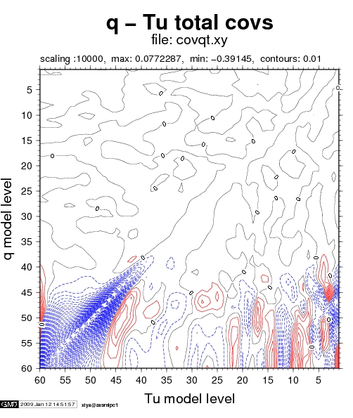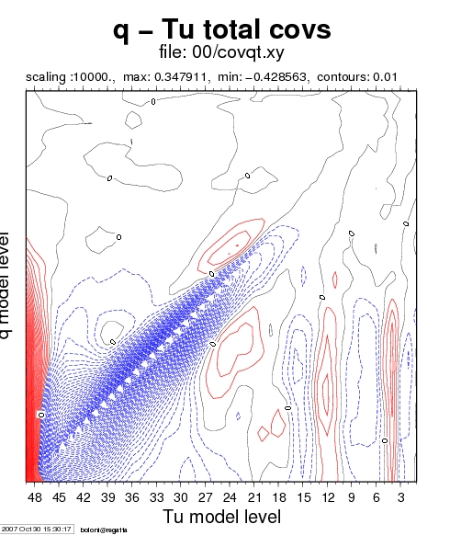

Fig1.1 AT example Fig 1.2 HU example

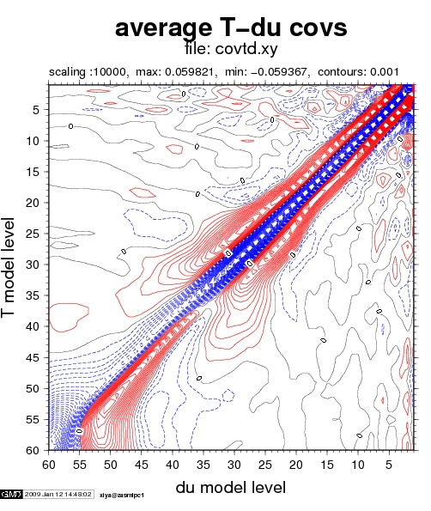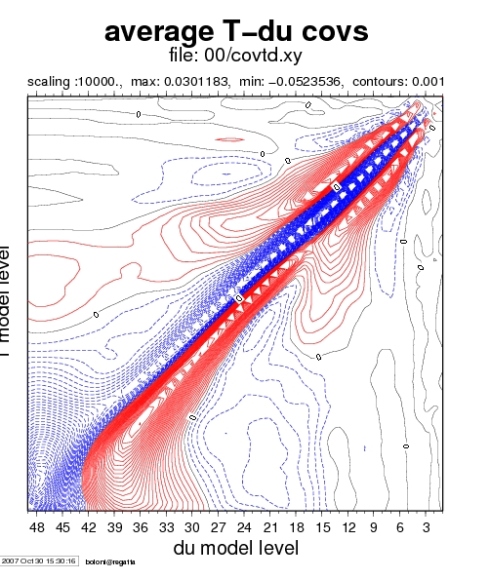

Fig 2.1 AT example Fig2.2 HU example

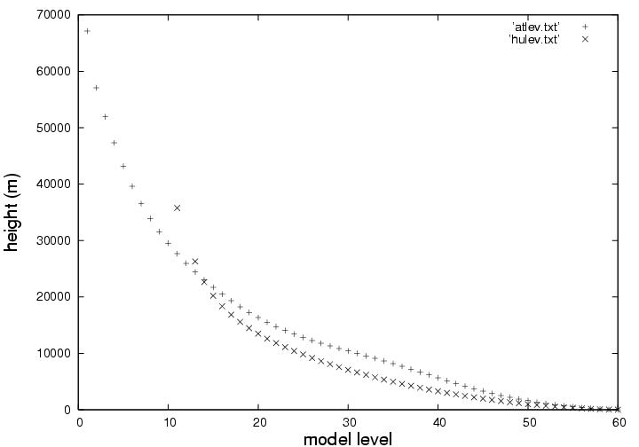

Fig 3: Model height in ALADIN/HU and ALADIN/AT

T2.2: Installation and validation of needed model configurations for data assimilation (by Sabine Leroch and Xin Yan)

Cycle: CY32T1

- Preprocessing, BATOR & ODB: The program BATOR was installed on NEC using gmkpack. Local OULAN routines have been written to read local SYNOP and TEMP databases and to provide ascii inputs for BATOR. A script to run OULAN and BATOR has been written. Bator also runs using (OBSOUL ascii and grib) data taken from OPLACE and provides correct ODB bases.

- Configuration 701: This configuration was installed without serious difficulties. An appropriate script was written to run CANARI. Czech operational namelists have been adopted to NEC. OI is carried out only over land, over sea the ARPEGE SST is used. The correct run of CANARI analysis was validated compared to test case files provided by CHMI.

- Configuration 002: Screening has been installed without serious difficulties. As validation, a reasonable Jo and SCREENING STATISTICS have been found for the tested data (TEMP, AMDAR).

- Configuration 131: The 3DVAR minimization works technically and seems to be reasonable according to the output listing. Further evaluation is done presently (single observation experiments).

T2.3: Evaluation of the assimilation system and preparation of an operational setup (by Sabine Leroch)
A parallel suite was set up to run an OI assimilation cycle for the surface parameters. There are 0, 6, 12 and 18 UTC runs giving the initial state for ALADIN/Austria which in turn provides the background (the 6 h forecast) for the OI. The parallel run was established in the middle of July 2008. First comparisons have been made between the parallel run (EX11) and the operational one (OPER) after a two weeks warm-up period. Figures 4 and 5 show the errors with respect to gauge measurements averaged over 9 Austrian SYNOP stations for a forecast range up to 72 hours and a verification period of 1 month.
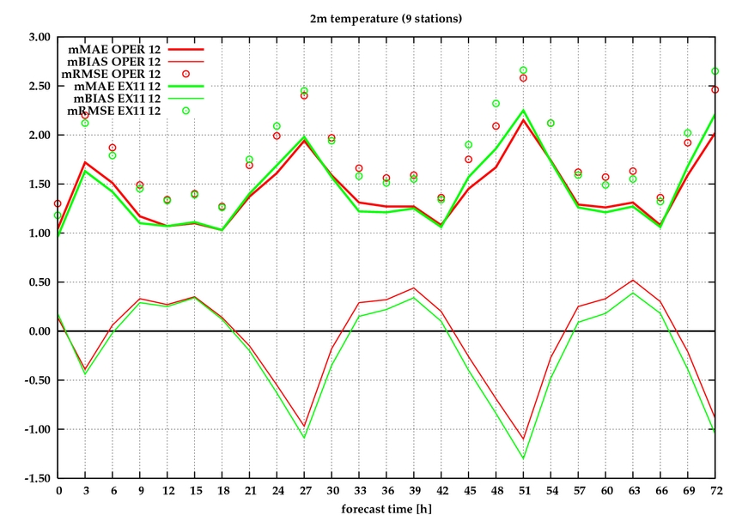
Fig 4: Verification of 2m temperature

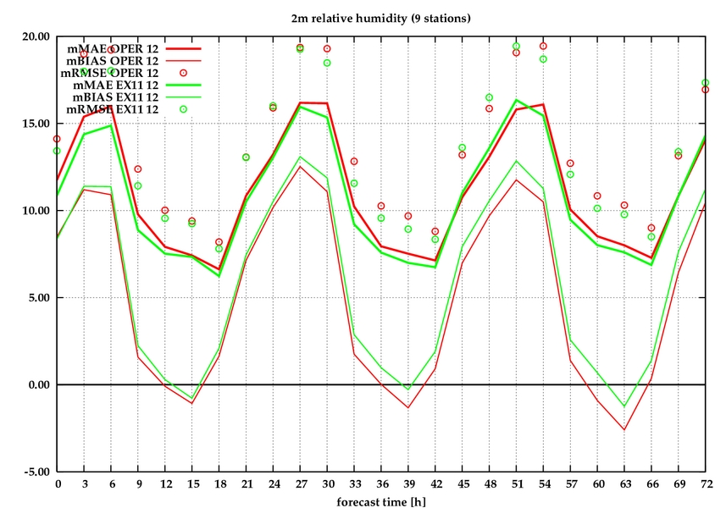
Fig 5: Verification of 2m temperature

Apparently, CANARI cools and moistens the analysis and the forecasts compared to the OPER run. The 2m temperature scores do not show a clear improvement for CANARI, on the other hand 2m relative humidity is clearly improved as far as rmse and mae is concerned. A more detailed report is available on the LACE website (Leroch, 2008) and (Yan, 2008).

Croatia

T2.1: Computation of background errors on local domains (by Kristian Horvath)

- Cycle: CY32T3

- Method: Standard NMC in total 100 samples of differences for a period of 17/02/2008 – 26/05/2008

- Results: Cross covariances and explained variances reflect reasonable background errors. A couple of examples are shown on Fig. 6., which are to be compared to Fig. 1.2 and Fig2.2 for instance

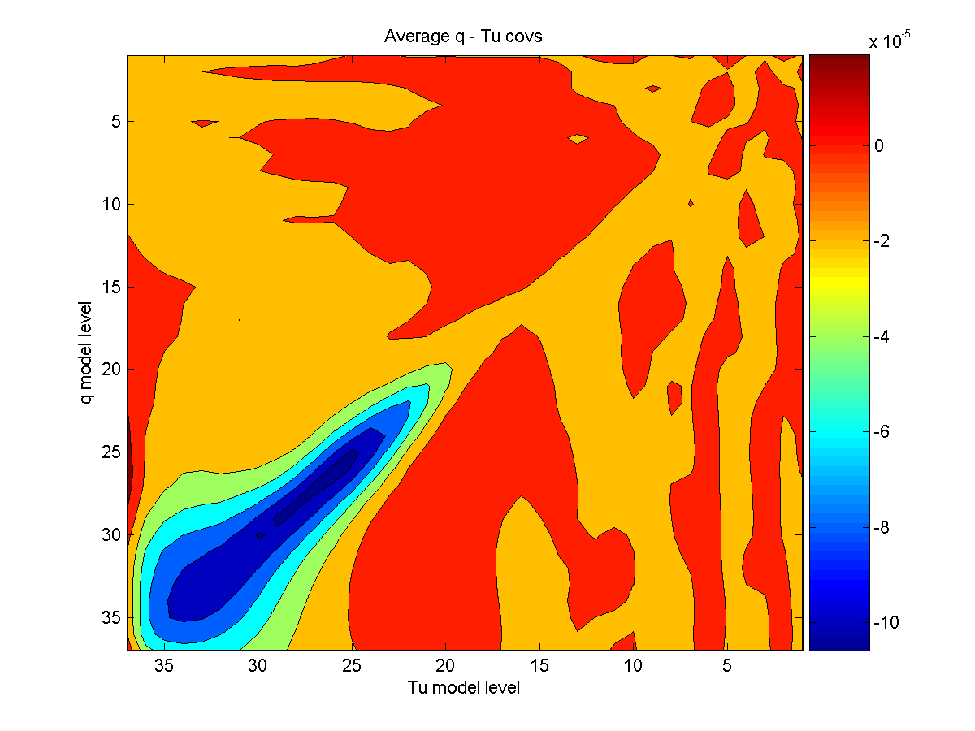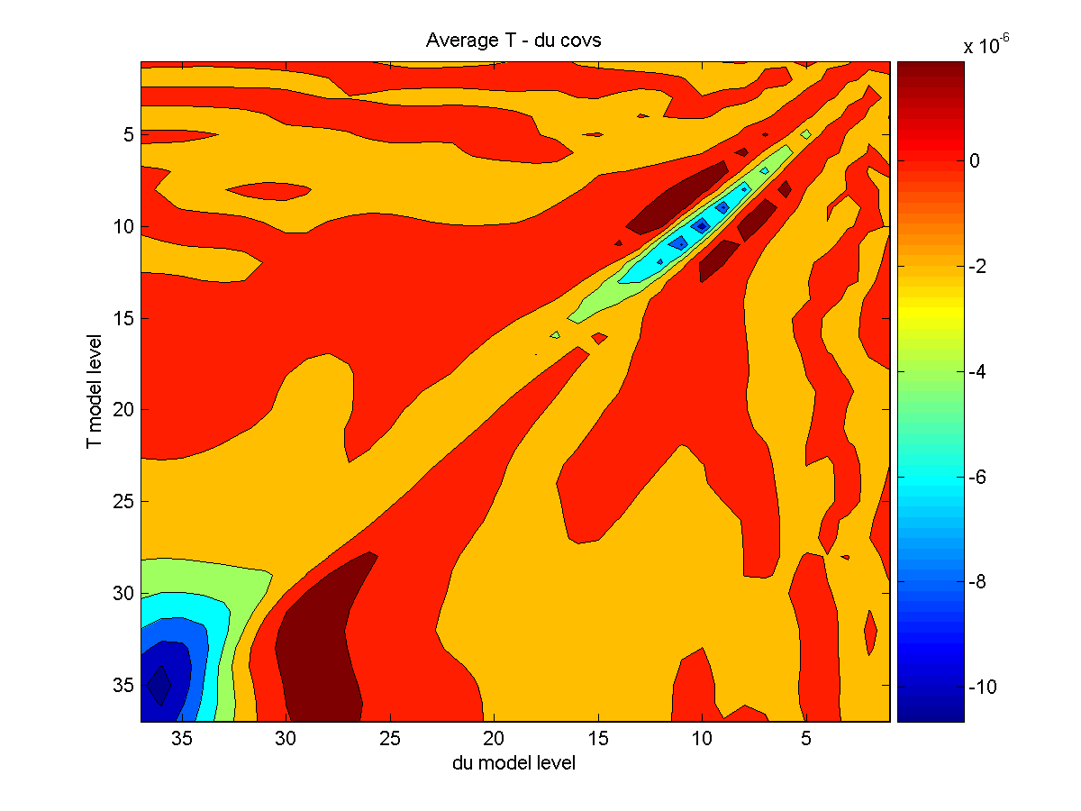
Fig. 6: Vertical cross covariances of temperature and unbalanced divergence (right) and specific humidity and unbalanced divergence (left)

T2.2: Installation and validation of needed model configurations for data assimilation (by Antonio Stanesic and Tomislav Kovacic)

Cycle: CY32T3

- Preprocessing, BATOR & ODB: Local OULAN routines have been written to read local SYNOP data and to provide ascii inputs for BATOR. BATOR has been installed through gmkpack. 3 problems came up during this exercise: 1) bug in subroutine odb/include/fodb.h 2) Bug in subroutine arp/obs_preproc/first.F90 3) Dr Hook w switched off (otherwise an abort occurred). A script to run OULAN and BATOR has been written. Bator also runs using (OBSOUL ascii and grib) data taken from OPLACE and provides correct ODB bases.

- Configuration 701: This configuration was installed without serious difficulties. Czech operational namelists have been adopted. One namelist modification was needed to run CANARI namely (NOBSHOR=201 instead of 203 in NAMOBS). This means that the bi-linear interpolation was used instead of the bi-cubic in the observation operator. Output listings were very similar to those of provided by CHMI (small differences in the no. of active observations probably due to the different interpolations). Single observation experiment plots are reasonable (Fig. 7.) and are similar to those of CHMI (not shown).

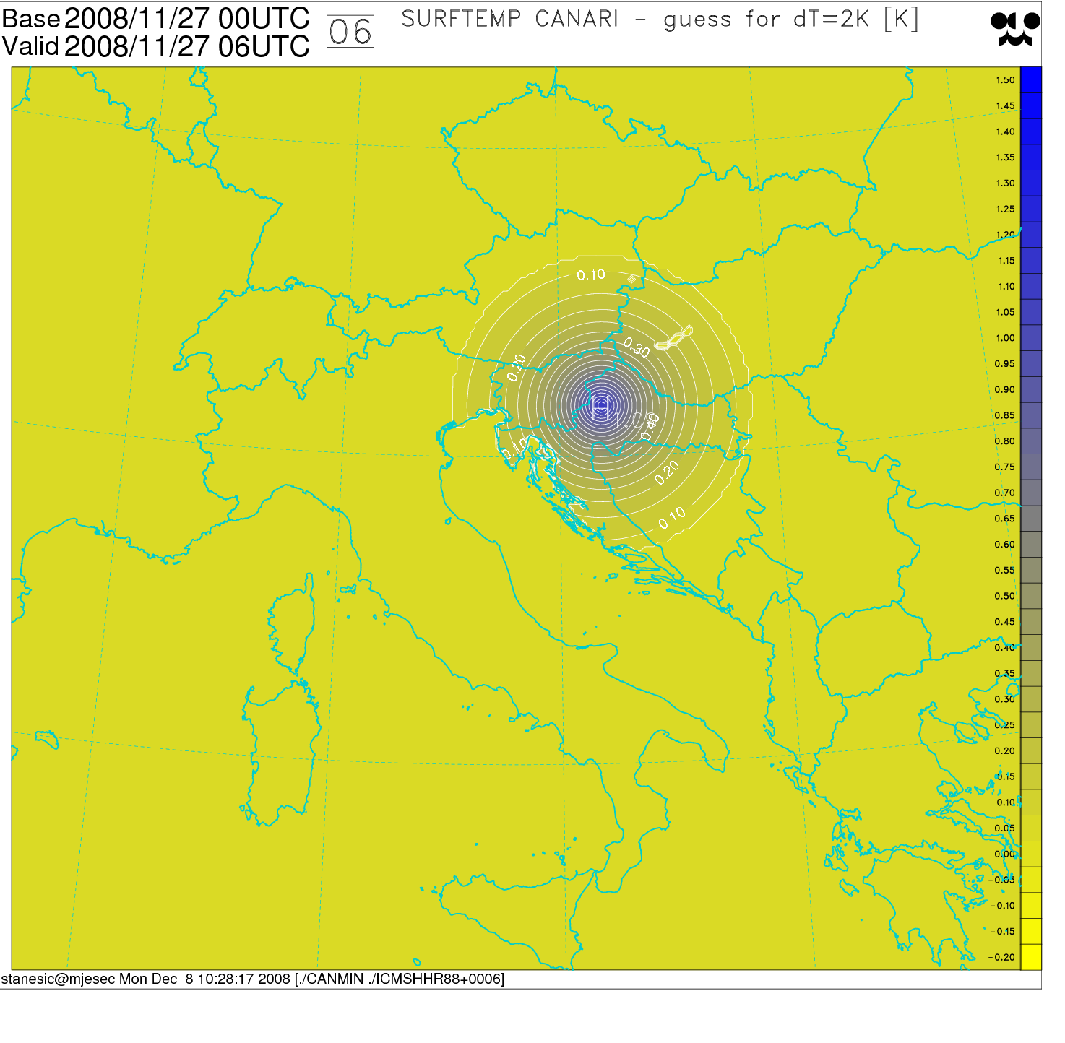
Fig. 7: Surface temperature CANARI analysis increment due to a single temperature observation at 2m (dT=2K)

- Configuration 002: Screening has been installed without serious difficulties.

- Configuration 131: 3DVAR was first tested through single observation experiments. The analysis increments are of reasonable magnitude and the horizontal correlations also reflect reasonable background error structure functions. An example is shown on Fig. 8. Some noise is present on the figure, which is probably due to the post-processing from Lambert projection to the sphere (Lat, Lon).

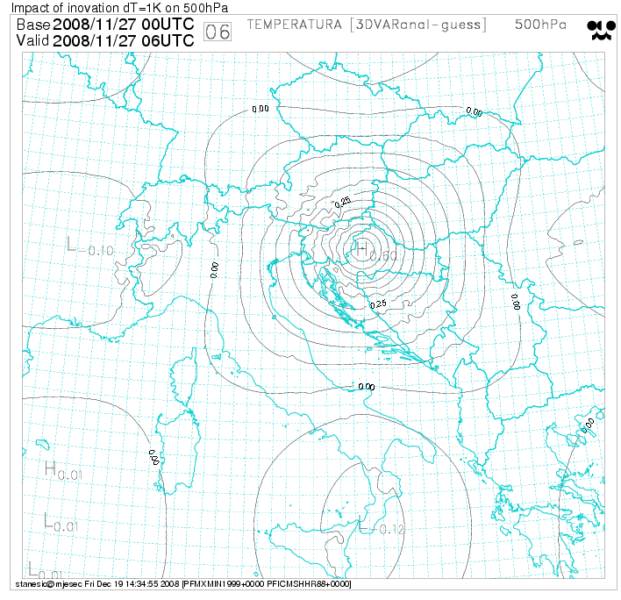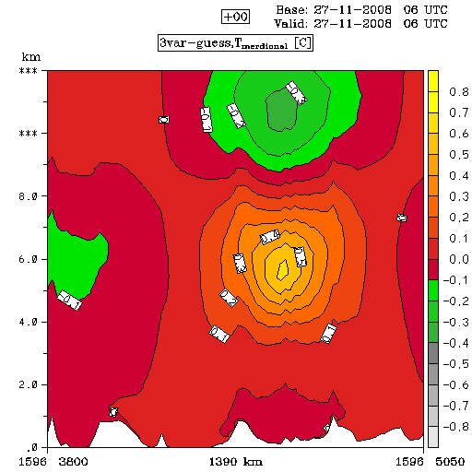

Fig. 8: Temperature analysis increments due to a temperature observation (dT=1K) on 500 hPa. Left: horizontal cross-section on 500 hPa, Right: vertical cross-section through the observation location

T2.3: Evaluation of the assimilation system and preparation of an operational setup (by Antonio Stanesic and Tomislav Kovacic)

A parallel suite using CANARI has been run since October 2008 but without a continuous objective verification. In lack of objective verification for this suite, it is not possible to tell yet anything about the impact of the OI surface assimilation. Although, it is interesting to present the way the assimilation cycle was designed (Fig. 9).

6h forecast
6h forecast
CANARI OI
Sea and atm. blending
ARP LBC0
ALADIN
GUESS
BLENDED GUESS
CANARI
ANALYSIS

Fig. 9: CANARI cycling in the parallel suite of ALADIN Croatia

What is important to highlight on Fig. 9. is that the atmospheric fields of the ALADIN 6h forecast (GUESS) are overwritten by those of the ARPEGE analysis (LBC0) just like the SST field. A more detailed report is available on the LACE website (Stanesic, Kovacic and Horvath, 2008).

Czech Republic

T2.1: Computation of background errors on local domains (by Alena Trojáková)

- Cycle: CY32T1

- Method: Standard and lagged NMC for a period in autumn 2006

- Results: Diagnostics were found reasonable. They were presented already during 2007.

T2.2: Installation and validation of needed model configurations for data assimilation (by Alena Trojáková)

Cycle: CY32T1

- Preprocessing, BATOR & ODB: Local OULAN routines have been written to read local SYNOP, TEMP and AMDR data. to provide ascii inputs for BATOR. BATOR has been installed already during 2007.

- Configuration 701: This configuration has been installed and validated during 2007 already and has been used operationally since that time.

- Configuration 002: This configuration has been installed and validated during 2007 already and was tested for SYNOP, TEMP and AMDAR data.

- Configuration 131: This configuration has been installed and validated during 2007 already and was tested for SYNOP, TEMP and AMDAR data.

T2.3: Evaluation of the assimilation system and preparation of an operational setup (by Alena Trojáková)

At CHMI, a 3DVAR (BlendVar) suite was set up for a 3 weeks period (26/03/2008 – 19/04/2008) in comparison with the operational Blending suite. The BlendVar setting consist of a 3DVAR minimization with local SYNOP and TEMP data after the atmospheric DFI blending step. Background error covariances based on the lagged NMC method have been used. Verification scores reflect an improvement of almost all the variables and for most of the vertical levels if 3DVAR is added. An example is shown on Fig. 10 and 11. On the other hand, a slight degradation was observed for 2m humidity and temperature with BlendVar (not shown).

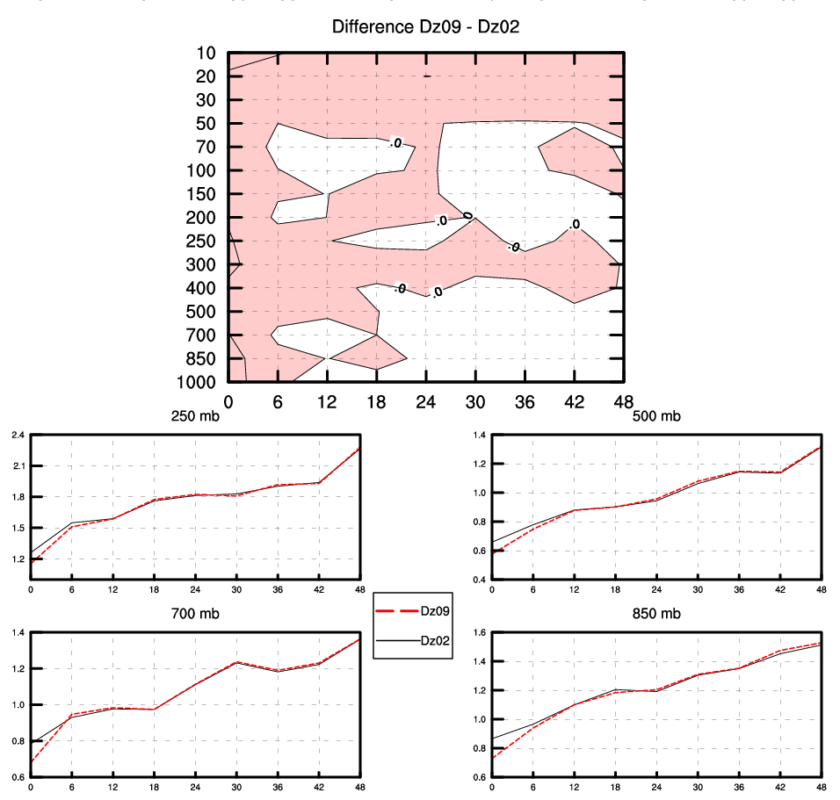
Fig. 10: rmse scores for temperature comparing the operational reference (Dz02) and the BlendVar experiment (Dz09)

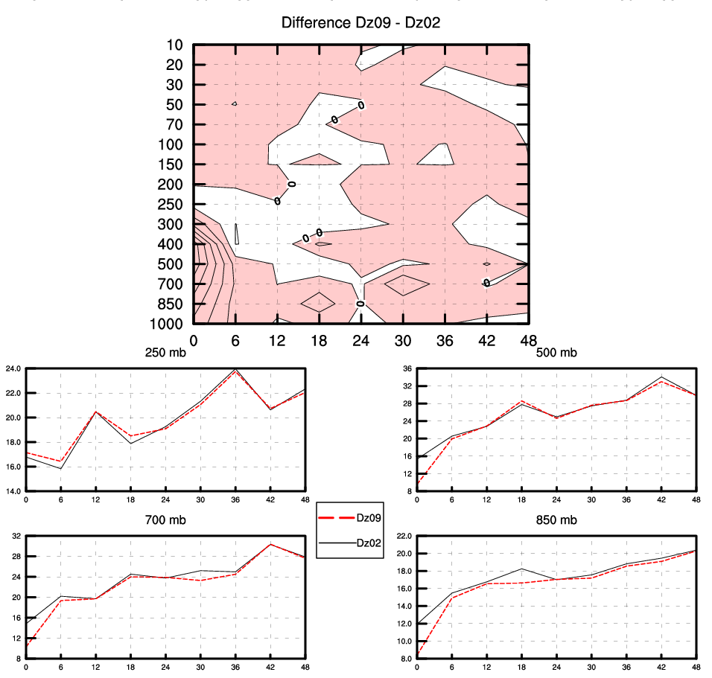
Fig. 11: rmse scores for relative humidity comparing the operational reference (Dz02) and the BlendVar experiment (Dz09)

On the top of the above parallel suite a tuning of the background and observation standard deviations was performed following the method of Desroziers et al. (2005). The method is based on the diagnosis of observation minus background and observation minus analysis departures. The tuning led to a slight improvement of the analysis and the forecast up to a very short range (not shown). A more detailed report is available on the LACE website (Trojáková, 2008).

Hungary

T2.1: Computation of background errors on local domains (by Gergely Bölöni)

- Cycle: CY30T1

- Method: Ensemble method with 95 samples in total for the period of February and March 2002 (based on an old ensemble assimilation of ARPEGE). Background error standard deviations are increased by a factor of 1.36 based on a posteriori tuning. Computed in 2007. There are no recent results to present.

T2.2: Installation and validation of needed model configurations for data assimilation (by Gergely Bölöni)

Cycle: CY33T1

- Preprocessing, BATOR & ODB: BATOR has been validated for all data used in the operational model (SYNOP, SHIP, TEMP, AMDAR, AMV, NOAA/ATOVS/AMSU, Wind Profilesr, SEVIRI). A significant work was done on the preprocessing system OPLACE (see Appendix 1).

- Configuration 701: The installation went rather smoothly, except that the bi-cubic interpolation (NOBSHOR=203 in NAMOBS) in the call of the observation operator works only if ald/adiab/elascaw.F90 compiled without optimization. On the other hand configuration 001 is very slow if this routine is not optimized. CANARI has been validated in comparison with CY30T1 results with a good agreement of the analysis increments.

- Configuration 002: The installation went rather smoothly, except that we had to place the call for Dr. Hook in arp/obs_preproc/screen.F90 differently to avoid an abort (caused simply by the Dr. Hook call). Another thing we had to do is to avoid a call for copie_radsta.F90 in odb/cma2odb/shuffledb.F90 for some suspicious abort in BATOR/SHUFFLE. The validation gives similar Jo values as with CY30T1, though we do not have exactly the same data accepted by screening due to the new blacklisting procedure came in between these cycles (bla project).

- Configuration 131: The installation is done. The minimization gives very similar results compared to CY30T1.

T2.3: Evaluation of the assimilation system and preparation of an operational setup (by Gergely Bölöni)

CANARI OI has been implemented operationally in the beginning of October 2008 (together with the LBC coupling with ECMWF fields). On Fig. 12 and 13 scores are shown that encouraged us for the operational implementation. A detailed report is available on the LACE website (Bölöni, Kullmann, Horányi, 2008)

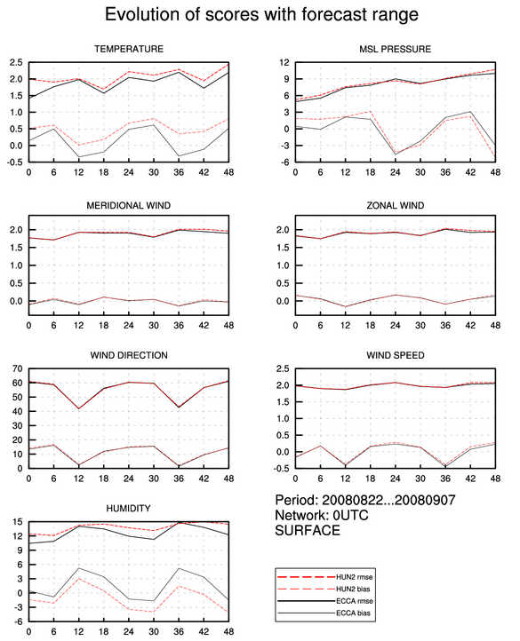

Fig. 12: rmse and bias scores for 2m comparing the former operational run (HUN2) and the parallel suite with CANARI and ECMWF coupling (ECCA)

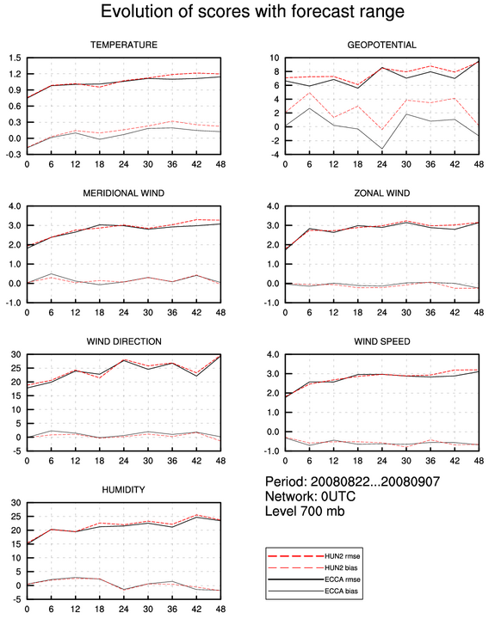

Fig. 13: rmse and bias scores for 700 hPa comparing the former operational run (HUN2) and the parallel suite with CANARI and ECMWF coupling (ECCA)

We kept doing tests with SEVIRI from MSG2 and SYNOP T and RH data with the help of a guest from Turkey. The point was to use only the water vapor channels from of SEVIRI. The previously found degradation of the PBL temperature scores were eliminated by the blacklisting of the infrared channels, however also the overall good impact has been reduced in terms of rmse and bias scores compared to SYNOP/TEMP observations and ECMWF analysis. A good impact of the SYNOP T and RH observations was found (Not shown).

Experiments have been run in order to use HIRS data from the NOAA satellites in high resolution (80 km thinning) together with SYNOP T and RH data. Over the chosen period the HIRS data had neutral impact on the forecast skill, while the SYNOP observations improved it significantly for the PBL levels (not shown). A detailed report is available on the LACE website (Bouzid, 2008).

Romania

Slovakia

Slovenia

T2.2: Installation and validation of needed model configurations for data assimilation (by Jure Cedilnik and Benedikt Strajnar)

Cycle: CY32T3

- Preprocessing, BATOR & ODB: BATOR was installed and fed by local SYNOP observations through the OULAN program.

- Configuration 701: The installation went rather smoothly, except that the bi-cubic interpolation (NOBSHOR=203 in NAMOBS) was changed to bi-linear one (NOBSHOR=201 in NAMOBS). Another problem was due to the fact that the gmkpack version used (6.2b) did not care about the compilation and linking of the routine odb_glue.c so it had to be done separately. Dr. Hook had to be switched off in the routines blendsur.F90 and addgfl.F90. The analysis was validated through single observation experiments. An example is shown on Fig. 14.
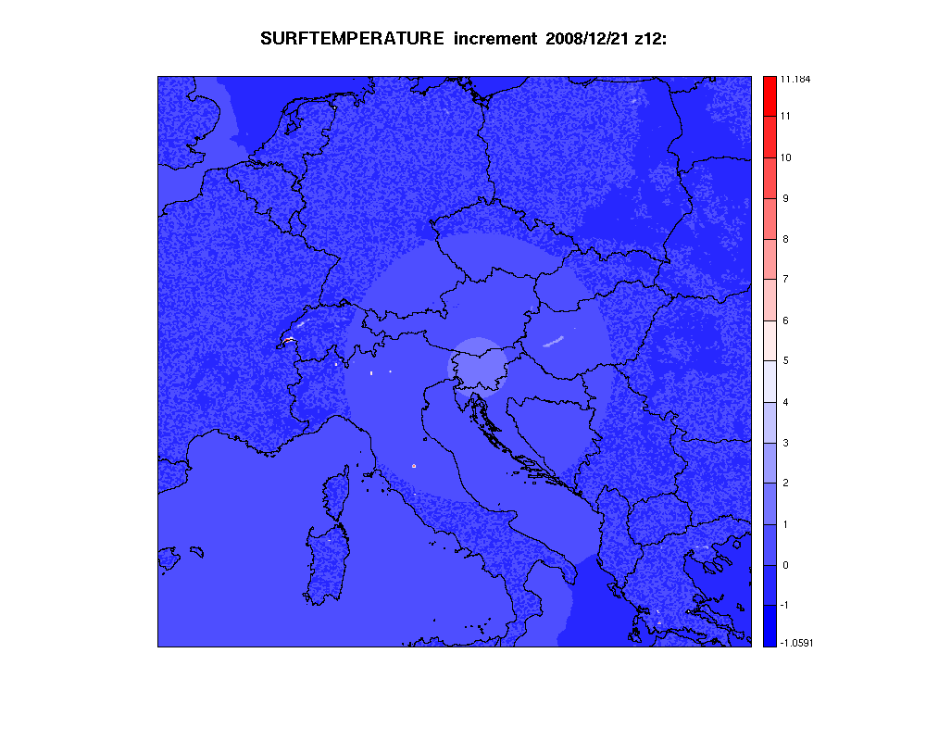
Fig. 14: rmse and bias scores for 700 hPa comparing the former operational run (HUN2) and the parallel suite with CANARI and ECMWF coupling (ECCA)

T2.3: Evaluation of the assimilation system and preparation of an operational setup (by Jure Cedilnik and Benedikt Strajnar)

A CANARI assimilation cycle was put under SMS in comparison with the operational model. The assimilation cycle consist of the following steps at each analysis time:
- 6 hour ALADIN forecast using short cut-off ARPEGE LBCs (guess)
- copy the SST analysis from ARPEGE to the guess
- CANARI surface analysis using T2m and RH2m observations (analysis)
- Cycling of microphysics (copy them from the guess to the analysis file) as ALARO physics with 3MT have been used in the test
It is an important detail that both the integration and the analysis is done on 4 km resolution, which is the highest resolution data assimilation ever within LACE so far. There are no objective verification scores yet to present. A more detailed report is available on the LACE website (Cedilnik and Strajnar, 2008).

References

Bölöni, G, L., Kullmann, A. Horányi, 2008: Experiences in using ECMWF lateral boundary conditions for the operational ALADIN model in Hungary
http://www.rclace.eu/File/Data_Assimilation/2008/ecm_newsletter.01.pdf

Bouzid, A., 2008: Assimilation of HIRS and SYNOP data in the ALADIN/HU model
http://www.rclace.eu/File/Data_Assimilation/2008/Bouzid_hirs.doc

Cedilnik, J. and B. Strajnar, 2008: Test implementation of assimilation cycle with CANARI surface analysis at the Environmental Agency of Slovenia
http://www.rclace.eu/File/Data_Assimilation/2008/lace_da_si_deliverable_jan09.pdf

Leroch, S., 2008: Status report Data-Assimilation for LACE
http://www.rclace.eu/File/Data_Assimilation/2008/status_assim_leroch.pdf

Stanesic, A, Kovacic, T., Horvath, K., 2008: Report about DA installation at DHMZ
http://www.rclace.eu/File/Data_Assimilation/2008/DA_CRO.pdf

Trojáková, A., 2008: Data assimilation at CHMI, progress report from September 2008
http://www.rclace.eu/File/Data_Assimilation/2008/DA_progress_CHMI.pdf

Yan. X., 2008: Status report: B matrix validation in ZAMG
http://www.rclace.eu/File/Data_Assimilation/2008/zamg_da.02.doc

7. Appendix 3 (Long term research topics)

Topic 1: Development of ALADIN 4DVAR (by Filip Vana)
Recent results: Data assimilation in general has been studied during the stay at Météo-France. 4DVAR assimilation experiments have been done following the first ALADIN 4DVAR setup by Bernard Chapnik.

Topic 2: Research on background error modeling (by Edit Adamcsek and Benedikt Strajnar)
Recent results: Two topics have been tackled during the year, the Ensemble Transform Kalman Filter (ETKF) and the use of Grid point background error standard deviations in ALADIN 3DVAR.
1) ETKF: The work has been continued with a testing of the Transform matrix. It was found that the Ensemble Transformation provides a similar spatial structure of the analysis perturbations as a set of real 3DVAR assimilations but with smaller amplitudes. This suggested the use of an inflation factor in order to amplify the perturbations. Presently, experiments are ongoing in order to test different inflation techniques. Another important step is that the ETKF elements are now organized in a cycle (except the update of the P_{f} matrix). A more detailed report can be found on the LACE website (Adamcsek, 2008)
2) Grid point background error standard deviations: The ARPEGE code of normalizing with standard deviations in grid point space was adapted to ALADIN (so far the normalization was possible only in spectral space). This allows a less simplified approach to take into account background errors of vorticity, namely we can consider a spatial variability of the vorticity error amplitudes. After the code development and its validation, parallel tests in comparison with the operational 3DVAR of ALADIN France, have been run. These tests were done in two different steps concerning the time variability of errors. In the first experiment, the grid point errors were estimated in a “constant” way, namely computing statistics over a period of couple of months. In the second “flow dependent” experiment, the grid point errors “of the day” have been estimated from the background errors of the ARPEGE ensemble assimilation system (EnVar). Both experiments showed some improvement up to 12 hours for several variables. A detailed report is available on the LACE website (Strajnar, 2008).

Topic 3: Research on surface assimilation (by Jure Cedilnik)
Recent results: Surface assimilation experiments have been performed using satellite derived albedo data (LandSAF products) in comparison with dynamical adaptation. Partly the use of ECOCLIMAP data (together with the LandSAF data) was also tested. The assimilation of LandSAF albedo data was done with the simplified Kalman Filter method developed at Météo-France. In terms of objective scores, the extra (LandSAF and ECOCLIMAP) data improve the quality of the forecast during the winter (especially the bias is reduced). It was found that the relative impact of LandSAF data is bigger compared to the ECOCLIMAP data. It is also a conclusion, that the convection parametrization reacts very sensitively to the modification of the albedo in the initial conditions (during the summer). Beside the overall encouraging results remaining a short period of overestimation of 2m temperature was observed when assimilating the LandSAF albedo data. Apparently, this was related to an intensive snow melting during that period. A detailed report is available on the LACE website (Cedilnik, 2008)

Topic 4: Research on radar reflectivity assimilation
Recent results: A general article on the recent results is available on the ERAD 2008 website (Watterlot et al., 2008)

References

Adamcsek, E., 2008: An experiment with the ETKF Transformation matrix at HMS, http://www.rclace.eu/File/Data_Assimilation/2008/etkf_at_hms.pdf

Cedilnik, J., 2008: Estimating the Added Value of Land SAF Albedo Assimilation in ALADIN, http://www.rclace.eu/File/Data_Assimilation/2008/Cedilnik.LACE_MF_stay_report.oct08.pdf

Strajnar, B., 2008: Grid point mapping of background errors in Aladin 3D-VAR, http://www.rclace.eu/File/Data_Assimilation/2008/report_beni_gpsigma.pdf

Watterlot, E., O. Caumont, S. Pradier-Vabre, M. Jurasek, G. Haase, 2008: 1D +3DVar assimilation of radar reflectivities in the pre-operational AROME model at Météo-France
http://erad2008.fmi.fi/proceedings/extended/erad2008-0097-extended.pdf

