ASSIMILATION OF HIRS AND SYNOP DATA IN THE ALADIN/HU MODEL

Report from LACE stay in Budapest, 07/09/08- 17/10/08

Scientific supervisor: Gergely BÖLÖNI

Ahmed BOUZID

Office nationale de la météorologie
Avenue KHEMESTI BP 153
DAR EL BEIDA ALGIERS
ALGERIA

Contents

1 – Introduction…………………………………………………………………2

2 - Main characteristics of the ALADIN/HU model and its assimilation system………………………………………………………2

3 - Experiment design………………………………………………………..3

4 - Results and comments……………………………………………………4

5 – Conclusion……………………………………………………………….…4

6 – Acknowledgments…………………………………………………………..5

7 – Bibliography………………………………………………………………..5

8 - List of pictures………………………………………………………………6

1 - Introduction

The High-resolution Infrared Radiation Sounder (HIRS) blown on NOAA' satellites is a 20 channel scanning radiometer that perform operational atmospheric sounding to provide calibrated vertical profiles of temperature and cloud phase, as well as surface albedo.

The HIRS instrument provides multispectral data from one visible channel (0.69 µm),
Seven shortwave channels (3.7 to 4.6 µm) and twelve longwave channels (6.7 to 15 µm). The swath width is 2160 km with a 10 km resolution, from a spacecraft altitude of 837 km.
ALADIN/HU uses 12 channels from 4th to 15th .

This report presents the results of the experiments on the impact of HIRS and SYNOP data on the analysis and forecasts of the ALADIN model.
The second section 2 gives a brief description of the characteristics of the operational ALADIN/HU model and its assimilation system. The third section describes the experiments done in this stay and section 4 presents the results, followed by conclusions and discussion.

2 - Main characteristics of the ALADIN/HU model and its assimilation system

Main features of the operational ALADIN/HU model
Model version AL30T1
Initial conditions: 3D-VAR assimilation
Four times productions a day: 00 UTC (54H); 06 UTC (48H); 12 UTC (48H); 18 UTC (36)
Boundary conditions from ARPEGE model

Model geometry
8 km horizontal resolution (349*309 points)
49 vertical levels
Linear spectral truncation
Lambert projection

Assimilation settings
6 hour assimilation cycle
No surface assimilation
Short cut-off analyses for the production runs
Background error covariances based on the Ensemble method
Digital filtre initialization
LBC coupling at every 3 hours

Observation usage
SYNOP (geopotential)
SHIP (geopotential)
TEMP (T, u, v, q)
ATOVS/AMSU-A (radiances from NOAA 15, 16, and 18) with 80km thinning distance
ATOVS/AMSU-B (radiances from NOAA 16, 17, and 18) with 80km thinning distance
AMDAR (T, u, v) with 25 km thinning distance and 1 hour time-window, together with a special filter
AMV (GEOWIND) data (u,v)
Wind Profiler data (u,v)

3 - Experiments design

During the 6 weeks of my stay, two experiments were done in Hungarian Meteorological Service, in order to examine the impact of assimilation of both SYNOP and HIRS data on forecasts, and analyses. Assimilation cycles were run during a winter and a summer period, followed by production forecasts up to 48 hours. The results were compared with the operational run using classical verification scores such as BIAS and RSME scores.

The following experiments were carried out:

1- Assimilation of HIRS and SYNOP data on the top of the present operational observations for the period of 20080620 to 20080719.(BSW3)

2- Assimilation of HIRS and SYNOP data on the top of the present operational observations for the period of 200800206 to 20080229 (BSW3)

HUN2 stand for the operational run

For the further testing of HIRS data assimilation, a third experiment has been started at HMS, using only HIRS data.

The results of this experiment will be reported later on by Gergely Bölöni.

4 - Results and comments

Experiment 1

Both HIRS and SYNOP data assimilation in the summer period

We found the both data have a neutral impact on the analyses and forecast of wind speed and wind direction. (Fig. 1, 2)A positive impact has been found on the 2m temperature for the forecast range +6 hour. This impact decreases with the forecast range. On the higher levels the temperature impact generally positive below 500 hPa especially for the BIAS. (Fig. 4, 5)
For the relative humidity we have found a slight positive impact on 1000, 850 and 700 hPa especially in the BIAS scores. See (fig. 2, 3, 6 and 7).
Why do not you show surface scores for experiment 1?

Experiment 2

Both HIRS and SYNOP data assimilation in the winter period

Generally neutral impact on wind speed and wind direction has been found (fig. 8, 9 and 10).We has found negative impact on temperature especially on low levels, (fig. 11, 12)
For relative humidity, we have found a positive impact at 2m (fig. 9) but a negative impact at higher PBL levels (fig. 13, 14 and 15). A positive impact has been found at 250 hPa (fig. 10, 15).

Comments:
The neutral impact of HIRS and SYNOP on the wind forecast and the positive impact on temperature, for the both experiments due may be for the SYNOP data observation, and not only for the HIRS. So the third experiments will give the impact of only HIRS data
The results above come from the mixed impact of HIRS and SYNOP T and RH data. In order to see the impact of the HIRS data alone, a third experiment has been launched by the end of the stay. Results from this run will be reported later on.

5 – Conclusion

The impact of assimilation of HIRS and SYNOP data in the ALADIN /HU model gave neutral impact in general the wind speed and direction and on the geopotential. Temperature scores show positive impact in the summer experiment but rather negative in the winter experiment. Similarly, the impact on relative humidity is rather positive during the summer period but negative over the winter period.

For clarifying the impact of the HIRS data alone, a new experiment has been started and will be evaluated in the future.

We find necessary to continue with the assimilation of HIRS data, especially to elaborate the reason for the different impact of the data in summer and winter periods.

6 - Acknowledgments

The author wishes to thank Gergely Bölöni the kind supervision of the work and his big patience and also the help of Ersin KUCUKKARACA from the Turkish state meteorological institute, who spent a stay at HMS at the same time. Also the author would like thank the fruitful discussion with other colleagues of the NWP team of the Hungarian Meteorological Service. This work was financed by the LACE (Limited Area model for Central Europe) project.

7 – Bibliography
Roger Randriamampianina and Regina Szotak 2004: Impact of the ATOVS data on the Mesoscale ALADIN /HU Model, HMS 2003.08.28

Roger Randriamampianina 2005: Use and impact of the full grid AMSU-B data in the ALADIN/HU model, HMS Budapest Hungary, RC LACE report

Alena Trojakova and Michal Majek 2006: Assimilation of SEVIRI data HMS Budapest Hungary, RC LACE report
Sandor Kertesz 2007: Overview of the observation usage in the ALADIN variationnal data assimilation system, , HMS Budapest Hungary, RC LACE report

http://www.eumetsat.int/Home/Main/What_We_Do/Satellites/EUMETSAT_Polar_System/Space_Segment/

http://www.ncdc.noaa.gov/oa/pod-guide/ncdc/docs/podug/index.htm

http://www.wmo.int/pages/prog/sat/CGMS/Directoryofapplications/fr/ap10-09.htm
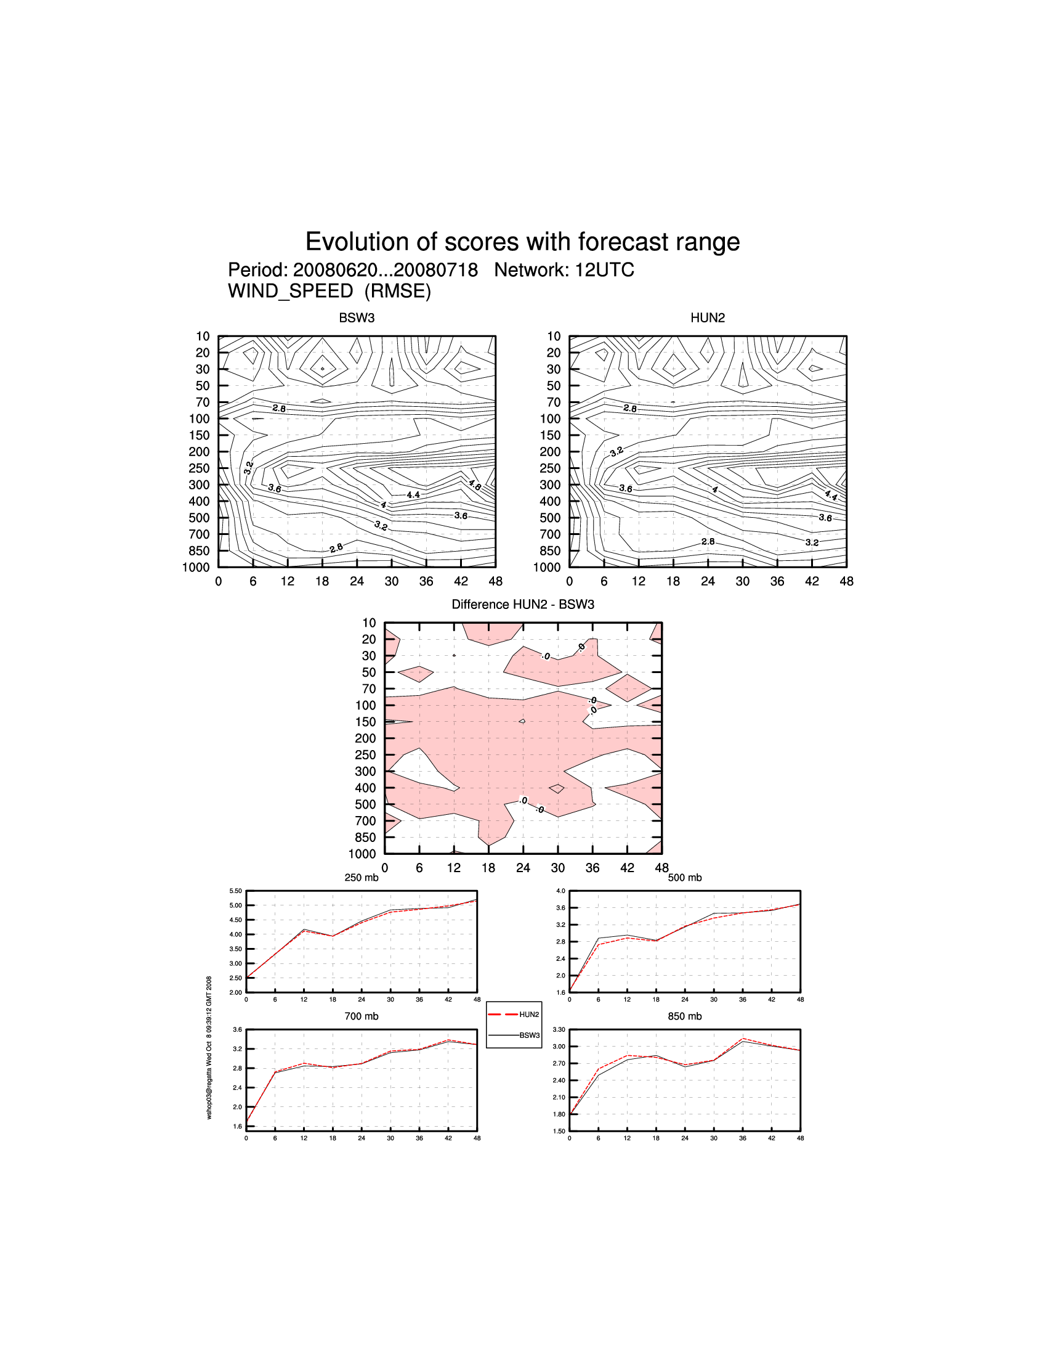
Fig. 1: RMSE of wind speed 12 UTC

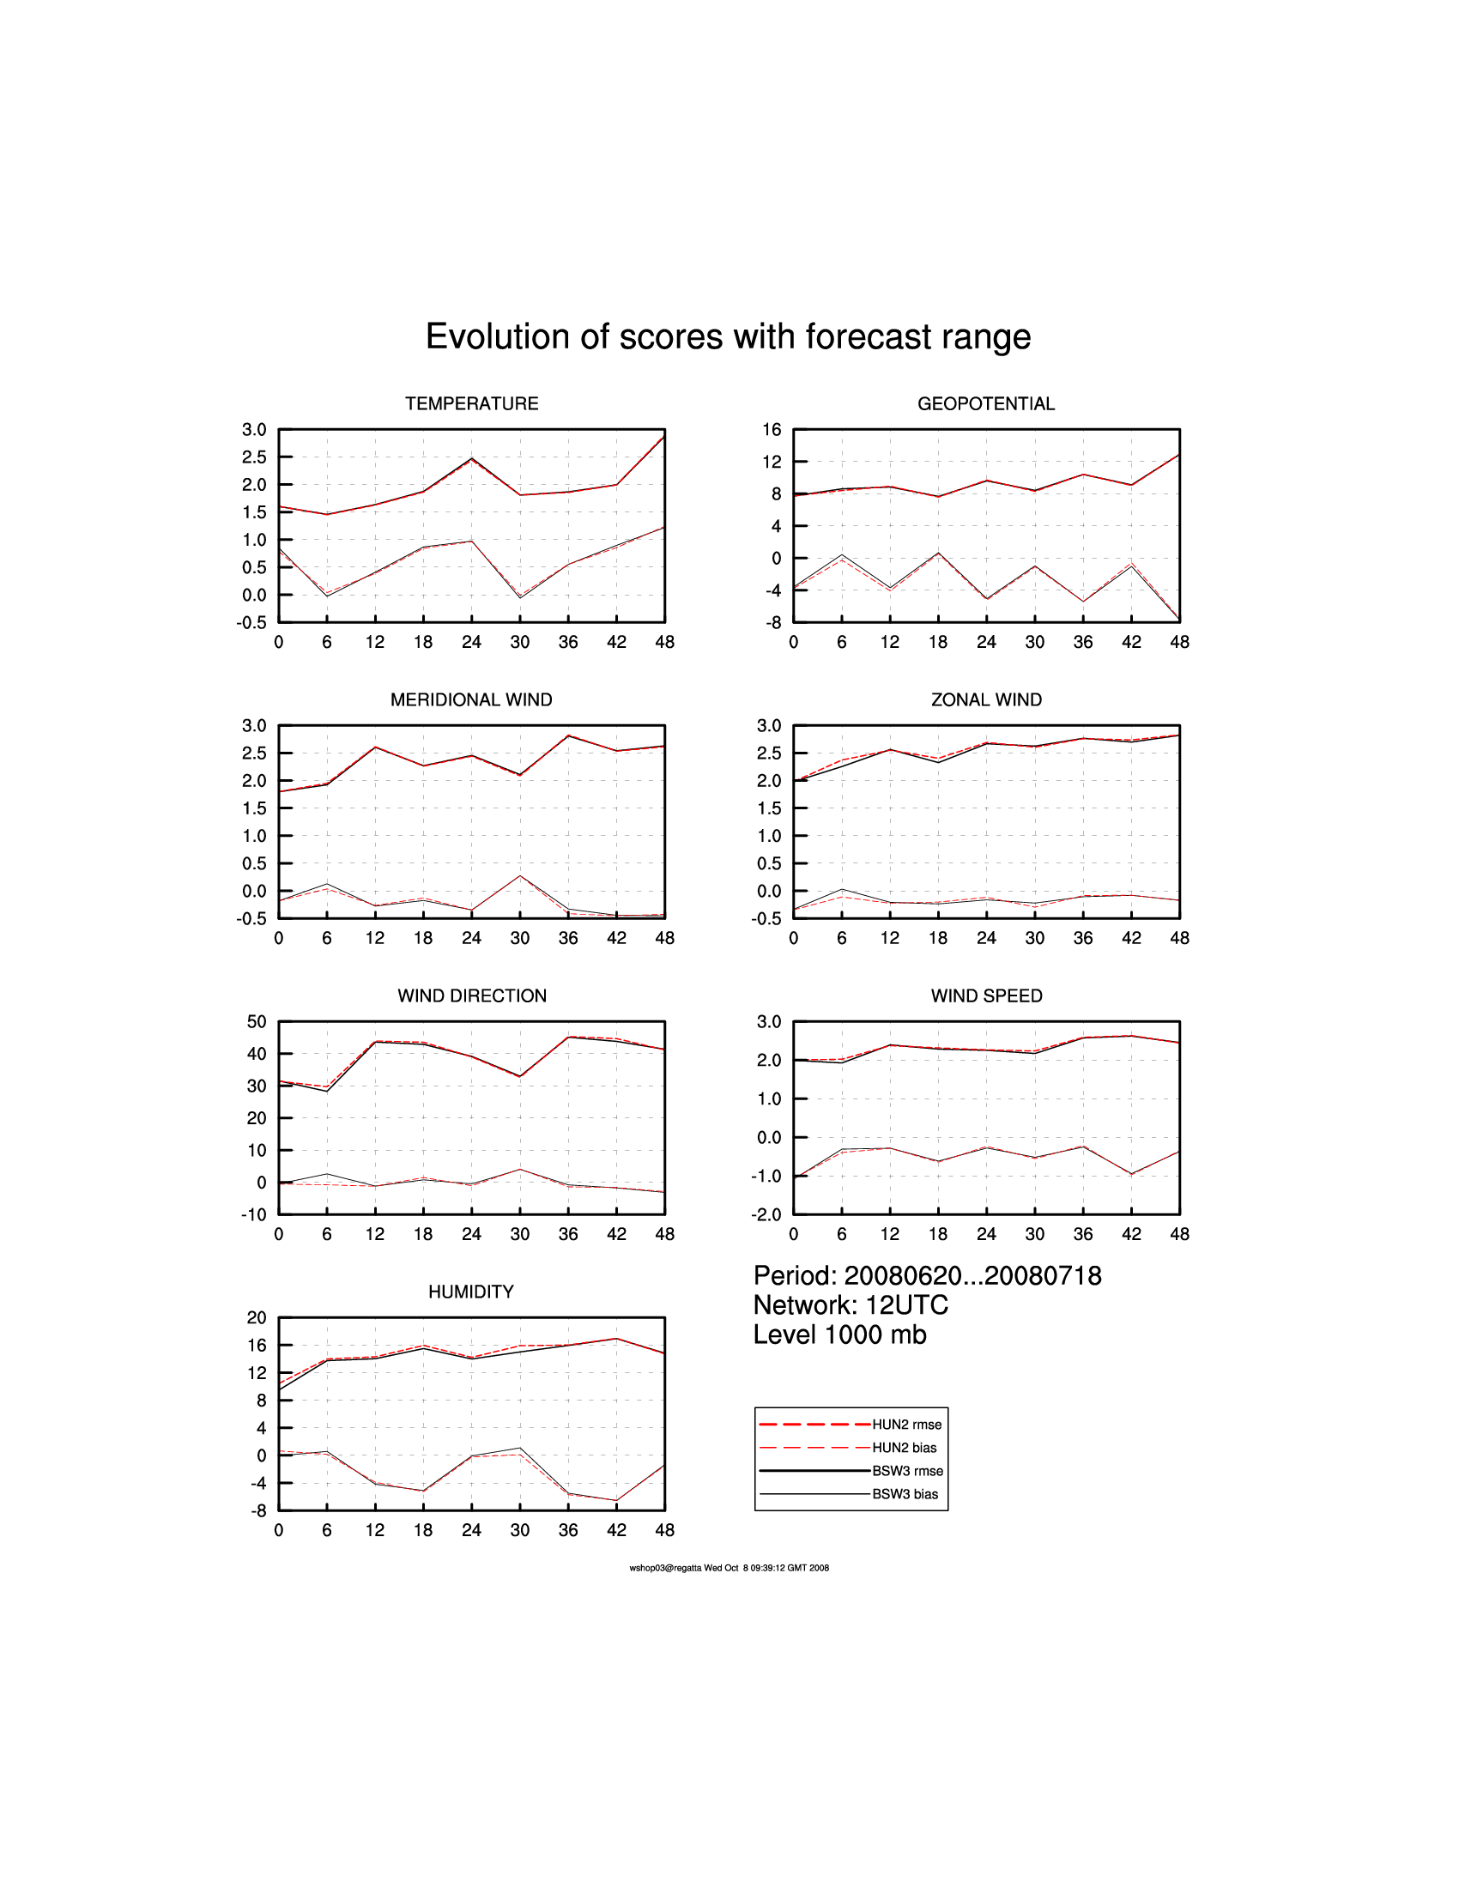
Fig. 2: RMSE and BIAS of parameters in 1000 mb level, 12 UTC

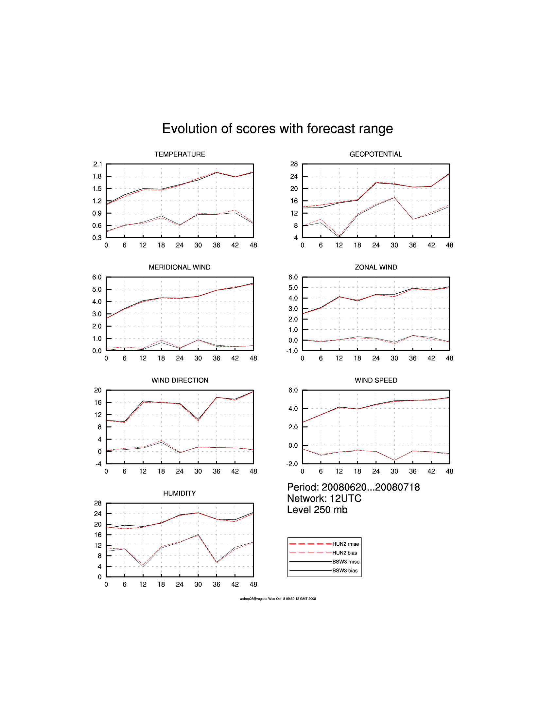
Fig. 3: RMSE and BIAS of parameters in 250 mb level, 12 UTC

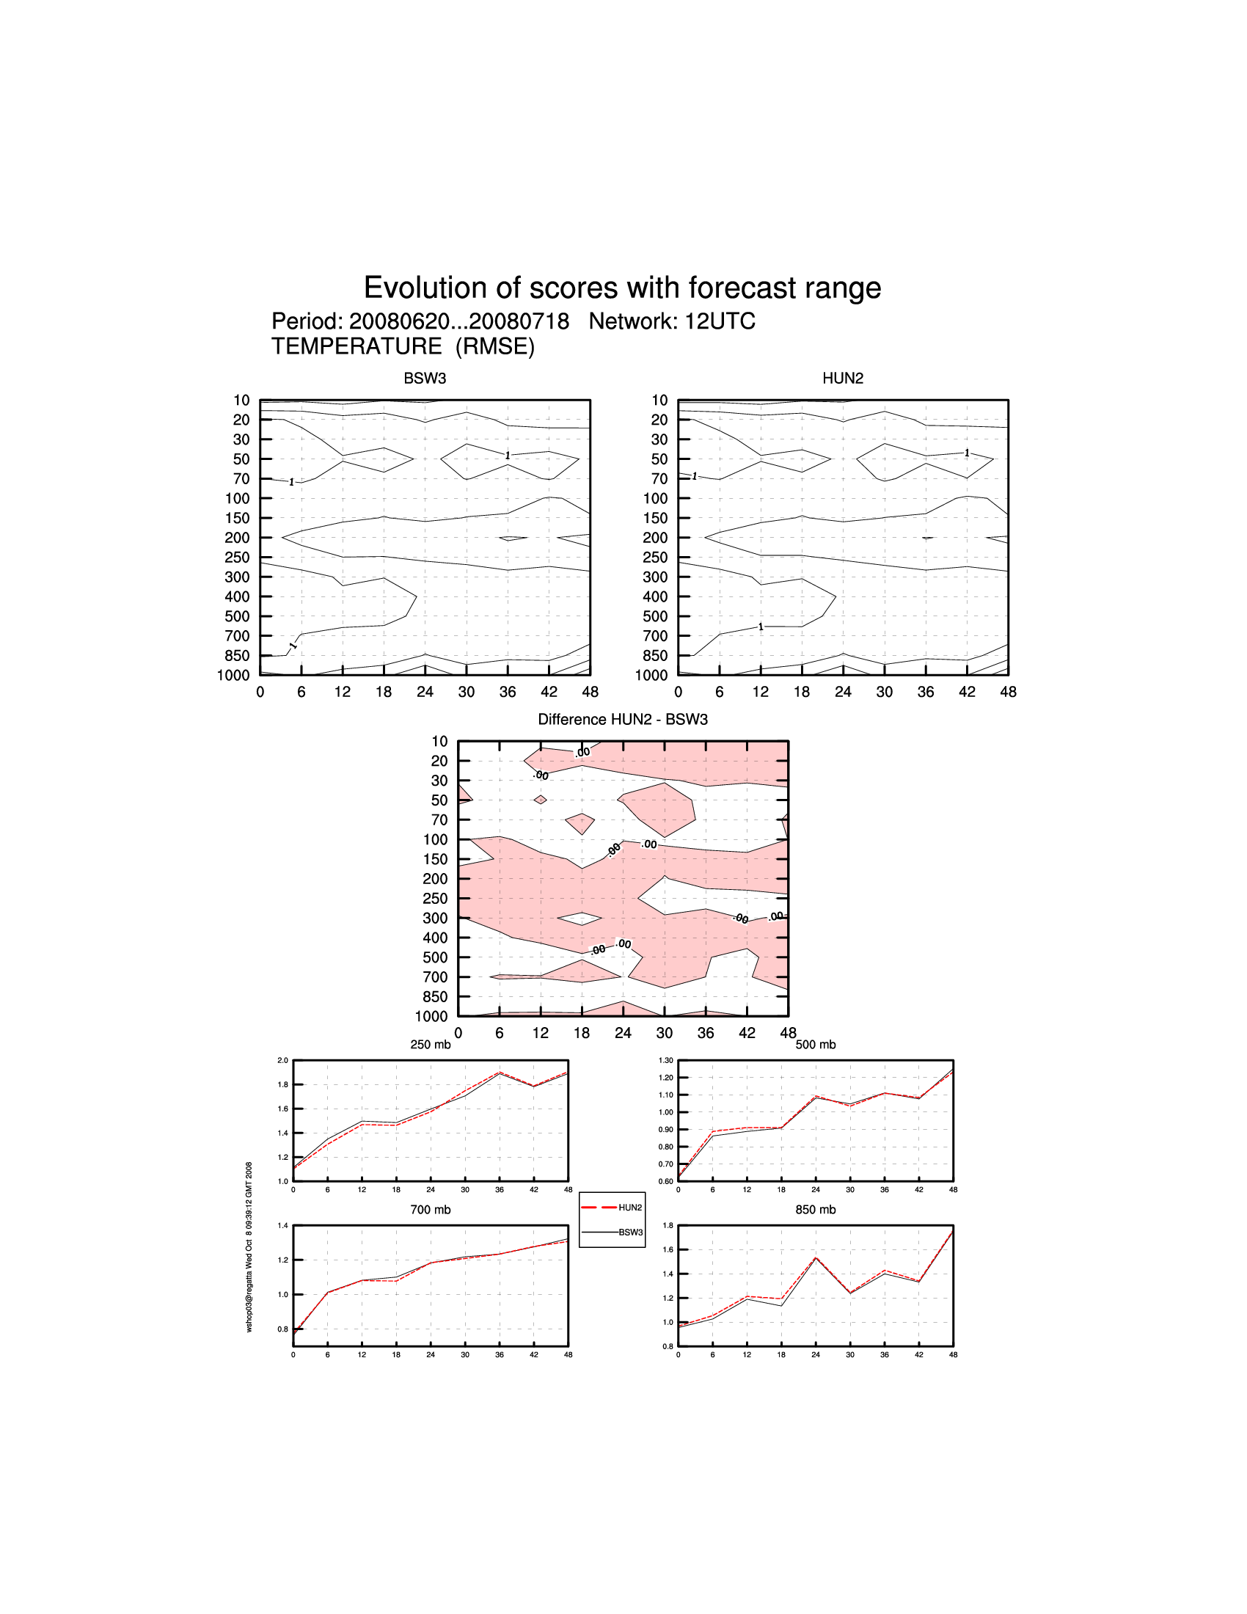
Fig. 4: RMSE of Temperature 12 UTC
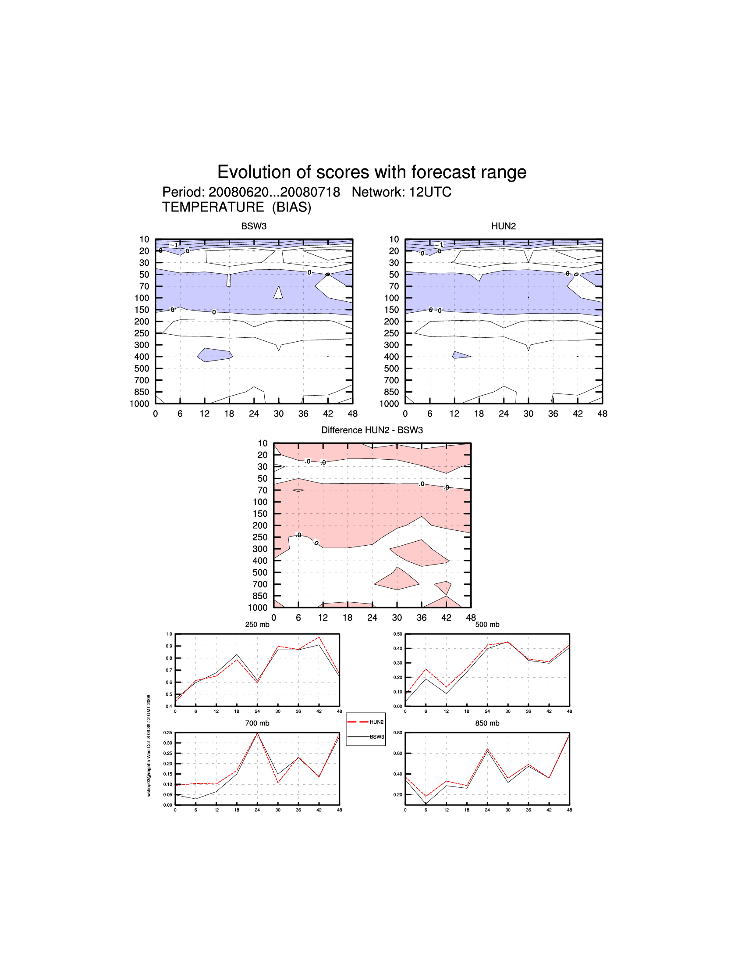
Fig. 5: BAIS of Temperature 12 UTC

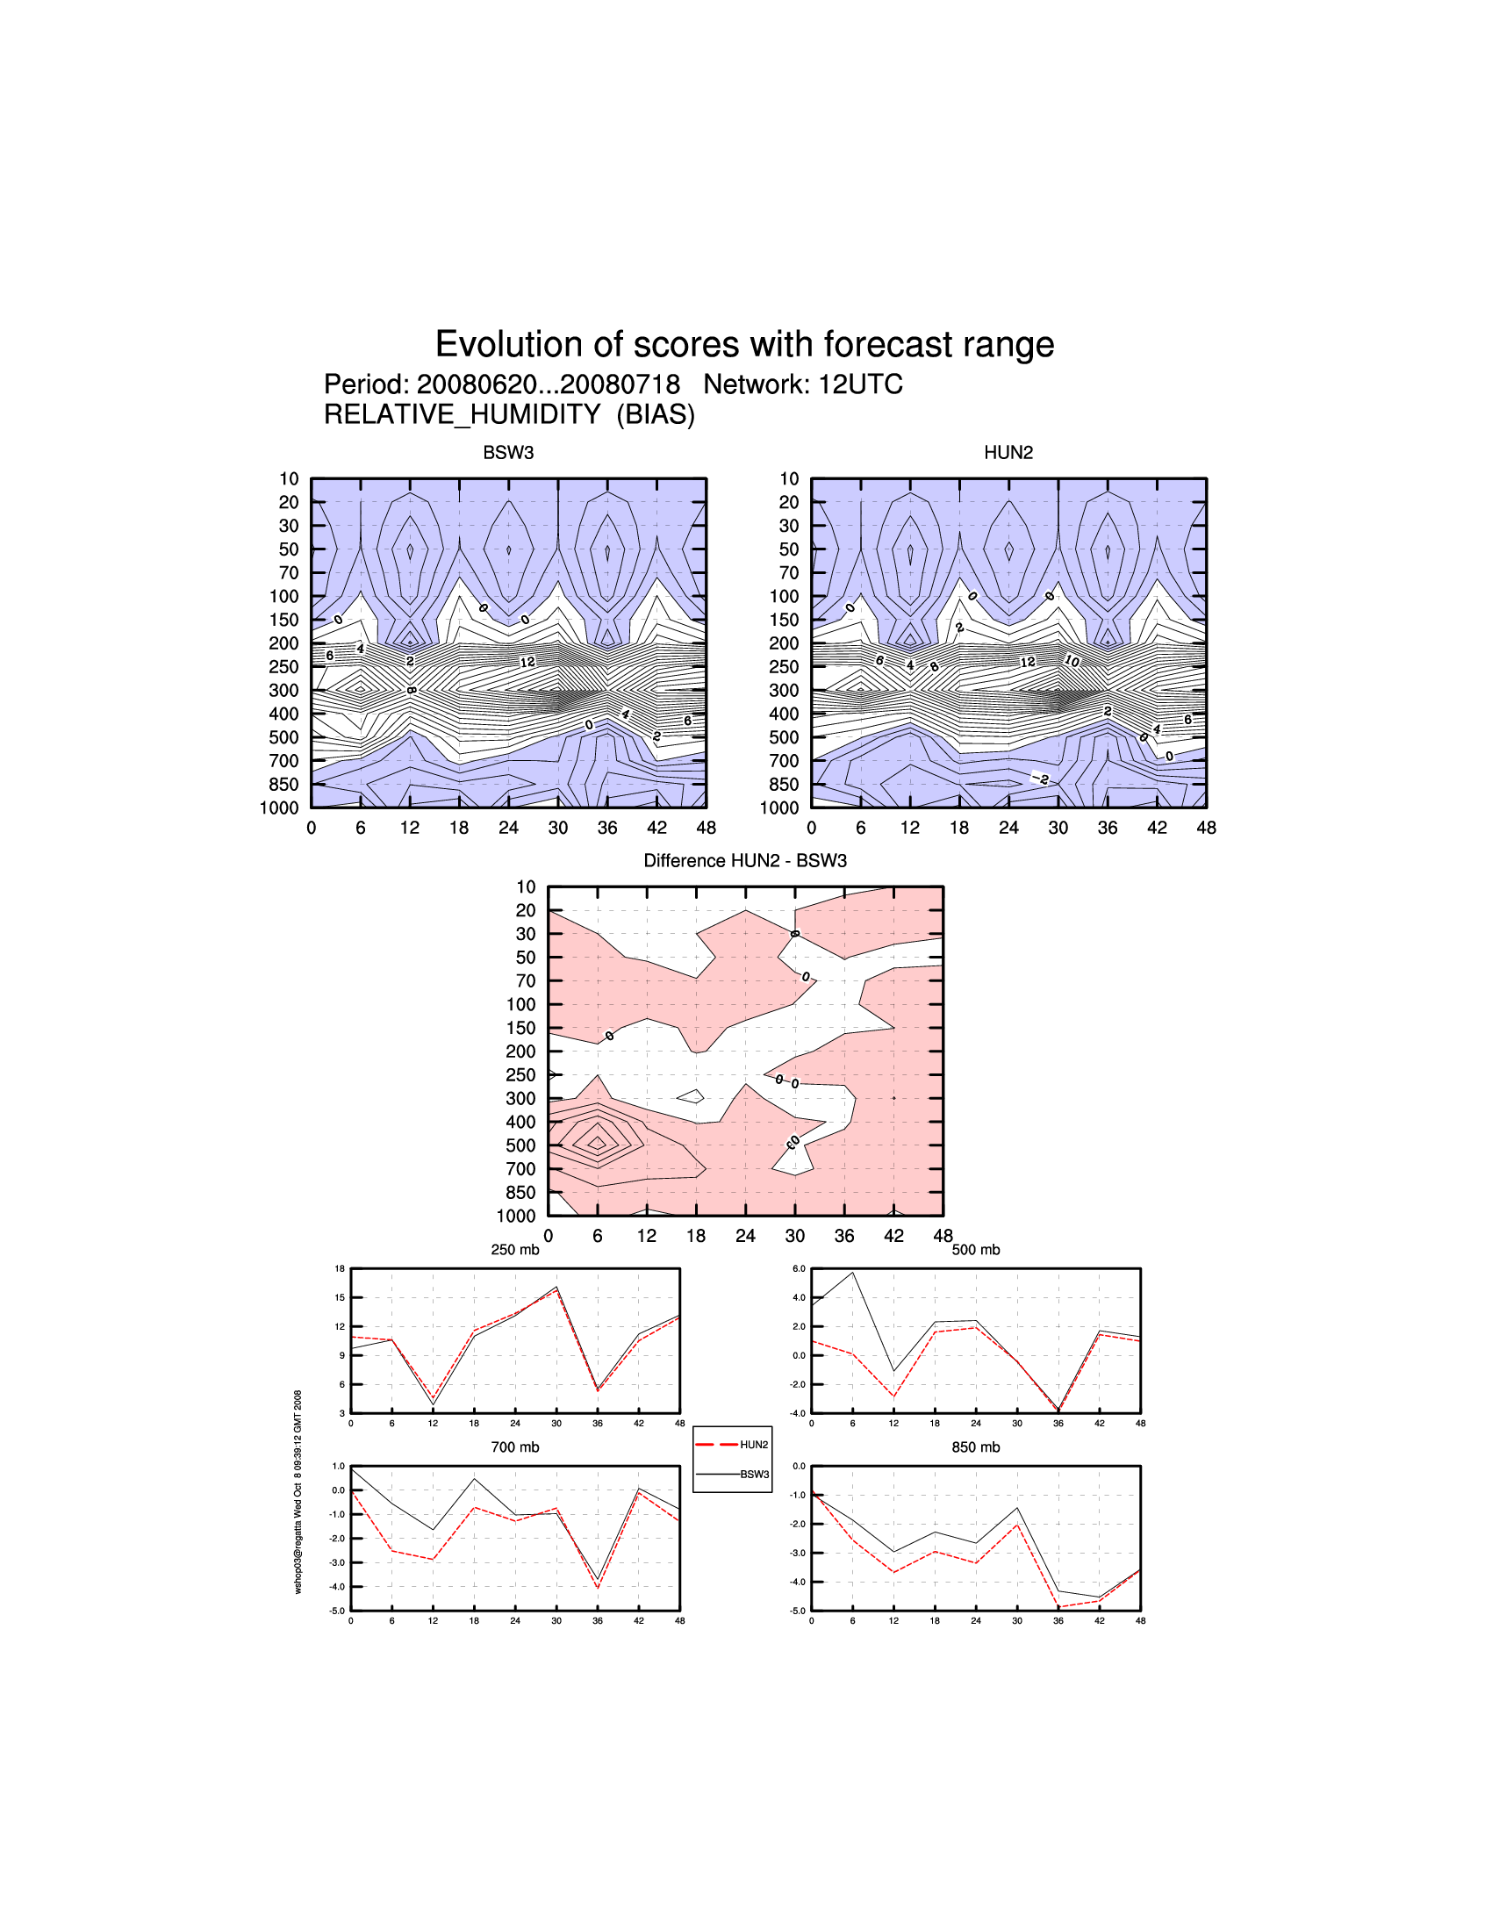
Fig. 6: BIAS of Relative humidity 12 UTC

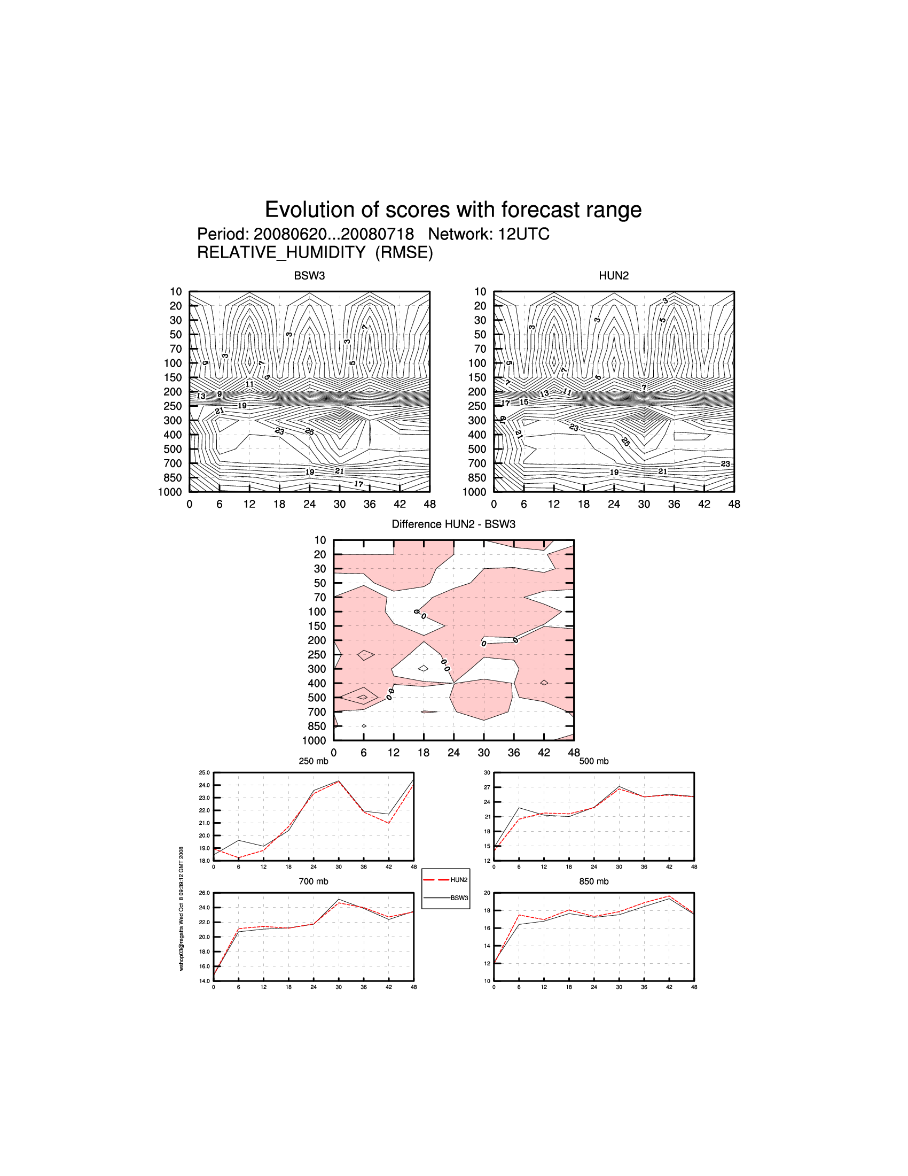
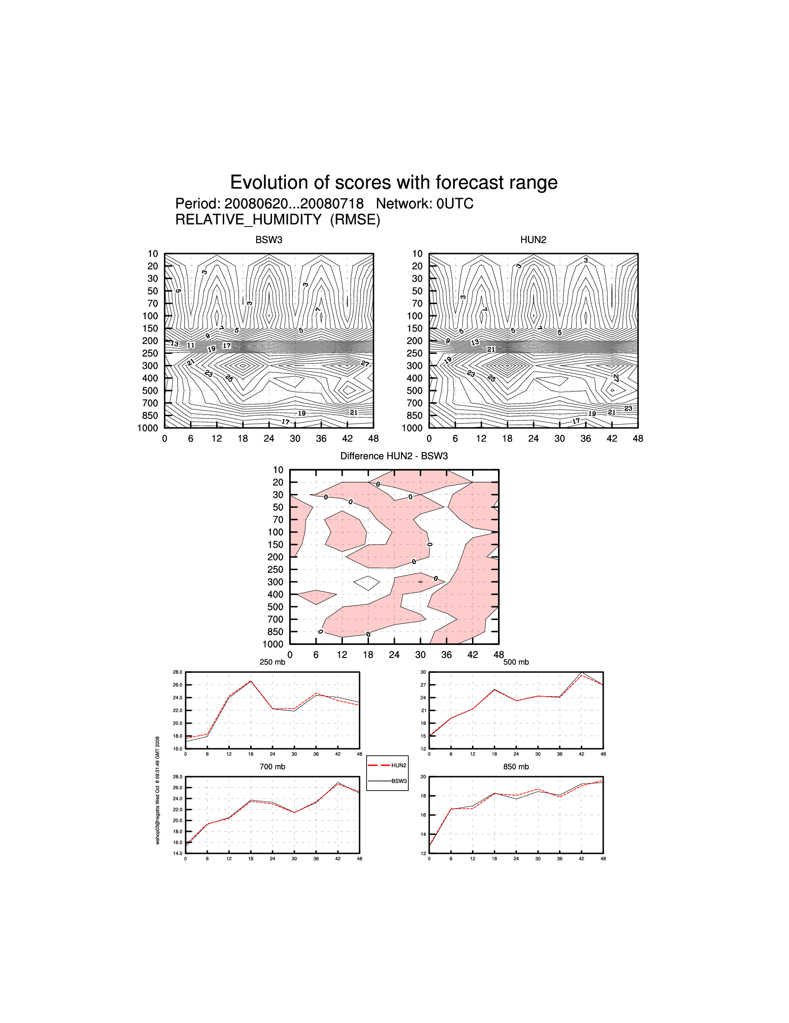
Fig. 7: RMSE of Relative humidity 00 UTC

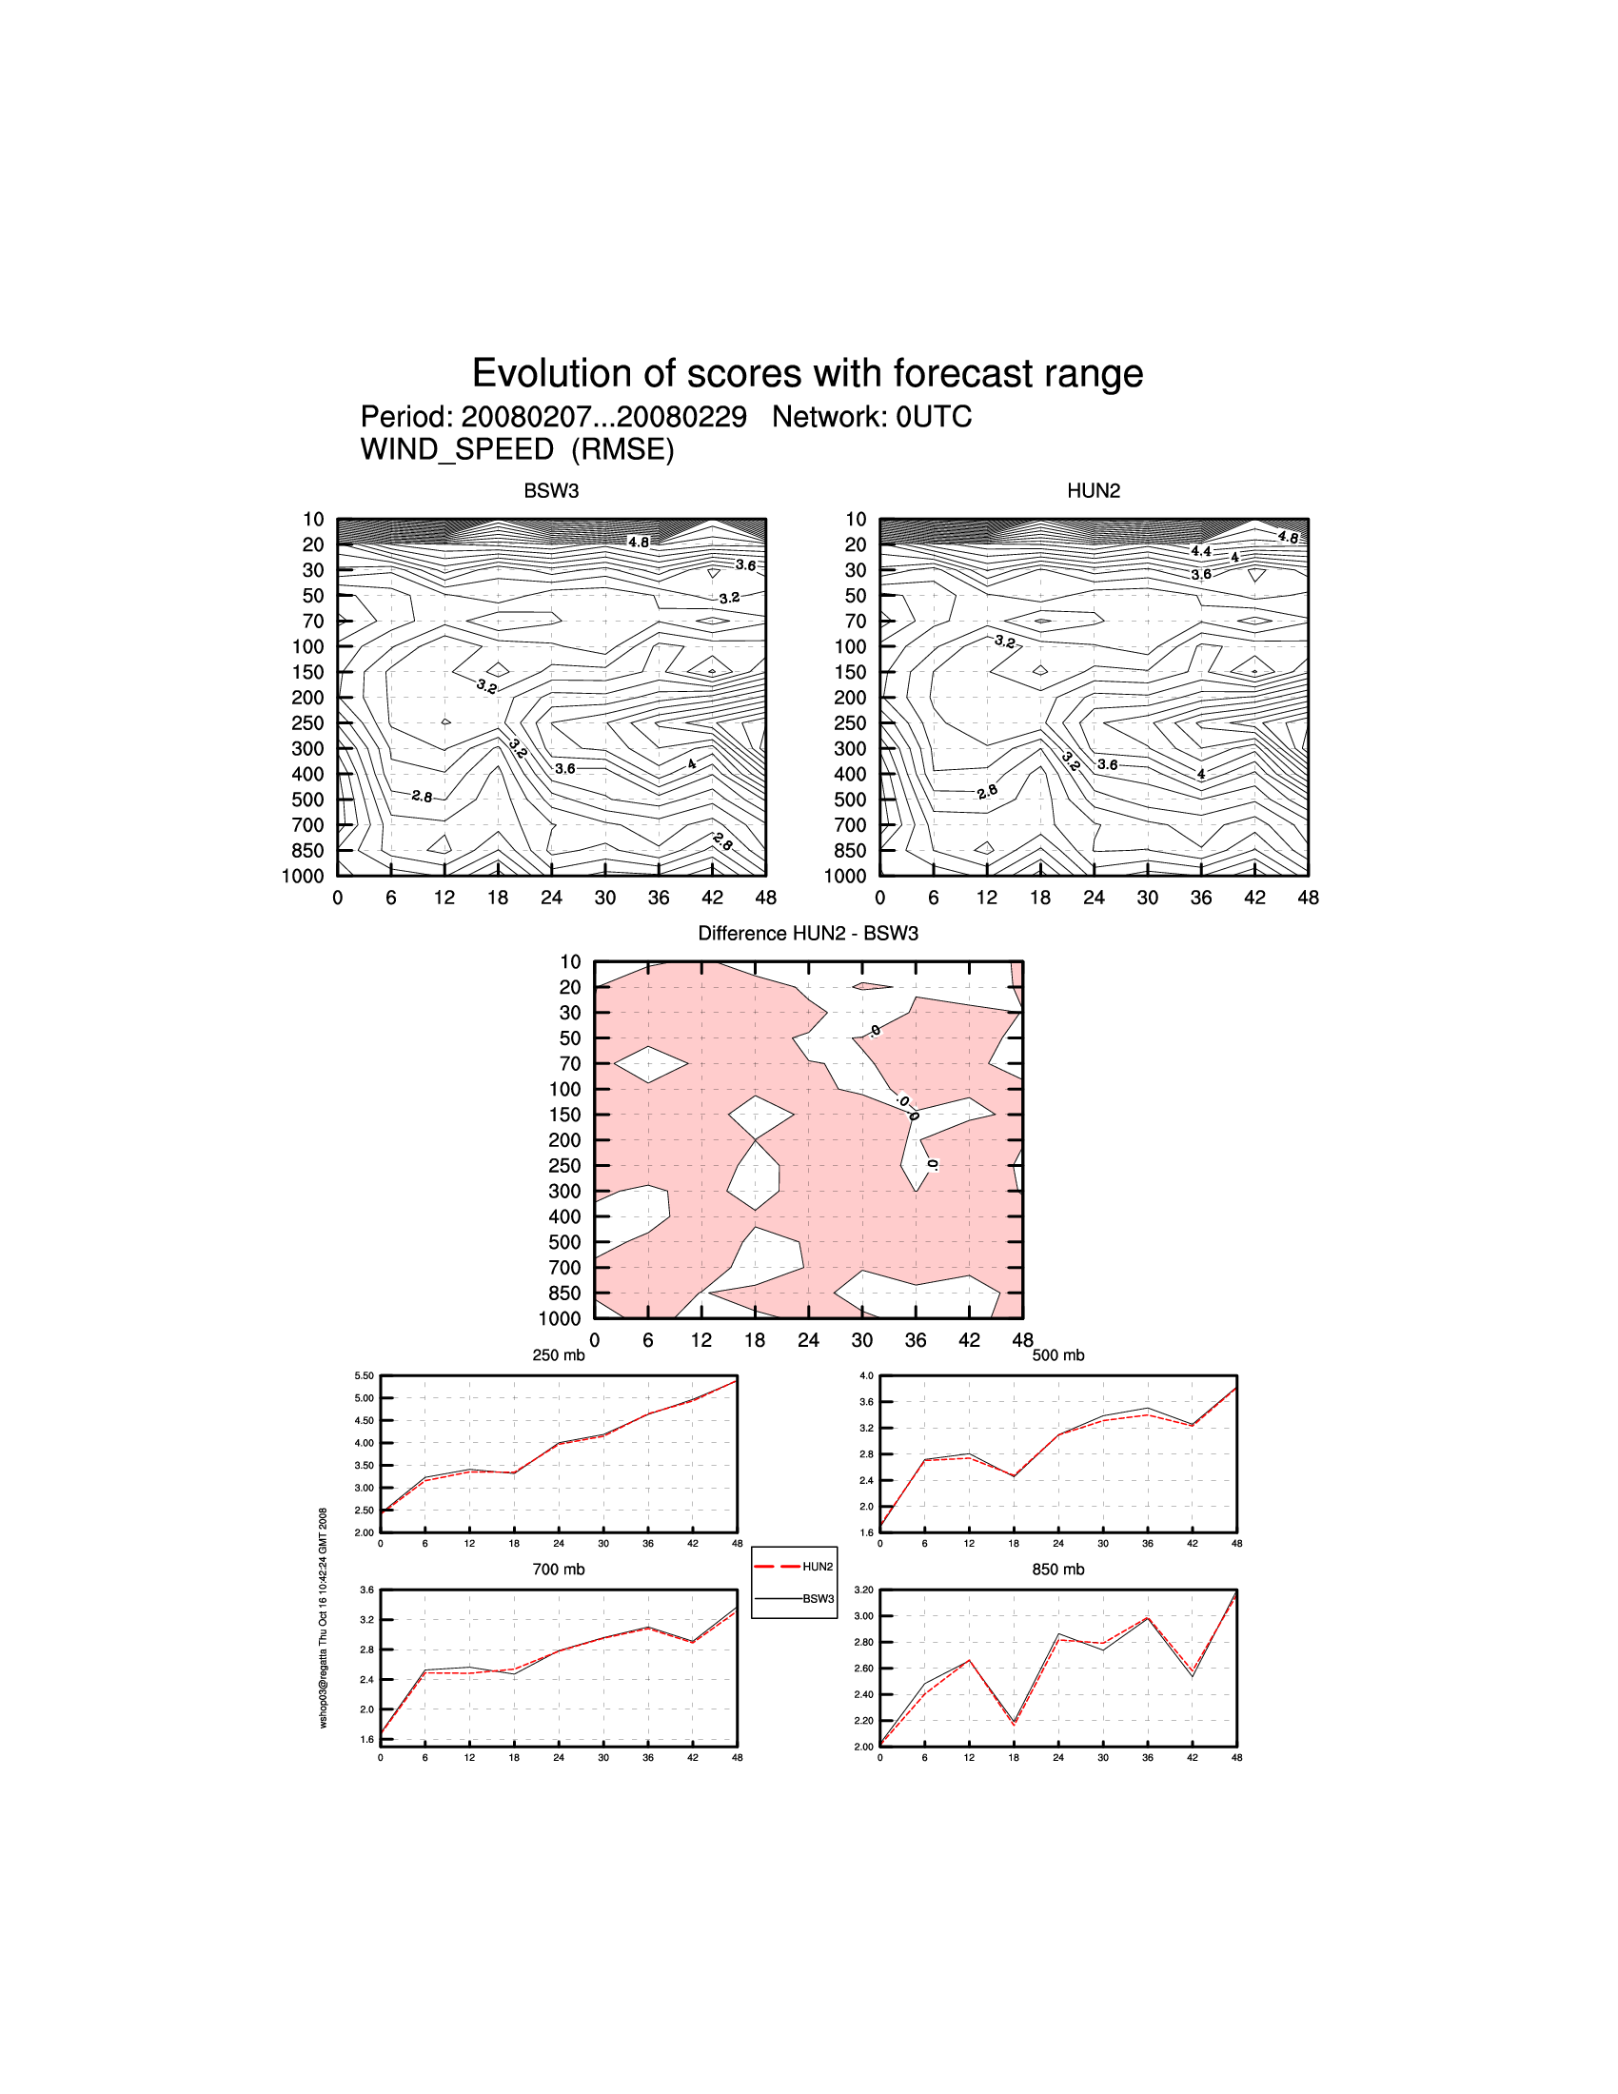
Fig.8: RMSE of wind speed 00 UTC
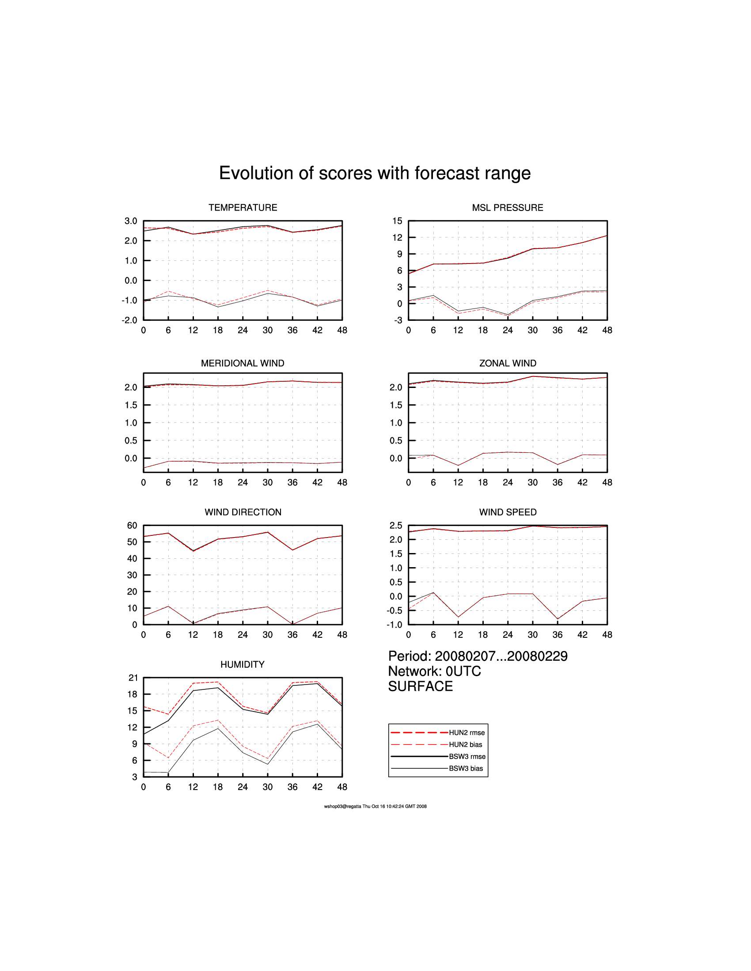

Fig. 9: RMSE and BIAS of parameters for surface, 00 UTC

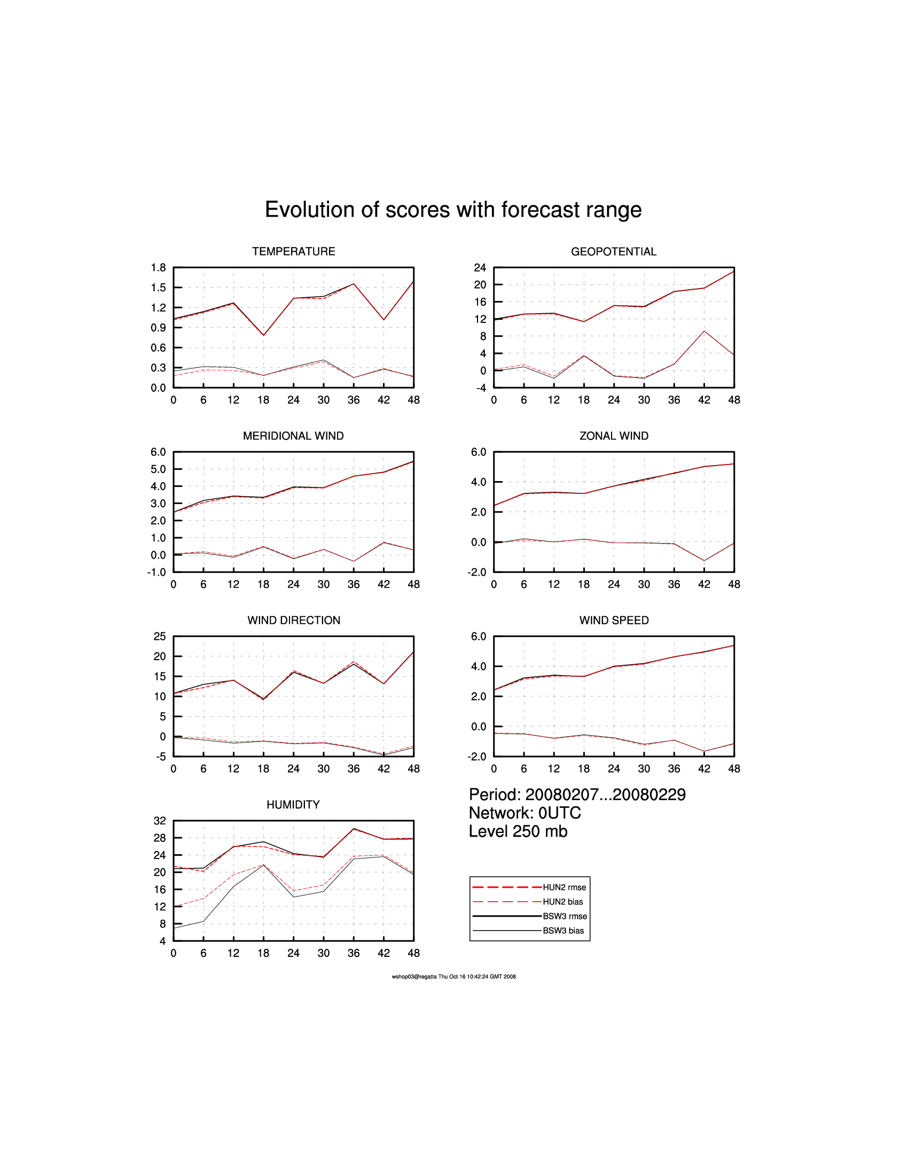

Fig. 10: RMSE and BIAS of parameters in 250 mb level, 00 UTC

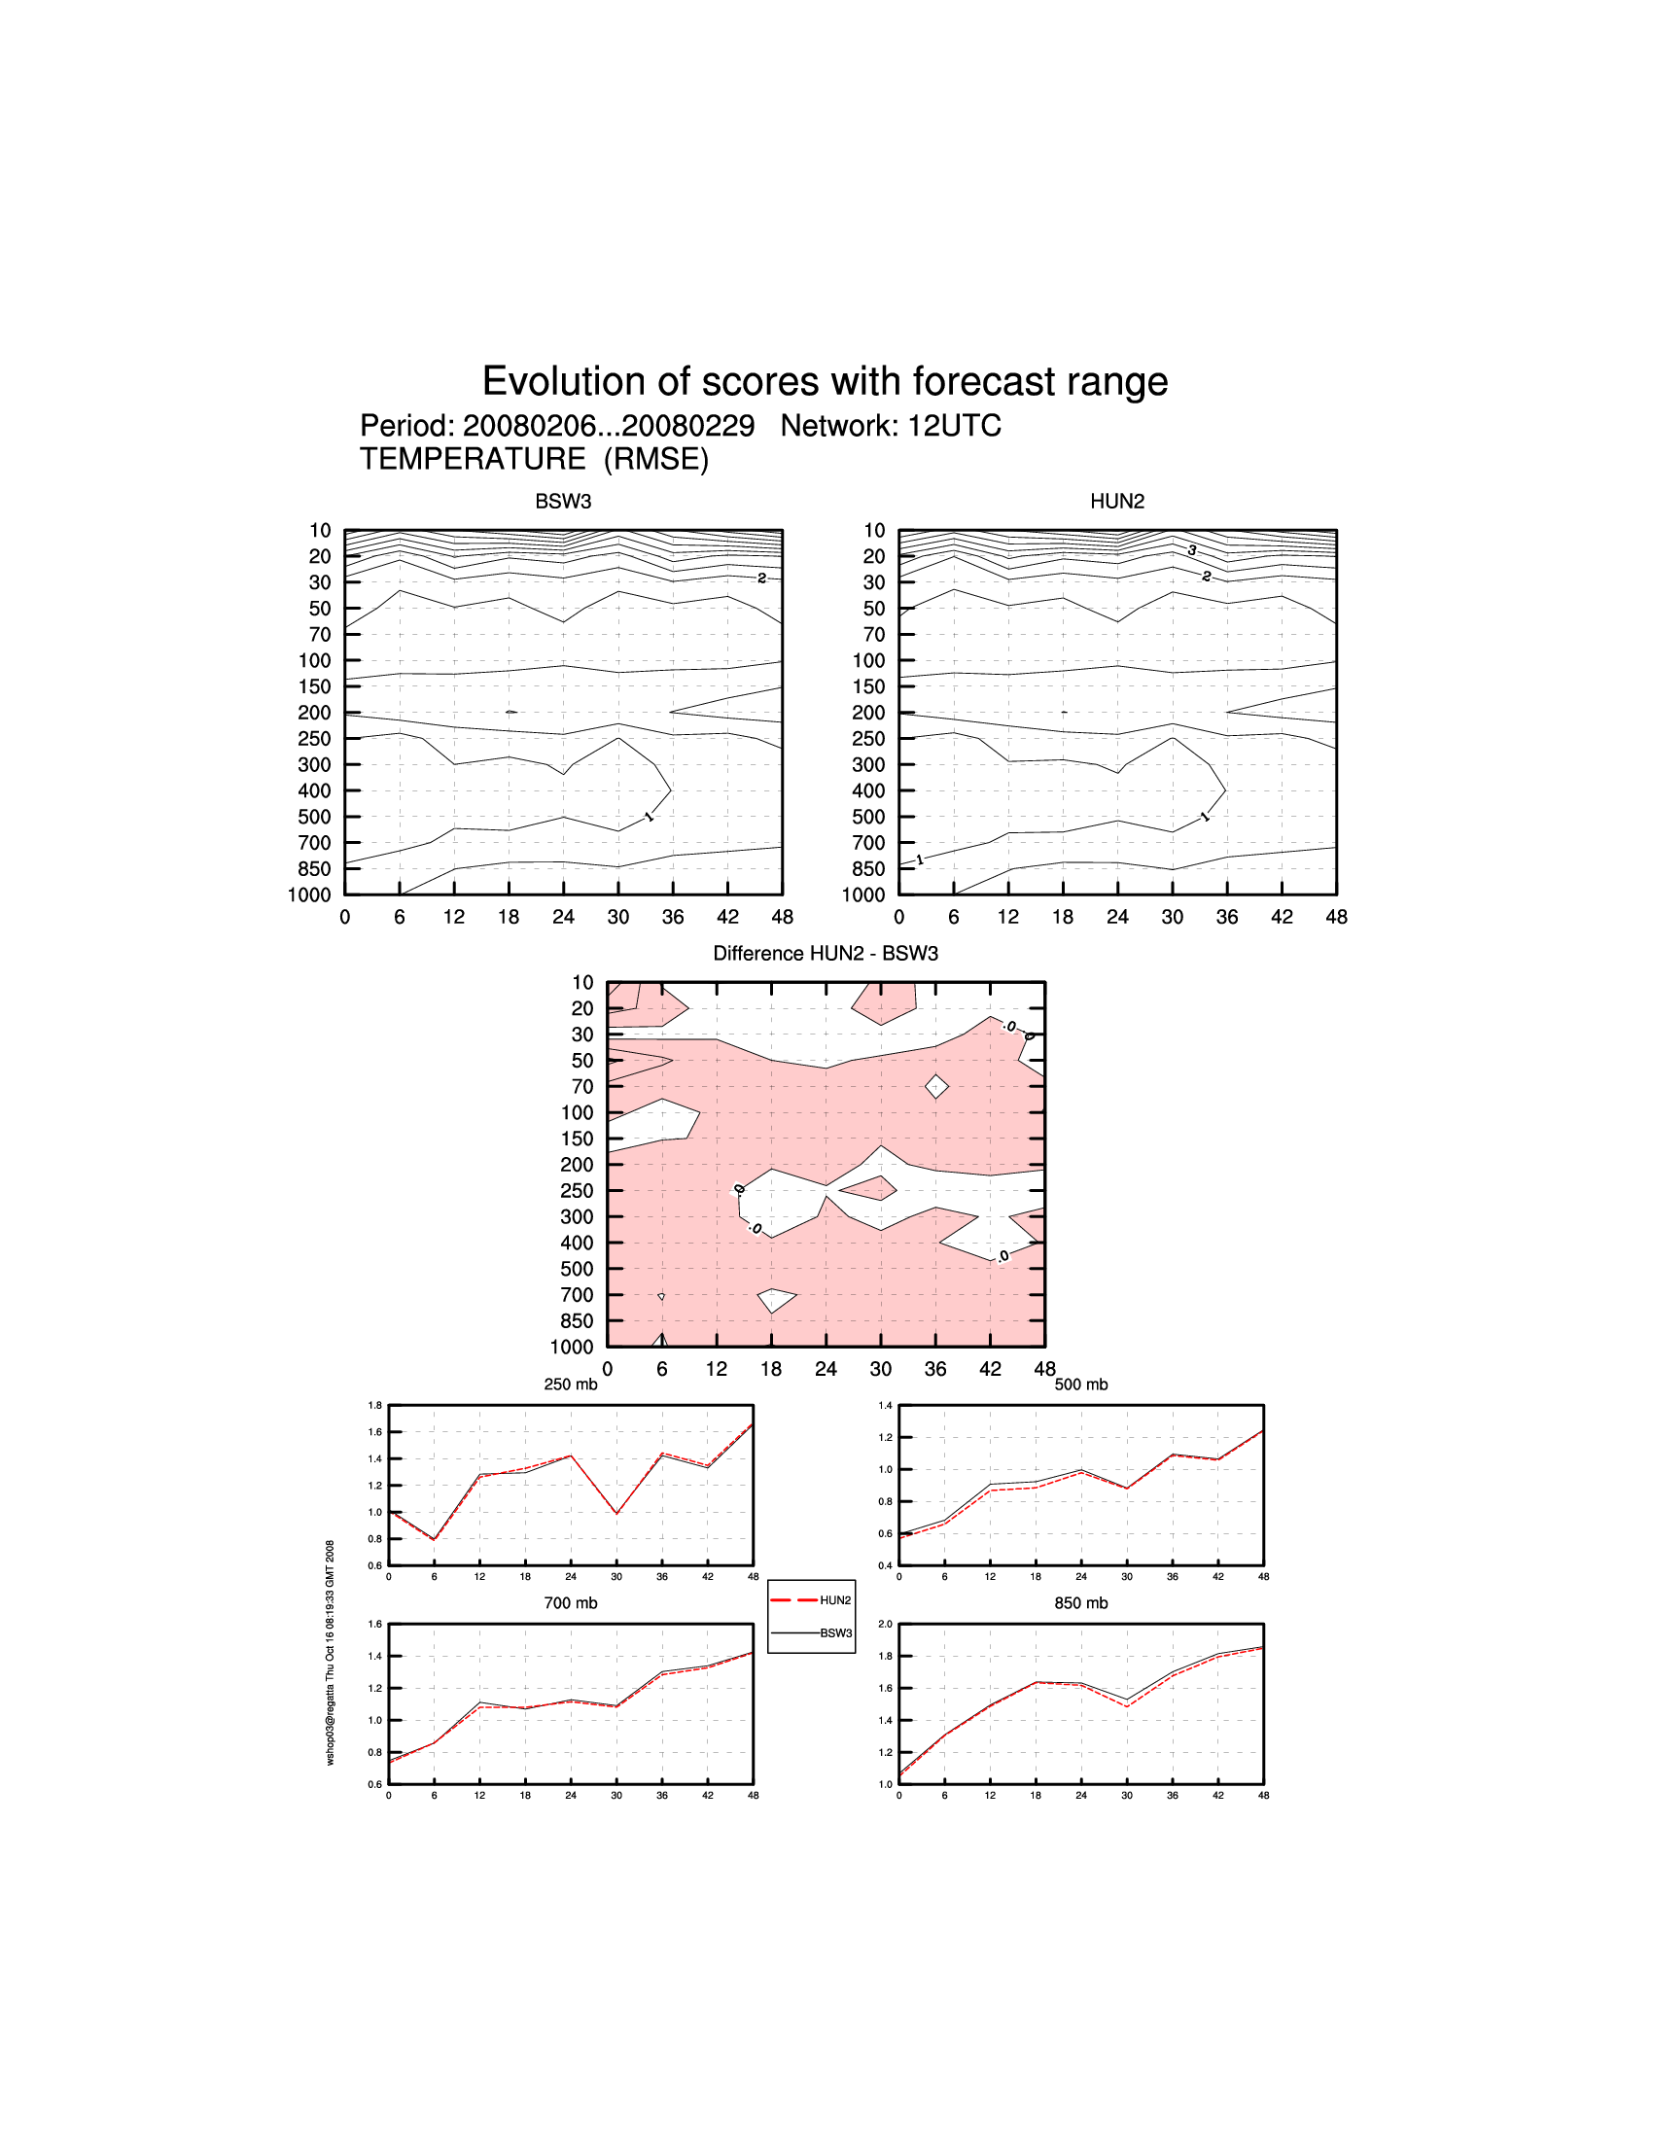

Fig. 11: RMSE of Temperature 12 UTC

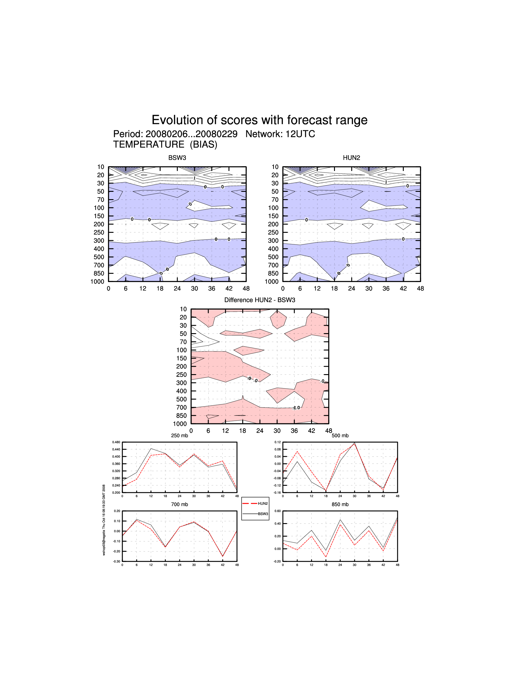

Fig. 12: BAIS of Temperature 12 UTC

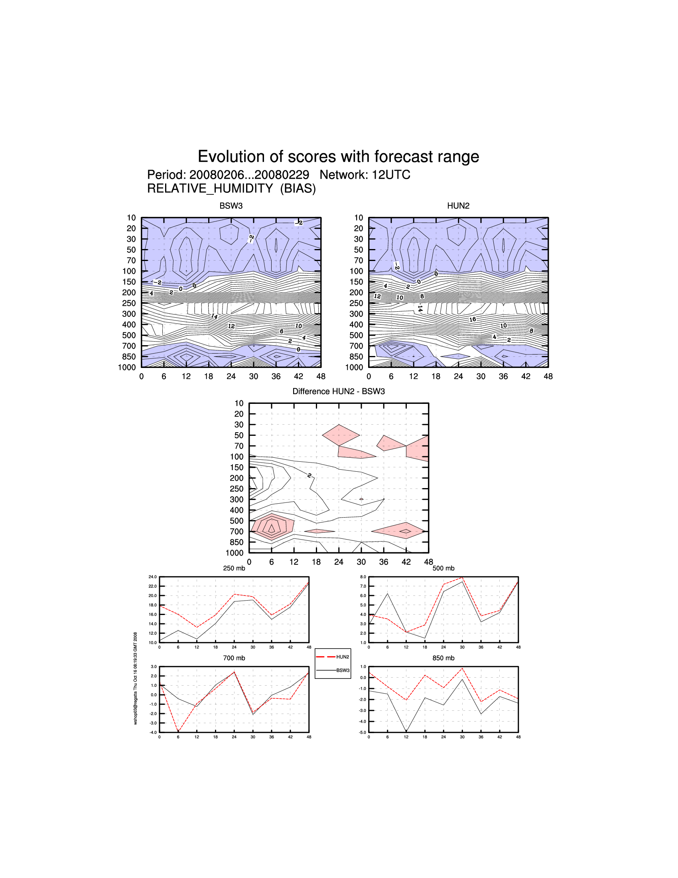

Fig. 13: BIAS of Relative humidity 12 UTC
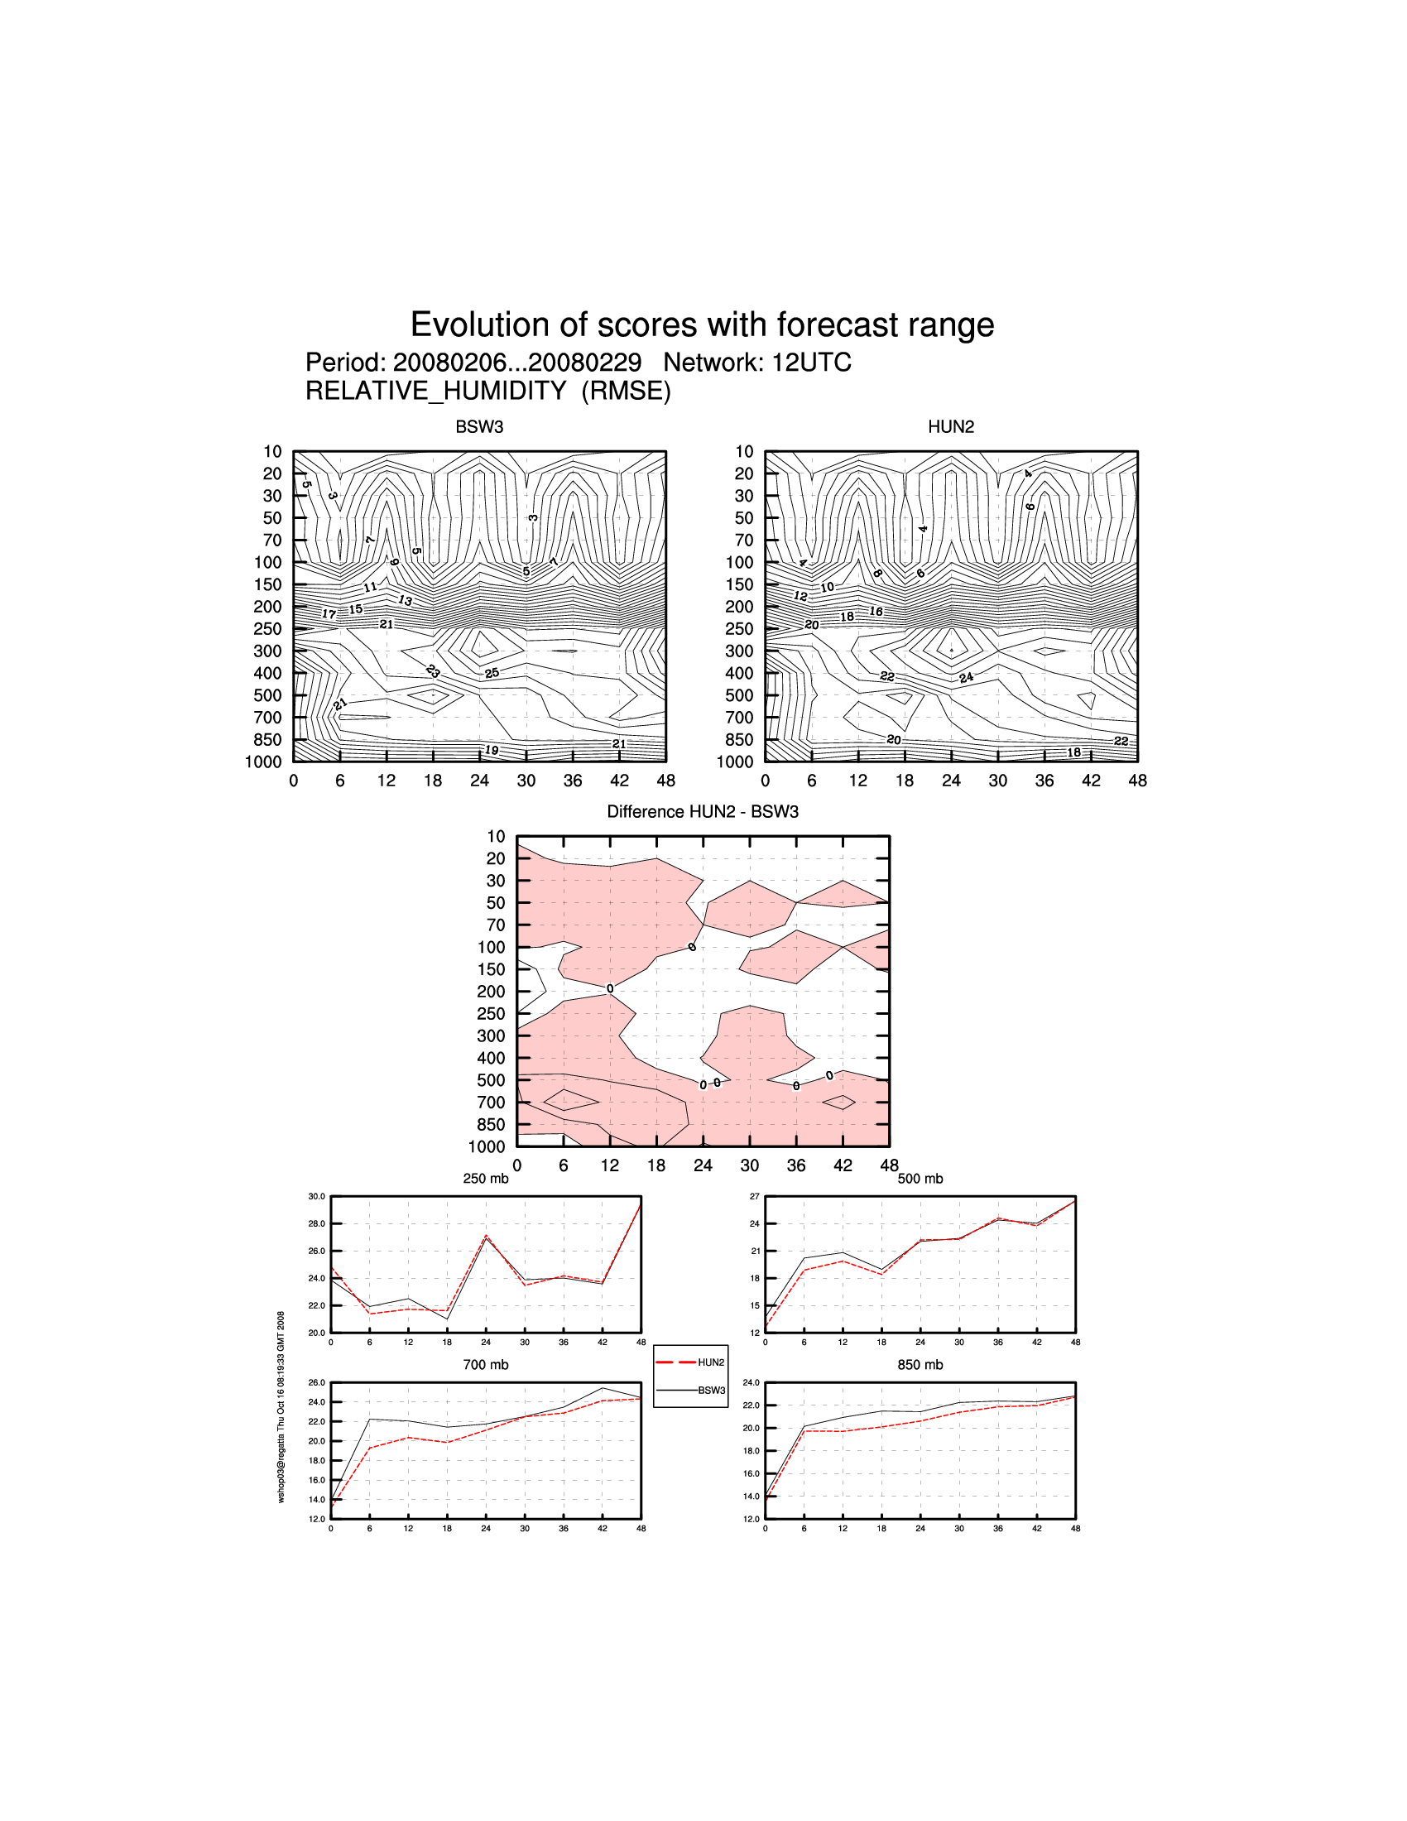
Fig. 14: RMSE of Relative humidity 12 UTC

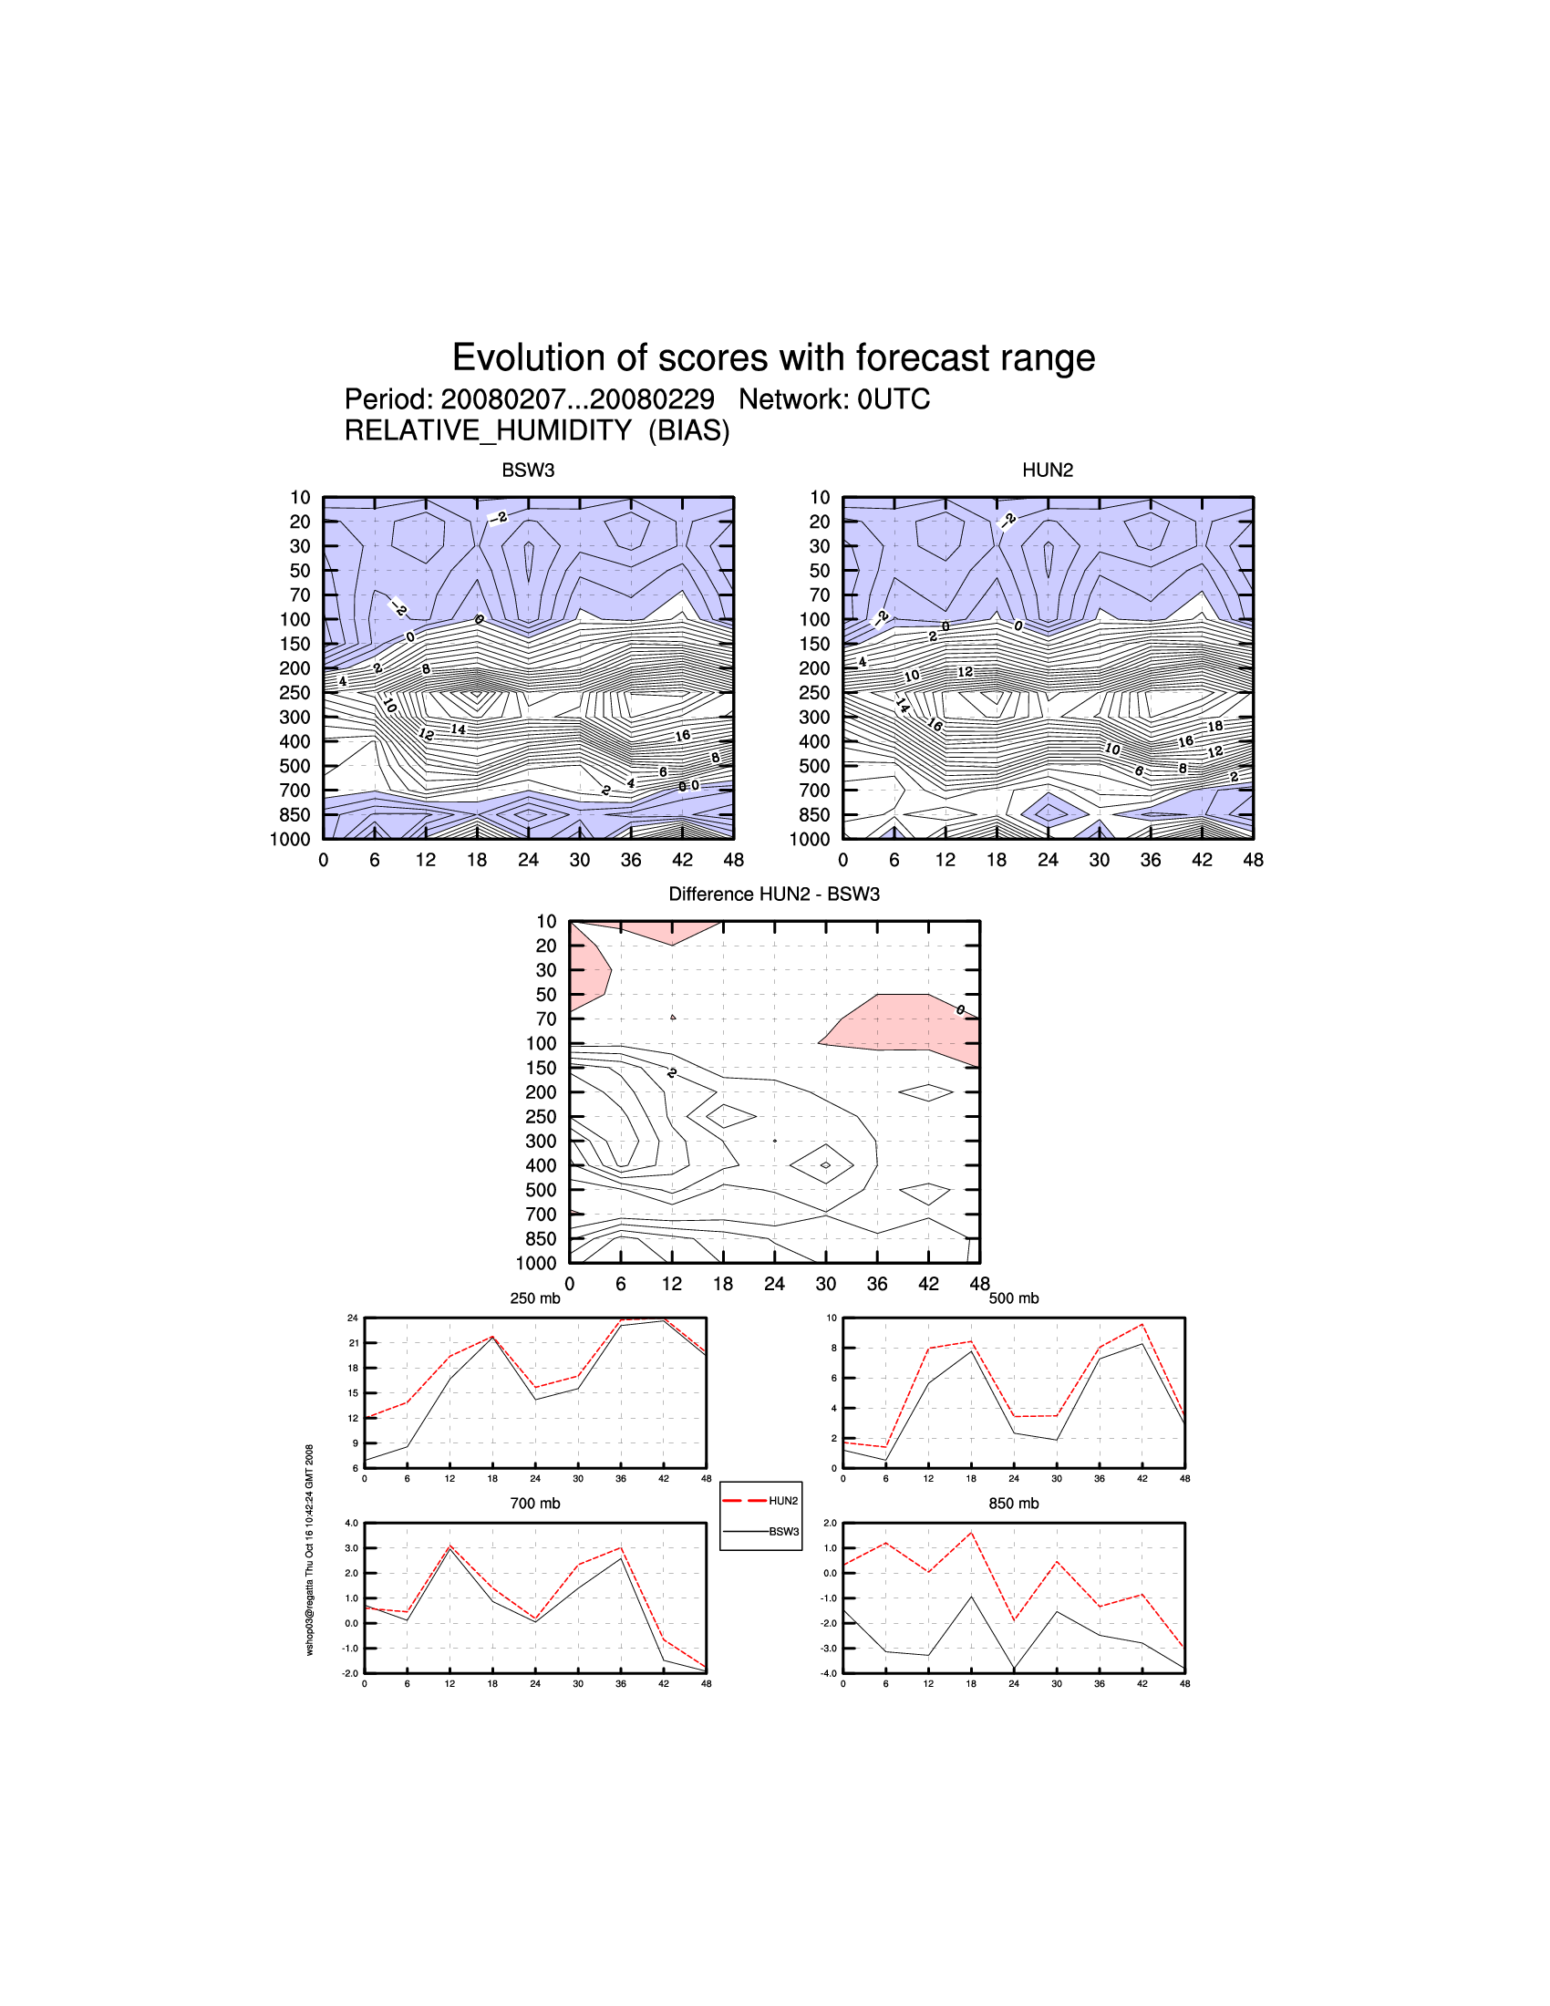
Fig. 15: BIAS of Relative humidity 00 UTC

