Assimilation of SEVIRI water vapour channels and SYNOP data
report from ALADIN stay in Budapest, 08/09-17/10/2008

Scientific supervisor: Gergely Bölöni

Ersin KUCUKKARACA
Turkish State Meteorological Service
06120 Kalaba Ankara

Contents
1 Introduction | 3
2 Main characteristics of the ALADIN/HU assimilation system | 3
3 Definition of experiments and data | 4
4 Comparison of experiments | 5
4.1 Verification against observations | 5
4.2 Verification against ECMWF analysis | 5
5 Conclusions | 5
6 Acknowledgments | 6
References | 6
Appendix A Technical notes | 6

1 Introduction

The first implementation of SEVIRI data in ALADIN/HU 3D-VAR data assimilation system was successfully performed in 2006 by Trojáková and Majek. Afterwards, impact of SEVIRI and SYNOP data were studied in 2007 by Trojáková. However impact of SEVIRI data was small and not positive in ALADIN/HU 3DVAR system (Trojáková, 2007).

SEVIRI data are received in GRIB format and contain brightness temperature for channels 3.9 μm, 6.2 μm, 7.3 μm, 8.7 μm, 9.7 μm, 10.8 μm, 12 μm, 13.4 μm. In the present study only water vapour channels ( 6.2 μm, 7.3 μm) were used, contrary to the earlier experiments at HMS. The blacklisting of the IR channels was based on experiences at MF, namely these channels from MSG2 can degrade the analysis (Thibaut Montmerle personal communication)

The paper is divided into four main sections. Section 2 describes the data assimilation system used. In section 3, I describe the assimilation experiments performed. . Section 4 presents results of the experiments and conclusions are drawn in section 5.

2 Main charasteristics of ALADIN/HU assimilation system

All experimets were performed with 3D-VAR ALADIN/HU system with the following settings:
- Model version :AL30t1
- 8 km horizontal resulation and 49 vertical levels
- 6 hours assimilation cycle without surface assimilation
- background error covariances based on the Ensemble method
- Short cut-off analyses for the production runs

and used observations:
- SYNOP (geopotential)
- SHIP (geopotential)
- TEMP (T, u, v, q)
- ATOVS AMSU-A and AMSU-B
- AMDAR (t, u, v)
- AMV (GEOWIND) data (u,v)
- Wind profiler data (u,v)

3 Definition of experiments and data

Using way of SEVIRI data was based on Montmerle (2005), one pixel of 5 excracted from SEVIRI dataset, thinnig box of 70 km was applied during screening and air-mass bias correction as described in Trojáková and Majek (2006). The six infrared channels of SEVIRI ( 3.9 μm,8.7 μm, 9.7 μm, 10.8 μm, 12 μm, 13.4 μm ) were blacklisted.

The experiments are summarised below:
HUN2 : Operational ALADIN/HU system as reference run.
ESS1 : HUN2+SEVIRI water vapour channels+SYNOP (T2m and RH)
ESS2 : HUN2+SEVIRI water vapour channels+SYNOP (T2m and RH) observation in daytime.

Note that 06 UTC, 12 UTC and 18 UTC SYNOP observations were accepted as daytime observation in ESS2 case. The 00 UTC SYNOP observations were blacklisted through the NOTVAR variable of the 3D-VAR namelist as follows:
NOTVAR(1,1)= 0, 0,-1,-1,-1,-1,-1, 0,-1,-1,-1,-1,-1,-1,-1,-1,-1,-1,-1,-1,-1,-1,-1,-1,-1,On the other hand, at network times when the SYNOP T and RH data were used a different 3D-VAR namelist was used with the following NOTVAR variable:
NOTVAR(1,1)= 0, 0,-1,-1,-1, 0,-1, 0,-1,-1, 0,-1,-1,-1,-1,-1,-1,-1,-1,-1,-1,-1,-1,-1,-1,

The effect of assimilation of the water vapour channels data from SEVIRI was tested for the period between 23 June 2008 and 18 July 2008. All experiments started from the same operational first guess valid at 20080619 18UTC . The period from 20080620 00 UTC to 20080622 18 UTC was taken as warm up assimilation cycles , so only the following 26 days have been taken for the verification.

During the period of experiments, 20080703 06 UTC short cut-off LBC files were missing. Long cut-off LBC files thereupon used 20080703 06 UTC assimilation cycle. Also 3 forecast cycles of experiments couldn't run. The date and the reason are below:
- 20080703 12 UTC and 20080704 00 UTC : LBC files were missing in HMS archive,
- 20080622 12 UTC : obs.short.gz file was missing in HMS archive.

4 Comparison of experiment
4.1 Verification against observations

Figure 1 and Figure 2 show surface parameters verification score for 00 UTC runs against observations. RMSE and bias score of ESS1 2 meter temperature are better than operational cycles (HUN2). RMSE and bias score of ESS2 are also better than HUN2, but worse than ESS1. RMSE of ESS1 surface humidity has better score although bias scores is about same with ESS2 and HUN2. Impact of ESS2 is less than ESS1 for 00 UTC. Impact of ESS1 and ESS2 are same for 12 UTC run (Figure 3 and 4). Impact of SEVIRI and SYNOP data is very limited on low troposphere for ESS1 (Figure 5 and 7) and ESS2 (Figure 6 and 8) for temperature and humidity. However, there is a positive impact on wind speed and humidity BIAS at 500 hPa (Figure 5).

There is a significant negative impact reversely for humidity and temperature at 500 hPa level (Figure 9, Figure 10 and Figure 11). ESS1 and ESS2 produced less biased humidity forecast than HUN2 at 250 hPa level (Figure 12 and Figure 13). Upper level scores of ESS1 and ESS2 are the same for 00 UTC and 12 UTC network (not shown).

4.2 Verification against ECMWF analyasis

Figure 14 and 15 show difference of RMSE scores of ESS1 and HUN2 against ECMWF analysis. RMSE scores are reflect that ESS1 performs better than HUN2 for T and RH. The most noticeable effect of SEVIRI and SYNOP is in 12 hours forecast range. As well as simple counting of significant improvements displayed as white cycles on figures show us better results of ESS1.

5 Conclusions

The report presents an investigation to assimilate SEVIRI water vapour channels and SYNOP temperature and humidity in the ALADIN/HU system.

Experiment ESS1 provided scores, which were significantly different from those of the operational run. Impact of SEVIRI and SYNOP is positive in the low troposphere but it is negative for mid-levels. Experiment ESS2 shows us that the blacklisting of SYNOP observation at night time (00 UTC) does not improve the analysis and forecast during this summer period.

ESS1 and ESS2 were run both over a summer period. In the future winter period should be also tested. Also, in order to examine the single impact of SEVIRI water vapour channels a new experiment should be started without SYNOP observation..

6 Acknowledgments
The author wishes to thank Gergely Bölöni for kind supervising of my study and providing results from verification against ECMWF analysis.

References
Montmerle, T., 2005: Assimilation of the satellite data in a regional mesoscale model. Eumetsat research fellowship, third semester report.

Trojáková, A., 2007: Assimilation of SYNOP and SEVIRI data. LACE report (Avaible from http://www.rclace.eu/?page=11).

Trojáková, A. and Majek, M., 2006: Assimilation of SEVIRI data. LACE report (Avaible from http://www.rclace.eu/?page=11).

Appendix
A Technical notes
All scripts and namelists are stored on SGI/ALTIX 3700a under user ekukukk.

ESS1 scripts are in /home/ekukukk/3dvar/al30t1/EXP/ESS1 and ESS2 scripts are in /home/ekukukk/3dvar/al30t1/EXP/ESS2. There are two e131 namelist under ESS2 path; e131.nml.day and e131.nml.night. e131.nml.day is linked as e131.nml for 06, 12, 18 UTC runs and e131.nml.night is linked as e131.nml for 00 UTC run.

Veral scores of experiments (ESS1 and ESS2) are stored on IBM/regatta in /workdir/wshop02/compare_EXP/ESS1 and /workdir/wshop02/compare_EXP/ESS2, respectively.

Verification scores are also stored on IBM/regatta under user wshop02 and their path is /workdir/wshop02/veral/visu .

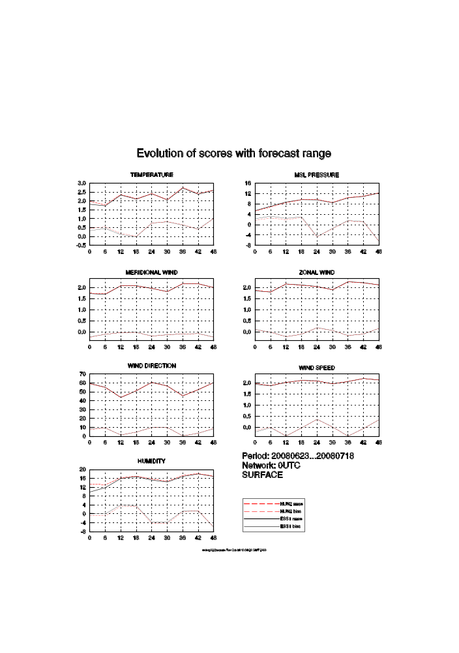
Figure 1:RMSE and BIAS for surface from 20080623 till 20080718 for all range of 00 UTC protuction. ESS1 scores are shown black and operational run (HUN2) scores are shown red.

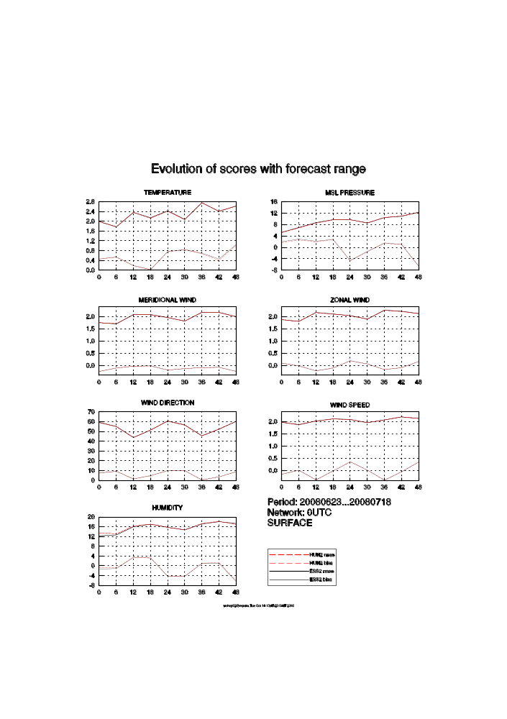
Figure 2:As Figure 1, but for ESS2

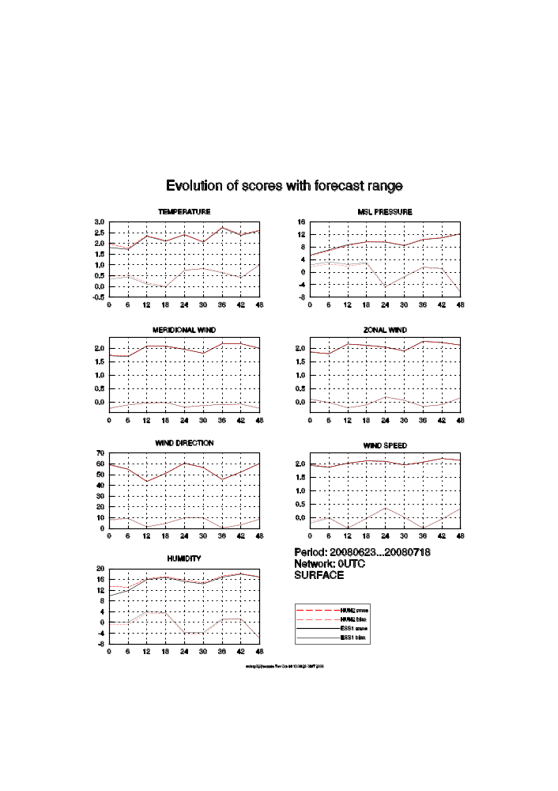
Figure 3:RMSE and BIAS for surface from 20080623 till 20080718 for all range of 12 UTC production. ESS1 scores are shown black and operational run (HUN2) scores are shown red.
Figure 4:As Figure 3, but for ESS2

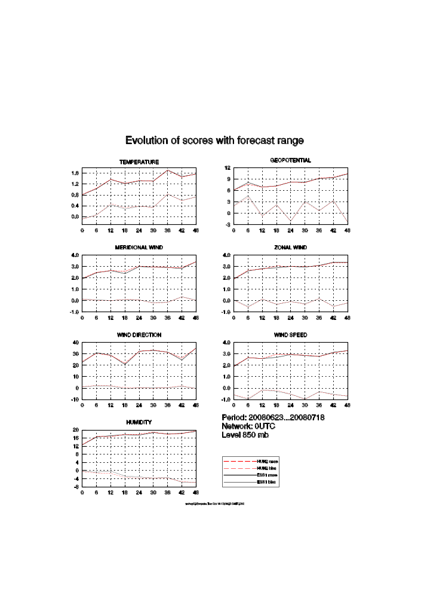
Figure 5:RMSE and BIAS for 850 hPa level from 20080623 till 20080718 for all range of 00 UTC production. ESS1 scores are shown black and operational run (HUN2) scores are shown red.

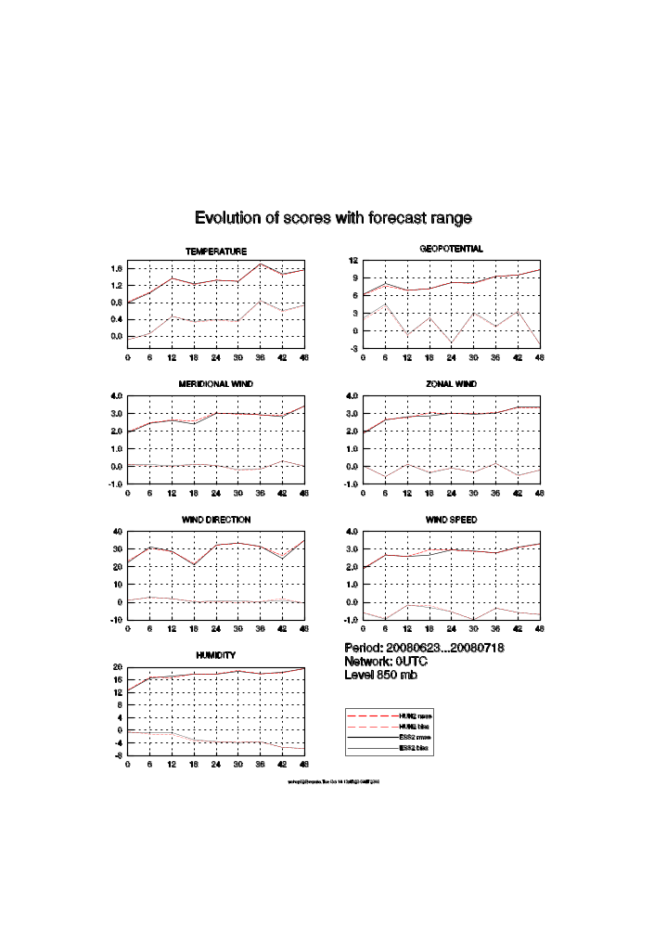
Figure 6:As Figure 5, but for ESS2.

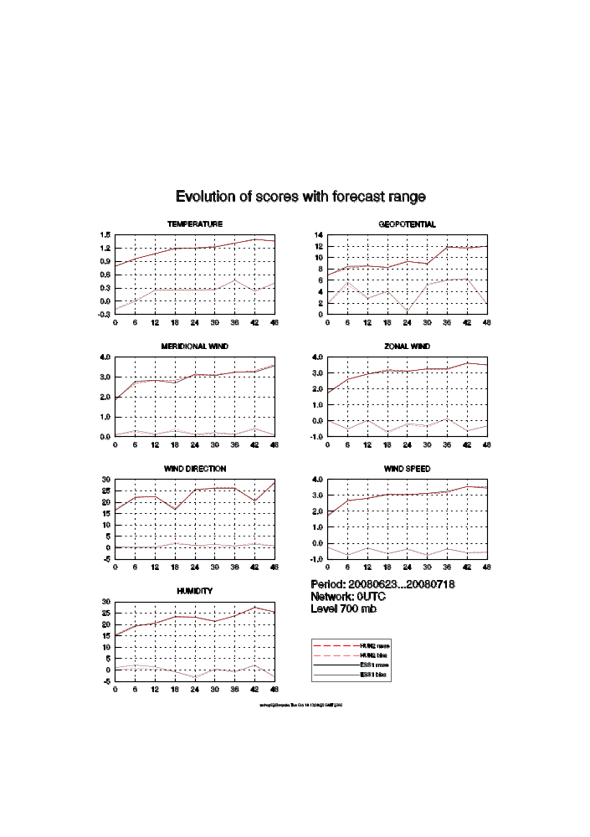
Figure 7:RMSE and BIAS for 700 hPa level from 20080623 till 20080718 for all range of 00 UTC production. ESS1 scores are shown black and operational run (HUN2) scores are shown red.

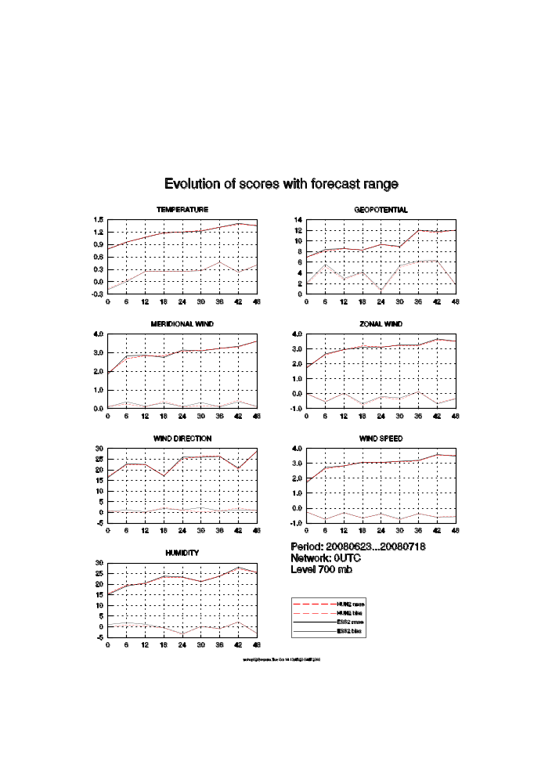
Figure 8:As Figure 7, but for ESS2.

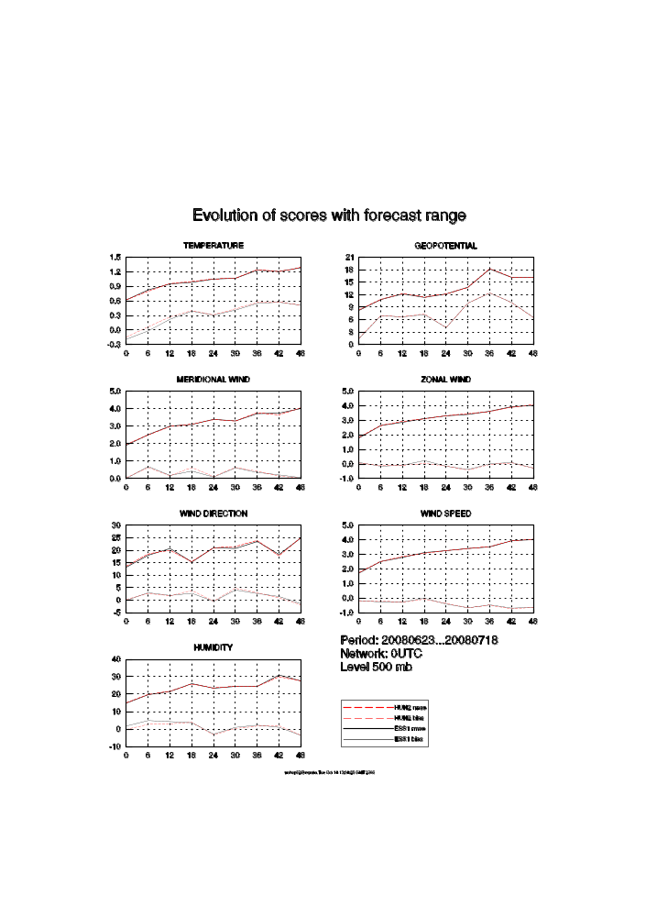
Figure 9:RMSE and BIAS for 500 hPa level from 20080623 till 20080718 for all range of 00 UTC production. ESS1 scores are shown black and operational run (HUN2) scores are shown red.

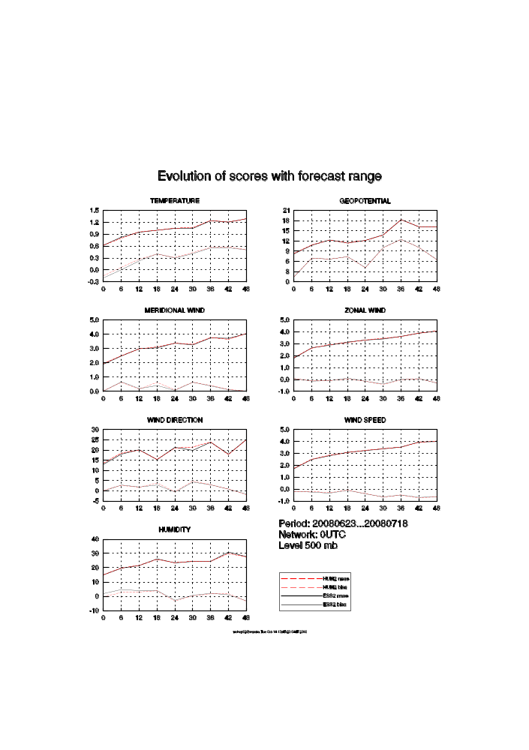
Figure 10:As Figure 9, but for ESS2.

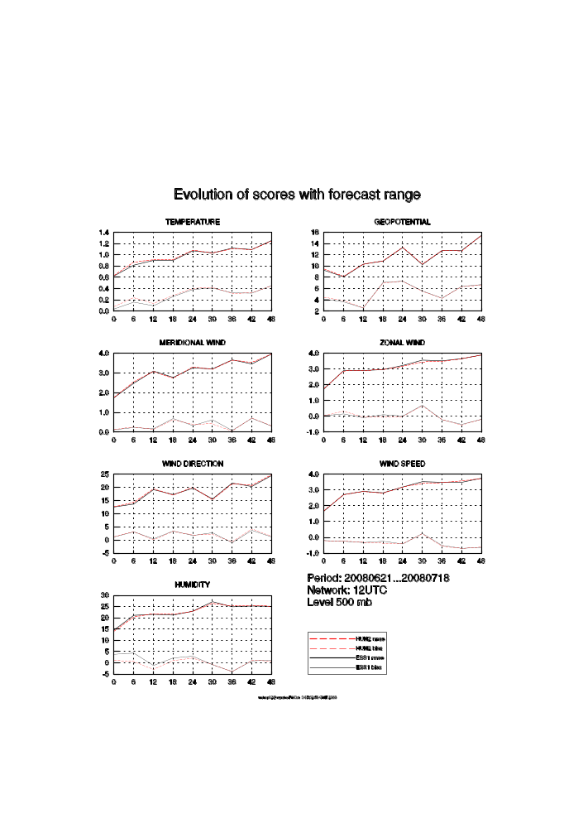
Figure 11:As Figure 9, but for 12 UTC production.
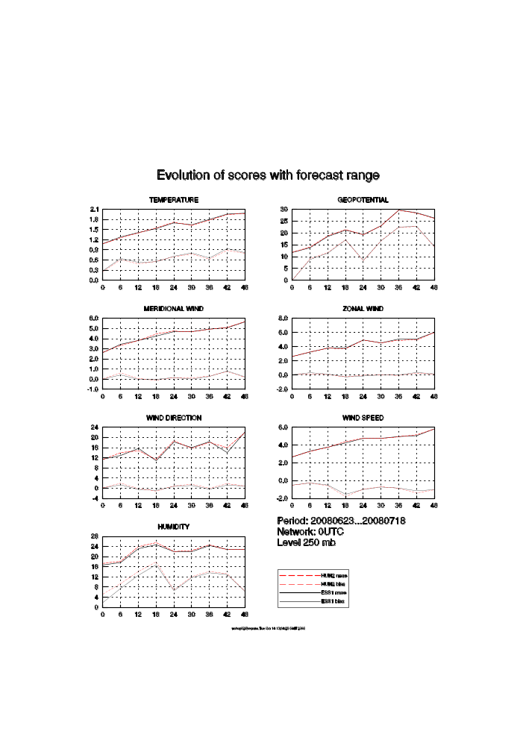
Figure 12:RMSE and BIAS for 250 hPa level from 20080623 till 20080718 for all range of 00 UTC production. ESS1 scores are shown black and operational run (HUN2) scores are shown red.

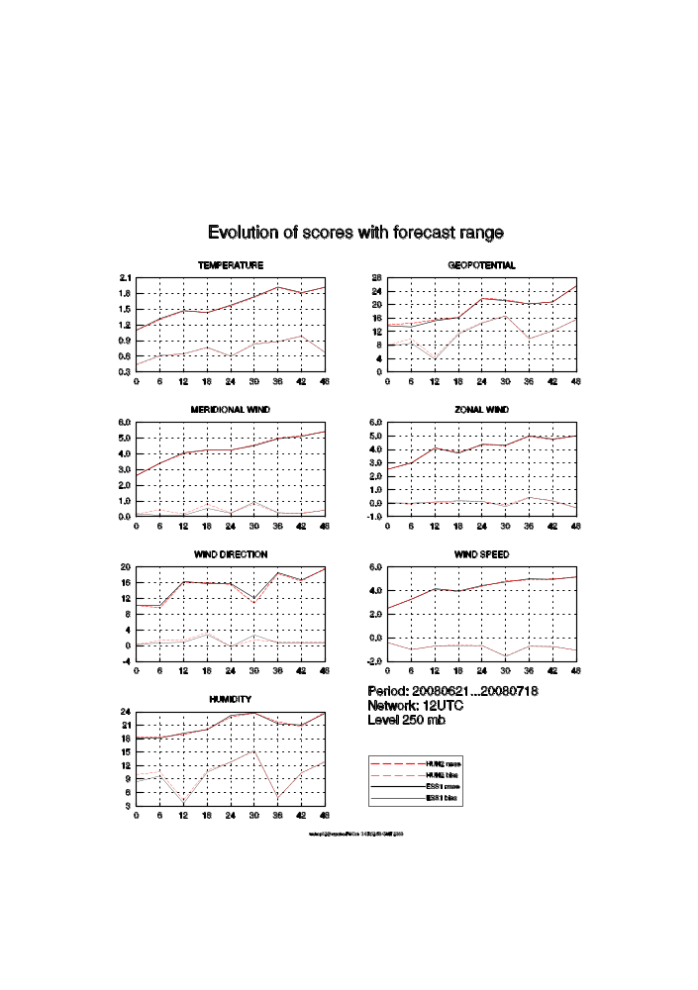
Figure 13:As Figure 12, but for 12 UTC production.

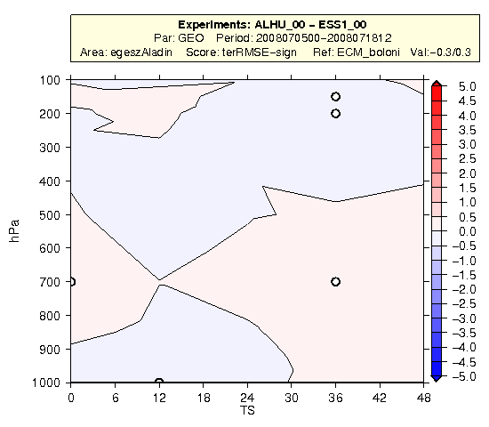
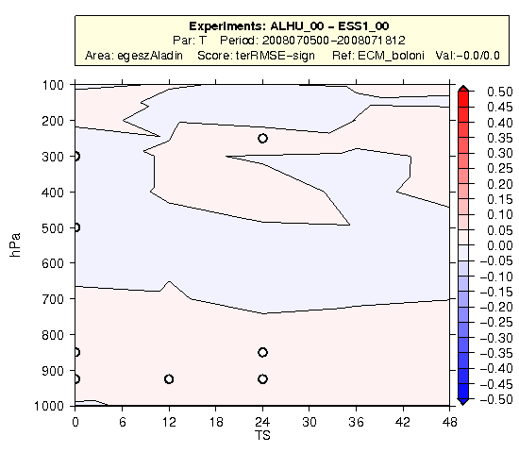
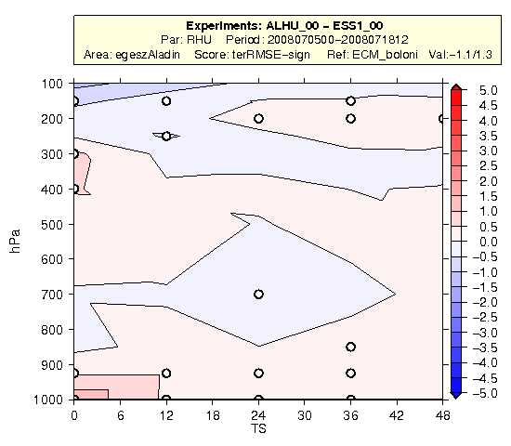
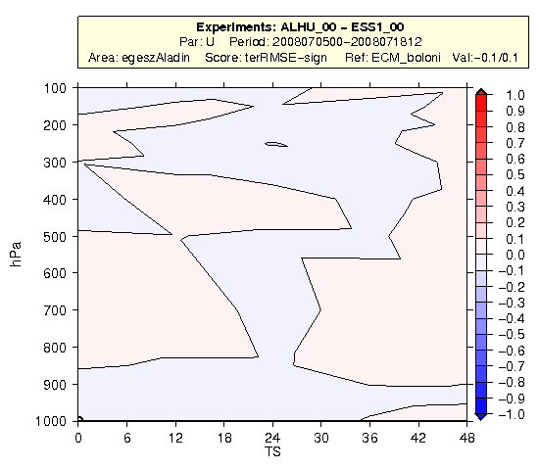
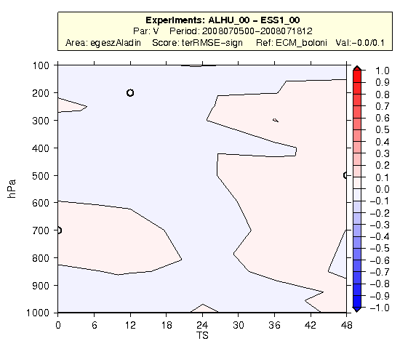

Figure 14: Difference of RMSE scores of the 00 UTC forecast of ESS1 and HUN2. White circles show that the difference is significant on a 90 % confidence level. The figure order is following Ф, T, RH, u and v.
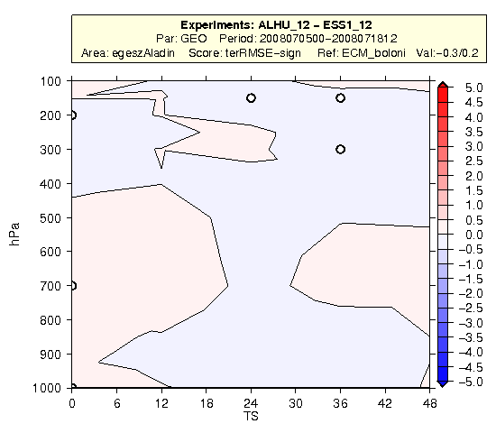
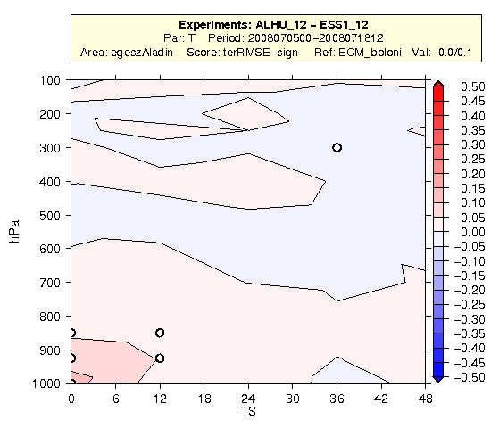

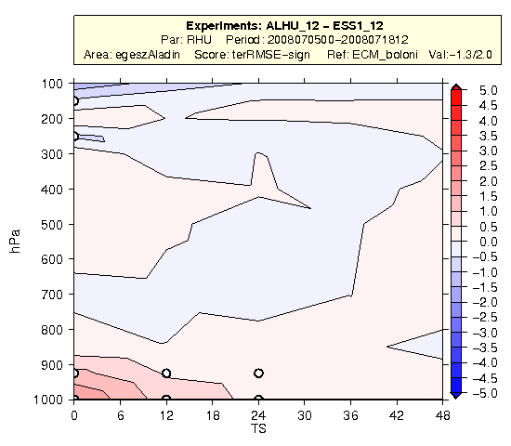
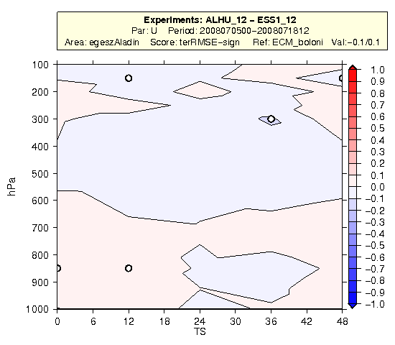
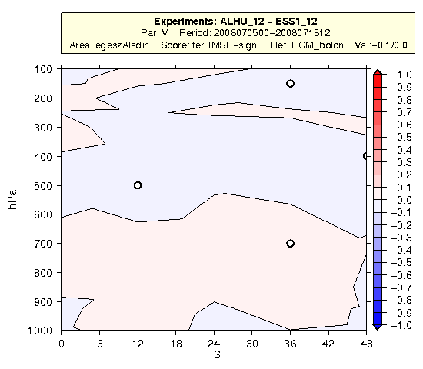

Figure 15: Difference of RMSE scores of the 12 UTC forecast of ESS1 and HUN2. White circles show that the difference is significant on a 90 % confidence level. The figure order is following Ф, T, RH, u and v.

